

Modul Profile Manager

MicroStep HDO s.r.o

júl 2025

Pracovné postupy

Content of the report

Obsah 5

1. Aplikácia Profile Manager 11

1.1. Ako sa prihlásiť do aplikácie 11

1.2. Horná lišta aplikácie 12

1.3. Zmena farby hornej lišty aplikácie 16

1.4. Ako pridať na plochu okná prieskumník, tabuľka a graf 16

1.4.1. Pravidlá pre názvy okien 17

1.5. Ako sa odhlásiť z aplikácie 18

1.6. Ako zmeniť jazykovú verziu 19

1.7. Ako zmeniť predvolené nastavenia 19

1.8. Ako zobraziť profil prihláseného užívateľa 20

1.9. Globálny dátumový rozsah 21

1.9.1. Ako aplikovať dátumový filter vo vybranom okne 22

1.9.2. Ako aplikovať dátumový filter vo všetkých oknách naraz 23

1.10. Ako obnoviť viditeľné dáta 23

1.11. Všeobecné nastavenia 23

1.11.1. Globálne všeobecné nastavenia 23

1.11.2. Všeobecné nastavenia pre tabuľku 28

1.11.3. Všeobecné nastavenia pre graf 31

1.11.4. Všeobecné nastavenia pre prieskumník 33

1.12. Nastavenia pre sviatky 35

1.12.1. Ako vytvoriť profil pre sviatky 35

1.12.2. Ako vybrať profil pre sviatky 39

1.12.3. Ako odstrániť profil pre sviatky 40

1.13. Ako zobraziť informácie o statuse 40

1.14. Ako zobraziť upozornenia 41

1.15. Ako zväčšiť okno stromovej štruktúry 42

1.16. Synchronizácia panelov 44

1.16.1. Zarovnať časové rozsahy 44

1.16.2. Ako synchronizovať tabuľky 45

1.16.3. Ako synchronizovať grafy 47

1.17. Ako importovať, exportovať a ukladať zostavy 47

1.17.1. Ako importovať zostavu 48

1.17.2. Ako exportovať zostavu 50

1.17.3. Ako aktualizovať zostavu 50

1.17.4. Ako uložiť novú zostavu 52

1.17.5. Ako zarovnať zostavu do stĺpcov 54

1.17.6. Ako zarovnať zostavu do riadkov 56

1.17.7. Ako zarovnať všetko do jedného panelu 58

1.17.8. Ako rozdeliť zostavu do samostatných panelov 58

1.17.9. Ako nastaviť globálny časový rozsah pri zobrazení zostavy 59

1.17.10. Ako zatvoriť zostavu 61

1.18. Ako horizontálne zarovnať okná 62

1.19. Ako vertikálne zarovnať okná 63

1.20. Ako zobraziť a stiahnuť exporty 63

1.21. Ako zobraziť importy 65

1.22. Klávesové skratky 67

1.23. Ako vyhľadať profil v aplikácii 71

1.24. Informovanie užívateľa o odhlásení 71

1.25. Ako zobraziť čas, ktorý ostáva užívateľovi do odhlásenia 72

2. Práca s adresármi a profilmi 74

2.1. Ako pridať nový adresár 74

2.2. Ako premenovať adresár 76

2.3. Ako editovať adresár 77

2.4. Ako zmazať adresár 78

2.5. Ako kopírovať adresár 78

2.6. Ako vystrihnúť/presunúť adresár 79

2.7. Ako nahrať súbor 79

2.8. Ako zmazať dáta profilov 81

2.9. Ako filtrovať adresáre a profily 84

2.10. Ako zrušiť filter adresárov a profilov 85

2.11. Ako zobraziť komentáre 85

2.12. Ako zobraziť tooltip 86

2.13. Ako zobraziť charakter 88

2.14. Ako obnoviť zoznam 89

2.15. Ako nastaviť práva používateľov a skupín 89

2.16. Ako vytvoriť export 94

2.17. Ako vytvoriť import 98

2.18. Ako pridať nový profil 101

2.18.1. Ako zadať definíciu pre počítaný typ profilu 105

2.19. Ako pridať novú zostavu 112

2.20. Ako premenovať profil 113

2.21. Ako editovať profil 113

2.22. Ako zmazať profil 114

2.23. Ako zobraziť závislosti profilu 114

2.24. Ako vytvoriť nový profil 116

2.25. Ako nastaviť Politiku profilu 116

2.26. Ako zobraziť informácie o profile 117

2.27. Ako skopírovať profil 118

2.28. Ako vystrihnúť/presunúť profil 121

2.29. Ako zobraziť náhľad časovej rady v strome 122

2.30. Ako zväčšiť okno pre vytvorenie a úpravu počítaného profilu 123

2.31. Ako premiestniť okná 123

2.32. Ako premenovať dokument 124

3. Spoločné ovládacie prvky pre prieskumník, tabuľku a graf 125

3.1. Ako obnoviť dáta v oknách 125

3.2. Ako zmeniť dátumový rozsah 125

3.3. Ako zväčšiť okno cez celú plochu aplikácie 126

3.4. Ako zatvoriť okno 127

3.5. Nastavenie názvu a farby panelu 127

3.6. Ako exportovať zobrazené dáta z okna Prieskumník 129

3.7. Ako skryť horný panel s tlačidlami v okne prieskumník, tabuľka a graf 129

3.8. Ako pridať profil do grafu a tabuľky 130

4. Práca s oknom Prieskumník 132

4.1. Ako zobraziť profily z vybraného adresára v okne Prieskumník 132

4.2. Ako vytvoriť nový adresár 132

4.3. Ako synchronizovať prieskumník so stromom 132

4.4. Ako filtrovať profil 133

4.5. Ako zoradiť dáta v stĺpcoch 134

4.6. Ako vypočítať hodnoty v stĺpcoch Min, Max, Sum, Avg a Count v okne Prieskumník 134

4.7. Náhľad časovej rady 135

4.8. Ako presunúť profil z okna Prieskumník do okna Graf alebo Tabuľka 138

4.9. Ako upraviť pridať alebo odobrať stĺpce v okne Prieskumník 139

4.10. Ako upraviť polia Názov a Komentár 141

4.11. Funkcie pre prácu s adresármi v okne Prieskumník 141

4.12. Funkcie pre prácu s filtrami v okne Prieskumník 142

4.13. Tlačidlo Branch view 143

4.14. Ako zobraziť vymazané položky v okne Prieskumník 145

4.15. Ako skopírovať zobrazené dáta 146

4.16. Použiť ako východzie nastavenie Prieskumníka 148

4.17. Ako filtrovať v stĺpcoch pomocou * wildcard 149

5. Práca s grafom 152

5.1. Ako zobraziť profil v grafe 152

5.2. Ako zobraziť informačné okno s hodnotami pre konkrétne miesto v grafe 153

5.3. Ako zmeniť v grafe dátum od-do 155

5.4. Ako uložiť graf vo formáte JPG 155

5.5. Ako skopírovať celý graf do nového okna 155

5.6. Ako nastaviť parametre grafu 156

5.6.1. Ako nastaviť počet desatinných miest pre každú z Y-ových osí 158

5.6.2. Ako vypnúť vodorovné čiary 159

5.7. Funkcie pre prácu nad označenými profilmi 160

5.7.1. Ako vybrať profily 161

5.7.2. Ako zobraziť vlastnosti profilu 161

5.7.3. Ako zmeniť nastavenia označeným 162

5.7.4. Ako označiť všetky profily 164

5.7.5. Ako odznačiť všetky profily 165

5.7.6. Ako invertovať označené profily 166

5.7.7. Ako zobraziť len označené profily 167

5.7.8. Ako označené profily nezobrazovať 167

5.7.9. Ako odstrániť označené, všetky alebo chybné profily 168

5.7.10. Ako nastaviť koeficient označeným profilom 169

5.7.11. Ako nastaviť offset 171

5.7.12. Ako zobraziť štatistické čiary 172

5.7.13. Ako nahradiť text označeným 174

5.8. Funkcie pre prácu s jedným profilom 175

5.8.1. Ako upraviť nastavenia 176

5.8.2. Ako odstrániť profil 178

5.8.3. Ako presunúť profil na začiatok 179

5.8.4. Ako posunúť profil hore 180

5.8.5. Ako posunúť profil dole 181

5.8.6. Ako presunúť profil na koniec 181

5.8.7. Ako zobraziť komentár 182

5.8.8. Ako nájsť prvú hodnotu 183

5.8.9. Ako nájsť poslednú hodnotu 183

5.8.10. Ako zobraziť subprofily 184

5.8.11. Ako otvoriť umiestnenie profilu 185

5.8.12. Ako otvoriť info okno 187

5.8.13. Ako nastaviť koeficient 189

5.8.14. Ako zadať offset 190

5.8.15. Ako vymeniť profil 193

5.8.16. Ako editovať profil 194

5.8.17. Ako nastaviť farbu pre profil 196

5.8.18. Ako nastaviť veľkosť bodu 197

5.8.19. Ako zobraziť profil v tabuľke 201

5.9. Rýchla zmena typu grafu 203

5.10. Ako priblížiť vybranú časť grafu 205

5.11. Ako posúvať graf 206

5.12. Ako zrušiť zoom 207

5.13. Ako zobraziť/skryť legendu 207

5.14. Ako zobraziť/skryť tooltip 208

5.15. Ako nastaviť y-ovú os, aby bolo vidieť hodnoty 209

5.16. Ako vymeniť profil 211

6. Práca s tabuľkou 215

6.1. Ako zobraziť profil v tabuľke 215

6.2. Ako nastaviť stĺpcové zobrazenie 216

6.3. Ako prepnúť na jednoprofilové zobrazenie 217

6.4. Ako zmeniť časový formát zobrazenia 219

6.5. Ako nastaviť počet stĺpcov 219

6.6. Ako vybrať spôsob prevzorkovávania 221

6.7. Ako zobraziť prvú hodnotu 222

6.8. Ako zobraziť poslednú hodnotu 222

6.9. Ako zobraziť aktuálny deň 222

6.10. Ako zobraziť konkrétny dátum 223

6.11. Ako posúvať dátum o deň, týždeň, mesiac 224

6.12. Ako pridať stĺpec Suma, Priemer, Min, Max 225

6.13. Ako zapnúť/vypnúť tooltip 226

6.14. Ako zapnúť/vypnúť zvýraznenie riadku 227

6.15. Ako upraviť hodnotu profilu v tabuľke 228

6.16. Ako zmeniť definíciu profilu 229

6.17. Ako odstrániť profil z tabuľky 230

6.18. Ako zapnúť automatické nastavenie šírky stĺpcov 230

6.19. Ako otvoriť umiestnenie profilu 231

6.20. Ako pridať profil 232

6.21. Ako exportovať zobrazené dáta do CSV 235

6.22. Ako zmeniť definíciu 236

6.23. Ako zmeniť metadáta profilu 236

6.24. Ako odstrániť profil zo zobrazenia 238

6.25. Ako zobraziť profil v grafe 239

6.26. Ako nájsť pozíciu v grafe 240

6.27. Ako otvoriť profil v strome 241

6.28. Označiť blok pomocou ľavého tlačidla myši 241

6.29. Ako nastaviť, aby sa kurzor posúval v tabuľke pomocou kolieska myši 242

6.30. Ako zmeniť poradie profilov v tabuľke 244

7. Aritmetika počítaných profilov 247

7.1. Pravidlá prevzorkovávania 247

7.1.1. Pravidlá prevzorkovávania vstupného profilu na výstupný so zohľadnením charakteru 247

7.2. Počítaný profil 248

7.2.1. Spôsob zápisu výrazu 250

7.2.2. Vyčíslenie výrazu 250

7.2.3. Aritmetické operácie: 250

7.2.4. Funkcie 251

8. Príplatkové/doplnkové funkcie 262

8.1. Monitorovanie profilov 262

8.1.1. Ako vytvoriť nový monitorovací job 262

8.1.2. Ako editovať job v JMW 268

8.1.3. Ako zmazať job 269

8.1.4. Ako exportovať monitorovacie joby a výsledky jobov 269

8.1.5. Ako zobraziť všetky monitorovacie joby 270

8.1.6. Ako obnoviť zoznam jobov v okne „Monitoring“ 270

8.1.7. Ako zobraziť prehľad výsledkov monitorovacieho jobu 270

8.2. Analýza profilov 270

8.2.1. Ako vytvoriť analýzu profilov 271

8.2.2. Ako zobraziť existujúcu analýzu profilov 274

8.2.3. Ako zmeniť platnosť vytvorenej analýzy profilov 275

8.2.4. Ako exportovať zobrazené dáta v analýze profilov 275

8.3. Report Manager 276

8.3.1. Ako vytvoriť nový report 276

8.3.2. Práva pre Report Manager 283

8.4. Ako obnoviť vymazané položky z koša 284

# The Profile Manager app

The Profile Manager application is a tool for presenting profiles (time rows) in graphical or tabular form and their basic management.

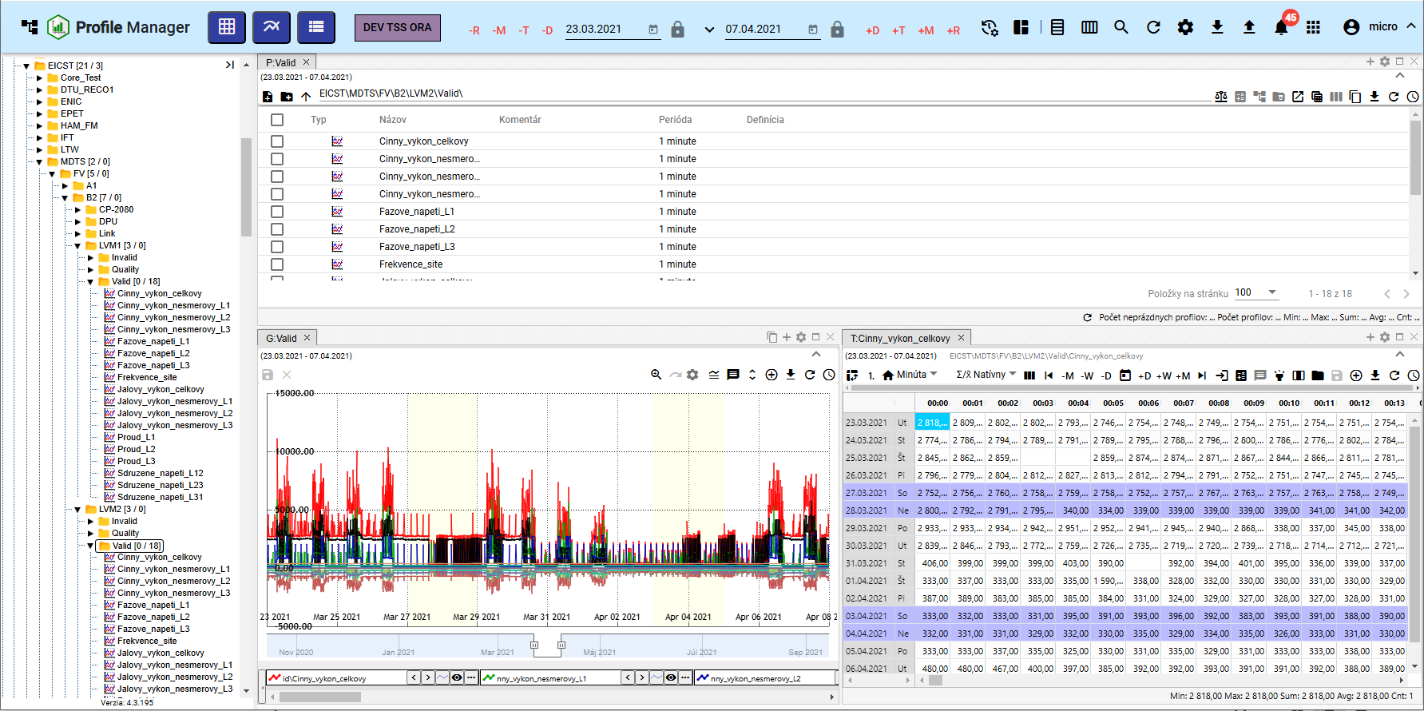

Figure 1: Profile Manager app

## How to sign up for the application

When you run Profile Manager, you will see a login screen. You need to enter your login name and password. Clicking the checkbox Remember will prevent you from entering your login details again when you log in again.

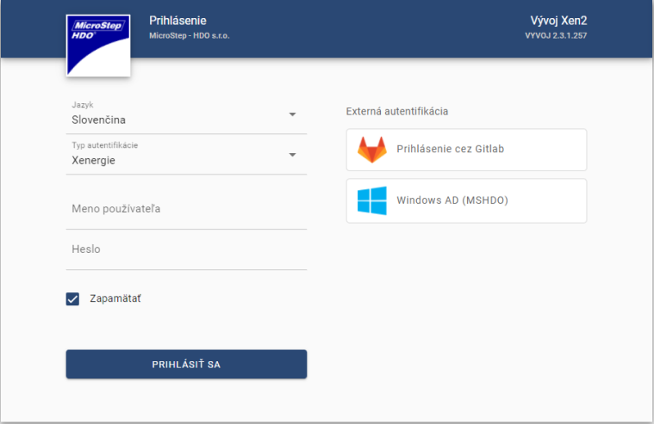

Figure 2: Log in to the Profile Manager

## Top of the application sheets

The top of the application sheet shall contain:

* a button to minimise and maximize the application name

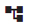

Figure 3: Hide and view app name button

* name of the application Profile Manager - after pressing the button, the application Profile Manager will be reloaded

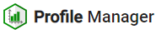

Figure 4: The Profile Manager key

* Add table - by moving the button to the screen, the Table window is added.

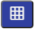

Figure 5: Tape Add a table

* Add Graph - is used to add the Graf window to the application area.



Figure 6: Press the Add the chart

* Add Explorer - by moving the button to the application screen, you can add the Explorer window.



Figure 7: Press the Add the explorer

* the button representing the environment name for the button can be set to text and colour.



Figure 8: Names of the environment

* The global date range - represents the date filter, Chapter 1.9



Figure 9: Global date range

* The Synchronization of panels button allows you to align time frames (1.16.1) and synchronize tables (1.16.2)



Figure 10: Tape Synchronization of panels

* Import and withdrawal buttons Procedures are developed in Chapter 1.17



Figure 11: The Designs button

* Profile search button Profile search is described in Chapter 1.23



Figure 12: Profile search button

* The 'Recover visible data' button - is used to restore data in the application, Chapter 1.10



Figure 13: Pressure Recover the data that is visible

* the Export button contains the list of exports, Chapter 1.20.



Figure 14: Export button

* The Import button contains the list of imports, Chapter 1.21.



Figure 15: Import button

* The Alert button - signals changes made to the application, Chapter 1.14



Figure 16: The Warning button

* The button to view the list of applications. Here is a list of applications for the environment. After clicking on the application in the list, the application will open in the new browser tab.



Figure 17: The button to display the list of applications

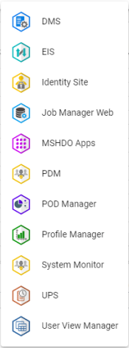

Figure 18: List of applications

* a button with the name of the registered user that allows:
  + change in the language version of the application, Chapter 1.6,
  + the restore of default settings, Chapter 1.7,
  + display key shortcuts,
  + the profile display, 1.8,
  + display of the status information of the application and services, Chapter 1.13,
  + the withdrawal from the application, Chapter 1.5.

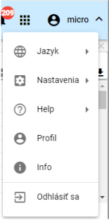

Figure 19: Keyboard with the name of the registered user

* The Hide the top sheet button is used to hide the top sheet, then the appearance of the button changes and is used to display the top sheet, Figure 21.

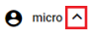

Figure 20: Pressure Serve the top sheet of the toolbar

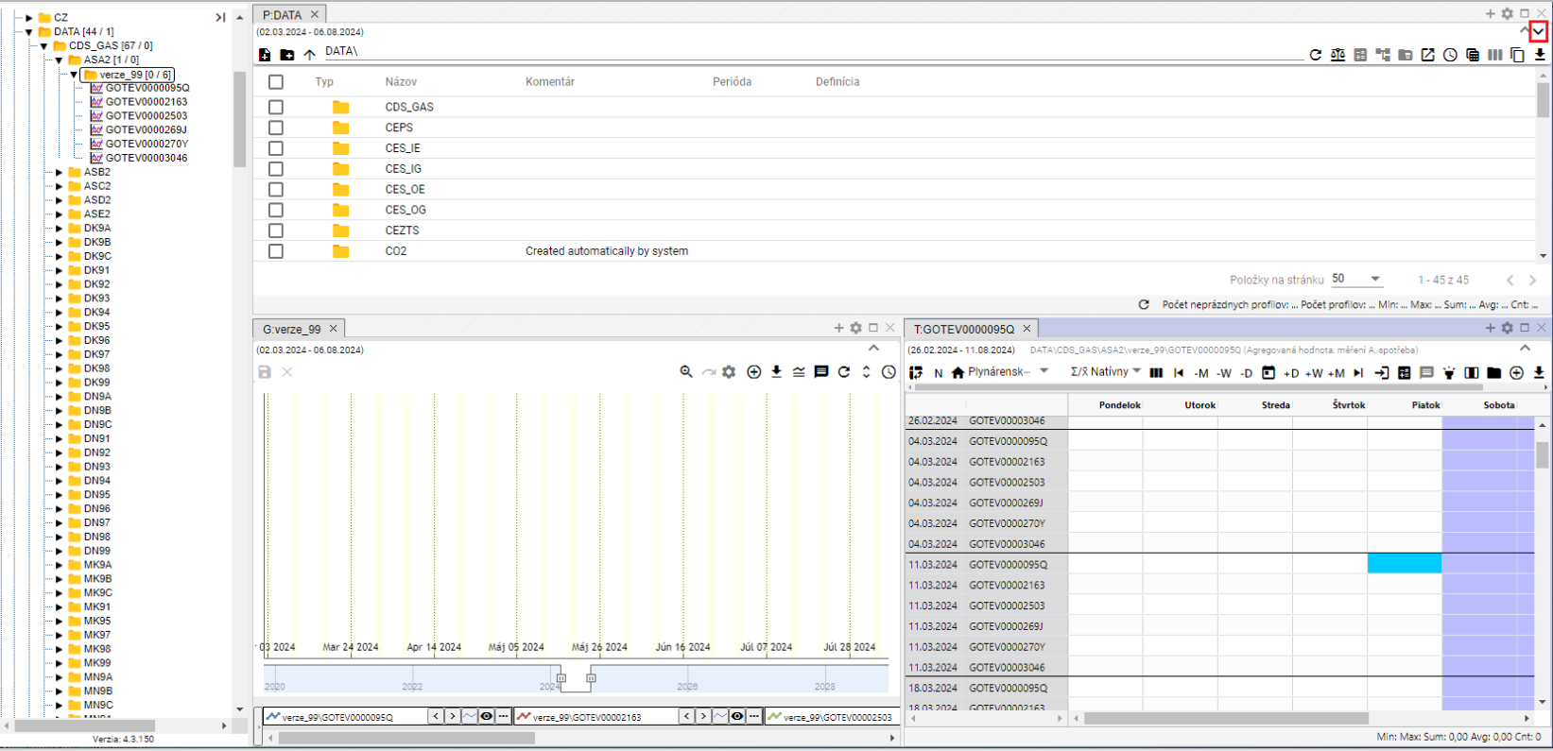

Figure 21: The button to display the top dashboard



Figure 22: Top of the application sheets

## Change in colour of the top sheet of the application

The customer may request a change in the colour of the upper sheet of the instruments.



Figure 23: Top of the application sheets

## How to add a window area to the scanner, table and graph

You can add any number of browser, table and graph windows to the Profile Manager area.

1. Use the left mouse button to grab the button and move it to the application surface.
2. Hold the button above the surface and move to the place where you want to add the window.
3. Choose the shape that the window should have.

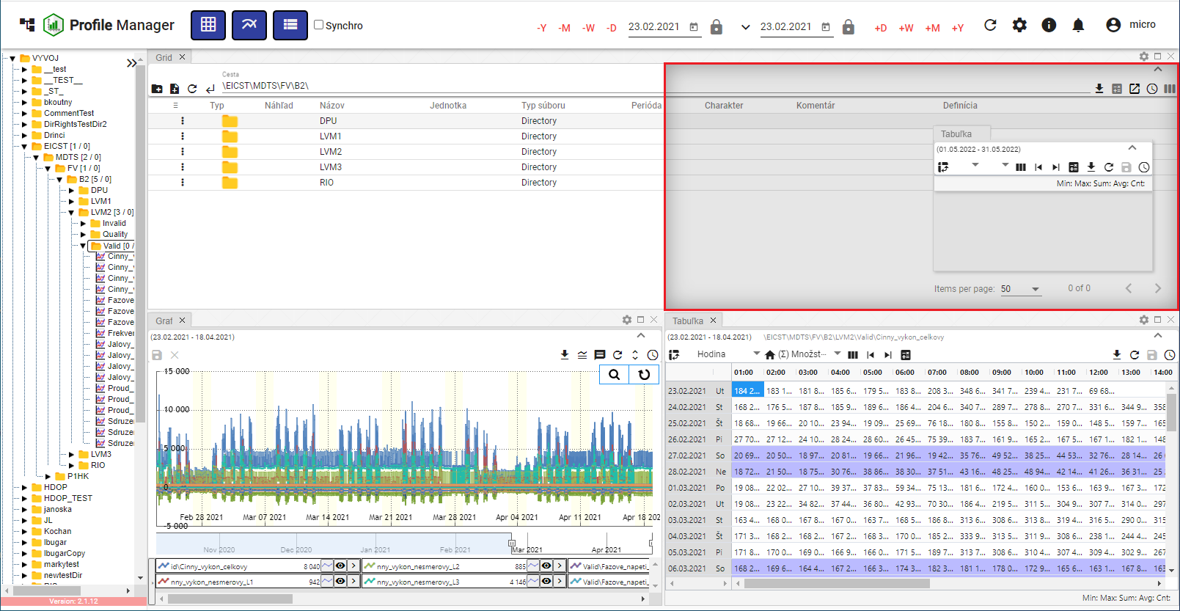

Figure 24: Selection of the shape and position of the window

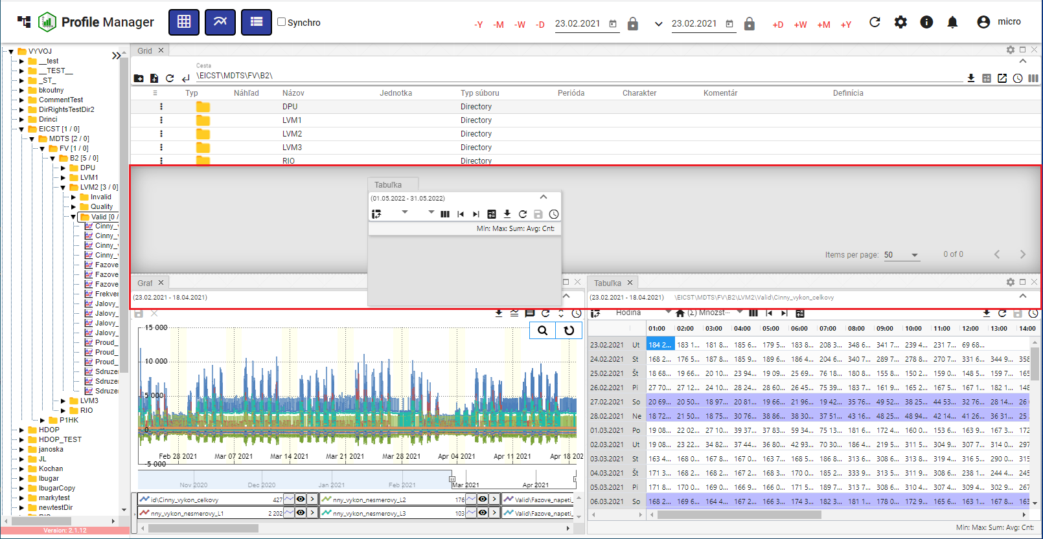

Figure 25: Shape and location of the table window

1. The button presses to add a window to the selected location.

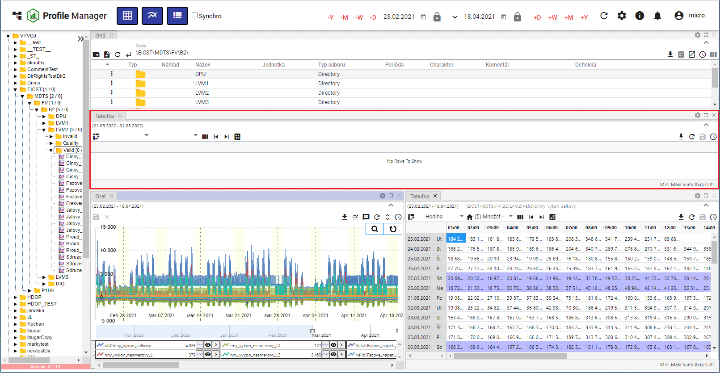

Figure 26: Table window added

### Rules for window names

The Explorer, Graph and Table windows are automatically named according to the following rules:

Table of the year

The name of the table is T: <name of the first profile in the table>.

For example: T:HPFC profile.

Graph

The name of the graph is G: <name of the first profile in the graph>.

The following is the list of the types of products that are used in the manufacture of the product:

The investigator

The name for the survey in Slovak and Czech is P: <name of the address in which I am >.

For example: P: AddressarTEST.

In the root directory, the word P:Root will be there.

In English, the survey is called E: <name of address in which I am >.

For example, E:AddressarTEST.

In the root directory, the word E:Root will be there.

The Commission shall adopt implementing acts in accordance with Article 21 of Regulation (EC) No 1907/2006 and with the opinion of the Committee on Budgets.

The browser - Branch view is named B: <name of address in which the branch view was launched >.

For example, B:AdresarTEST. For the root address, the name B:Root will be.

Each time the profile or address is changed, the name of the window is adjusted accordingly. If the user enters the name of the window using a button, the automatic setting will be turned off and no longer apply.

## How to opt out of the application

Log out of the app by pressing the login button. A window will appear where you can press "Log out".

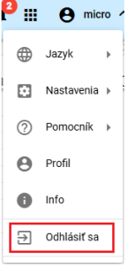

Figure 27: Item to be reported

## How to change the language version

To change the language version, press the name of the registered user and then set the cursor to Language.

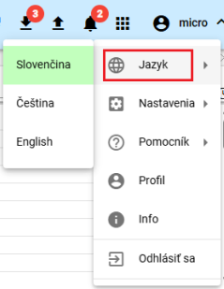

Figure 28: Changes in the language version

## How to change default settings

Restore the default settings in the Profile Manager app as follows:

1. Press the button with the name of the registered user.
2. Use the mouse cursor to set to Settings.
3. Press the Set the default settings button.

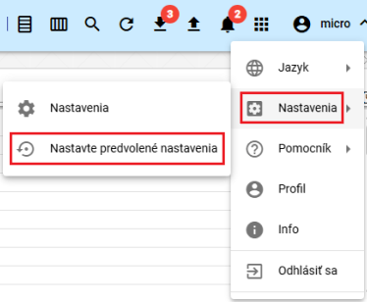

Figure 29: Position of the settings

1. A confirmation window will appear where you can press the NO button.

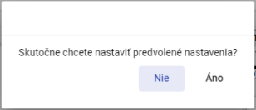

Figure 30: Confirmation of setting the default settings

## How to display the profile of the logged-in user

You will see the profile of the logged-in user:

1. Press the button with the name of the registered user.
2. Please click on Profile.

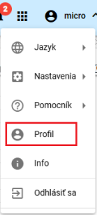

Figure 31: Item Profile

1. The new browser tab will display the profile of the user logged in to the IdentitySite application.

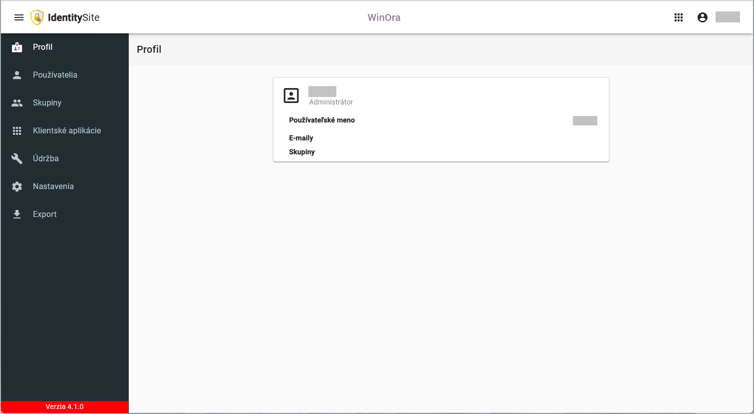

Figure 32: Profile of the registered user in the IdentitySite

## Global date range

By default, the date filter is set to the current date.



Figure 33: Global date range

Click on the button to see the default date range options, Figure 34.

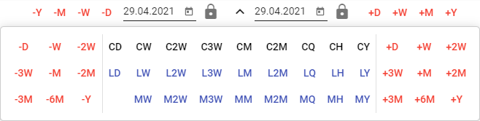

Figure 34: Options for the default date ranges

You can lock the dates. When you change the date range, the locked date doesn't change.



Figure 35: Locking the date

### How to apply the date filter in the selected window

The date range in the top of the app is linked to the marked window. If the date range in the marked window changes, it will also change in the top of the app. If the date range changes in the top of the app, it will apply to the marked window.

Step by step:

1. Select the window where you want to apply the filter by clicking on the top of the window, Figure 36.

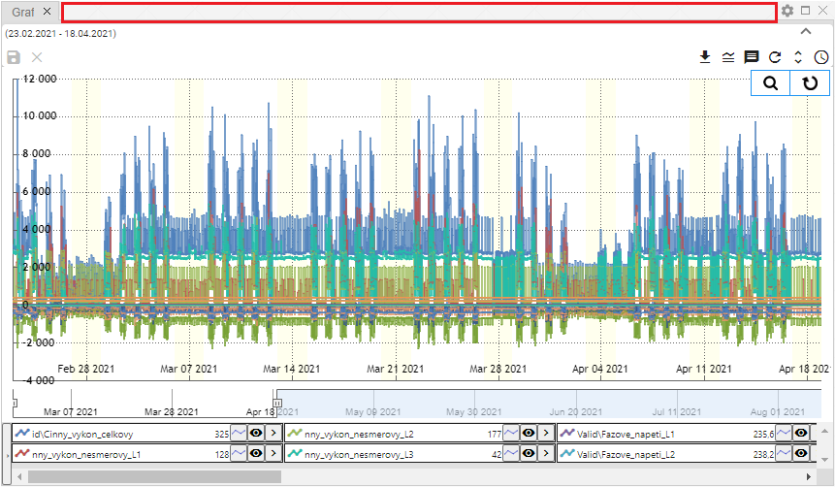

Figure 36: Place of marking of the window

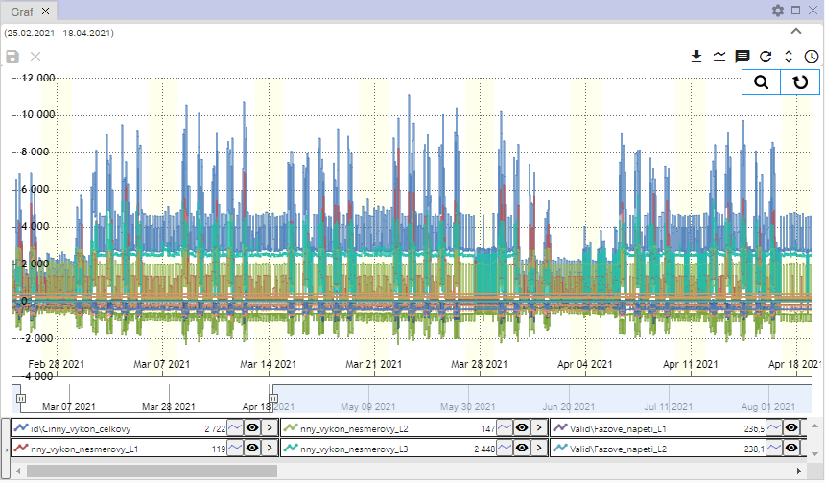

Figure 37: Selected window for filter

1. In the top of the app, select the date filter.



Figure 38: Global date range

1. The data in the selected window shall be displayed according to the selected date filter.

### How to apply a date filter to all windows at once

Step by step:

1. Please click on the checkbox Synchronous.



Figure 39: Checkbox Synchronous

1. Select one of the Explorer, Table or Graph windows by clicking on the top of the window, Figure 36 and Figure 37.
2. Next, enter the date filter in the top of the application tab.



Figure 40: Global date range

1. The data filter is applied to all windows in the application.

## How to Recover Visible Data

To recover data in the Profile Manager app, press the Recover Visible Data button, which is located at the top of the app.



Figure 41: The button Recover the data that is visible

## General settings

The tab General in the Settings window is divided into parts:

* Global general settings for the Profile Manager application,
* Table General settings for the table,
* Graph general settings for the graph,
* The test subject General settings for the test subject.

The individual settings are described in the following subchapters.

### Global general settings

#### How to turn on automatic refresh after profile editing

If you want to restore data after you save it, go to:

1. Press the button with the name of the registered user, which is located at the top of the app.

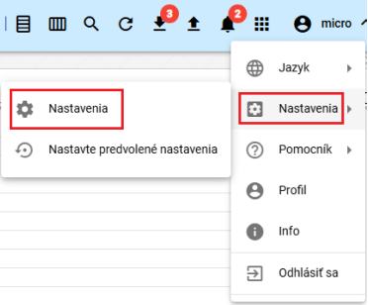

Figure 42: Position of the settings

1. The Settings window will appear.
2. In the General section, click Recover the data after saving.

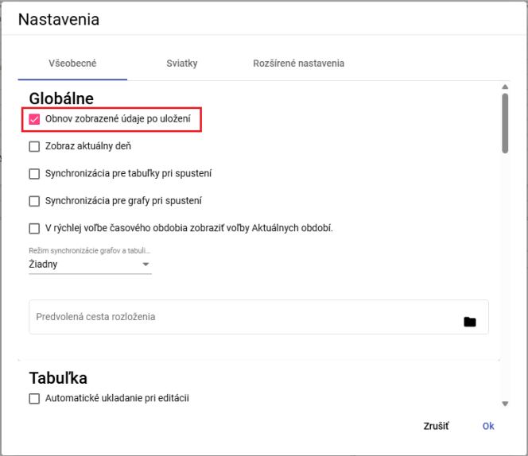

Figure 43: Item Recovered data after storage

1. Save changes by pressing the OK button.

#### How to display new windows on the current day

To see the new Explorer, Table and Graph windows on the current day, please proceed to:

1. In the Settings window in the General tab, in the Global section, click the current date field, Figure 43.
2. Save changes by pressing the OK button.

#### How to sync time for tables

To synchronize the time for tables, follow:

1. In the Settings window in the General tab, in the Global section, click the Sync for tables when running, Figure 43.
2. Save the changes by pressing the OK button.
3. Next, restart the application.
4. If you click on the Sync for tables field when running the Sync tables, 1.16.2 button will also be clicked.

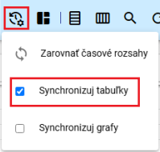

Figure 44: Field Synchronize tables

1. The table window will display the text SYNC.

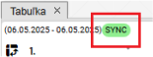

Figure 45: The text SYNC is displayed in the table

#### How to sync time for charts

To synchronize the time for tables, follow:

1. In the Settings window in the General tab, in the Global section, click the field Synchronization for charts when running, Figure 43.
2. Save the changes by pressing the OK button.
3. Next, restart the application.
4. If you click on the Sync for charts field when you start the Sync charts button will also click, 1.16.3

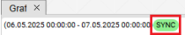

Figure 46: The graph shows the text SYNC

#### How to turn on sync between graph and table

**[TRANSLATION ERROR - MANUAL REVIEW NEEDED] Pre zapnutie synchronizácie medzi grafom a tabuľkou postupujte:**

1. In the Settings window in the General tab, select the item in the Global section in the Chart and Table Sync Mode field.
   1. No - synchronization between graph and table is disabled,
   2. Start - synchronize the start of the graph,
   3. the center of the graph is synchronized.

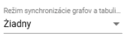

Figure 47: Chart and table synchronization mode

1. Save the changes by pressing the OK button.
2. Next, restart the application.

#### How to display the current time options in Quick Time Period Selection

In the rapid time-period selection, the options AR, AM, AT, AD are displayed instead of +R, +M, +T, +D. Instead of -R, -M, -T, -D, MR, MM, MT, MD are displayed.

Step by step:

1. Click the field In the Quick Time Period Selection to display the Current Period Selections.
2. Save the changes by pressing the Ok button in the Settings window.
3. Restart the application. Changes to the application will be displayed.



Figure 48: Quick selection of time period

#### How to set the path to the default distribution

The Default layout path field is used to set the path to the stored Profile Manager application.

Step by step:

1. In the Settings window in the General tab in the Global section of the Default layout path, enter the path to the saved set or click the button to display the Select Set window in which to search for the saved set.

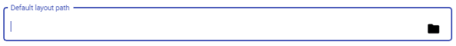

Figure 49: Field Default layout path

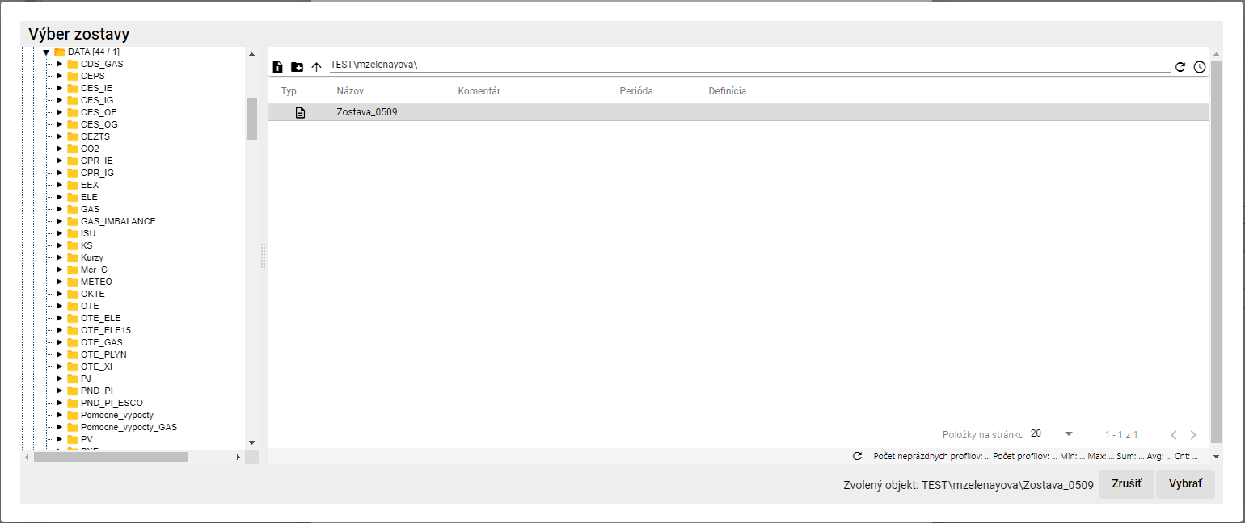

Figure 50: Selection of the report

1. In the Select reports window, press the Select button.
2. The path path path is the path to the selected file.



Figure 51: Selected sample

1. To save changes, press the OK button in the Settings window.

### General settings for the table

#### How to set automatically save changes in a table

By setting automatic table saving, changes made to the table will be saved immediately.

1. In the Settings window in the General tab in the Table, click Automatic saving when editing.

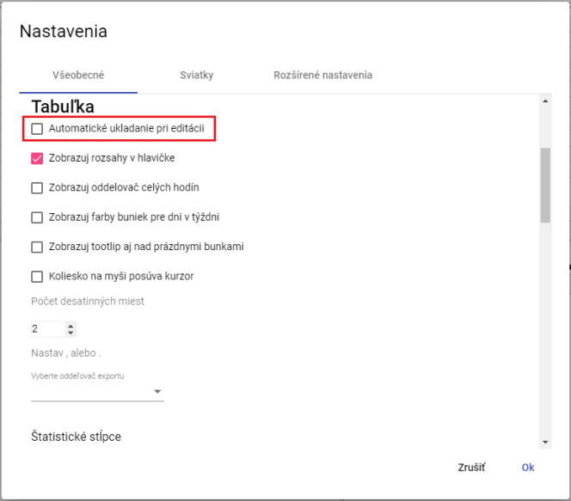

Figure 52: Settings for the table

1. Save changes by pressing the OK button.

#### How to display ranges in the table header

The header ranges for the table window are set to:

1. In the Settings window in the General tab in the Table section, click on the Display ranges in the header, Figure 52.
2. Save changes by pressing the OK button.

#### How to set the full hour separator for a table

Set the whole-hour separator in the Table window:

1. In the Settings window in the General tab in the Table section, click on the Display of the full time separator, Figure 52.
2. Save changes by pressing the OK button.

#### How to set the color of cells for days of the week in the table

Set the color of the cells for days of the week:

1. In the Settings window in the General tab in the Table section, click on the Display of cell colors for weekdays, Figure 52.
2. Save changes by pressing the OK button.

#### How to display tooltip over empty cells in a table

To set the tooltip display to the empty cells in the table, go to:

1. In the Settings window in the General tab in the Table section, click on the View tooltip above the empty cells, Figure 52.
2. Save changes by pressing the OK button.

#### How to set the mouse wheel to move the cursor

You set the cursor to move by the mouse wheel:

1. In the Settings window in the General tab in the Table section, click on the mouse-switched curve, Figure 52.
2. Save changes by pressing the OK button.

#### How to set the number of decimal places in a table

To set the number of decimal places in the Table window, go to:

1. In the Settings window in the General tab in the Table, set the number of decimal places in Figure 52.
2. Save changes by pressing the OK button.

#### How to set the export separator for the table

For the setting of the export separator for the table, please proceed to:

1. In the Settings window in the General tab in the Table section of the box Select the export separator Select the separator.
2. Save changes by pressing the OK button.

#### How to set the used statistical columns in the table

For setting which statistical columns to use in the table, proceed to:

1. In the Settings window, in the General tab, in the Table, select the statistical columns to use.

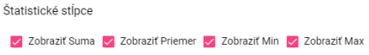

Figure 53: Statistical columns

1. Save changes by pressing the OK button.

#### How to set the right-hand attachment

To set the alignment to the right of the table, proceed to:

1. In the Settings window in the General tab in the Table, click the field to display the attachment on the right.



Figure 54: Item Show attachment on the right

1. Save changes by pressing the OK button.

#### How to set the default widths of the table columns

To set the default width of the table columns, proceed to:

1. To set default values for column widths, click the field Use default values, which is located in the tab General in the Table section of the Settings window.

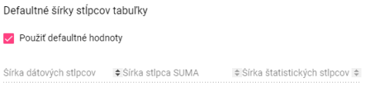

Figure 55: Item Use the default values

1. To set custom values for column widths, leave the field Use default values unattended. This will make fields available for column width settings.

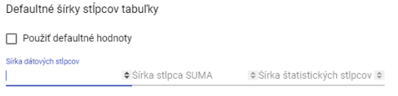

Figure 56: Setting of own values for column widths

1. Enter the width of the columns and save the changes by pressing the Ok button.

### General settings for the graph

#### How to set the standard type of line graph

The standard type of line of the graph can be Chara or Chapter line.

1. In the Settings window in the General tab in the Graph section you can select the standard type of line.
2. By clicking on the Default line type field, you can select Crypt or Stepline.

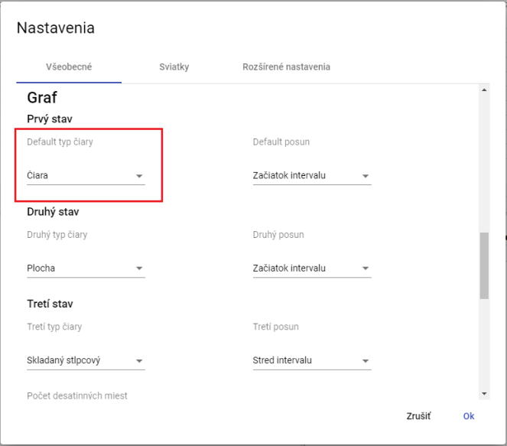

Figure 57: Selection of the standard line type for the graph

1. Save the changes by pressing the OK button.

#### How to set the second and third line types for the graph

To set the second and third line types, proceed to:

1. In the Settings window in the General tab, in the Graph, click on the Type of line field, which will show the window in which you select the type of line.
2. To select the third type of line, click on the box Third type of line, which will display the window in which to select the type of line.
3. Save changes by pressing the OK button.

#### How to set the standard shift, second and third shift for graph

Step by step:

1. In the Settings window in the General tab, click the Default shift box in the Graph and select one of the options shown.
2. In the field "Second shift", select the item for the second shift.
3. In the field Third shift, select the entry for the third shift.
4. Save changes by pressing the OK button.

#### How to set the number of decimal places for the graph

Step by step:

1. In the Settings window in the General tab, in the Graph section of the Count of decimal places field, enter the number of decimal places.
2. Save changes by pressing the OK button.

#### How to set the line start date for the graph

Step by step:

1. In the Settings window in the General tab in the Graph section, click the field to display the start date of the line.
2. Save changes by pressing the OK button.

#### How to display the current time

Step by step:

1. In the Settings window in the General tab, in the Graph section, click the field to view the current time.
2. Save changes by pressing the OK button.

#### How to set zoom out by typing left

The zoom function is used to move a selected place in a graph. The zoom out function causes the selected place in the graph to be moved away. To move a selected place in the graph, click the left mouse button in the graph and the mouse cursor to select the place in the graph by dragging left to right. To move a place in the graph away, you move in the opposite direction, the place in the graph is moved from right down to left up.

Step by step:

1. In the Settings window in the General tab in the Graph section, click the left-hand corner of the Zoom out field.
2. Save the changes by pressing the OK button.

#### How to set the automatic shift to shift after approach

The Automatically switch to move field after approach means that if you click the Repeat to zoom button in the graph window, the move will automatically be set when you approach the selected area in the graph.

Step by step:

1. In the Settings window in the General tab in the Graph section, click on the field to automatically switch to Shift.
2. Save the changes by pressing the OK button.

### General settings for the explorer

#### How to set decimal places in the Explorer window

For statistics in the Explorer window, you can set the number of decimal places by following the following procedure:

1. In the Settings window in the General tab at the bottom of the Settings window in the Examiner section set the number of tenths.

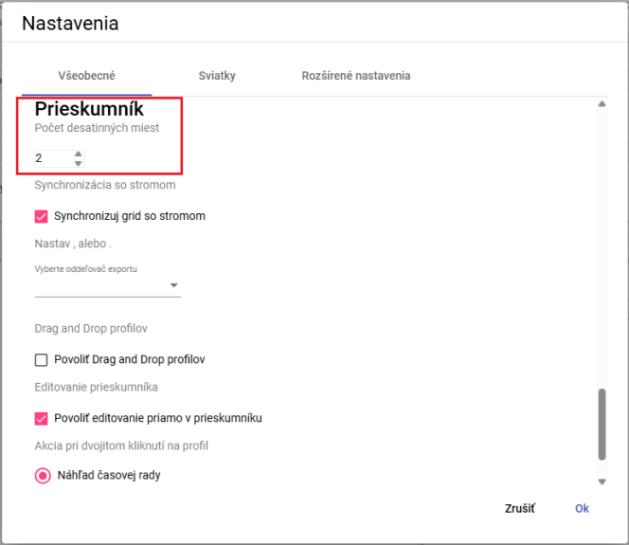

Figure 58: Determining the number of decimal places in the survey window

1. Save the changes by pressing the OK button.
2. In the Explorer window, statistics are displayed with a specified number of decimal places.

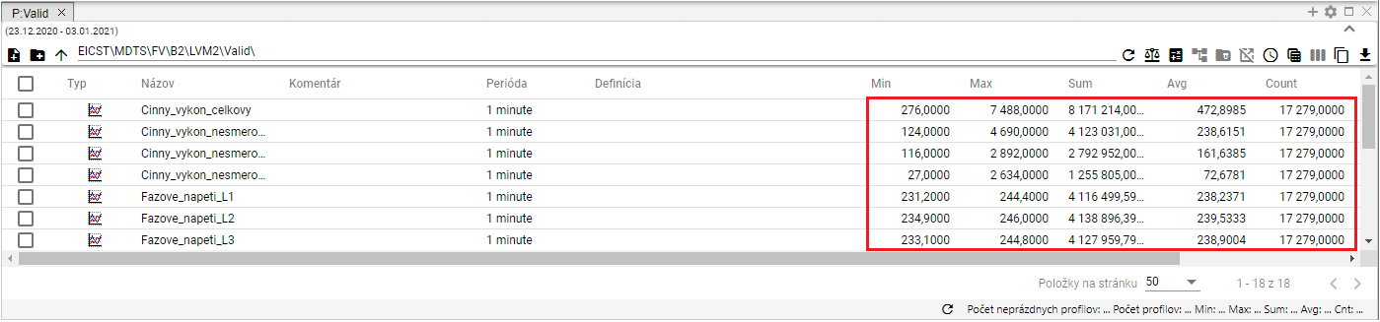

Figure 59: Selected number of decimal places in the Explorer window

#### How to sync window Explorer with tree

To synchronize the scanner with the tree, proceed to:

1. At the bottom of the Settings tab in the General section in the Explorer, click the field Synchronize grid with tree.
2. Save changes by pressing the OK button.

#### How to set up the export separator for the explorer

To set the export separator for the explorer, please proceed to:

1. At the bottom of the Settings tab in the General section in the Explorer is a field Choose export separator in which you can select a dot or line separator.
2. Save changes by pressing the OK button.

#### How to enable drag and drop functionality for profiles

To enable the Drag and drop profiles function, please proceed to:

1. At the bottom of the Settings tab in the General section in the Explorer, click the Drag and drop profiles field.
2. Save changes by pressing the OK button.

#### How to allow editing directly in the Explorer window

The Allow editing directly in the survey is activated by default. It allows you to edit the fields Name, Comment and Definition directly in the survey window.

To disable the function, proceed to:

1. Cancel clicking the field Allow editing directly in the survey.
2. Save changes by pressing the OK button.

#### How to select a double-click profile action

For double-clicking on the profile, you can select the action to be executed.

1. At the bottom of the Settings tab in the General section in the Examiner, select one of three actions.

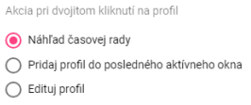

Figure 60: Selection of actions for double-clicking on profile

1. Save changes by pressing the OK button.

## The holiday settings

### How to Create a Holiday Profile

The Holiday Profile allows you to view holidays in all profiles. To create a holiday you need to create a holiday profile, Figure 61, where you enter a value of 1 on days when a holiday is and a value of NaN on days when a holiday is not. Create a holiday profile with a DAY period.

The advantage of a holiday profile is that you can choose which holidays you want to display Slovak or from another country or from several countries at once.

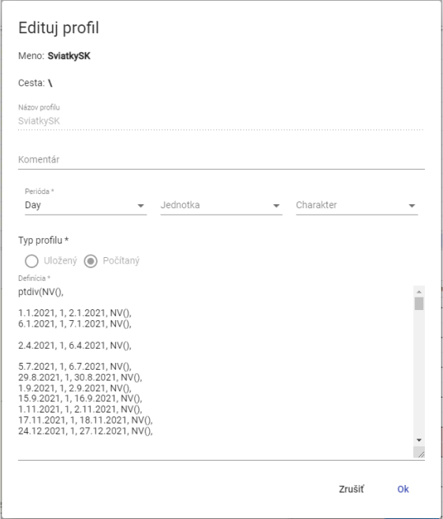

Figure 61: Example of definition of the holiday profile

You create a holiday profile:

1. Press the button with the name of the registered user, which is located at the top of the app.
2. The Settings window will appear, where you can click on the Settings tab.

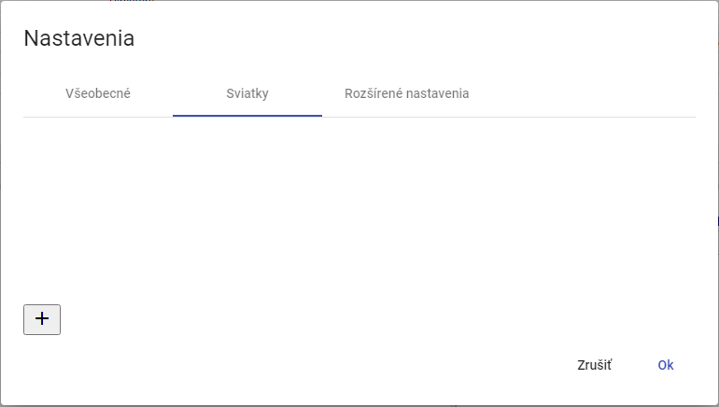

Figure 62: The tab "Worlds"

1. Press the button to create a profile.

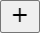

Figure 63: Profile setting button

1. A window World will appear to create a profile.

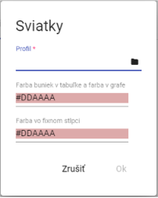

Figure 64: Creating a profile

1. In the Profile field, type a profile or press the profile selection button.
2. After pressing the button, a profile selection window will appear.

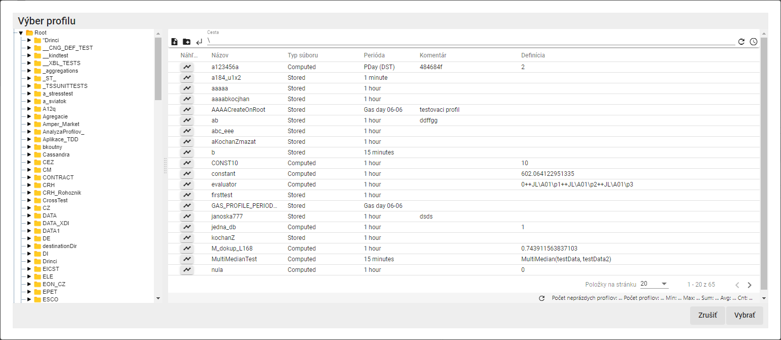

Figure 65: Profile selection window

1. Select the holiday profile and press the Choose button.
2. Select the color for the fields Color of cells in the table and color in the graph and Color in the fixed column.

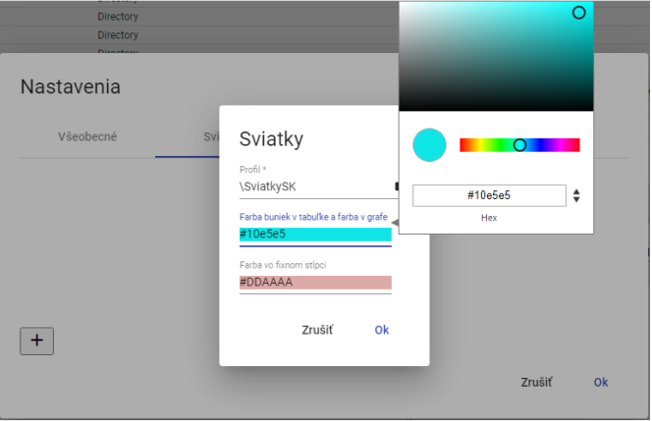

Figure 66: Choice of colour

1. You can create a profile by pressing the OK button.
2. The Worlds window displays a profile created for holidays.

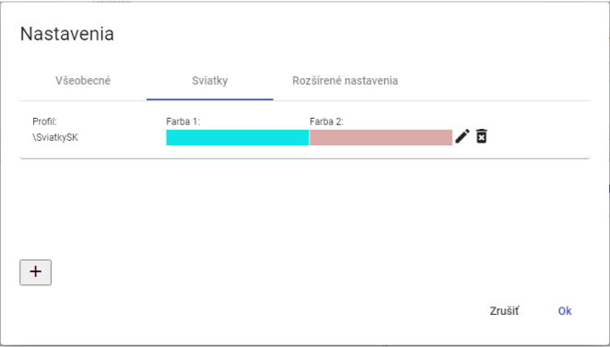

Figure 67: Created profile for holidays

1. Save the created profile by pressing the Ok button.

### How to choose a holiday profile

You'll adjust the holiday profile:

1. Press the button with the name of the registered user, which is located at the top of the app.
2. The Settings window will appear, where you can click on the Settings tab.
3. Press the edit button at the profile you want to edit.



Figure 68: Profile editing button

1. The Worlds window for editing the profile will appear.

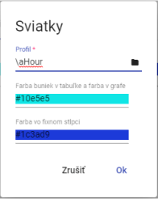

Figure 69: Editing the holiday profile

1. You need to edit the data.
2. Save the changes by pressing the OK button.
3. In the Settings window, press the OK button.

### How to remove the holiday profile

You'll adjust the holiday profile:

1. Press the button with the name of the registered user, which is located at the top of the app.
2. The Settings window will appear, where you can click on the Settings tab.
3. For the profile you want to delete, press the delete button.



The following table shows the following:

1. A window to confirm the deletion of the profile will appear, where you will press the NO button.

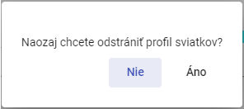

The following information is provided by the Commission to the Commission:

1. The profile shall be removed from the list of holiday profiles.
2. Confirm the deletion of the profile in the Settings window by pressing the OK button.

## How to display status information

To view the status information, press the button with the name of the registered user. The offer will appear where you select Info. Next, the State Information window will appear, which provides information about the status of the Profile Manager Web application and the status of TSS Service, TSS Core, MSHDO.DMST.API, DMS and MSHDO.Xenergy.UTS.Api.

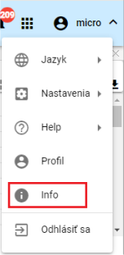

Figure 72: Item Info

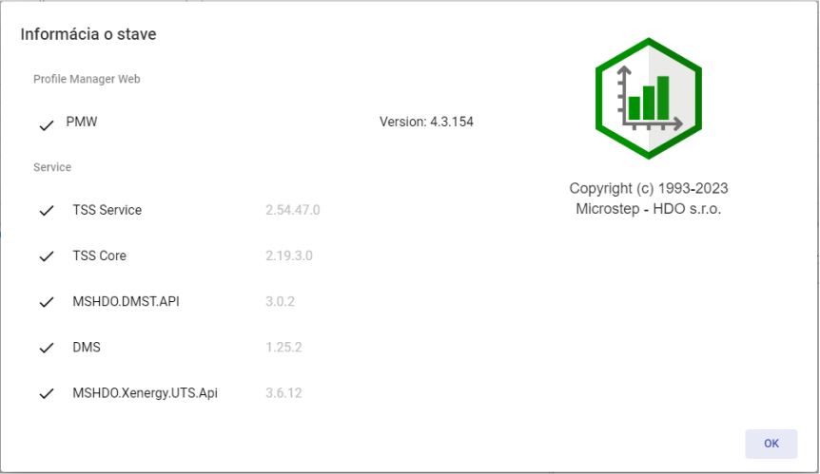

Figure 73: Window Information on the status of the data

## How to display alerts

The Alert button signals changes made to the system, such as creating a directory, etc. If there are alerts in the applications, the red circle in the upper right corner of the Alert button shows the number of alerts.



Figure 74: The Warning button

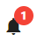

Figure 75: New warning

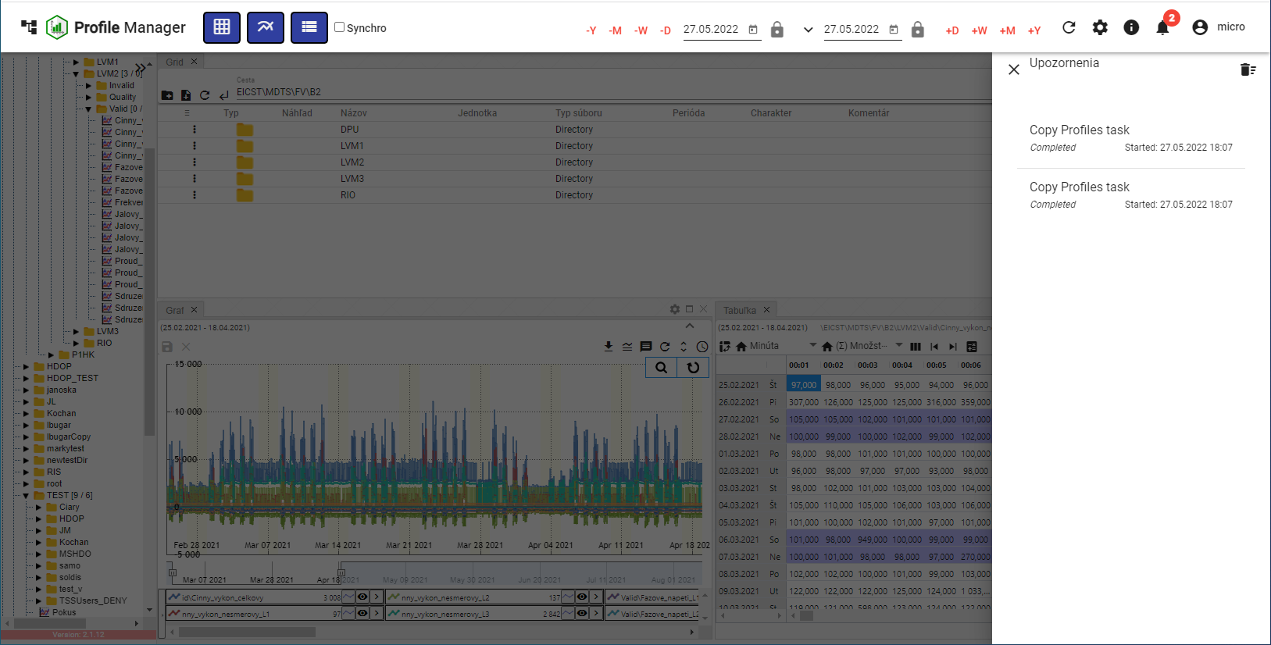

The following table shows the following information:

Remove the notifications by pressing the basket icon in the upper right corner of the Alert block.

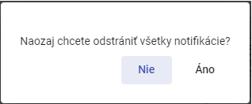

Figure 77: Window to confirm removal of notification

## How to Enlarge a Window of a Tree Structure

You're going to enlarge the tree structure window by pressing a button, Figure 78, which is in the upper right corner of the tree structure.

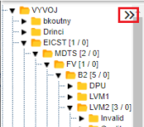

Figure 78: The tree structure extension button

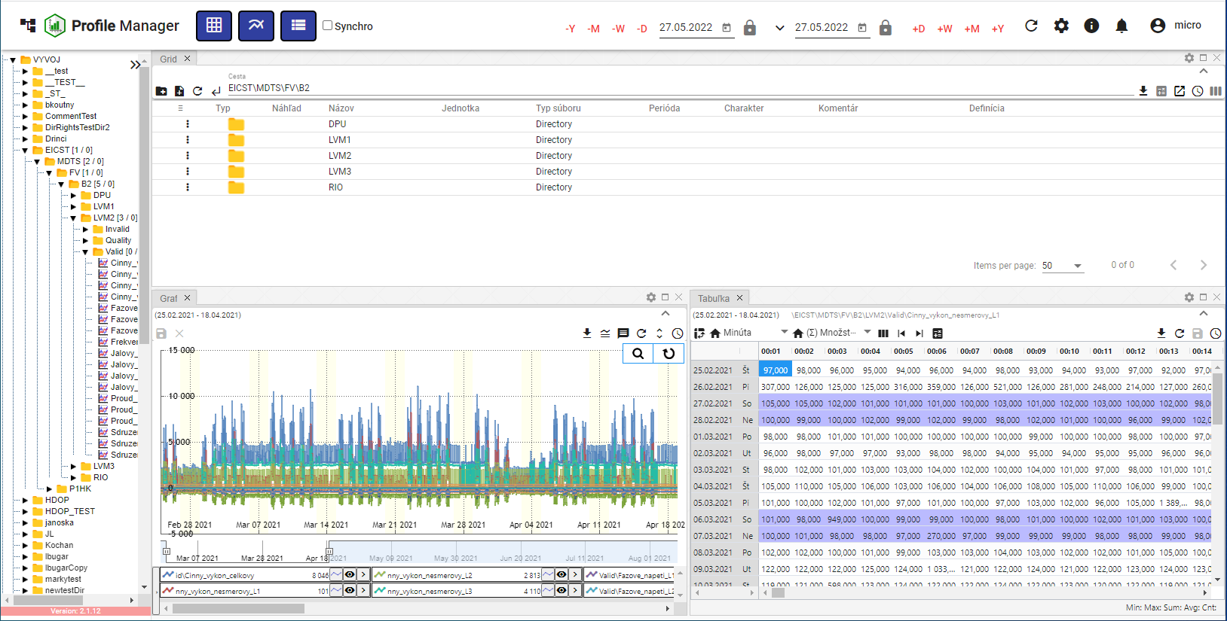

Figure 79: Standard width of window of tree structure

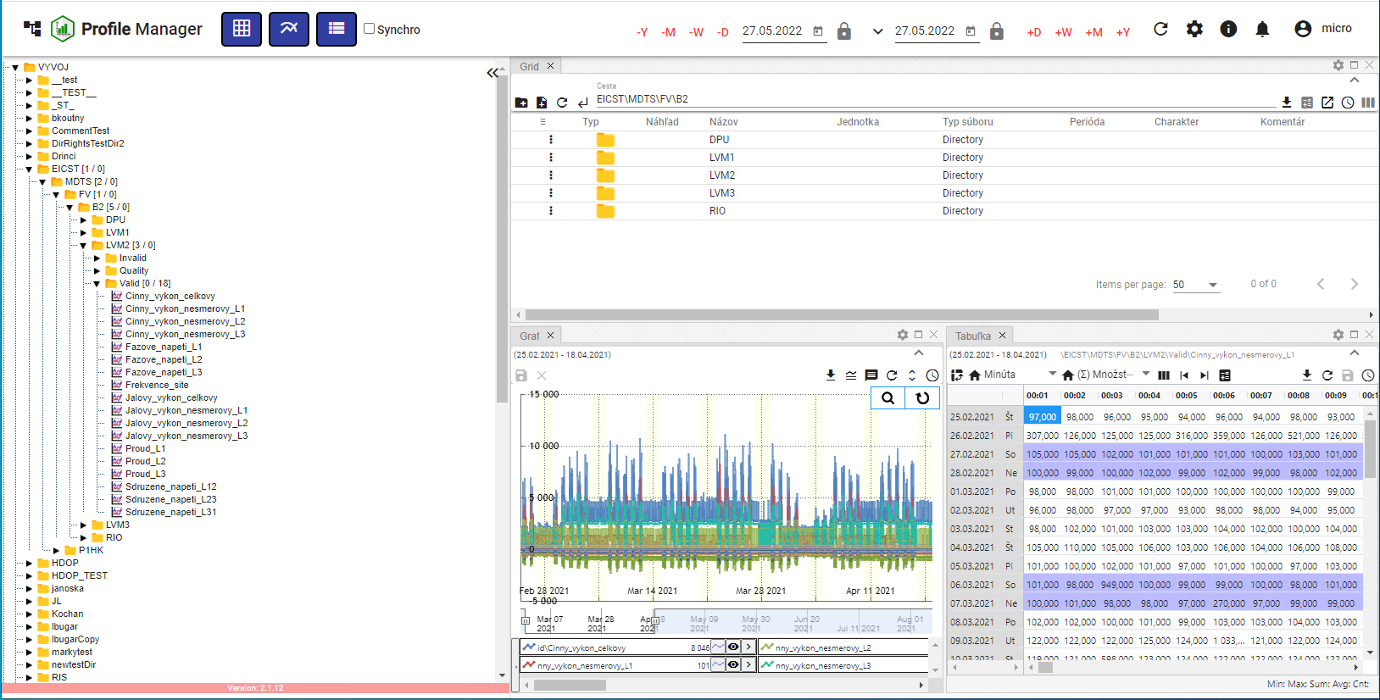

Figure 80: Enlarged window of tree structure

## Synchronization of the panels

The Pane Sync button is used to synchronize open windows in the Profile Manager application. It allows timing (chapter 1.16.1) and synchronizing tables (chapter 1.16.2).

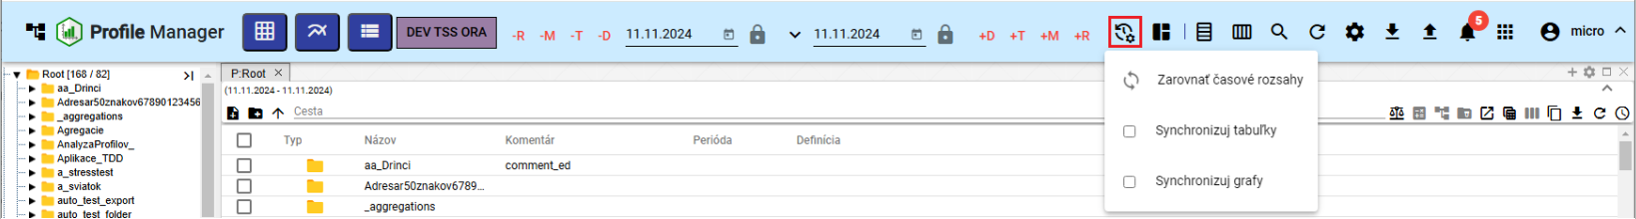

Figure 81: Pressure Synchronization of the panels

### Balancing the time frames

If the window has different date ranges and you want to set a uniform date range for all the windows that are open, proceed to:

1. Click the window header for the date range you want to set in the other windows.

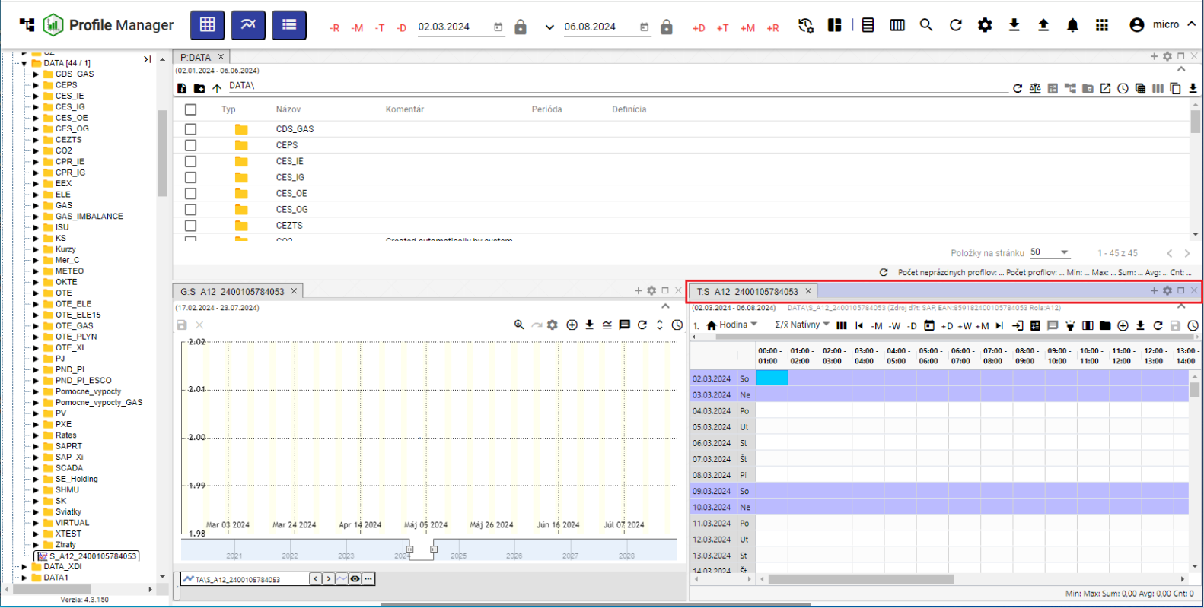

Figure 82: Active window

1. Press the Synchronize panels button and click on Compare time frames.

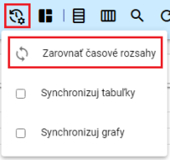

Figure 83: Position Compare the time frames

1. All windows will set the date range that was set in the active window.

### How to sync tables

The Synchronize tables means that the beginning of the range and cursor are synchronized with all open tables.

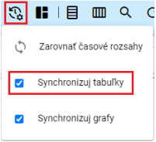

Figure 84: Item Synchronize the tables

To synchronize tables with each start, in the Settings tab in the General tab in the Global section, click the Synchronization for tables with each start (Figure 85) box.

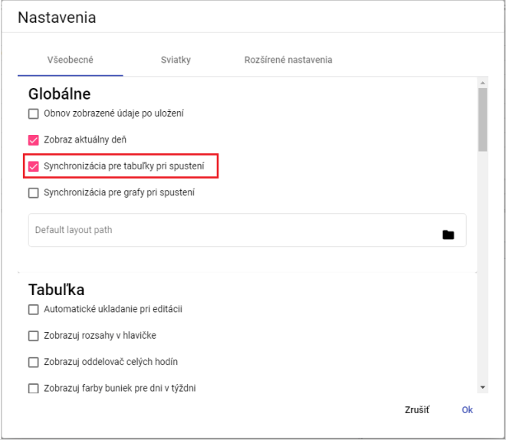

Figure 85: Field Synchronization for tables when running

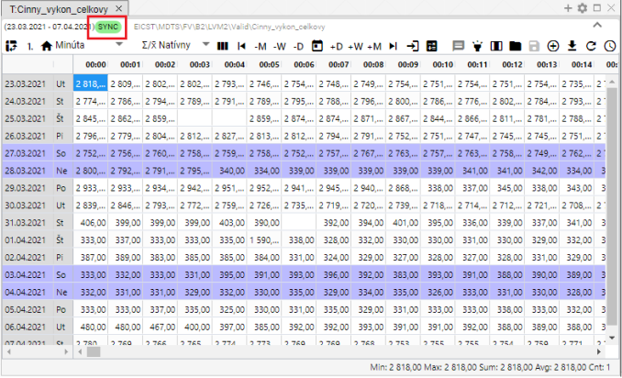

Figure 86: Text SYNC appears when table sync is enabled

### How to sync charts

To synchronize charts with each start, in the Settings tab in the General section in the Global section, click the Synchronize charts when starting field (Figure 85).

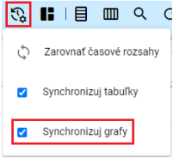

Figure 87: Item Synchronize the charts

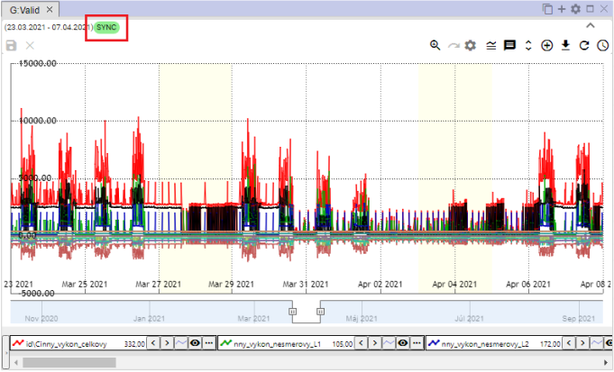

Figure 88: Text SYNC appears when the graph synchronization is enabled

## How to import, export and store reports

The button, Figure 89, is used for importing, storing and downloading residues.

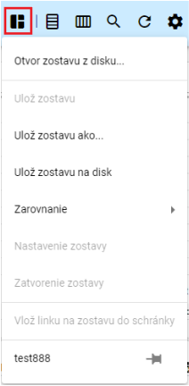

Figure 89: The Stay message button

### How to import a set

For import reports, please follow:

1. Press the Message stays button, which will display the window where you select Open a file from the disk....

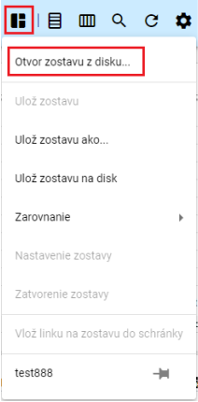

Figure 90: Item Open the file from the disk...

1. A window will appear in which you can select the set you want to import.

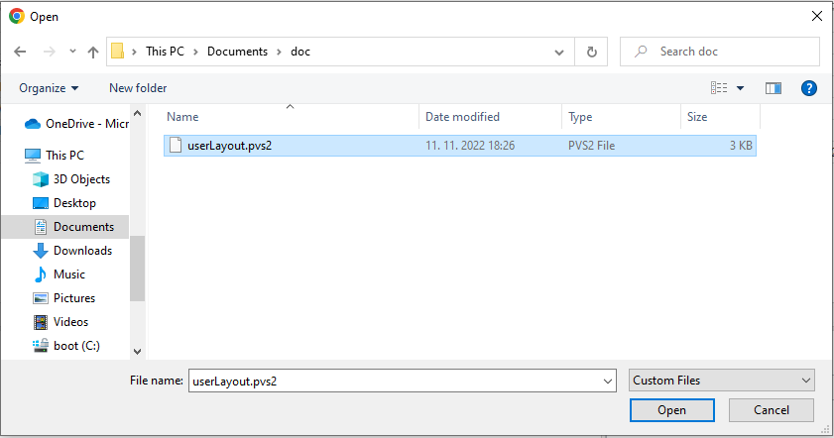

Figure 91: Selection of the import report

1. Confirm the import file selected by pressing the Open button.
2. Import the selected file and the appearance of the Profile Manager app will change according to the settings of the selected file number and size of windows, data displayed in windows and the like.
3. Next to the Message stays button, the name of the imported report is displayed.



Figure 92: Name of the imported report

### How to export the set

Export the composition as follows:

1. Press the "Message remains" button.
2. Select Save the set to disk.

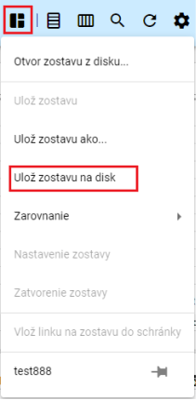

Figure 93: Item Settings on disk

1. The team will then withdraw.

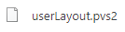

Figure 94: The downloaded file

### How to update the report

To update the report, please follow:

1. In the profile tree, open the file you want to update. You can open the file by double-clicking the left mouse button on the file name in the profile tree.

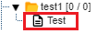

Figure 95: Building in the profile tree

1. The name of the open report is then displayed on the Message remains button.

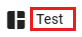

Figure 96: Name of the open report

1. Make changes to the report you want to save.
2. You can save changes by pressing the Message stays button and then selecting Settings.

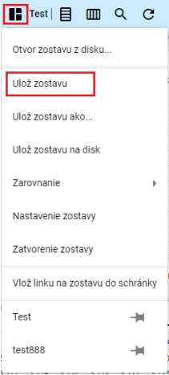

Figure 97: Item Settings input

1. A confirmation window will appear where you can press the NO button.

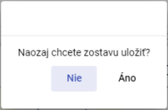

Figure 98: Confirmation window for the storage of the report

1. The building is being updated.

### How to save a new set

The view of the Profile Manager the number and size of windows displayed, the data displayed in the windows, you can save as a file.

You'll put the new set in the profile tree as follows:

1. Make the settings in the application that you want to save as a file.
2. Press the Message stays button and select Save the set as... in the displayed window.

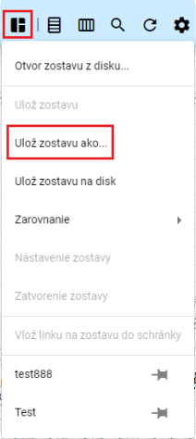

Figure 99: Item Settings as...

1. The window "New setup" will appear.

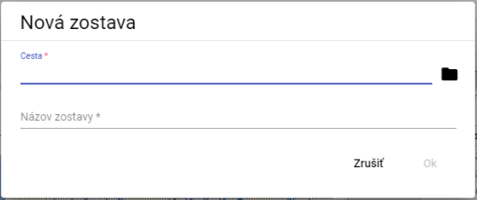

Figure 100: New setup window

1. In the Cesta field, enter the path where you want to save the file in the profile tree. You can also enter the path by pressing a button and selecting the address in the profile tree where the file is to be saved.

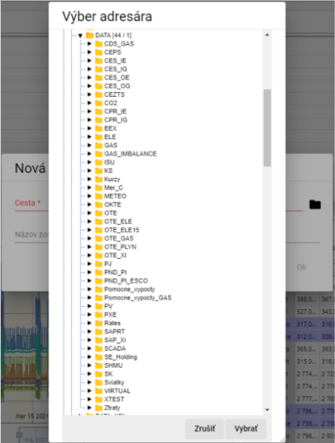

Figure 101: Selection of the directory for storing the report

1. Enter the name of the report.

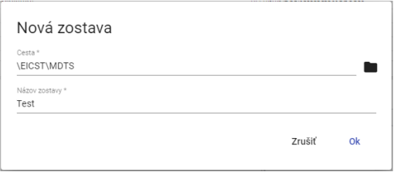

Figure 102: Data entered

1. Save the new set by pressing the OK button.
2. To display the file in the profile tree, click the directory in the profile tree and select Recover.

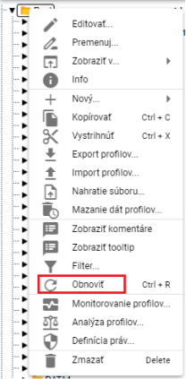

Figure 103: Item to be restored

### How to align a set to columns

Step by step:

1. Click on the Message stays button at the top of the application tab.
2. An offer is displayed where you set the mouse cursor to Call and set the mouse cursor to To columns....
3. The number of columns is displayed.

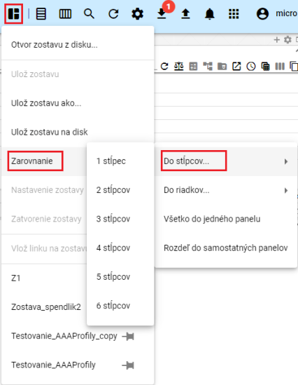

Figure 104: The position of the columns

1. The windows in the Profile Manager app are aligned to the selected number of columns.

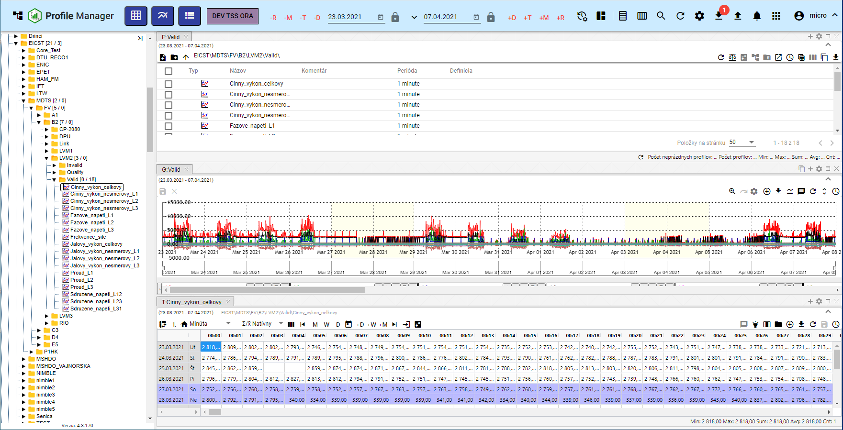

Figure 105: Aligning windows to one column

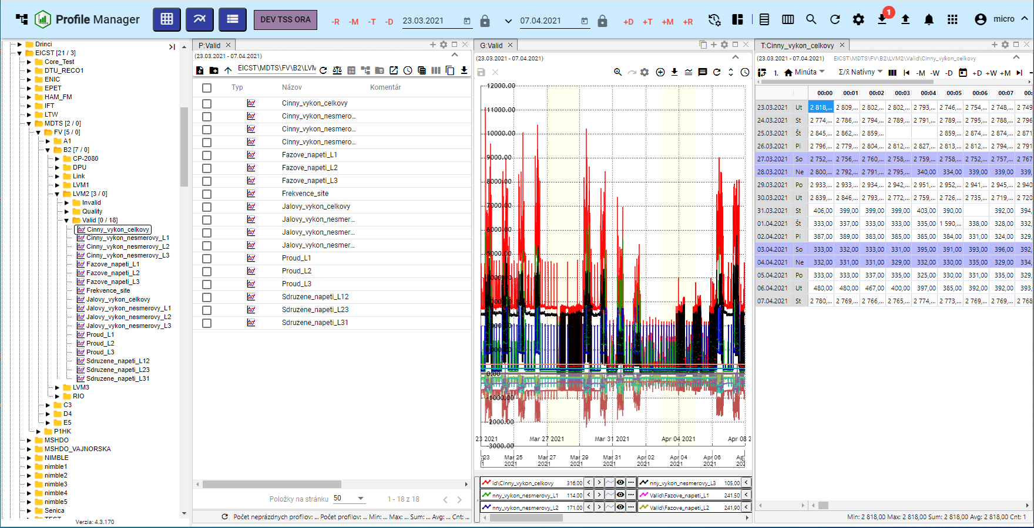

Figure 106: A three-column alignment

### How to align a set to lines

Step by step:

1. Click on the Message stays button at the top of the application tab.
2. An offer is displayed where you set the mouse cursor to Alert and set the mouse cursor to Do rows.
3. A bid will appear, in which you select the number of rows.

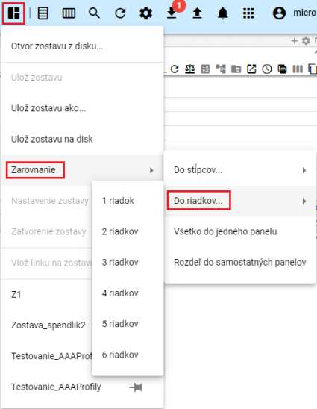

Figure 107: The heading Do lines

1. The application windows are aligned to the selected number of rows.

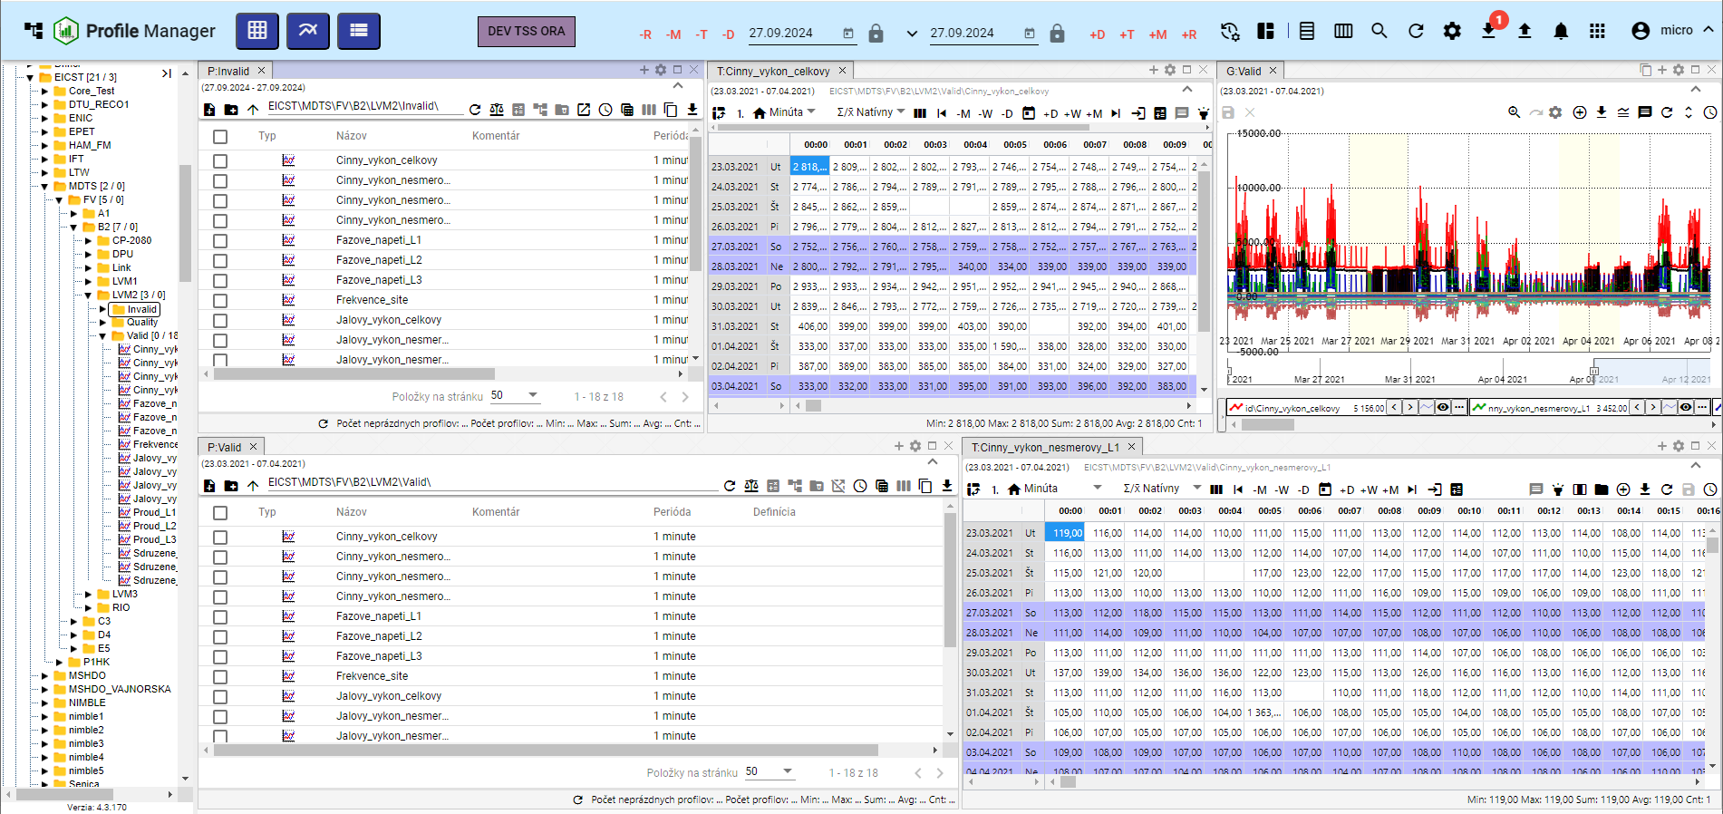

Figure 108: A linear alignment of two lines

### How to align everything in one panel

Step by step:

1. Click on the 'Message remains' button.
2. An offer will appear where you can set the cursor to Currency and select All in one panel.
3. All windows will be displayed in one panel.

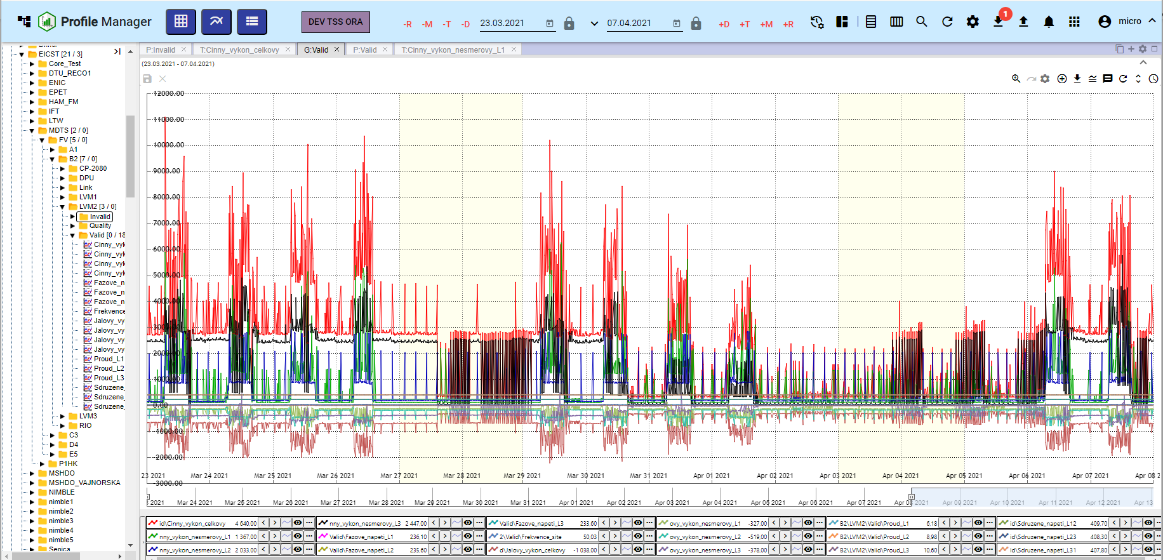

Figure 109: Alignment in one panel

### How to break up the set up into separate panels

Step by step:

1. Click on the 'Message remains' button.
2. An offer will appear where you can set the mouse cursor to Currency and select Section into separate panels.
3. Each window opened shall be displayed in a separate panel.

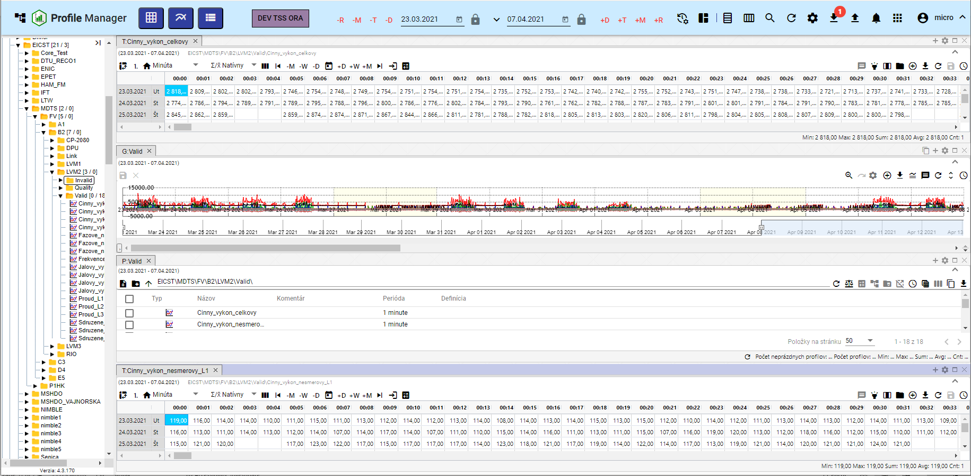

Figure 110: Divided into separate panels

### **[TRANSLATION ERROR - MANUAL REVIEW NEEDED] Ako nastaviť globálny časový rozsah pri zobrazení zostavy**

To change the global timeframe for the saved report, proceed to:

1. Press the "Message remains" button.
2. Select the item Setup of the report.

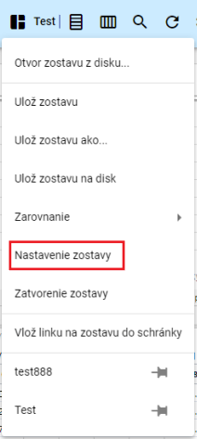

Figure 111: Item Setup of the report

1. The window "Setup of the report" will appear.

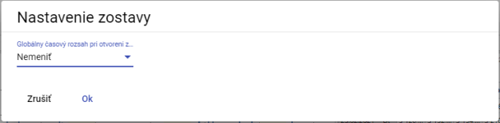

Figure 112: Window Set the report

1. Click on the field Global time range when opening the report.
2. The offer will be displayed, where you select the date range.

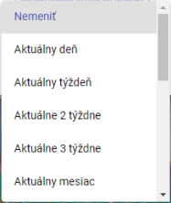

Figure 113: Offer for setting the global time range

1. Save by pressing the OK button.
2. A confirmation window will appear where you can press the NO button.

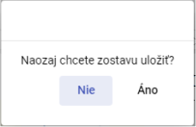

The following table shows the data in the table:

### **[TRANSLATION ERROR - MANUAL REVIEW NEEDED] Ako zatvoriť zostavu**

To close the report, press the Message stays button and select Close the report.

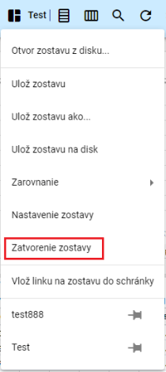

Figure 115: Item Closing the report

## **[TRANSLATION ERROR - MANUAL REVIEW NEEDED] Ako horizontálne zarovnať okná**

For horizontal alignment of windows, press the Horizontal alignment button, which is located at the top of the application bar.



Figure 116: The horizontal alignment button

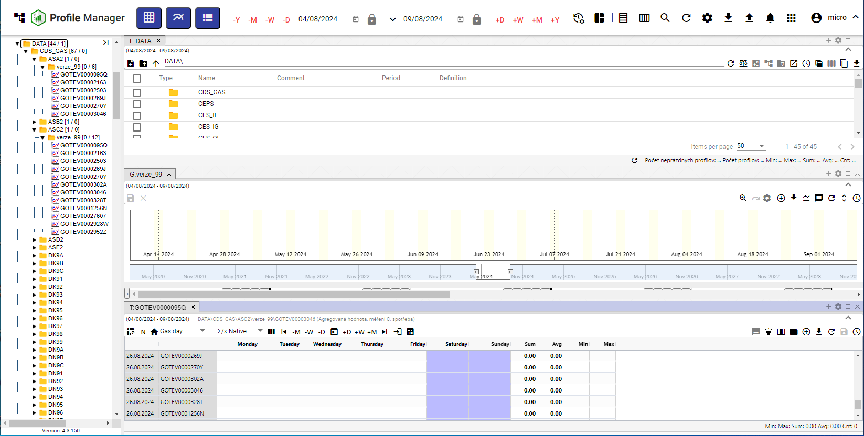

Figure 117: Horizontal alignment of the windows

## How to level windows vertically

For vertical alignment of windows, press the Vertical alignment button, which is located at the top of the application bar.



Figure 118: The vertical alignment button

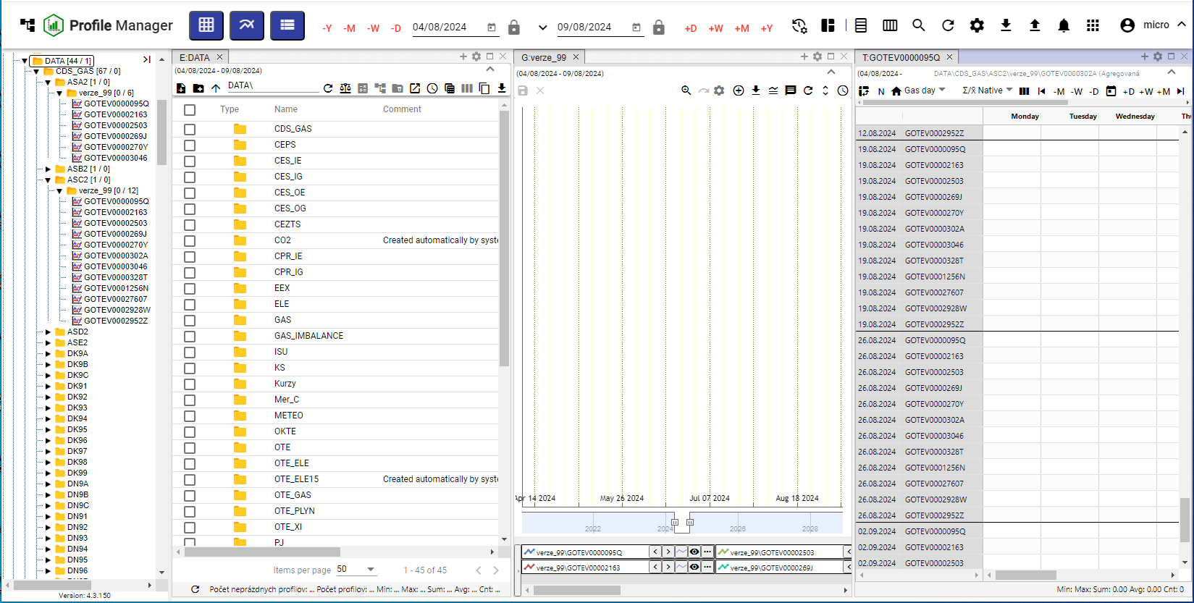

Figure 119: Vertical alignment of the windows

## **[TRANSLATION ERROR - MANUAL REVIEW NEEDED] Ako zobraziť a stiahnuť exporty**

The Profile Manager app has a Export button at the top of the Profile Manager app, which is used to display the list of exports in the Exportsy window. If the export has been successful, it can be downloaded by pressing the green Delete button. The procedure for creating the export is detailed in Chapter 2.16.



The following table shows the following:

The number of unloaded exports is shown as a number in the red circle at the Export button, Figure 121.

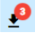

Figure 121: Three unrelated exports

Exports may be in the following condition:

* Excess of current exports.
* CONCLUSION Successfully completed export can be downloaded by pressing the Draw button.
* Error An error occurred during export.
* EXPORT Deleted Export was deleted.

Export settings are from the Export service and are only displayed in the Profile Manager.

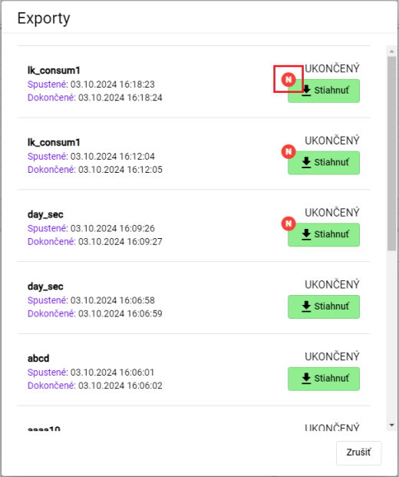

Figure 122: Window of exports

## How to display imports

The Profile Manager app has a Import button at the top, which serves to display the list of imports in the Importy window.



Figure 123: Import button

After pressing the Import button, the Importy window will appear, which will show the details of the imports, Figure 125.

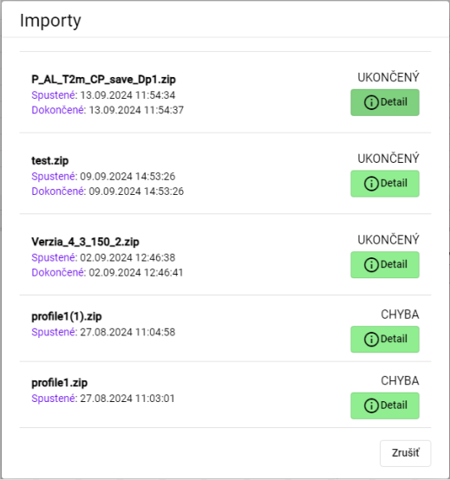

Figure 124: Window Imports

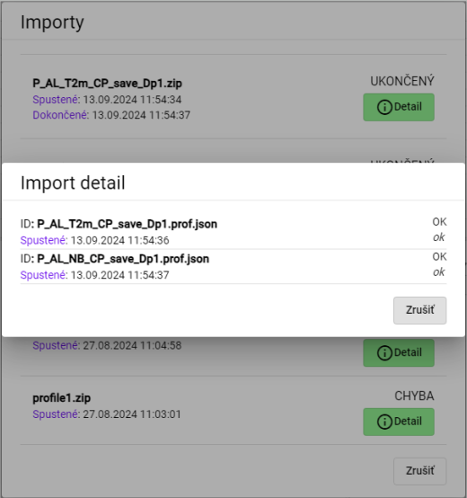

Figure 125: Display of the import details

## Keyword abbreviations

You can view a list of key shortcuts in the Profile Manager app:

1. Click the button with the name of the registered user located at the top of the app.
2. An offer is displayed where you can set the mouse cursor to Help.
3. Please click on Keyboard shortcuts.

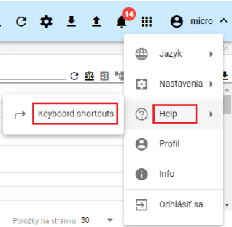

Figure 126: Item Keyboard shortcuts

1. The key shortcut window will appear.

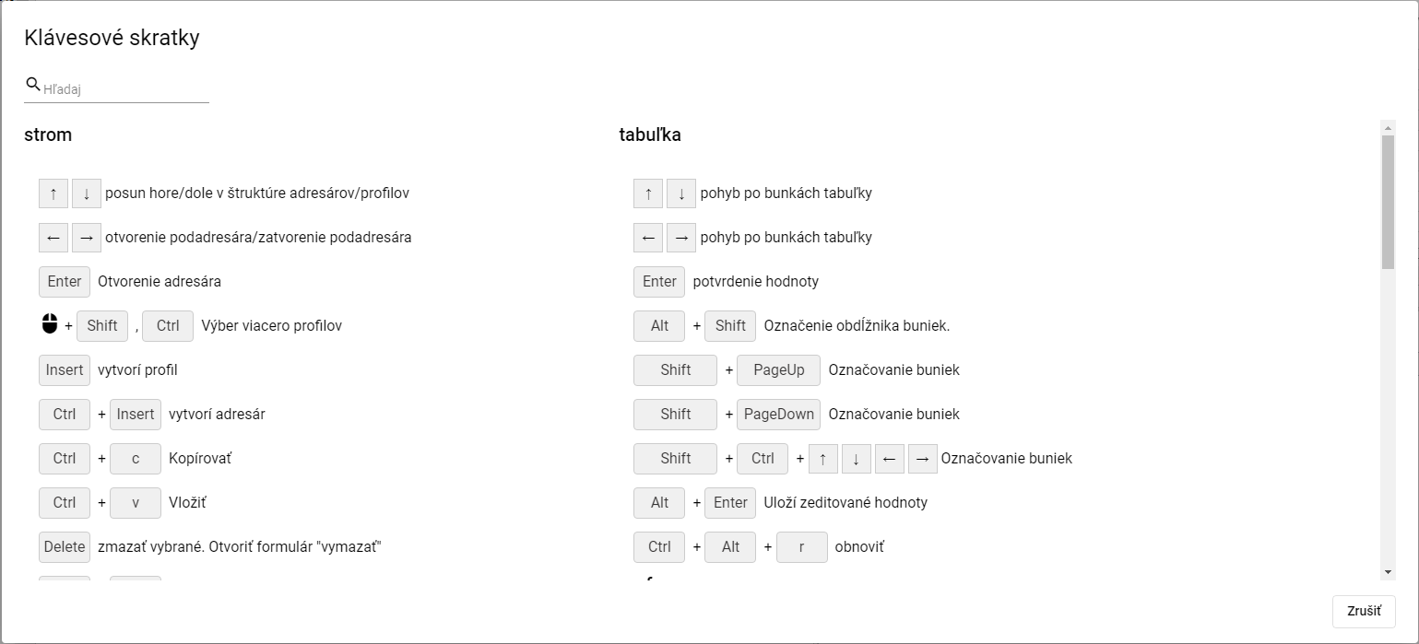

Figure 127: Window of key shortcuts

1. You can search for keywords by entering text into the Search field, which is located in the top left corner of the window.
2. You will close the window by pressing the "Cancele" button.

In the Profile Manager app, you can use the keyshots in the following table.

|  |  |  |
| --- | --- | --- |
| Klávesová skratka | Časť aplikácie | Popis |
| šípky HORE/DOLE | strom | Posun hore/dole v štruktúre adresárov/profilov |
| šípky HORE/DOLE | prieskumník | Posun hore/dole v štruktúre adresárov/profilov |
| šípky HORE/DOLE | tabuľka | Pohyb po bunkách tabuľky |
| šípky HORE/DOLE | graf | Hore zoom OUT, dole zoom IN |
| šípky Doprava a doľava | strom | Otvorenie podadresára/zatvorenie podadresára |
| šípky Doprava a doľava | prieskumník | Posun celej tabuľky doľava a doprava, aby bolo možné vidieť schované stĺpce |
| šípky Doprava a doľava | tabuľka | Pohyb po bunkách tabuľky |
| šípky Doprava a doľava | graf | Posun grafu o jedno zobrazené časové okno doľava a doprava |
| ENTER | strom | Otvorenie adresára |
| ENTER | prieskumník | Otvorenie adresára/Otvorenie editačného okna profilu |
| ENTER | tabuľka | Potvrdenie hodnoty |
| ENTER | graf | Bez akcie |
| Výber myšou pomocou Shift, Ctrl | strom | Výber viacero adresárov/profilov |
| Výber myšou pomocou Shift | prieskumník | Výber viacero adresárov/profilov |
| Výber myšou pomocou Shift, Ctrl | graf | Výber viacero profilov |
| Alt + Shift | tabuľka | Označenie obdĺžnika buniek |
| Insert | prieskumník | Založí profil |
| Ctrl + Insert | prieskumník | Založí adresár |
| Insert | strom | Založí profil |
| Ctrl + Insert | strom | Založí adresár |
| Ctrl + ALT + K | graf | Zmena koeficientu označeného profilu / označených profilov |
| Ctrl + ALT + W | graf | Skryje označený profil / označené profily |
| Ctrl + ALT + Q | graf | Odkryje označený profil / označené profily |
| Ctrl + ALT + T | PMW | Nové okno Tabuľka |
| Ctrl + ALT + G | PMW | Nové okno Graf |
| Ctrl + ALT + E | PMW | Nové okno Prieskumník |
| Ctrl + C | strom/ prieskumník | Kopírovať |
| Ctrl + ALT + C | prieskumník | Export prieskumníka do clipboardu |
| Ctrl + V | strom/ prieskumník | Paste |
| Ctrl + S | PMW | Uloženie zostavy. Ak nie je žiadna otvorená ponúkne formulár na uloženie do stromu. |
| Ctrl + O | PMW | Otvorenie zostavy z disku |
| Ctrl + ALT + F4 | PMW | Zavretie grafu/tabuľky |
| Ctrl + šípka NAHORU/DOLŮ | graf | Posun/radenie zobrazovaných profilov pod grafom |
| Alt + ENTER | graf | Uloží rozkreslenú čiaru |
| Alt + ENTER | tabuľka | Uloží zeditované hodnoty |
| Delete | graf | odoberie z grafu vybrané profily |
| Delete | strom/prieskumník | Zmazať vybrané. Otvoriť formulár "Delete" |
| CTRL+ R | strom/prieskumník | Refresh |
| CTRL+ ALT + R | graf/tabuľka | Refresh |
| Koliesko myši | graf | Zmena rozsahu časovej osi |
| Koliesko myši + CTRL | graf | Zmena rozsahu ľavej osi |
| Koliesko myši + CTRL + ALT | graf | Zmena rozsahu pravej osi |
| SHIFT + šípka NAHORU/DOLŮ | prieskumník | Výber adresárov/profilov |
| SHIFT + HOME | prieskumník | Výber viacero adresárov/profilov |
| SHIFT + END | prieskumník | Výber viacero adresárov/profilov |
| CTRL + X | prieskumník /strom | Presun adresárov/profilov |

## How to find a profile in an app

To find the profile, please follow:

1. Press the button at the top of the application bar.
2. The field Searched profile will appear, where you will type the name of the profile.

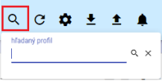

Figure 128: Field for profiling

1. Enter the text that you want to search for profiles.
2. Press the Enter key or the search button.

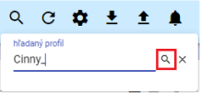

Figure 129: Search button

1. In the window that is active, the tab B:Root will appear containing profiles that match the text entered.

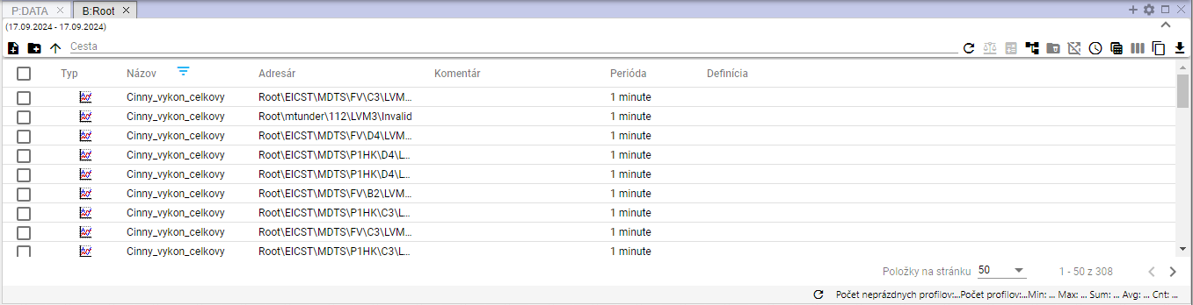

Figure 130: Profiles searched

## Information to the user about the opt-out

If a user has the Profile Manager app open in multiple browser tabs and the user logs out in one of the tabs, a window will appear to inform the user of the log-out, Figure 131. To log in, press the Profile Manager button. A log-in screen will appear where you enter the login username and password, Figure 2.

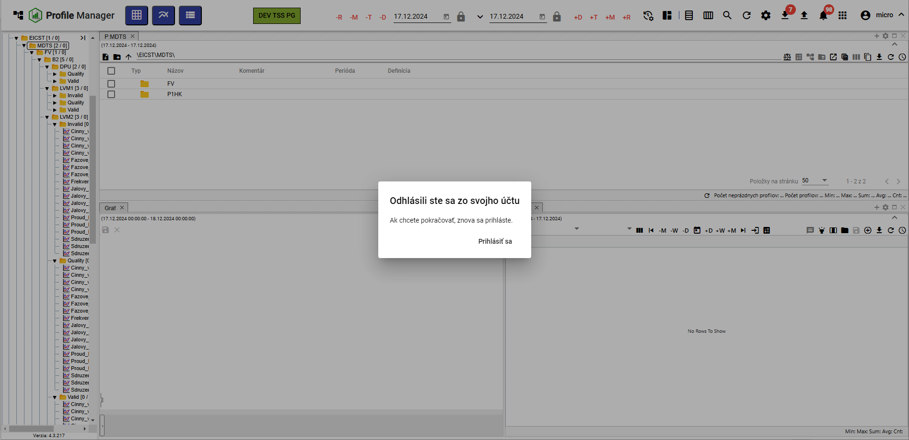

Figure 131: Window You have logged out of your account

## **[TRANSLATION ERROR - MANUAL REVIEW NEEDED] Ako zobraziť čas, ktorý ostáva užívateľovi do odhlásenia**

**[TRANSLATION ERROR - MANUAL REVIEW NEEDED] Ak s aplikáciou „Profile Manager“ aktívne nepracujete, odpočítava sa čas, ktorý ostáva do odhlásenia užívateľa z aplikácie „Profile Manager“. Ak s aplikáciou pracujete, čas sa obnovuje.**

**[TRANSLATION ERROR - MANUAL REVIEW NEEDED] Koľko času do odhlásenia ostáva si môžete skontrolovať:**

1. **[TRANSLATION ERROR - MANUAL REVIEW NEEDED] Kliknite na tlačidlo s názvom prihláseného užívateľa.**
2. **[TRANSLATION ERROR - MANUAL REVIEW NEEDED] Zobrazí sa menu, v ktorom sa nachádza informácia o aký čas vyprší doba prihlásenia, Obrázok 132.**

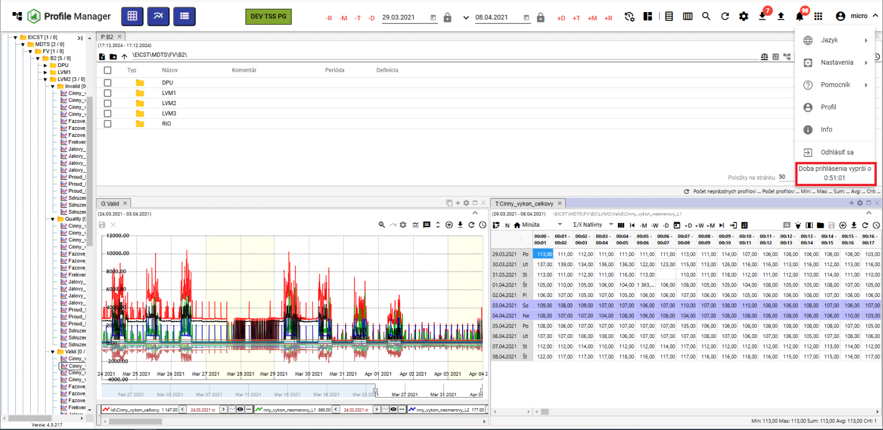

Figure 132: Information on the time remaining until the user logs out

If the user has not been actively working with Profile Manager and the login period has expired, the user is logged out of the application.

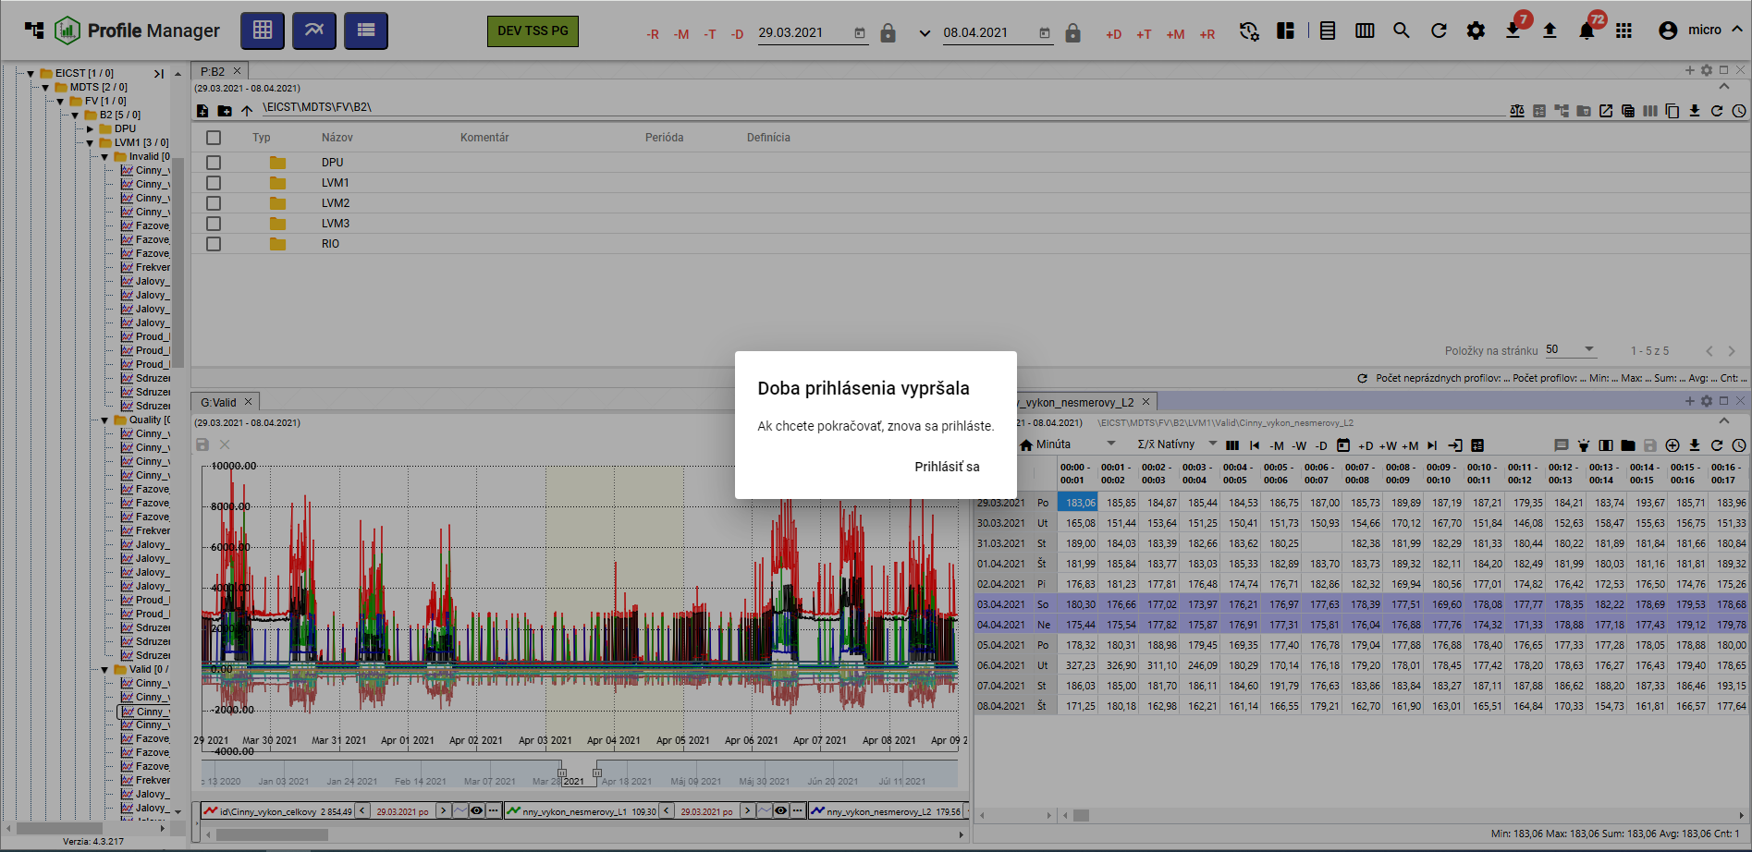

Figure 133: Notification of the expiry of the application

# Work with directories and profiles

The tree structure has directories and profiles that you can create, rename, edit and polish.

The address book allows logical grouping of data into one group. Each address book may contain additional address books or profiles.

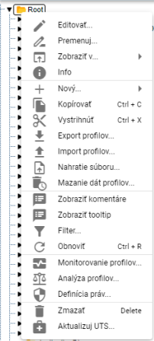

Figure 134: Window with address and profile functions

## How to add a new directory

To add a new directory, please follow:

1. Right-click the tree-structured directory to which you want to add a new directory.
2. In the offer, select New and then Address.

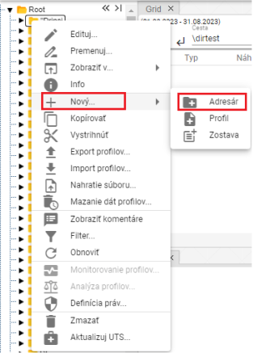

Figure 135: The address

1. A window to create a directory will appear.

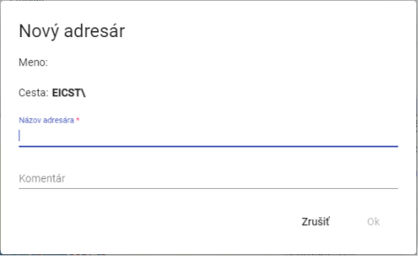

Figure 136: Window to create a directory

1. Enter the data. The field Address Name is mandatory. The address name must not start with a number. It can contain letters, numbers and footnotes. The name must be at least 3 characters and not more than 50 characters. If you do not enter the name or enter an invalid name, the information about the address name for the address is displayed, Figure 137.

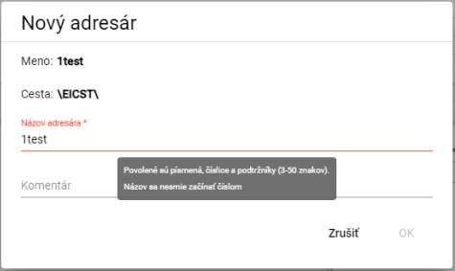

Figure 137: Information on the rules for entering the address name

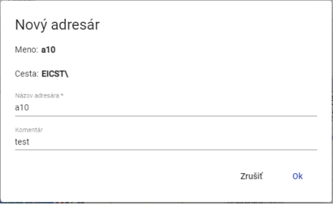

Figure 138: Name and comment entered

1. You can create an address by pressing the OK button.

## How to rename the directory

The procedure for changing the address:

1. Left-click the address book name and press F2 or right-click the address book you want to rename and select Move.

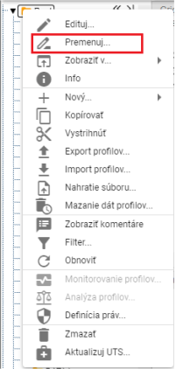

Figure 139: The item Move

1. A window will appear to enter a new address name. The address name must not start with a number. It may contain letters, numbers, and footnotes. The name must be at least 3 characters long and not more than 50 characters long. If you do not enter a name or enter an invalid name, the address name information will appear. Rules for entering the address name may vary depending on the configuration of the environment.

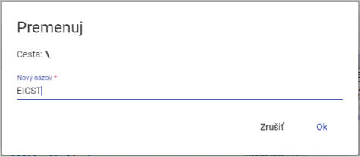

Figure 140: Window for changing the address

1. Save the changes by pressing the OK button.

## How to edit a directory

To edit the directory, please follow:

1. Right-click the directory you want to edit.
2. Please select Edit from the offer.
3. A window will appear where you can edit the Comment field.

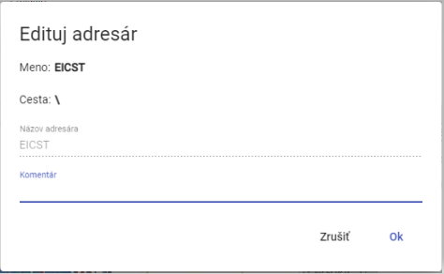

Figure 141: Window for editing the directory

1. Save the changes by pressing the OK button.

## How to delete the directory

Please remove the address:

1. Right-click the mouse on the directory you want to delete.
2. The offer to delete appears.
3. In the confirmation window for deletion, press the NO button.

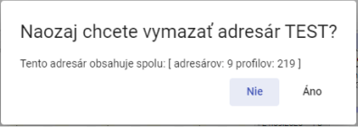

The following table shows the following information:

## How to Copy a Directory

To copy the directory, please proceed to:

1. Right-click the mouse on the directory you want to copy.
2. In the offer, select Copy.
3. Right-click the directory to which you want to insert the copied directory and select Insert.
4. The window Move/Copy will appear.

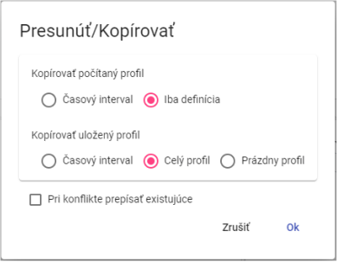

The following table shows the following information:

1. Press the OK button.

## How to remove/move the directory

To move the directory from one place to another in the tree structure, the heading Cut out is used.

1. Right-click the mouse on the directory you want to extract.
2. In the offer, select the item 'Sharp'.
3. Right-click the directory to the address book where you want to insert the directory.
4. Please select the entry Insert.
5. A confirmation window will appear where you can press the OK button.

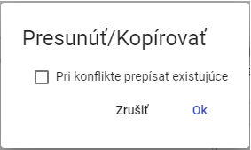

Figure 144: Window Move/Copy

## How to upload a file

To upload the file, follow:

1. Right-click the mouse to the location in the tree structure where you want to upload the file.
2. A window will appear where you can select Play the file....

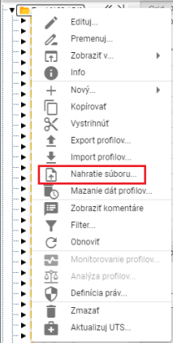

Figure 145: Location of the file...

1. The Play window will appear, where you can click and select the file you want to play.

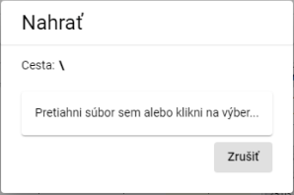

Figure 146: Window to play

1. The window closes and a message appears at the bottom of the screen: Request for recording has been sent.

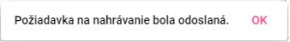

Figure 147: Notification Request for recording was sent.

Recognized types of document attachment:

* The following information shall be provided:
* pvs2 - reports
* xlsx - template for reports

## How to delete profile data

The "Profile Data Delete" function will delete data in all profiles in the selected folder according to the specified time interval. You can also select multiple folders at the same time or multiple profiles at the same time.

To delete the profile data, please do the following:

1. If you want to delete data in only one selected folder (you can also delete it in subfolders) or in one profile, right-click the selected folder or profile.

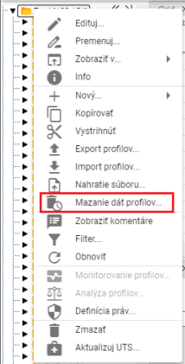

Figure 148: Item Deleting the profile data...

1. If you want to delete data in multiple folders or profiles at the same time, please do:
   1. Select the folders or profiles in which you want to delete data.
   2. If the folders you want to select are running in sequence, you can click the first folder on the left mouse button, hold the SHIFT key, and then click the last folder you want to select.

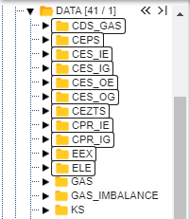

Figure 149: Selection of several folders

* 1. If the folders you want to select do not follow one another directly, click the left mouse button on the first folder, hold the Ctrl key, and click the left mouse button to select the other folders you want to select.

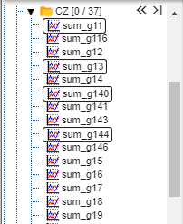

Figure 150: Selection of multiple profiles

* 1. To select the folders or profiles, right-click and select Delete profile data....

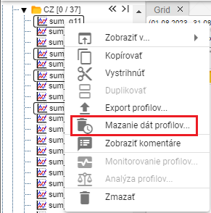

Figure 151: Item Deleting the profile data...

1. The window Delete the data range will appear, in which you select the daily or minute time interval.

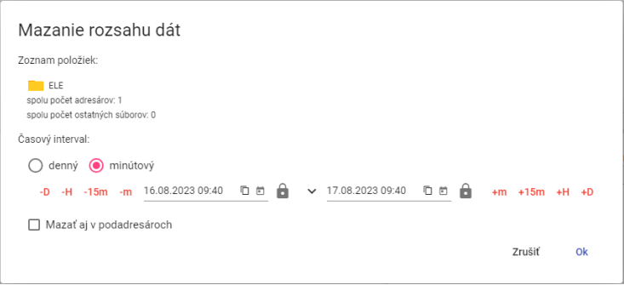

Figure 152: Window Delete the range of data for one selected folder

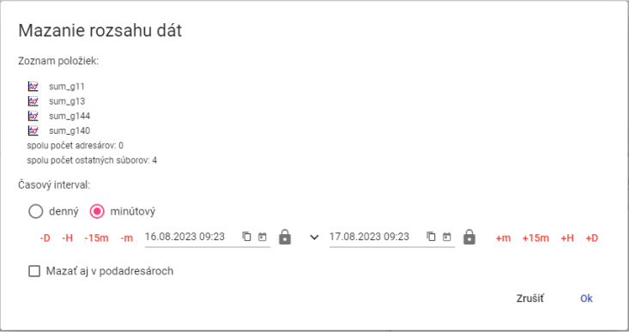

Figure 153: Window Delete the data range for multiple profiles selected

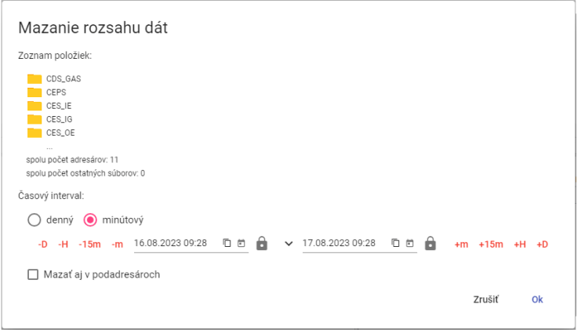

Figure 154: Window Delete the range of data for selected multiple folders

1. Next, enter the time interval in which the data are to be deleted.
2. If you click on the checkbox Delete sub-addresses, the sub-addresses will also be browsed and the profile data will be deleted according to the time interval selected.
3. Confirm by pressing the OK button.

## How to filter directories and profiles

To filter directories and profiles, please follow:

1. Right-click the directory with the mouse.
2. Select Filter from the offer.
3. A filtering window will appear. To filter directories, type the name or part of the name of the directory in the directory filter field. To filter profiles, type the name or part of the name of the profile in the profile filter field. The star convention is not used here, it searches for any Substring. Filtering is also case sensitive - sensitive to capital letters and capital letters.

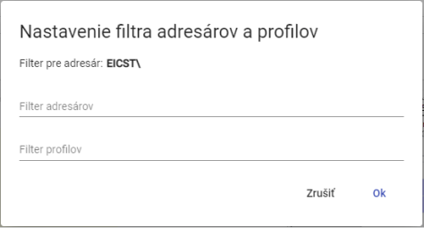

Figure 155: Window Set the address and profile filter

1. Confirm the filter by pressing the OK button.

## How to uninstall the directory and profile filters

To cancel the filter, please proceed to:

1. Right-click the directory on which the filter is set.
2. Select the Filter.
3. Cancel the filter.
4. Save the changes by pressing the OK button.
5. After the filter is removed, all directories and profiles are displayed in the tree structure.

## How to display comments

You can enter comments when you create directories and profiles.

1. Right-click any directory or profile in the tree structure.
2. A window will appear where you can set the mouse cursor to View and select View Comments.
3. When comments are enabled, the address and profile names are in round bars and the comments are shown before the names, Figure 156.



Figure 156: Address box with comment display enabled



Figure 157: Address without comment

1. In the window that appears, set the mouse cursor to View and select Hide Comments.

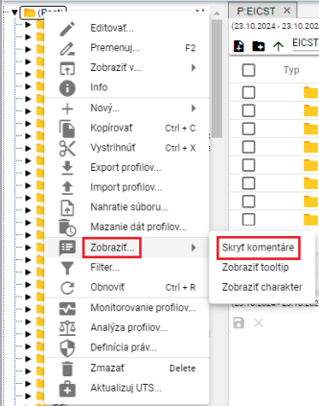

Figure 158: Item Hide comments

1. Comments are then hidden and the address or profile names are displayed without rounded curtains.



Figure 159: Address with hidden comments

## How to display tooltip

To view the tooltype to the tree structure profiles, proceed to:

1. Right-click any directory or profile in the tree structure.
2. A window will appear where you can set the mouse cursor to Show... and click Show tooltip.

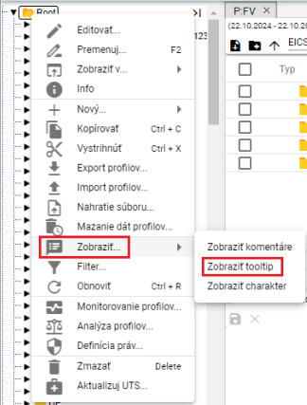

Figure 160: Item Show tooltip

1. Tooltip is displayed when you set the mouse cursor to a profile name.

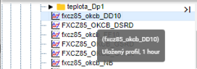

Figure 161: The tooltip shown

1. Turn off tooltip display by right-clicking on any directory or profile in the tree. In the window that appears, set View to Hide tooltip.

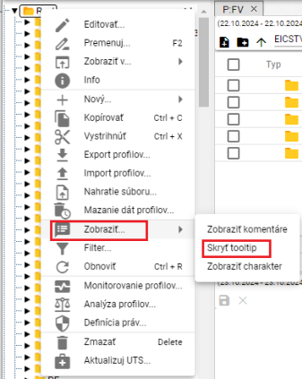

Figure 162: Item Hide tooltip

## How to Show Character

The profile character can be Multiple or Period, which are represented by the marks.

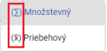

Figure 163: Marks representing quantitative and continuous character

For the character to profile in tree structure, proceed to:

1. Right-click any directory or profile in the tree structure.
2. A window will appear where you can set the mouse cursor to View... and click View character, Figure 160.
3. If a character has been entered, the character tag shall appear before the profile name.

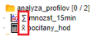

Figure 164: Character shown in the profiles

1. You can turn off character display by right-clicking on any directory or profile in the tree. In the window that appears, set View to Hide character.

## How to Restore the List

To restore the list of profiles and directories, right-click the tree-structured directory and press the Restore button.

## How to set user and group rights

Set the rights for users and groups of users:

1. Right-click the directory for which you want to set the rights.
2. Please select the heading Definition of rights.

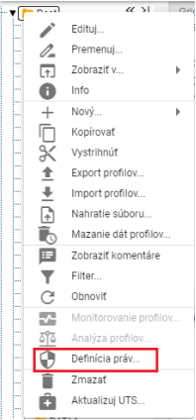

Figure 165: Item Definition of rights

1. The window "Setting rights" will appear.

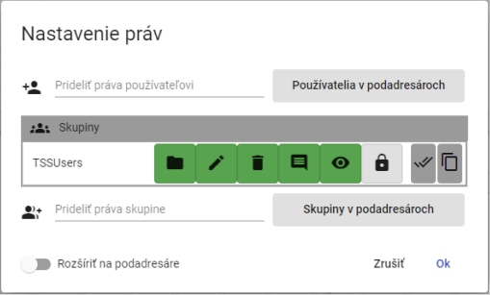

Figure 166: Window setting of rights

1. To add user rights, click on the field Assign user rights and start typing the user name.

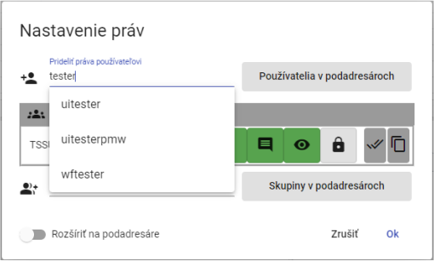

Figure 167: In the Assignment of rights to the user field, start typing the user name

1. Select a user to display the table Users containing the selected user.

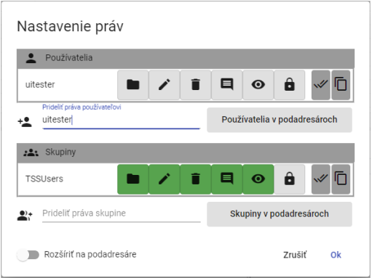

Figure 168: Selected user

1. Click the buttons to add rights to the user.

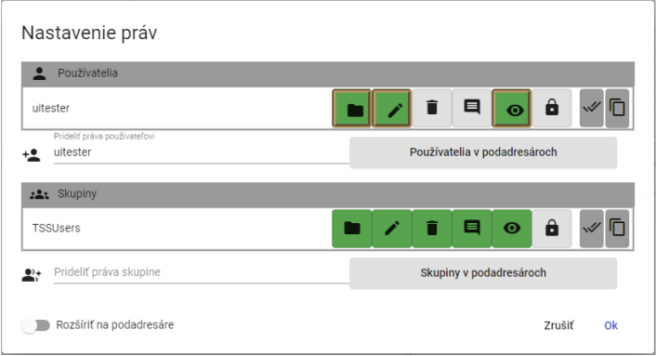

Figure 169: Allocation of rights to the user

1. To assign rights to a group, select a group in the field To assign rights to a group.

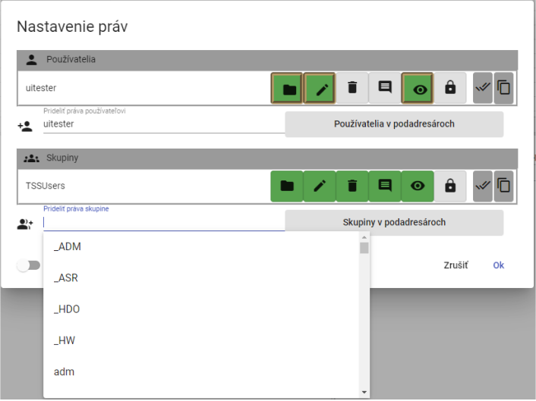

Figure 170: Selection of group

1. The selected group is shown in the table Group.

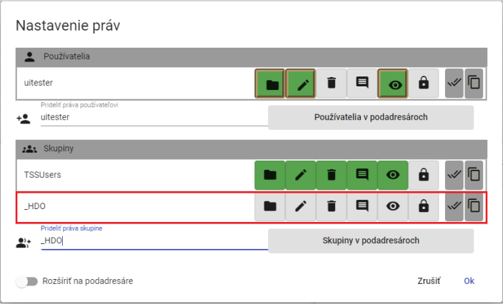

Figure 171: Selected group

1. Click the buttons to set the rights for the selected group.

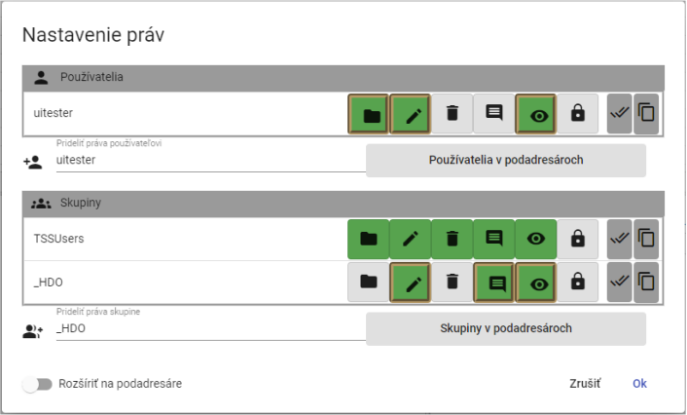

Figure 172: Allocation of group rights

1. To set rules for sub-addresses too, click the Expand to sub-addresses button.

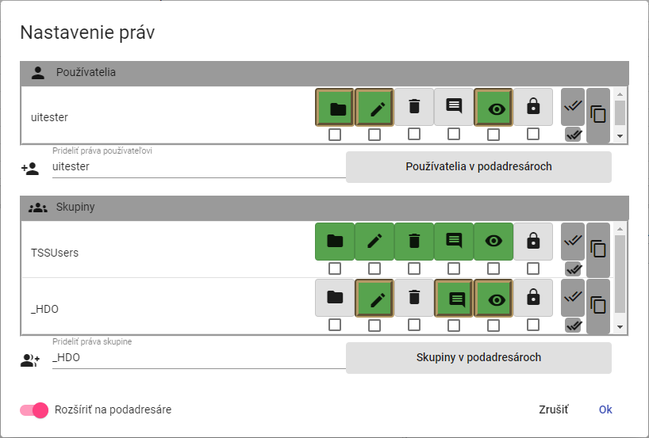

Figure 173: Permission to disseminate to sub-addresses

1. A click box will appear under the buttons representing user and group rights. Click the box under the buttons that you want to expand the right to sub-addresses.

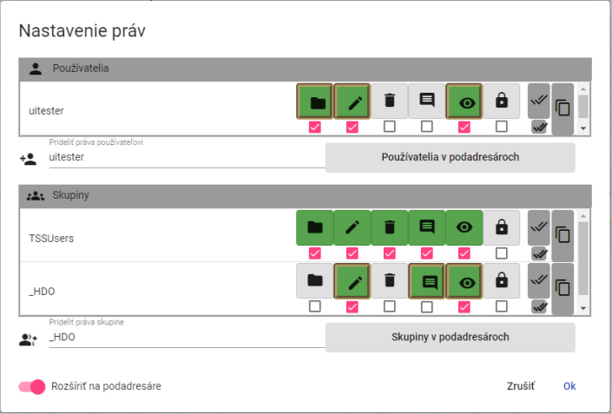

Figure 174: Set up user and group rights for sub-addresses

1. Save changes by pressing the OK button.

## How to create an export

For exporting profiles, please:

1. In the tree structure, right-click the directory mouse or in the browser window, right-click the directory row from which you want to export profiles.
2. Select the item Export profiles....

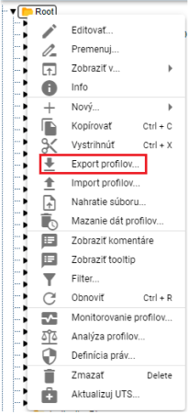

Figure 175: Item Export profiles...

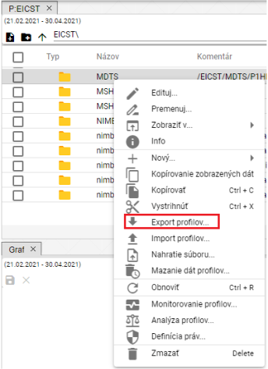

Figure 176: Item Export in the Explorer window

1. The Export window will appear, which contains two tabs All and Profils (CSV). By default, the All tab will appear. The All tab allows you to export the calculated profiles in the form of an expression. The Profils (CSV) tab exports only data.

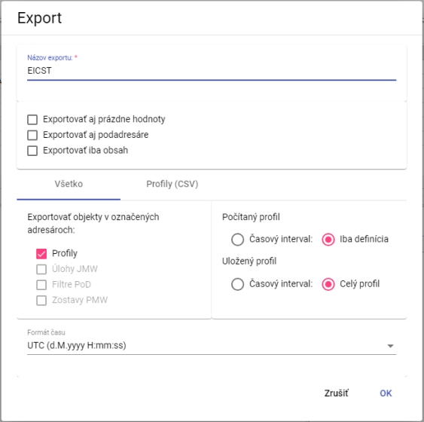

Figure 177: Window Export tab All

1. The field Export Name is filled by default with the address from which you want to export profiles.
2. At the top of the window, select what to export (both sub-addresses and empty values, content only).
3. In the All tab in Export items in the selected directories select which items to export.
4. For the Counted profile, select whether to export Time interval or Only definition.
5. In the section Invested profile, select whether to export Time interval or All profile.
6. In the Time format field, select the time format.
7. To export the CSV profiles, click on the Profils (CSV) tab.
8. In the Time interval (mm/dd/rrrr), select the dates in the fields Date from and Date to.
9. Click on the box Separator of columns and select the separator.
10. Click on the box "Separator of decimal places" and select the separator.
11. In the Time format field, select the time format.

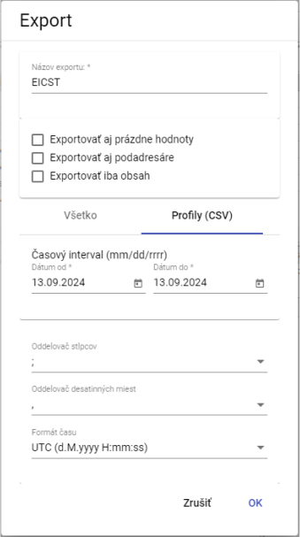

The following table shows the following:

1. You can start export by pressing the OK button.
2. The export status information is displayed in the Exports window, which is covered in Chapter 1.20, and the Exports window is then available to download the completed export.

## How to create import

For the creation of imports, proceed to:

1. Right-click the tree structure mouse to the directory to which you want to import the file.
2. Select the item Import profiles....

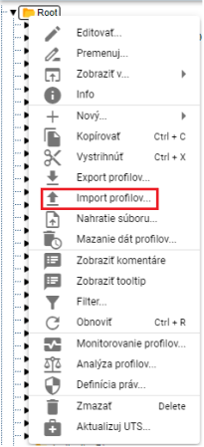

Figure 179: Item Import profiles...

1. The Import window will appear.

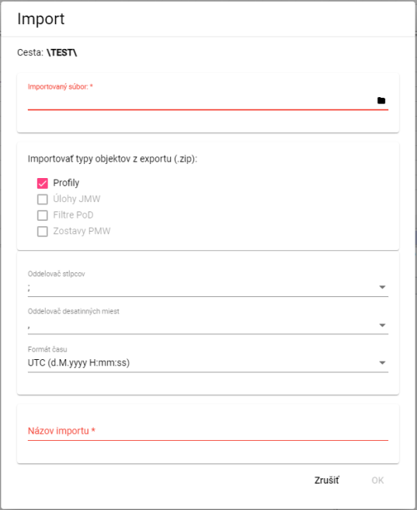

The following table shows the following:

1. **[TRANSLATION ERROR - MANUAL REVIEW NEEDED] V časti „Importovaný súbor“ kliknite na čiernu ikonu súboru a vyberte súbor, ktorý chcete importovať.**
2. In the Import export object types (.zip) section, select what to import.
3. Click on the box Separator of columns and select the separator.

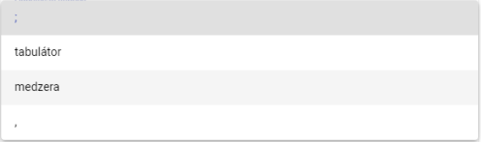

Figure 181: Offer for the heading 'Shark separator'

1. Click on the box "Separator of decimal places" and select the separator.
2. In the Import Name field, enter the name of the imported file.
3. You import the file by pressing the OK button.
4. The selected directory will display the imported file.



Figure 182: Imported file

Information on the status of imports is shown in the Imports window, which is addressed in Chapter 1.21.

## How to add a new profile

To add a profile, please follow:

1. Right-click the directory to which you want to add a profile.
2. In the offer, select New and then Profile.

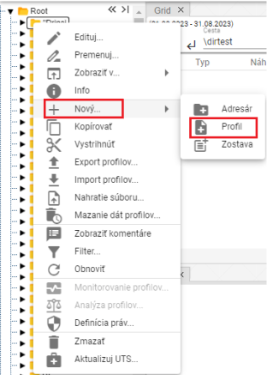

Figure 183: Creating a profile

1. A profile window will appear.

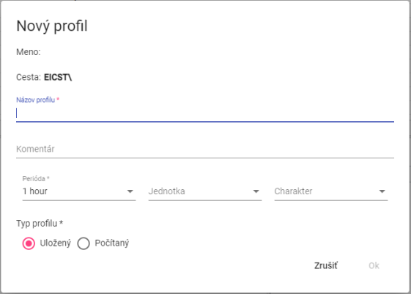

Figure 184: Profile window

1. Enter the data.
2. The fields Profile Name, Period and Profile Type are mandatory.
3. The profile name must not start with a number. It may contain letters, numbers and footnotes. The name must be at least 3 characters and not more than 50 characters. If you do not enter a name or enter an invalid name, the profile name information will be displayed. Rules for entering a profile name may vary depending on the configuration of the environment.

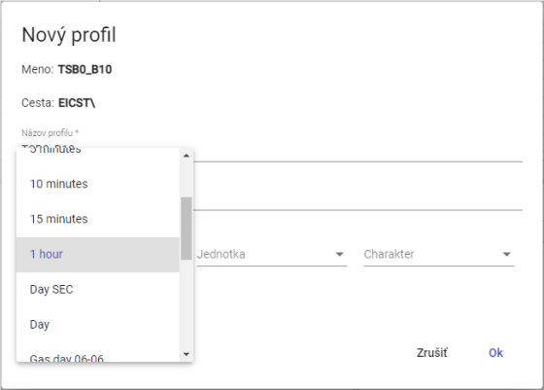

Figure 185: Selection of periods

1. If you select the calculated profile type, type the definition. For example profileA+2*(profileC-2). The arithmetic options are described in the document Xenergie TSS Kompl_prehl_fnc_G2 R12.xlsx. The definition of the calculated profile is dealt with in chapter 2.18.1.

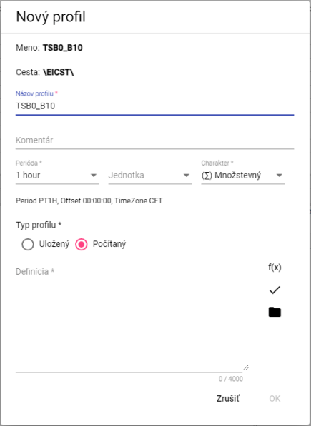

Figure 186: Calculated profile type

1. You can create a profile by pressing the OK button.

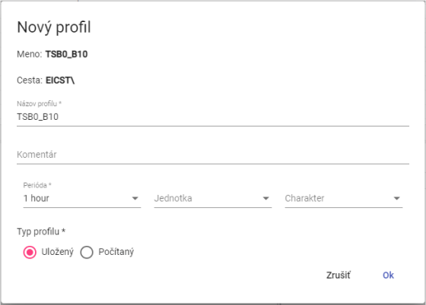

Figure 187: Type of profile stored

The character of the profile:

• Quantity represents the amount of energy consumed, for example, over a given period of time.

• The flow rate represents the state of a given quantity at a given time.

• Unused If the profile does not explicitly define one of the two above characteristics, the system will behave as if it were a Running System.

The profile character is used to identify how the values in the profile are to be resampled to a more subtle or rough sampling, e.g. the 1⁄4-hour energy value in MWh is to be calculated in the conversion to hours, while the 1⁄4-hour power value in MW is to be averaged.

The profile character is used exclusively and only in relation to the need to sample (count the profile for another period) the profile.

### How to specify the definition for the calculated profile type

To set the definition of the calculated profile type, proceed to:

1. In the New profile window, press the Wizard function button, which will display a function assignment window.



Figure 188: The Wizard button for functions

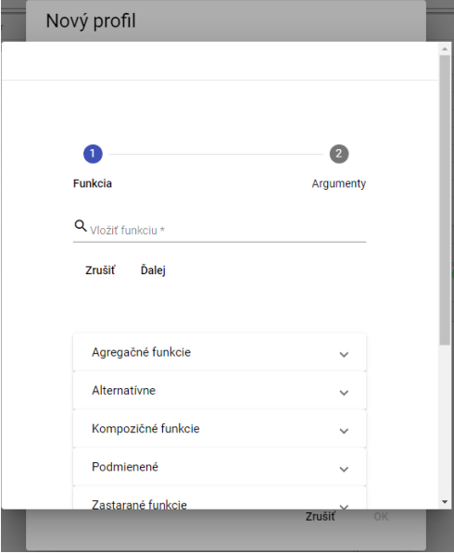

Figure 189: The function assignment wizard

1. Click on the field Input function.

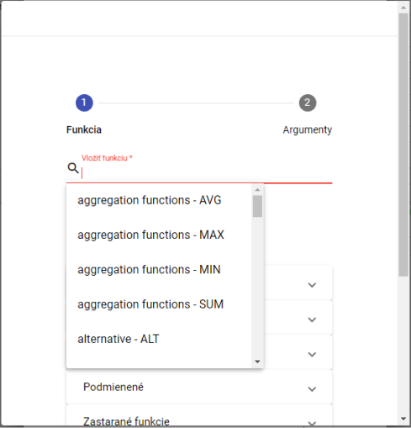

Figure 190: Selection of function

1. A list of the function you want to select will appear.
2. After selecting the function, a description is displayed.

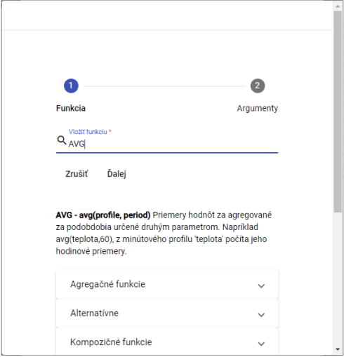

Figure 191: After selecting the function, a description of the function is displayed

1. Click on the function group to display a list of functions with a description.

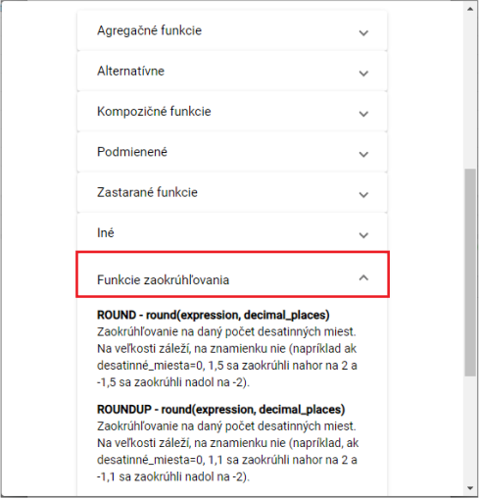

Figure 192: Description of the functions

1. Enter the path to the profile or press the button to display the window Choose Profile in which to select the profile.
2. Enter the period.

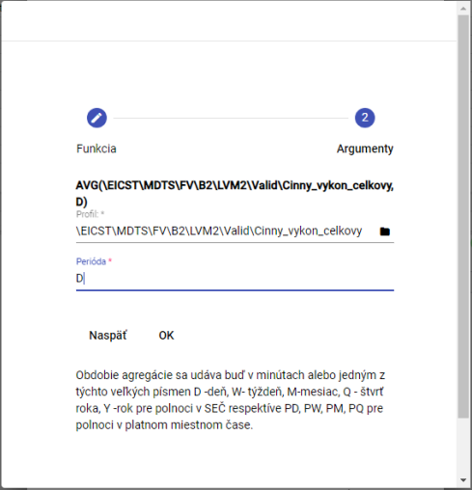

Figure 193: Period setting

1. Press the OK button.
2. In the New profile window, after entering the definition, press the Check the definition button.

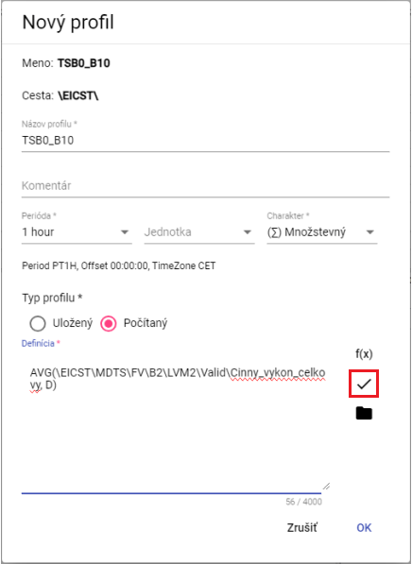

Figure 194: The Check the definition

1. The status window will appear and you will close it by pressing the OK button.

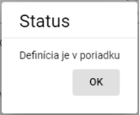

The following table shows the following:

1. The button is used to add a profile.
2. **[TRANSLATION ERROR - MANUAL REVIEW NEEDED] Profil uložíte stlačením tlačidla „OK“.**

## How to add a new set

You'll create a new setup:

1. Right-click the mouse to the folder you want to add a new set to.
2. Select the entry New... and then the entry Restaur.

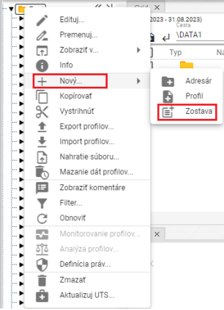

Figure 196: Item Based on

1. The window "Name of the report" will appear.

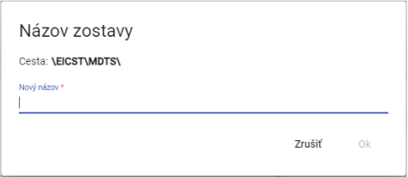

Figure 197: Window Name of the report

1. Enter a new name for the set. The name of the set must not start with a number. It can contain letters, numbers, and footnotes. The name must be at least 3 characters long and not more than 50 characters long. If you do not enter a name or you enter an invalid name, the name rules information will appear. The rules for naming may vary depending on the configuration of the environment.

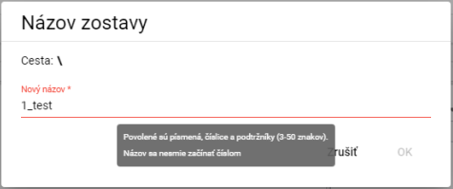

Figure 198: For invalid names, the information with the rules for the name is displayed

1. Confirm by pressing the OK button.
2. A new set is added to the selected folder.

## How to change profile

You change the profile:

1. Right-click the profile you want to change.
2. In the offer, select Move.
3. A new name will appear in the window. The profile name must not start with a number. It can contain letters, numbers and footnotes. The name must be at least 3 characters and not more than 50 characters. If you do not enter the name or you enter an invalid name, the profile name information will appear. Rules for entering the profile name may vary depending on the configuration of the environment.

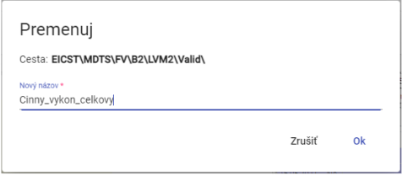

Figure 199: Changing the profile

1. Save the changes by pressing the OK button.

## How to edit a profile

To edit the profile, please follow:

1. Right-click the profile you want to edit.
2. Please select Edit from the offer.
3. A window will appear to edit the data.

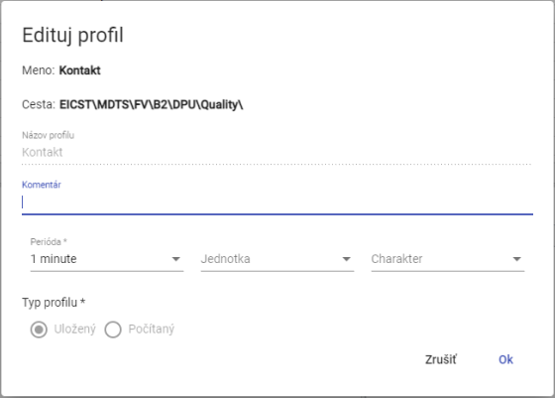

Figure 200: The window for editing the profile

1. Save the changes by pressing the OK button.

## How to delete the profile

Procedure for removal of the profile:

1. Right-click the profile you want to delete.
2. In the offer, select Delete.
3. A window will appear to confirm the deletion of the profile by pressing the NO button.

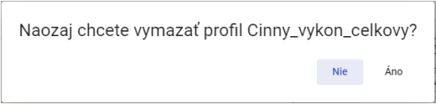

The following table shows the following:

## How to display profile dependencies

You will see the profile dependencies:

1. Right-click the mouse to profile the tree structure.
2. Please select the heading 'Dependency'.
3. A window with three tabs Used profiles, Full definition and Depending profiles will appear.

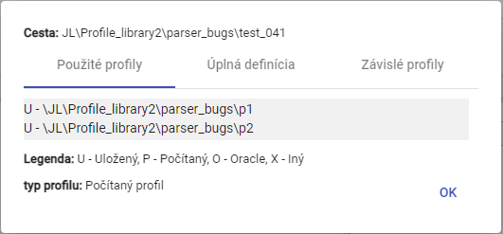

Figure 202: Tab Used profiles

1. The second tab Full definition contains the profile definition entered when creating a profile.

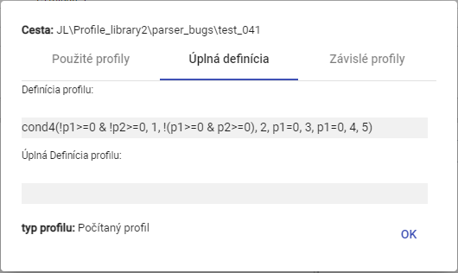

Figure 203: Table Full definition

1. The third tab Dependent profiles contains a list of dependent profiles.

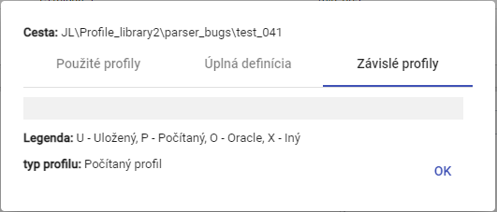

Figure 204: Tab of the dependent profiles

## How to create a new profile

In the Explorer window, you can create a new profile by pressing the Create a new profile button, which is located in the upper left corner of the Explorer window.

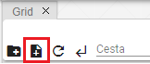

Figure 205: Tape Create a new profile

## How to set Profile Policy

The policy defines the specific behavior of the profile.

Time policy of profile:

A profile timing policy is a profile property that allows for the resolution of very specific cases of data transformation in profiles.

One of the policy's uses is the ability to change the storage profile period from 1h to 15min without the need for a long and slow data transformation. After applying the 1h policy, the 15min will become 15min from the original clocked storage profile to 15min, and this in full. All applications that use the profile will see it as 15min as of the time of transformation.

The 1h to 15min policy must however contain a fixed change date from which the profile is to be used as a full 15minute.

For example:

The original hourly profile contained a value of 100 MWh. If the profile character is set to Multi-volume, the 15-minute profile returns a value of 25 MWh every 15 minutes.

If the same profile is set to Period, the 15minute profile will return the value of 100 MWh every 15 minutes of the given hour after the policy is set.

To set the policy, please follow:

1. Right-click the profile of the tree structure to which you want to set the policy.
2. Please select the heading Policies.
3. The policy setting window will appear.

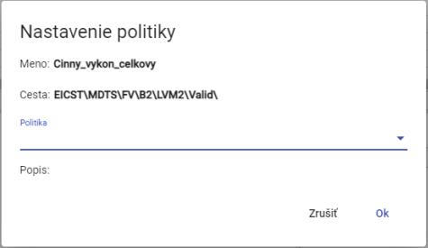

Figure 206: Window Setting up a policy

1. Two policies are currently available

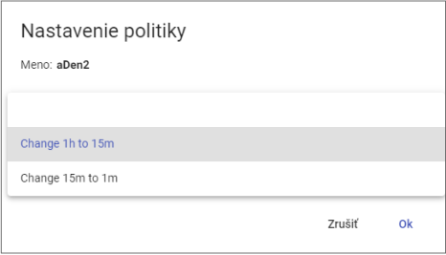

Figure 207: Policy selection

1. Save the changes by pressing the OK button.

## How to display profile information

To view the profile information, please follow:

1. Right-click the profile to which you want to view the information.
2. Please select the Info.
3. A window with information will appear.

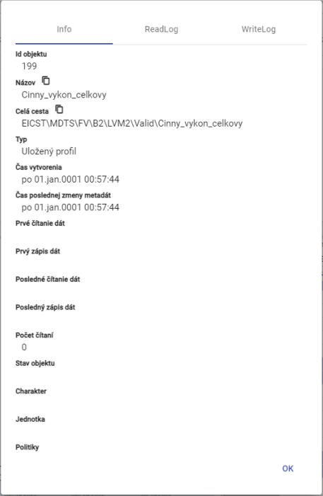

The following information is provided by the Commission:

## How to copy a profile

To copy the profile, please proceed to:

1. Right-click the profile you want to copy.
2. Please select the heading Copy.
3. Right-click the directory to which you want to insert the copied profile and select Insert.
4. The window Move/Copy will appear.

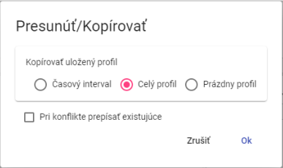

Figure 209: Window Move/Copy

1. Select whether to copy only the time interval, the entire profile or the blank profile.
2. Press the OK button.

You can also copy a saved profile from one directory to another by clicking the left mouse button on the profile and moving it over the directory to which you want to copy the profile.

To copy the directory, please proceed to:

1. Grab the directory and move it to the directory where you want to copy the profile.
2. Next, open the directory above the address box, which will show the Move/Copy window.

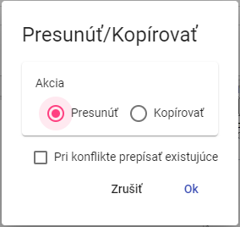

Figure 210: Window for moving the profile

1. Click on the copy action.

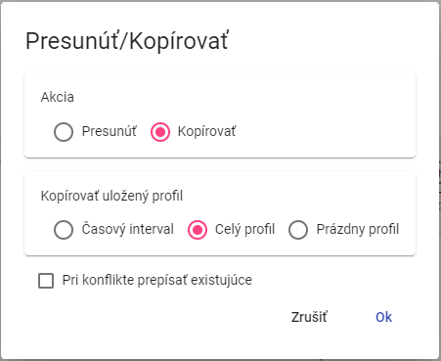

The following table shows the following information:

1. In the section Copy saved profile, select whether to copy the entire profile, the time interval of the profile or the empty profile.
2. If you select a time interval, type the time interval to be copied.

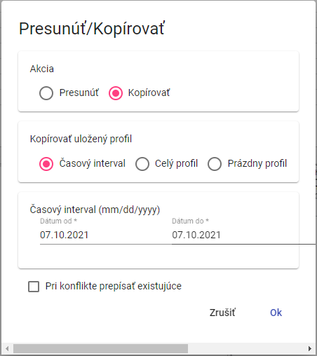

Figure 212: Window for copying the time interval of the saved profile

1. Clicking the checkbox Rewrite existing in the conflict means that if a profile with the same name as the profile you want to copy is found in the directory, the profile is rewritten.
2. You copy the profile to the directory by pressing the OK button.

## How to cut/move the profile

To remove the profile, please proceed to:

1. Right-click the mouse on the profile you want to cut.
2. In the offer, select the item 'Sharp'.
3. Right-click the directory where you want to insert the profile.
4. Please select the entry Insert.
5. A confirmation window will appear where you can press the OK button.

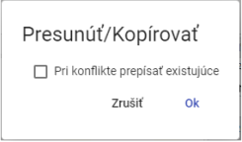

Figure 213: Window Move/Copy

You can also move a stored profile from one address book to another by clicking the left mouse button on the profile and moving it over the address book to which you want to move the profile.

To move the address book, please proceed to:

1. Grab the profile and move it to the address book where you want to move the profile.
2. Next, open the profile above the address book to display the Move/Copy window.



Figure 214: Window for moving the profile

1. Clicking the checkbox Rewrite existing in the conflict means that if there is a profile with the same name as the profile you want to move, the profile is rewritten.
2. You can put the profile in the directory by pressing the OK button.

## How to view a timeline in a tree

To view the timeline view, double-click the left mouse button on the tree structure profile.

## How to enlarge the window for creating and editing a calculated profile

You can enlarge the window to create and edit the calculated profile.

With the left mouse button, press the button and push it. Enlarge the window to the desired size and release the left mouse button.

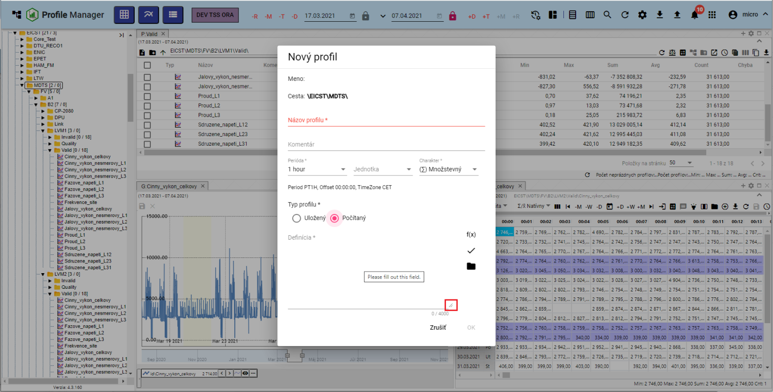

Figure 215: Window enlargement button New profile

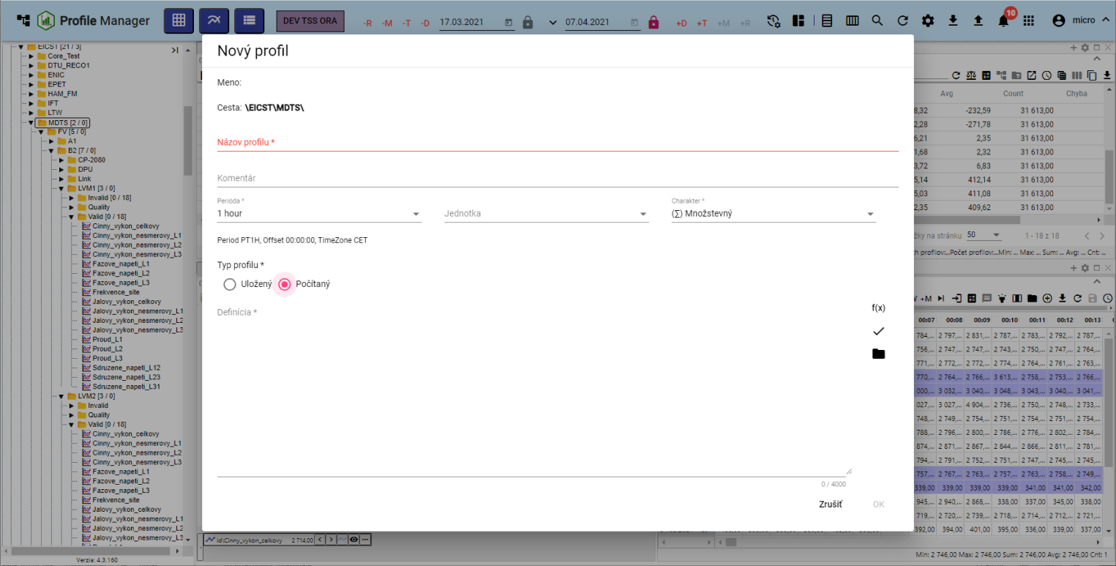

Figure 216: Enlarged window New profile

## How to Move Windows

Move windows in Profile Manager by pressing the left-hand button on the top of the window and moving the window to the desired location.

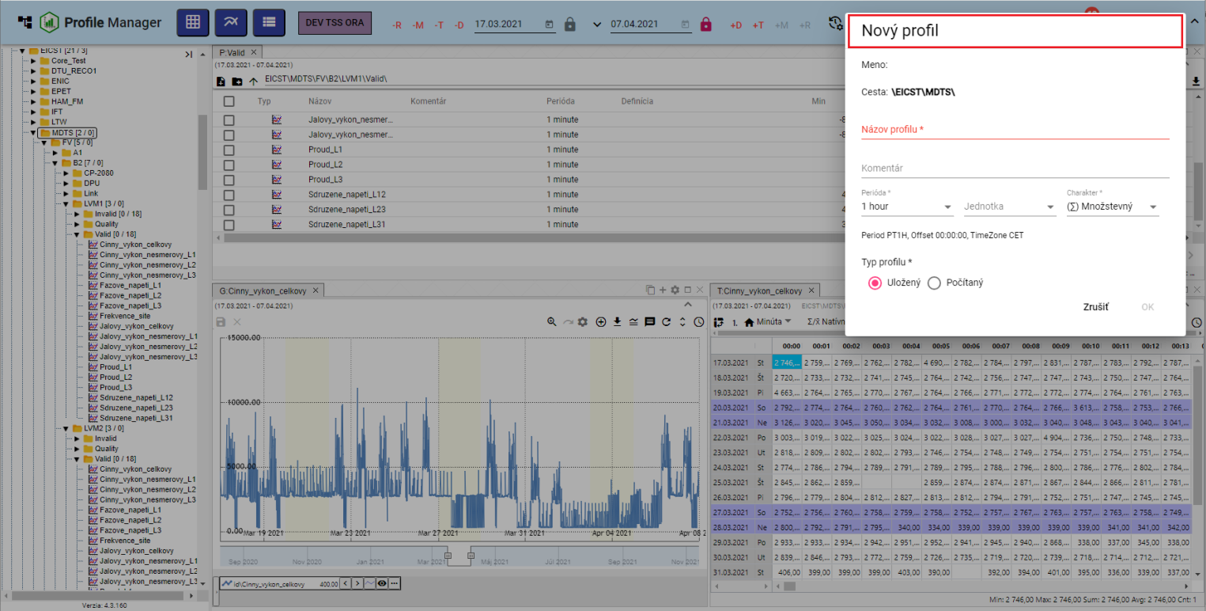

Figure 217: Moving the window New profile

## How to rename a document

You change the document (e.g. report, report) to:

1. Right-click the mouse on the document you want to rename.
2. In the offer, select Move.
3. The window "Move" will appear.

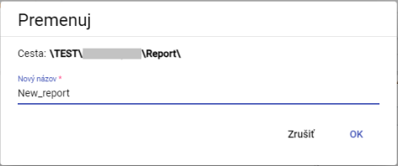

Figure 218: Window Move

1. Edit the name.
2. Please press the OK button.

# Common controls for the survey, table and graph

At the top of the window are the window controller, table and graph buttons, which are discussed in the following subchapters.

## How to Restore Data in Windows

To re-upload the data in the windows, press the button shown in Figure 219.



Figure 219: Data recovery button in the Explorer window, table, chart

## How to change the date range

Change the date range in the Explorer, Table or Graph window:

1. Press the Turn time range button located in the upper right corner of the window.



Figure 220: Pressure Changes the time range

1. The date range setting window will appear.

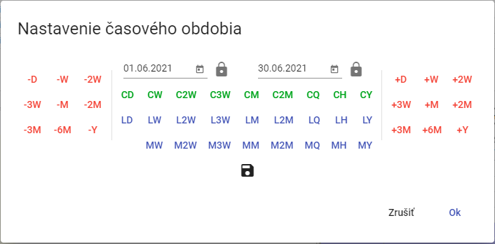

Figure 221: Window for changing the date range

1. You can set a date by pressing a button, selecting a date, or directly rewriting a date.
2. You can save the new date range by pressing the disk button.



Figure 222: Date range storage button

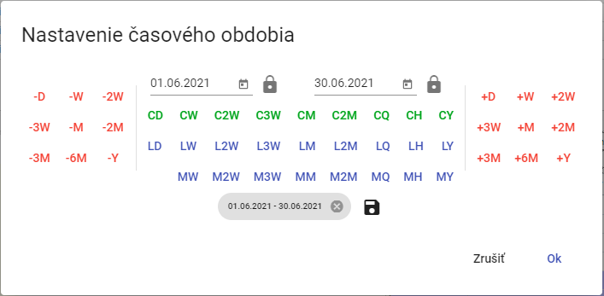

The data set shall be reported in the following table:

1. You can start the date range by pressing the OK button.

## How to enlarge the window across the entire application area

The graph, the scanner and the table can be enlarged by pressing the Maximize button (Figure 224) or by double-clicking on the top panel tab, Figure 226. The window will then appear across the entire application area.



Figure 224: The button Maximize



Figure 225: Pressure Restyle the size

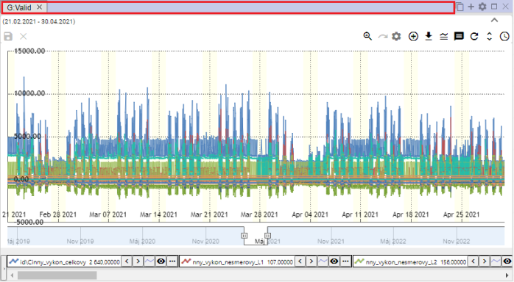

Figure 226: Top sheets of the panel

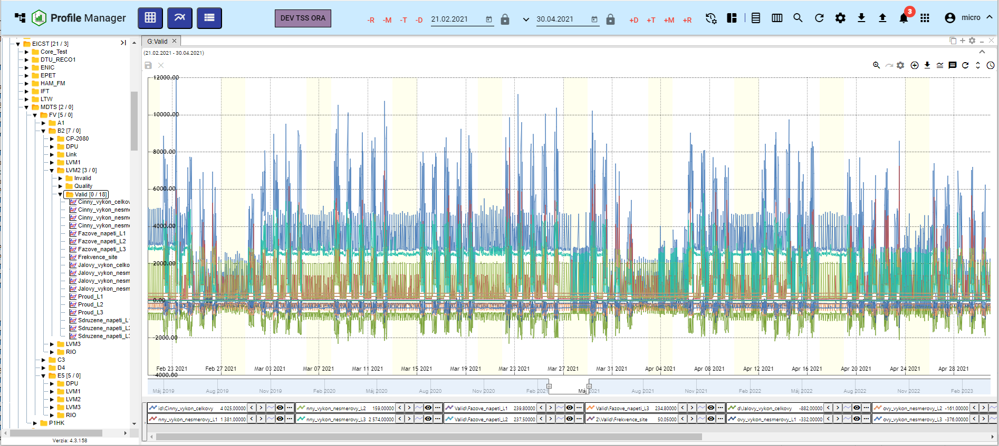

Figure 227: Enlargement of the graph window

## How to close a window

Close the graph, the scanner and the table by pressing the x button, which is located at the name of the window and in the upper right corner of the window.



Figure 228: Close button to close the window

## Set the name and colour of the panel

The panels are called by default Explorer, Table and Graph.

1. Press the Panel settings button located in the upper right corner of the window.



Figure 229: Panel settings

1. The window "Panel settings" will appear.

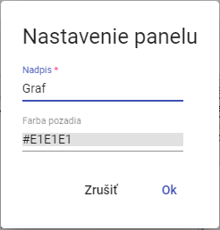

Figure 230: Window Setup of the panel

1. Enter the name in the Subscribe field.
2. You can set the panel color by clicking on the Behindground color field and selecting the color.

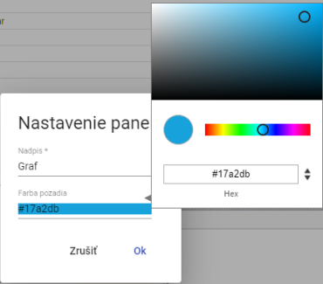

Figure 231: Choice of colour

1. Save changes by pressing the OK button.

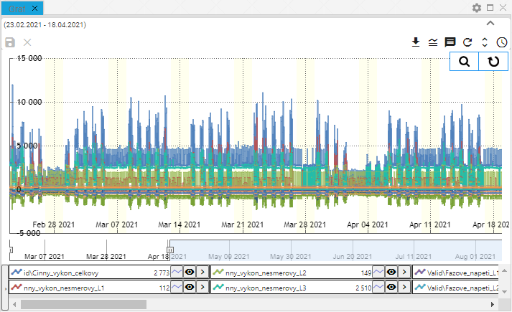

Figure 232: Changed panel colour

## How to export the displayed data from the Explorer window

The data displayed can be exported to the Explorer, Table or Graph window by pressing the export button, Figure 233.



The following table shows the calculation of the export price.

## How to hide the top panel with buttons in the Explorer, Table and Graph window

The top of the Explorer, Table and Graph window can be hidden by using a button that displays Figure 234.

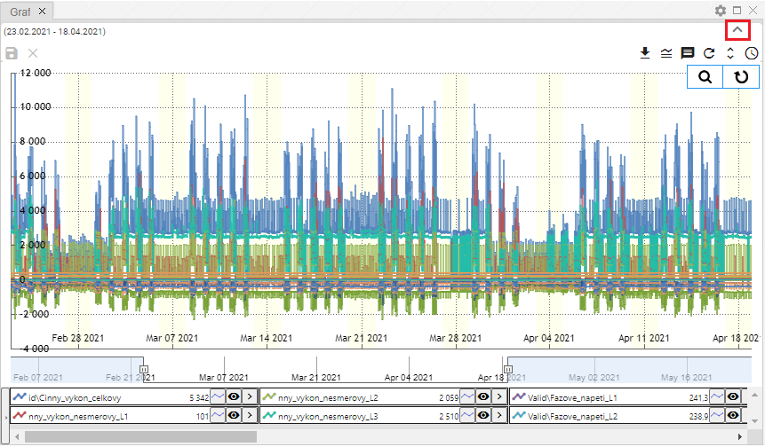

Figure 234: The button to hide the top of the window in the scanner, table and graph

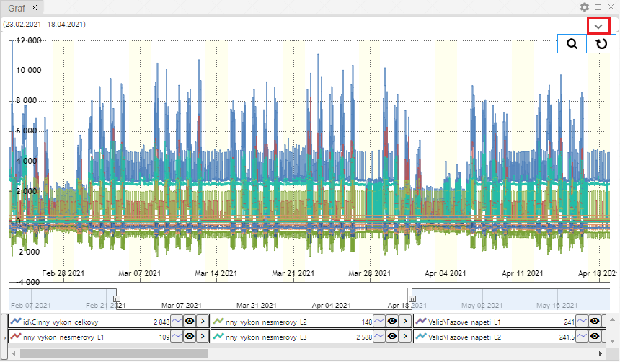

Figure 235: The button to display the top of the window in the Explorer, Table and Graph

## How to add a profile to a graph and table

In the Graph and Table window, you can add a profile as follows:

1. Press the Add profile button at the top of the graph or table window.



Figure 236: Press the Add profile

1. The Add profile window will appear.

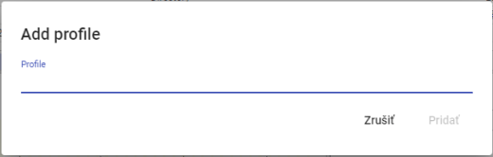

Figure 237: Window Add profile

1. Enter the path where the profile is stored.

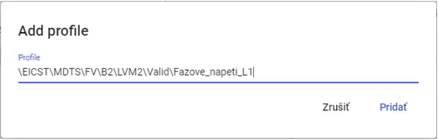

Figure 238: Providing a path to the profile

1. Press the Add button.
2. The selected profile is added to the graph/table window.

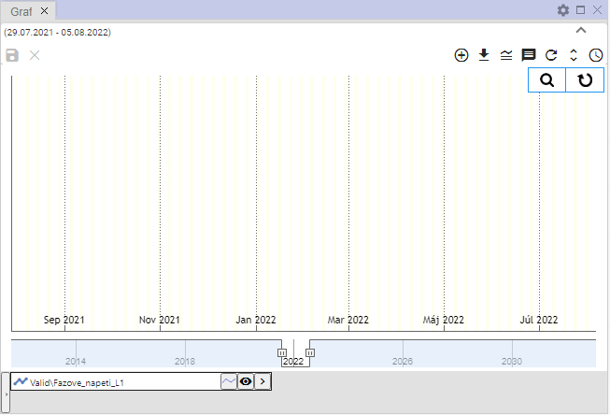

Figure 239: Added profile in the graph window

# Working with a window

When you run Profile Manager, the browser window is filled with tree-structured directories and profiles. You can add any number of browser windows while you work with the application.

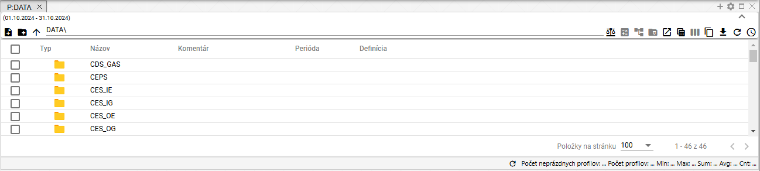

Figure 240: Window Examiner

## How to view profiles from the selected directory in the Explorer window

The Explorer window will display tree-structured directories and profiles as standard. The profiles from the selected directory will be displayed by double-clicking the left mouse button on the Typ button.

You can see the directory list back by clicking on the arrow

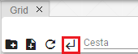

Figure 241: Step back button

## How to create a new directory

In the Explorer window, you can create a new directory by pressing the Create a new directory button.

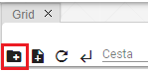

Figure 242: The button Create a new directory

## How to Synchronize the Explorer with the Tree

The Sync to tree button means that the browser is synchronized with the tree. The overlapping Sync to tree button means that if the tree directory changes, the change will not appear in the browser window.



Figure 243: Pressure Synchronization with the tree



Figure 244: Cancelled synchronization with the tree

## How to filter a profile

You can filter the profiles shown in the Explorer window by column.

1. Use the cursor mouse to set the name of the column to which you want to apply the filter.
2. Press the button to display the window for filtering.



The following table shows the following:

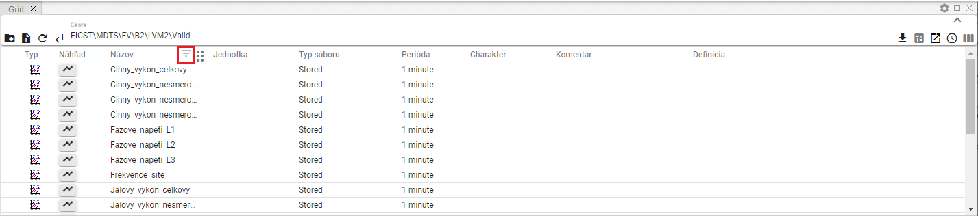

Figure 246: Filter button above the column Name

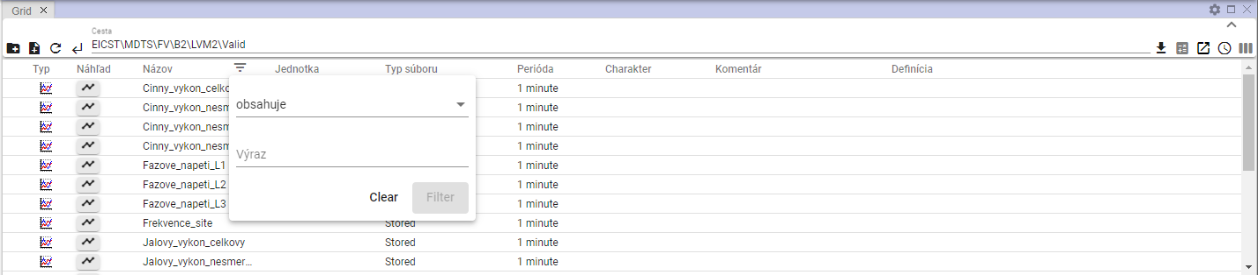

The following table shows the results of the analysis:

1. Write down the filter criteria.

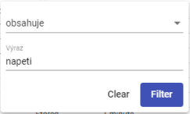

Figure 248: Setting of the filtration criterion

1. Press the Filter button or the Enter key.
2. Profiles meeting the filtering criteria shall be displayed.

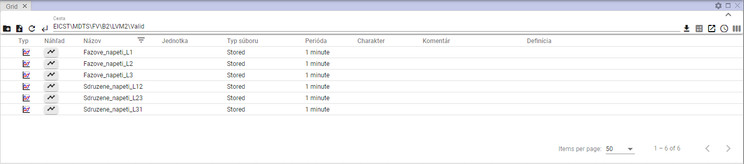

Figure 249: Filter applied

1. Above the column in which the filter is applied is a display button.
2. You can undo the filter by clicking the filter button , which will show a filter window and then pressing Clear.

## How to arrange data in columns

To sort the data in the column, set the column name with the mouse cursor and click the arrow that appears next to the column name.



Figure 250: The data sorting button in the column

## How to calculate the values in the Min, Max, Sum, Avg and Count columns in the Explorer window

For calculating the values in the columns in the survey window, proceed to:

1. In the Explorer window, see the address profile for which you want to calculate the sum of the values.

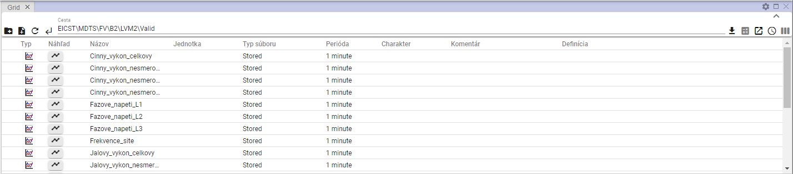

Figure 251: Display of the address in the Explorer window

1. Press the 'Statistics' button.



Figure 252: Statistics button

1. The values in the columns Min, Max, Sum, Avg and Count are added.

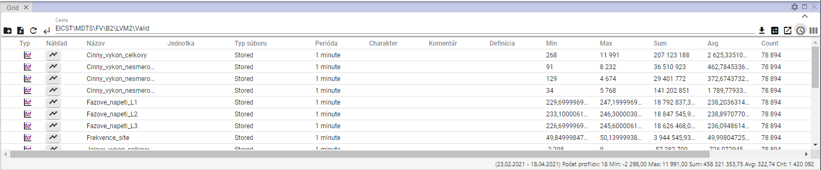

Figure 253: Calculation of statistics in the survey window

## The timeline

To view the timeline, please proceed to:

1. In the Explorer window in the Type column, double-click the left mouse button on the profile of the timeline you want to view.

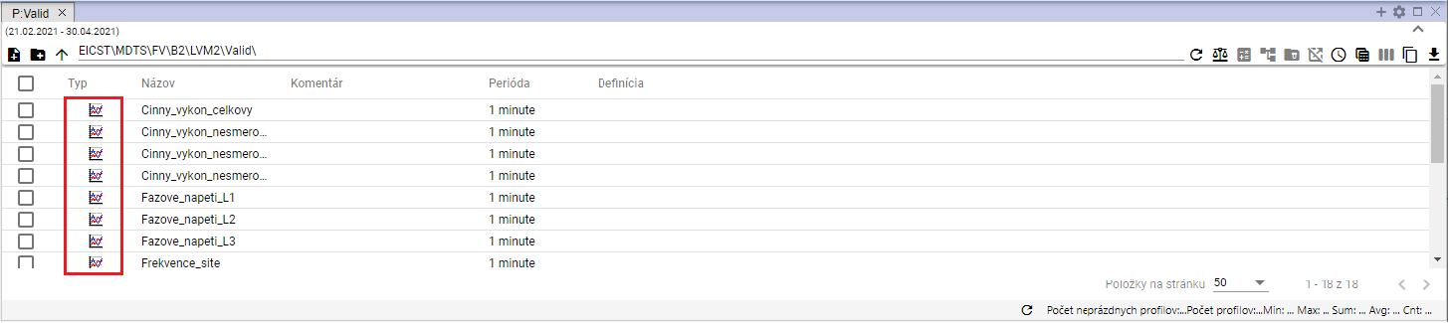

Figure 254: Window view button Looking for the timeline

1. The window "Look for the timeline" will appear.

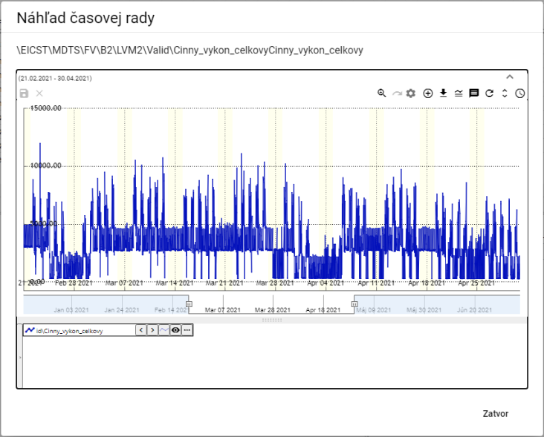

Figure 255: Window Looking for the timeline

1. The work with the buttons located in the upper right corner of the graph is covered by the subchapters in Chapter 5.



Figure 256: Presses for working with a graph

1. At the bottom of the window is the profile name. Right-clicking the profile name mouse will show you a list of functions to work with the profile.

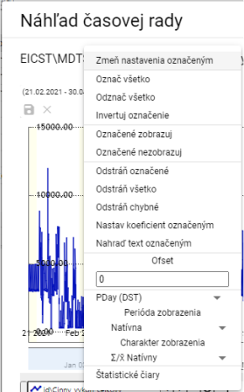

Figure 257: Functions for working with the profile

1. By clicking the arrow next to the profile name, you will see a window with the functions that are developed in Chapter 5.8.

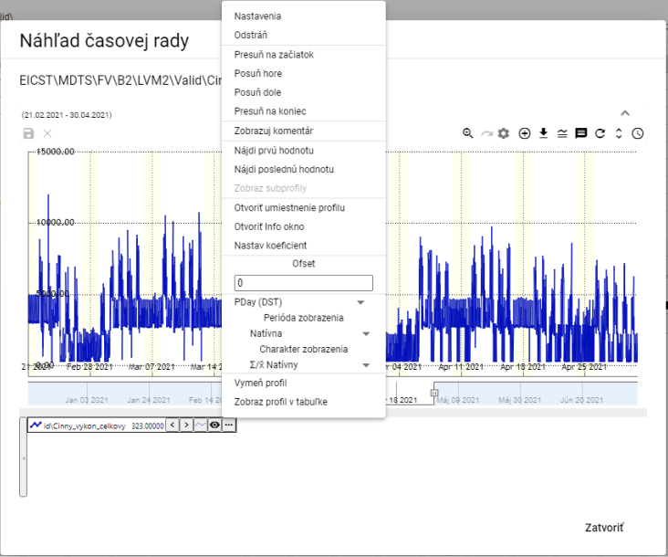

Figure 258: List of functions for working with profile

## How to move a profile from the Explorer window to the Graph or Table window

You can move the row from the Explorer window to the Explorer or Table window. You can move the address in the Explorer window to the Graph window. You can capture and move the profile in the Explorer window to the Graph or Table window.

Step by step:

1. In the Explorer window, set the cursor to the directory or profile row you want to move to the Graph or Table window.

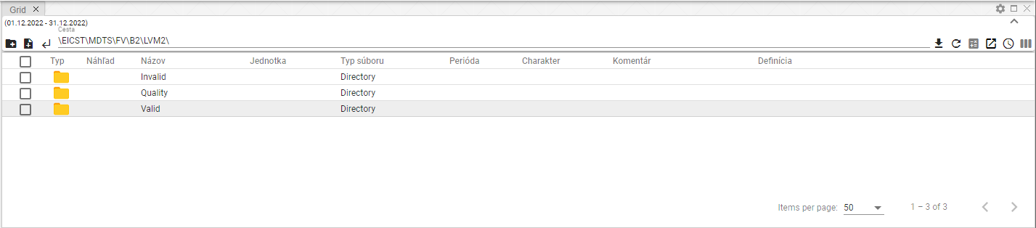

Figure 259: Selected profile

1. With the left mouse button, grab the row in the Explorer window and move the row over the window where you want to display it and release it.

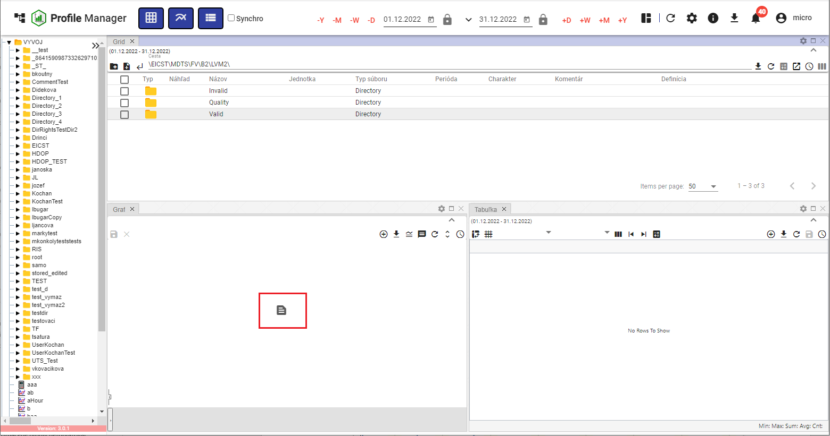

Figure 260: Moving the profile to the Graf window

1. The profile will appear in the selected window.

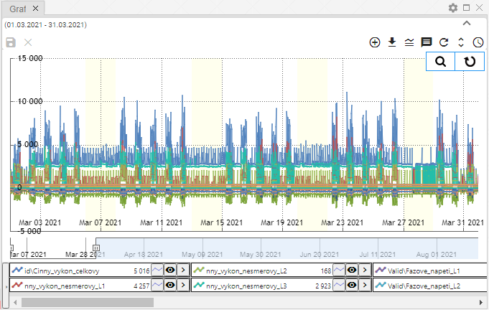

Figure 261: Profile moved from window Explorer to window Graph

## How to edit Add or Remove Columns in the Explorer window

You can change the list of columns in the Explorer window. You can add or remove columns.

For the change of the columns shown:

1. Press the Choose columns button located in the upper right corner of the Explorer window.

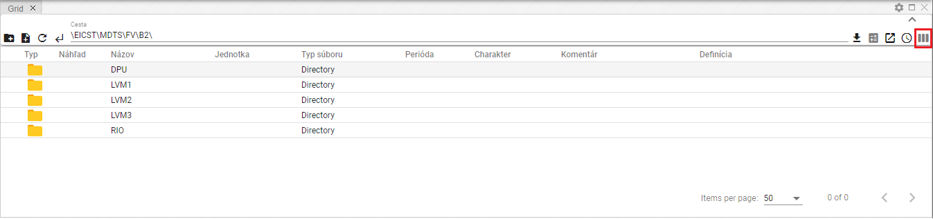

Figure 262: Pressure Selection of columns

1. A block with a list of columns will appear.

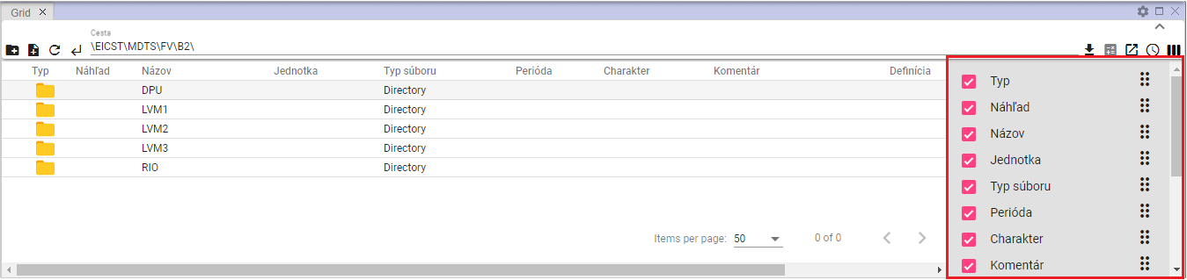

Figure 263: List of columns

1. Add/approve the columns to be displayed. When editing the list of selected columns, a change will automatically appear in the Explorer window.
2. You can change the order of the columns in the Explorer window. To change the order of the column, press the Move the column button and move the column to the desired place in the list.

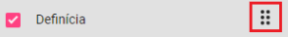

Figure 264: The button for moving the column

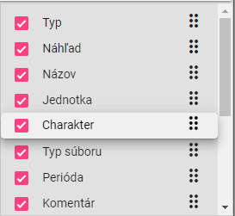

Figure 265: Moving the column Charakter

## How to edit the Names and Comments fields

You can edit the fields Name and Comment for profiles and directories in the Explorer window.

For adjustment, please proceed to:

1. Double-click the left mouse button on the field, making it available for editing.

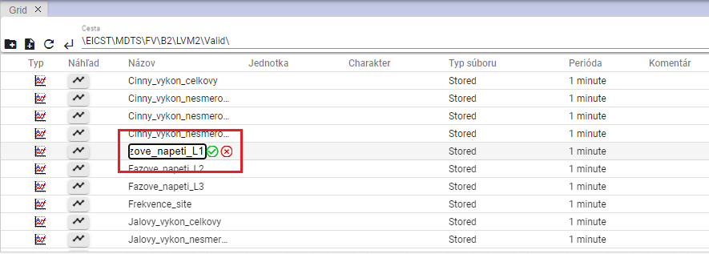

Figure 266: Modification of the profile name

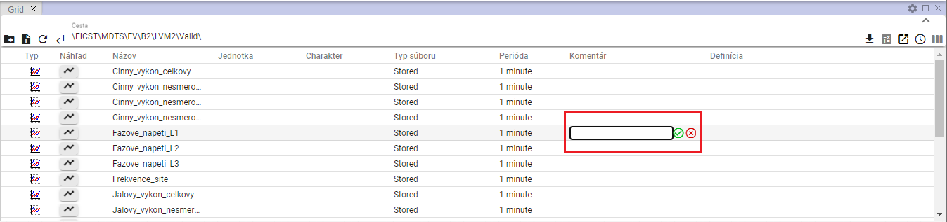

Figure 267: Commenting on the profile

1. Edit the text.
2. Save changes by pressing a button .

## Functions for working with directories in the Explorer window

You can view the functions for working with the directory by right-clicking the mouse on the directory in the Explorer window.

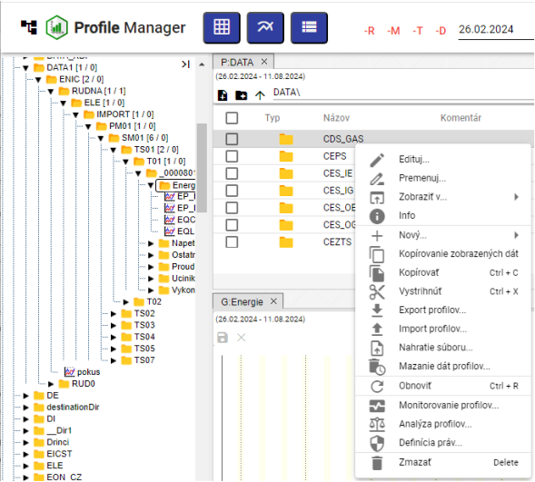

Figure 268: List of functions for working with directories

## Functions for working with window filters

You can view the functions for working with the profile by right-clicking the profile mouse in the Explorer window.

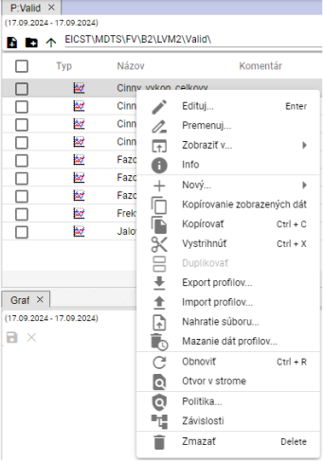

Figure 269: List of functions for working with profiles

## The Branch view button

The Branch view button allows you to perform mass operations on all profiles in the database regardless of the address of the profile.

The Branch view button displays items from the selected directory without sorting into embedded directories, Figure 271. To view the directories by default in the Explorer window, click again on the Branch view button.

Profile editing procedure for the mass:

1. Press the Branch view button to display a list of profiles without directories.

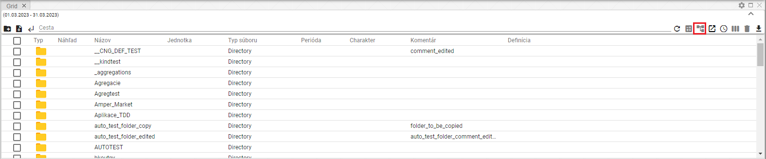

Figure 270: The button Branch view

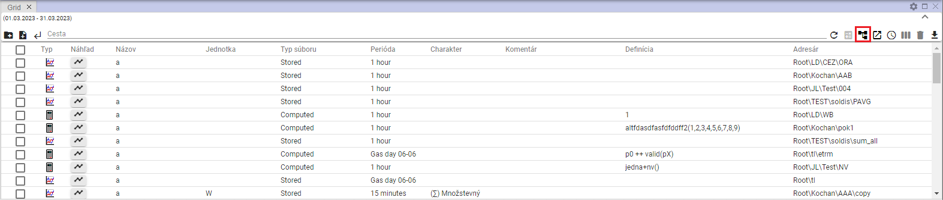

Figure 271: Displaying profiles without directory division

1. Set a filter to get a list of profiles you want to do mass operations on.

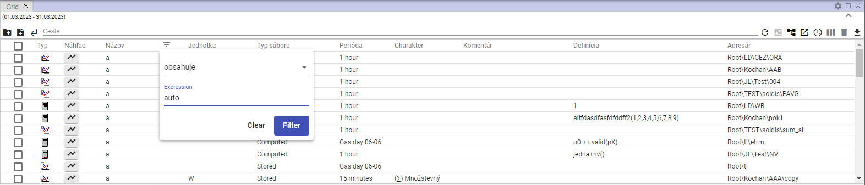

Figure 272: Filter setting

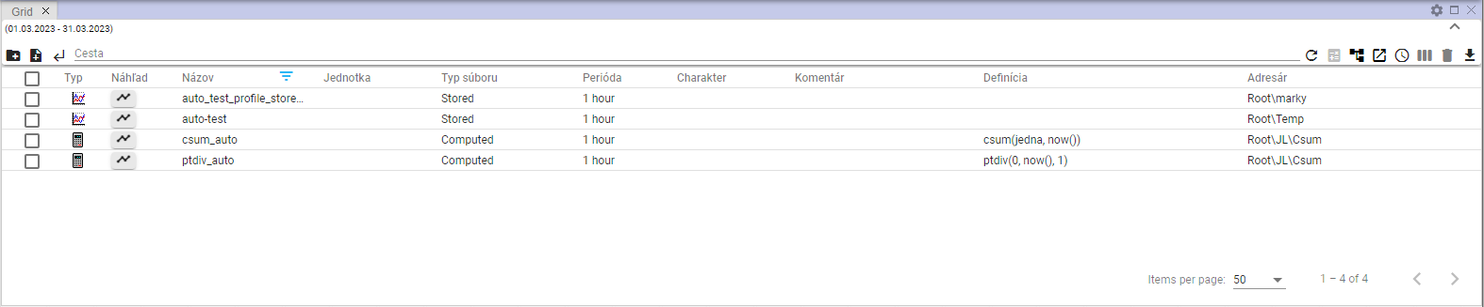

Figure 273: Filtered items

1. Click the box in the first column to select profiles to be used in the mass operation.

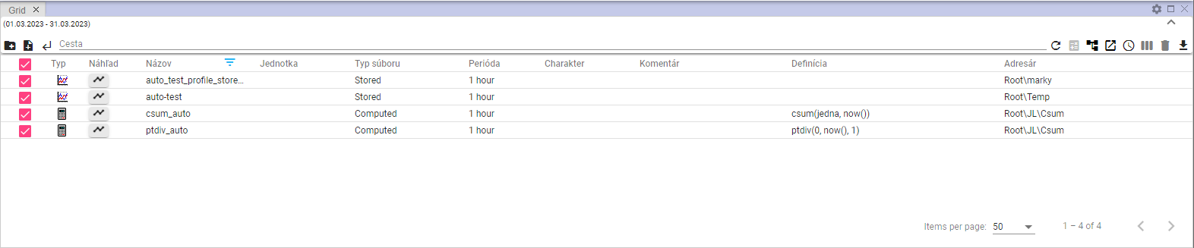

Figure 274: Selected profiles

1. Right-click any of the profiles and select Edit.

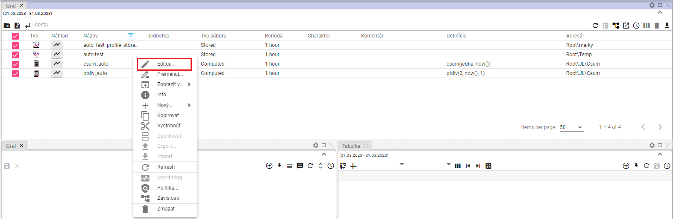

Figure 275: heading Edit

1. The "Mass editing" window will appear.

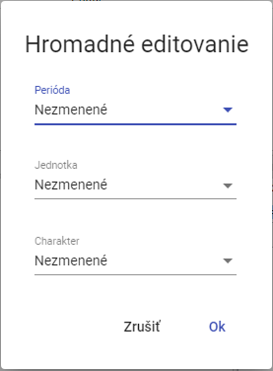

Figure 276: Window Mass editing

1. You can edit the fields Period, Notes and Charakter.
2. Edit the data and save the changes by pressing the Ok button.

## How to view deleted items in the Explorer window

The Cos button in the Explorer window is used to display items that have been deleted. The button is normally inactive gray. Once clicked, it is black. To cancel the deleted items, click again on the Cos button. The Explorer window will then display tree structure directories and profiles.



Figure 277: The Cos button is inactive



Figure 278: The Cos button is active

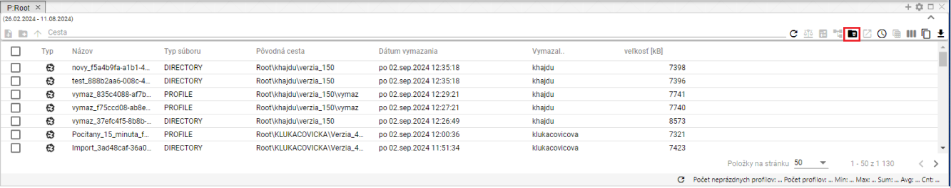

Figure 279: Display of contents of the Cos button

## How to copy the data displayed

The Copy the data displayed button, Figure 280, is used to copy the data from the Experiment window. Figure 282 shows the copied data.

Step by step:

1. In the Explorer window, enter the data you want to copy.
2. To copy all the data displayed, press the Copy the data displayed button.

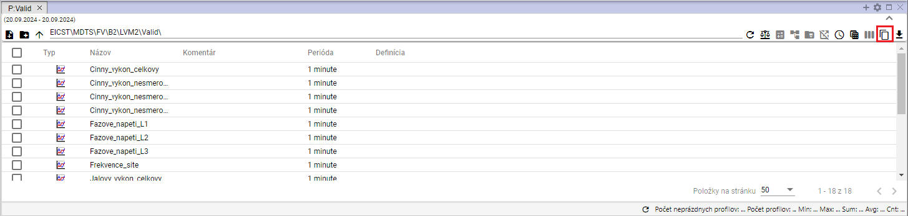

Figure 280: Tape Copy the data displayed

1. To copy a specific file or files, select the selected files in the Explorer window. Right-click the selected files and select Copy the displayed data.

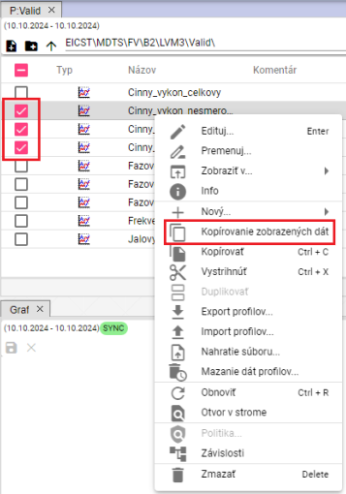

Figure 281: Item Copy the data displayed

1. You can insert the copied data into Microsoft Excel.

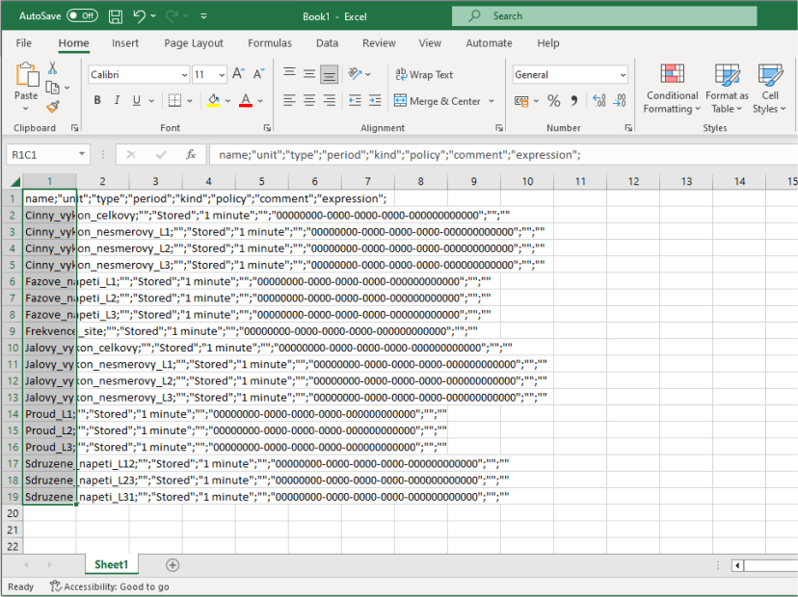

Figure 282: Data copied to MS Excel

## Use the Explorer setting as an output

You can set the current settings of the columns as outputs. Every time you open a new browser or open the Profile Manager app, you will see the saved settings of the columns.

To set the current settings of the Explorer columns to output, proceed to:

1. Press the Use the Explorer setting as an output, which is located in the upper right of the Explorer window.



Figure 283: Pressure Use the Explorer setting as an output

1. A confirmation window will appear where you can press the NO button.

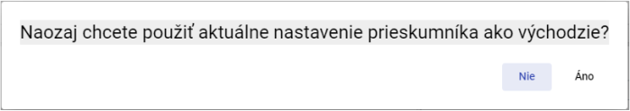

Figure 284: Window for confirming the installation of the explorer's output settings

## How to filter in columns using * wildcard

In the Explorer window, you can filter in columns using a wildcard, using *.

Examples:

* Text* - Searching for anything starting with the text entered
* **[TRANSLATION ERROR - MANUAL REVIEW NEEDED] *Text - vyhľadá sa všetko, čo končí na zadaný text**
* **[TRANSLATION ERROR - MANUAL REVIEW NEEDED] *Text* - vyhľadá sa všetko, čo obsahuje zadaný text**

Example: Cinny* - looks for anything that starts with Cinny

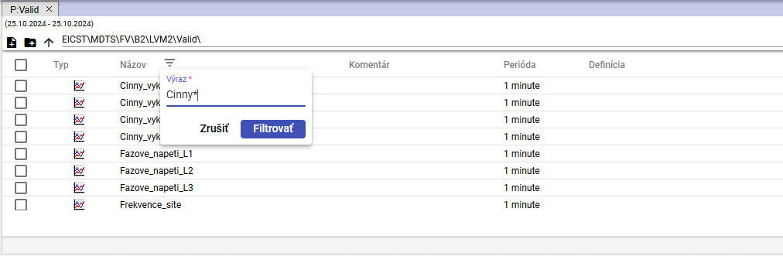

Figure 285: Set a filter to search for profile names starting with Cinny

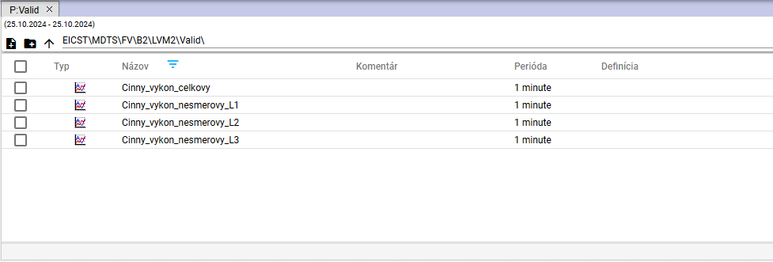

Figure 286: Searching for profiles starting with Cinny

**[TRANSLATION ERROR - MANUAL REVIEW NEEDED] Príklad: *L2 - vyhľadá všetko čo končí s textom „L2“**

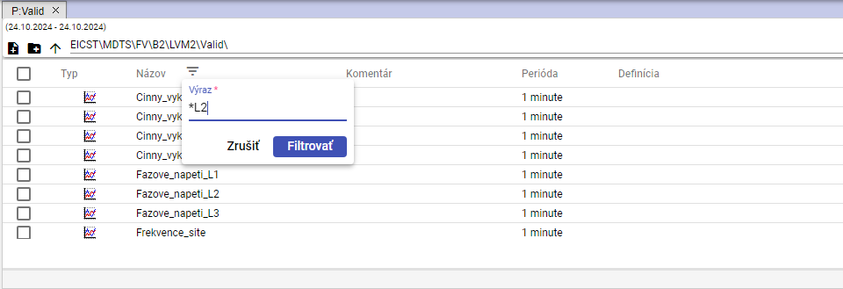

Figure 287: Set a filter to search for profile names ending in L2

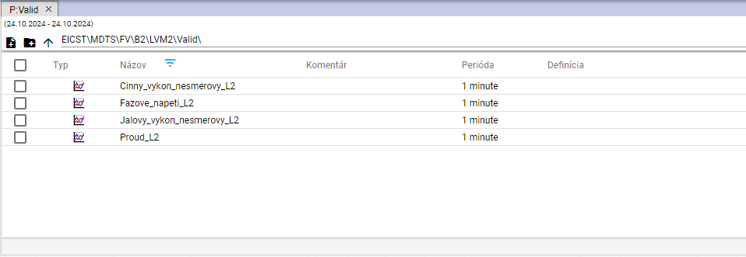

Figure 288: Searching for profiles ending in L2

Example: *tune* - looks for everything that contains text tune

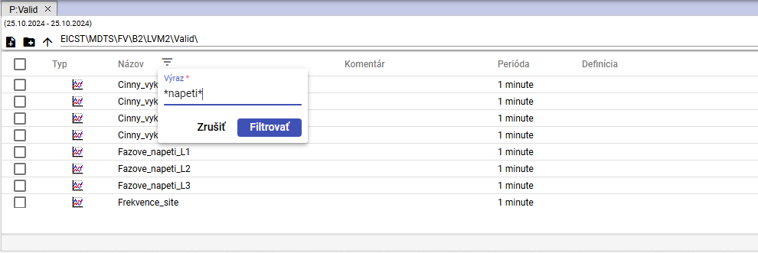

Figure 289: Set a filter to search for profile names containing text apply

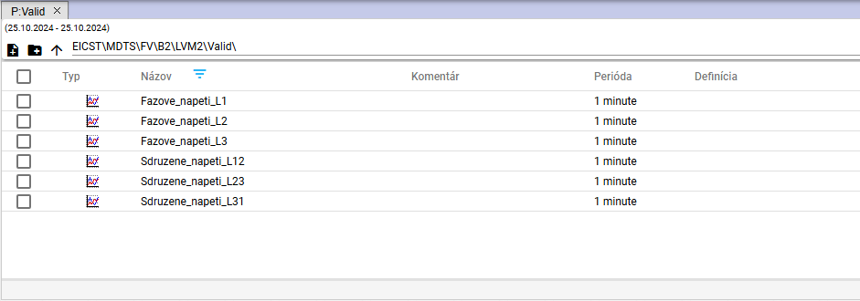

Figure 290: Searching for profile names containing text apply

# Graphing work

When you run Profile Manager, a graph space window opens. When you work with the app, you can add any number of graph windows you want. You can view any number of profiles in one graph.

## How to display a profile in a graph

To view the profile in the graph window, go to:

1. By default, the graph window is empty.

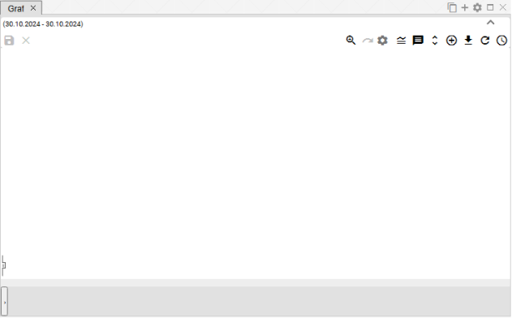

Figure 291: By default, the graph view window is empty

1. In the profile tree, tap the left mouse profile or profile directory and move it to the graph window.

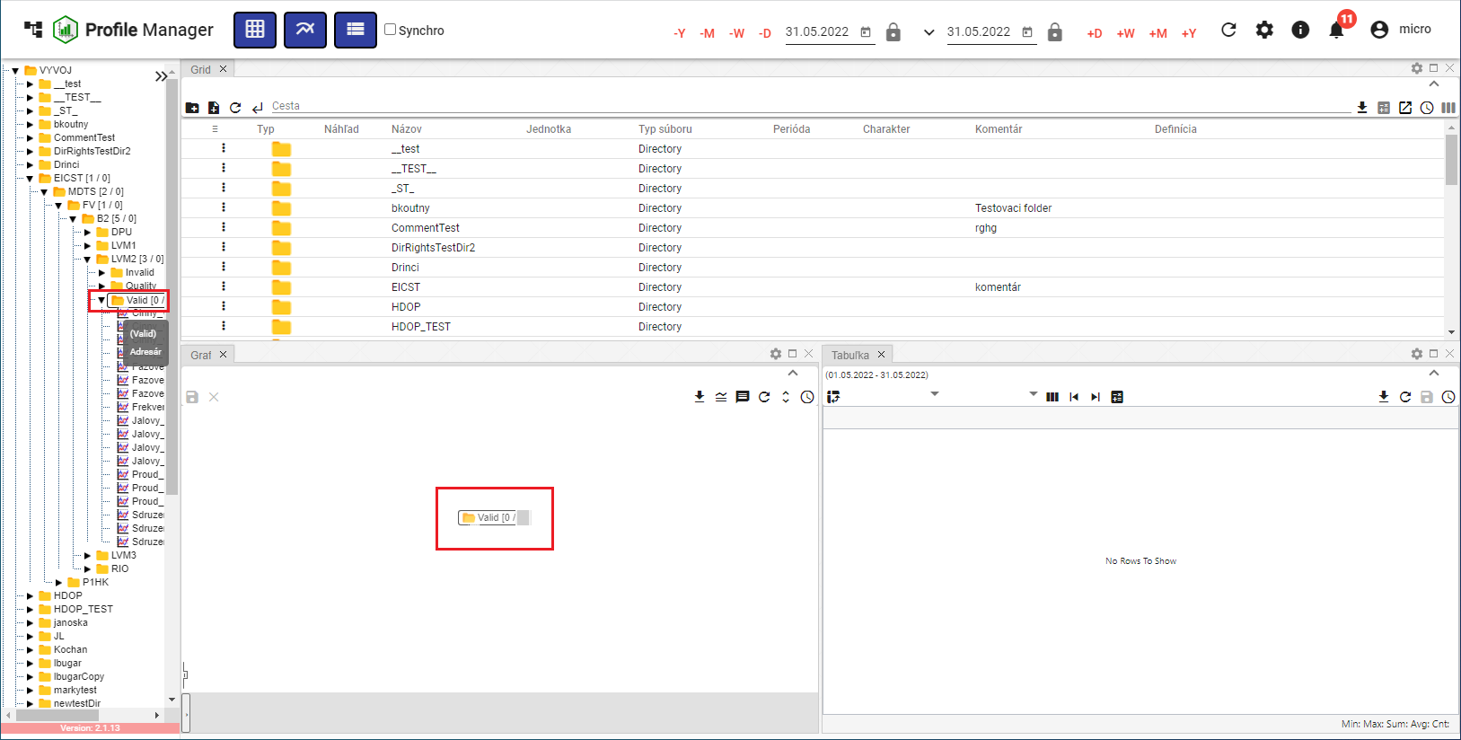

Figure 292: Moving the address to the graph area

1. The graph will be shown from the data in the graph window.

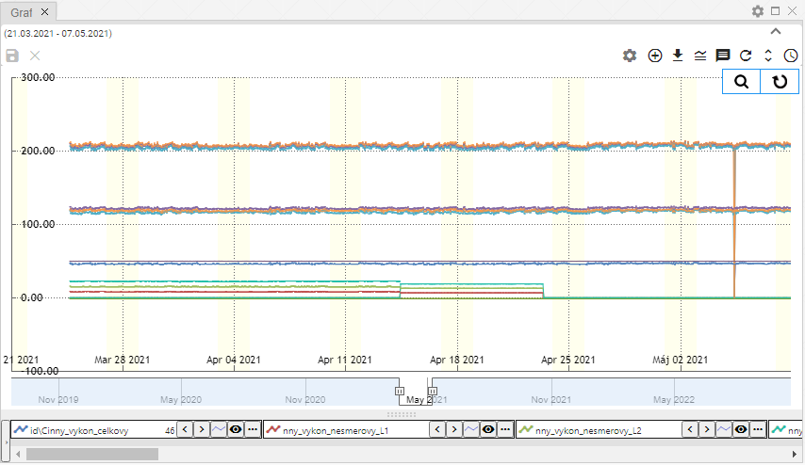

Figure 293: Graphical representation of the profiles

## How to display the information window with values for a specific location in a graph

To display values for a specific location in a graph, set the mouse cursor to the location you selected.

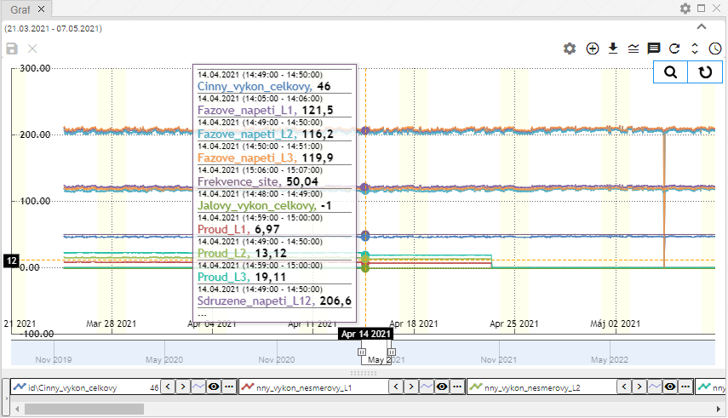

Figure 294: Display of profile values at a specific location in the graph

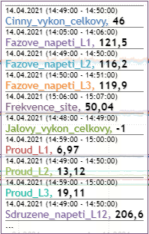

Figure 295: Values of profiles at the selected location in the graph

If the data are incomplete within the range (decimal), a yellow exclamation mark shall be displayed (Figure 296).

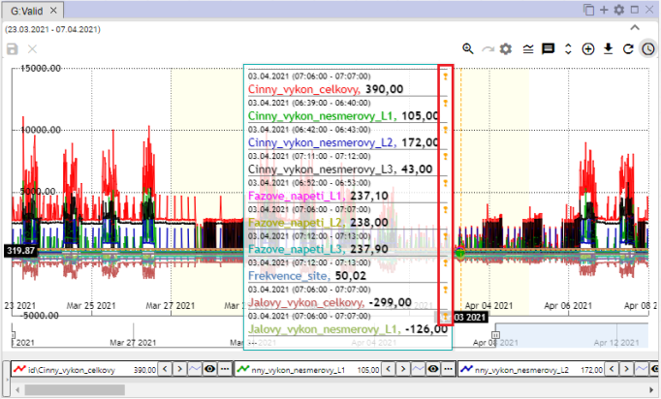

Figure 296: Yellow shout

## How to change the date from-to graph

You can change the time range for which the graph is displayed by using the Turn time range button located in the upper right corner of the graph window.



Figure 297: Pressure Change the time range

## How to save a graph in JPG format

You can save the graph as an image in JPG format.

1. Press the Export graph to jpg button located in the upper right corner of the graph window.



Figure 298: Export chart to jpg

1. A graph image is created and stored among the downloaded files on the computer.

## How to copy the entire graph into a new window

You can copy the entire graph to a new window:

1. Press the Copy the entire graph into the new window.
2. The graph is copied and displayed in a new tab in the graph window.

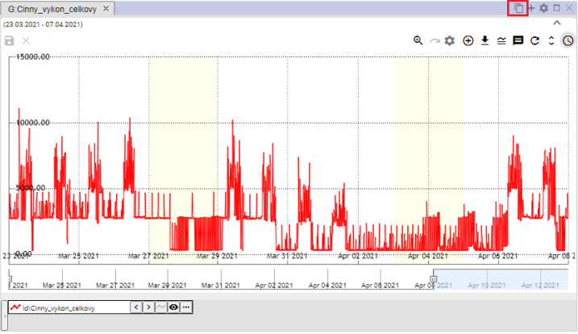

Figure 299: Press Copy the entire graph into a new window

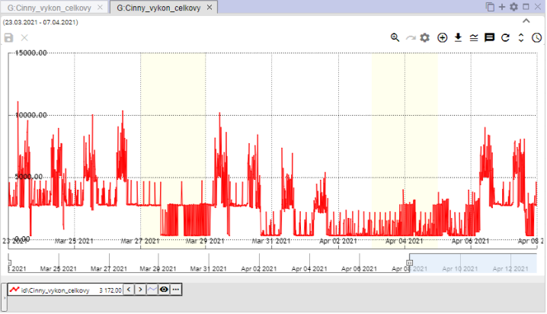

Figure 300: Copy of the graph in the new tab

## How to set the chart parameters

You can set the chart parameters, such as the font size for the chart name:

1. Press the Set graph button, which is located in the upper right corner of the Graf window.



Figure 301: Pressure Set the chart

1. A window Legend graph will appear, in which you can set the parameters.

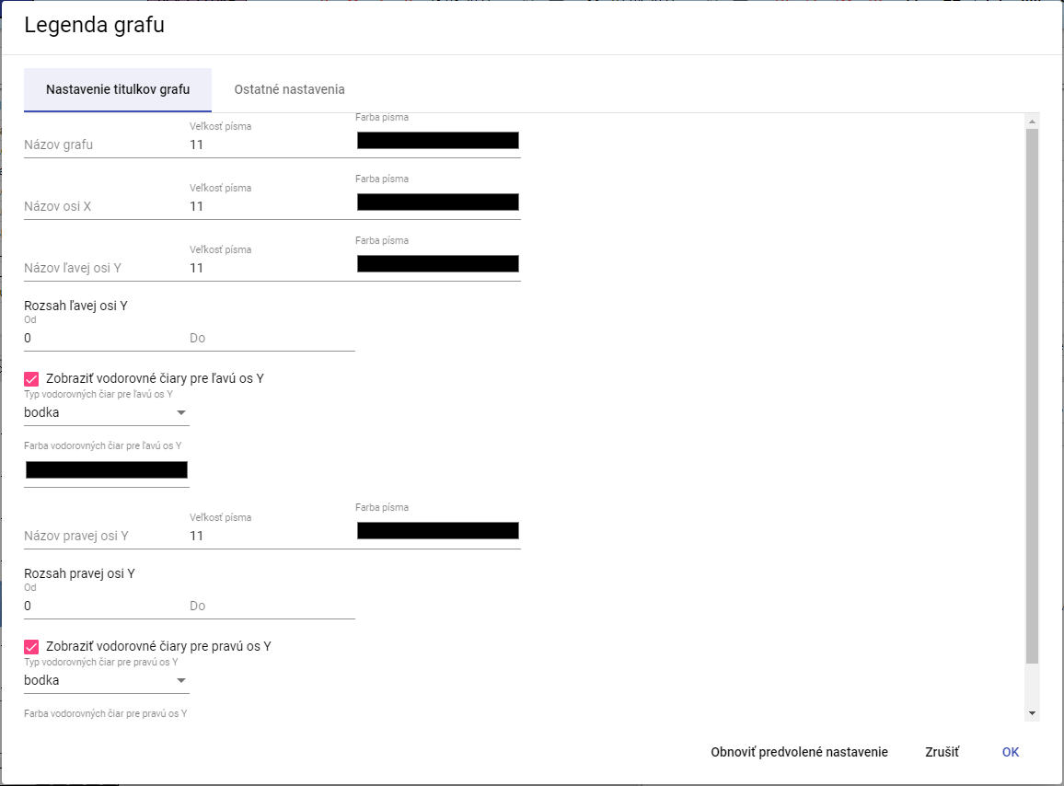

Figure 302: The window Legend of the graph

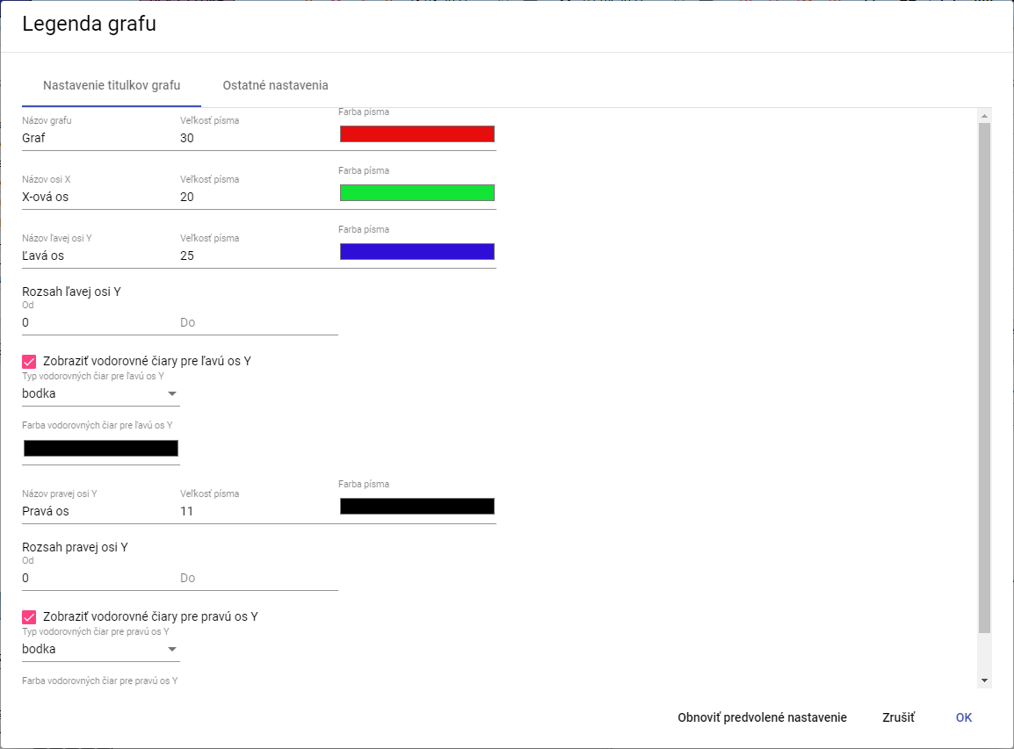

Figure 303: Changes in the window Legend graph

1. Save the changes by pressing the OK button.

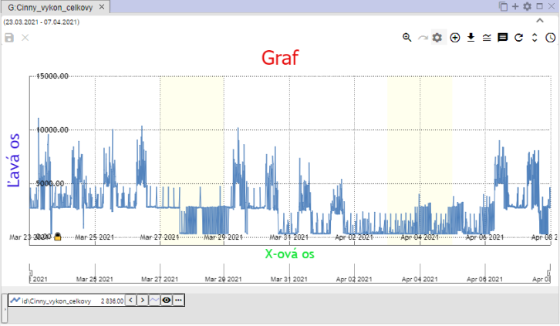

Figure 304: Changes in the Graph window

### How to set the number of decimal places for each of the Y-axes

**[TRANSLATION ERROR - MANUAL REVIEW NEEDED] Postupujte:**

1. **[TRANSLATION ERROR - MANUAL REVIEW NEEDED] V okne „Legenda grafu”, zadajte počet desatinných miest pre ľavu a pravú os Y.**

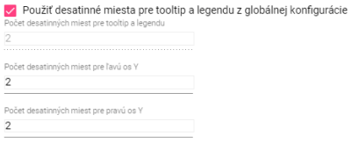

Figure 305: Settings for the Y axis

1. **[TRANSLATION ERROR - MANUAL REVIEW NEEDED] Ak chcete zadať hodnotu pre pole „Počet desatinných miest pre tooltip a legendu”, odkliknite pole „Použiť desatinné miesta pre tooltip a legendu z globálnej konfigurácie”.**

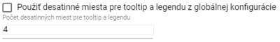

Figure 306: New value for field Number of decimal places for tooltip and legend

1. **[TRANSLATION ERROR - MANUAL REVIEW NEEDED] Zmeny uložte stlačením tlačidla „OK”.**

### **[TRANSLATION ERROR - MANUAL REVIEW NEEDED] Ako vypnúť vodorovné čiary**

**[TRANSLATION ERROR - MANUAL REVIEW NEEDED] Pre vypnutie vodorovných čiar v grafe postupujte:**

1. **[TRANSLATION ERROR - MANUAL REVIEW NEEDED] Stlačte tlačidlo “Nastavenie grafu”, Obrázok 301.**
2. **[TRANSLATION ERROR - MANUAL REVIEW NEEDED] V okne “Legenda grafu” odkliknite polia “Zobraziť vodorovné čiary pre ľavu os Y” a “Zobraziť vodorovné čiary pre pravú os Y”.**

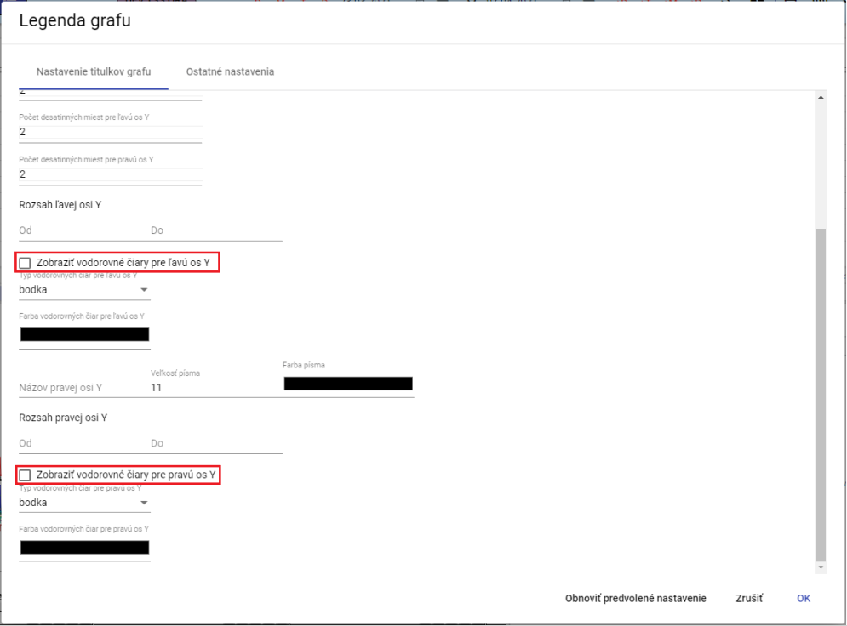

Figure 307: Disconnecting the horizontal lines in the graph

1. **[TRANSLATION ERROR - MANUAL REVIEW NEEDED] Zmeny uložte stlačením tlačidla “OK”.**

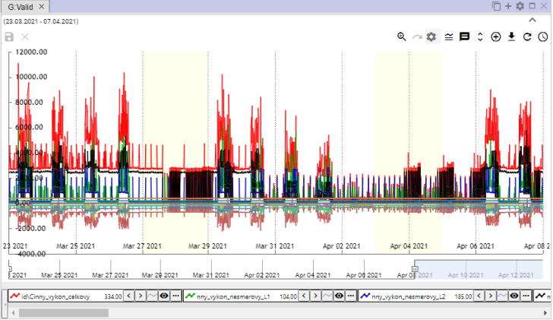

Figure 308: Off-line lines in the graph

## Functions for working on marked profiles

To view the function over multiple profiles, go to:

1. Press Ctrl and select the selected profiles by clicking the left mouse button on the profiles names selected.
2. Press the button in the lower left corner of the graph window.

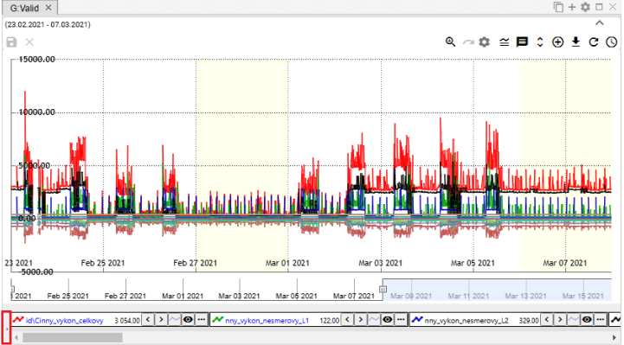

Figure 309: The display button for the function for the profiles marked

1. A list of functions for the profiles identified is displayed.

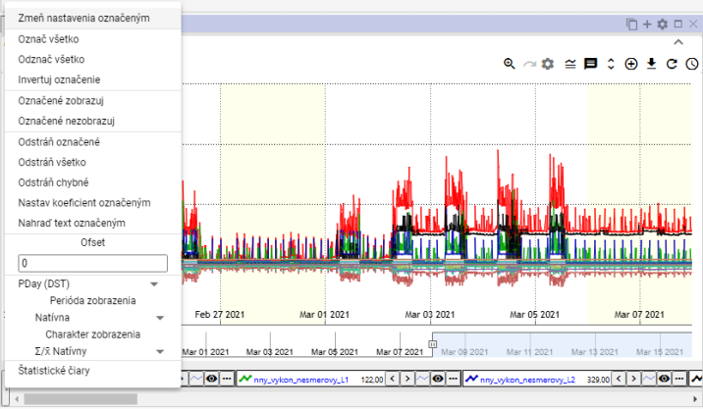

Figure 310: List of function for labelled profiles

### How to select profiles

To mark the profile, press Ctrl and click the profile name. You can mark multiple profiles at once. The font color of the selected profile will change from black to blue.

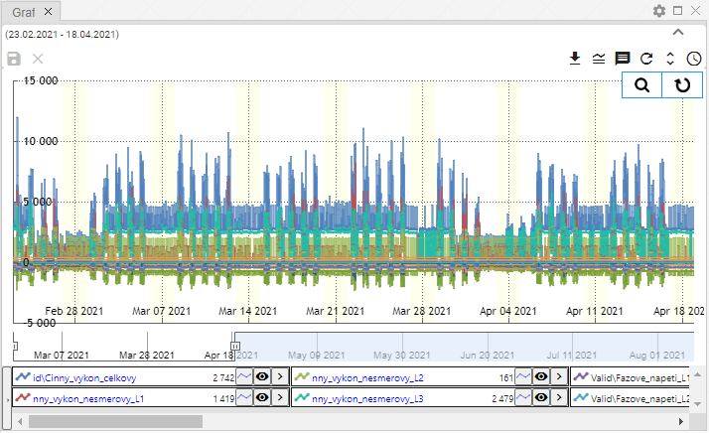

Figure 311: Indication of several profiles

### How to display profile properties

You 'll see the profile features:

1. Click the button that is located before the profile name at the bottom of the Graf window.

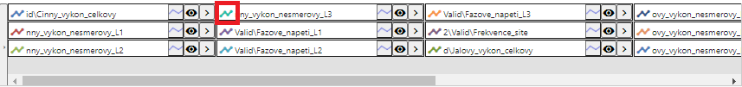

Figure 312: The profile characteristics display button

1. The profile line property window will appear.
2. You need to edit the data.
3. Save the changes by pressing the OK button.

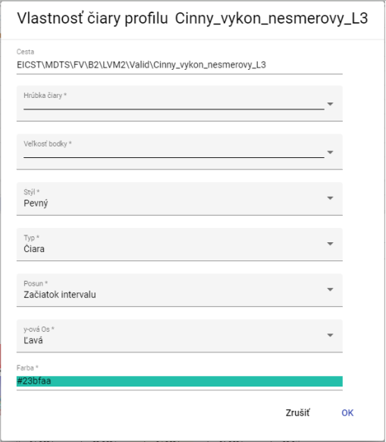

Figure 313: Window Property of the profile line

### How to change the marked settings

You can change the settings for multiple profiles at the same time:

1. Select the profiles you want to change the settings to.
2. Right-click the name of some of the profiles.
3. In the displayed window, select Change the setup marked.

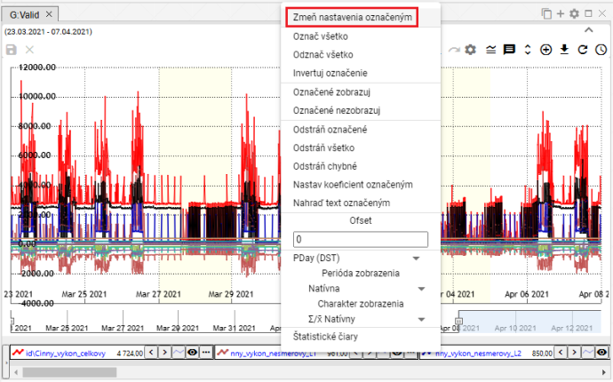

Figure 314: Item Changes in the marked settings

1. A window will appear to change the settings for the profiles you have marked.

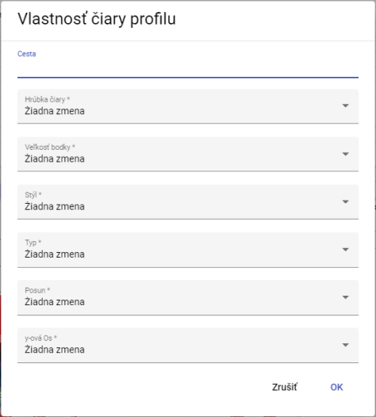

Figure 315: Window for setting the marked profiles

1. Save the changes by pressing the OK button.

### How to mark all profiles

To mark all profiles, right-click the profile name and select Mark everything, Figure 316.

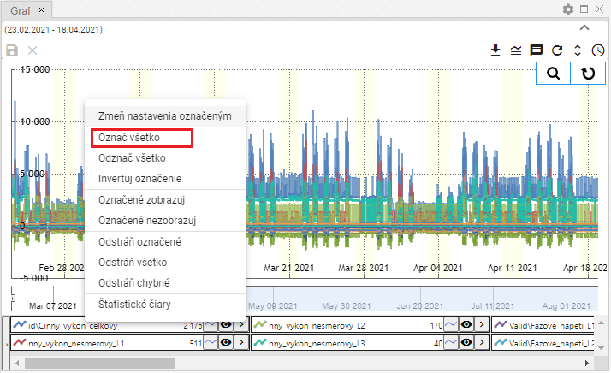

Figure 316: Item Tell all

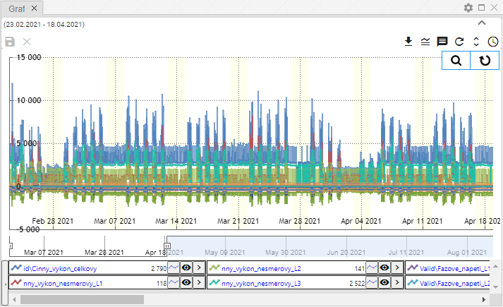

Figure 317: Indicated profiles

### How to mark all profiles

The heading 'All identification' is used to de-identify all marked profiles.

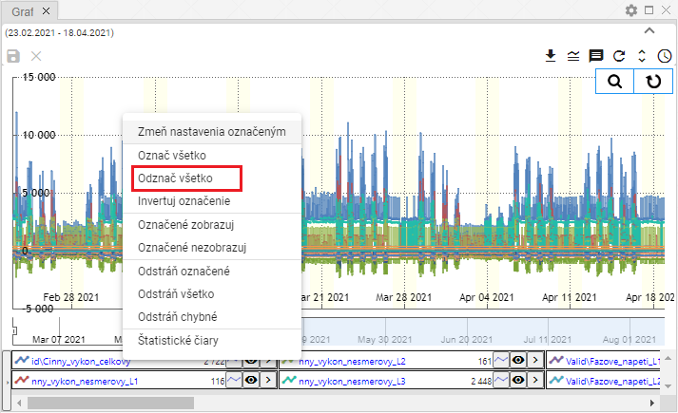

Figure 318: The position of the 'Return everything'

### How to Invert the Marked Profiles

The item Invert marking will cause the marking of profiles to be changed.

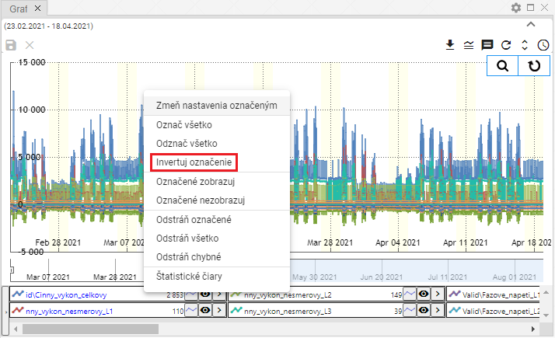

Figure 319: Item Invert the marking

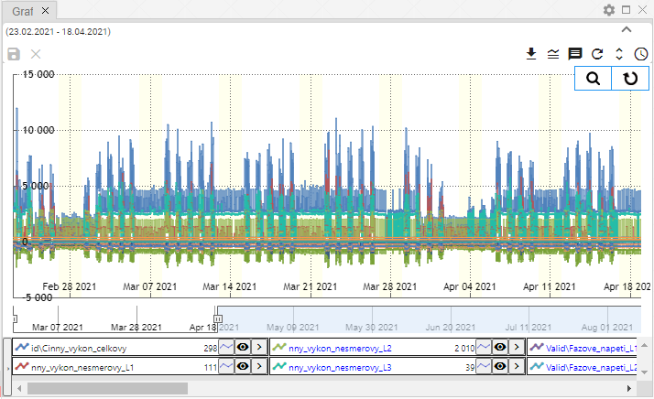

Figure 320: Inverted marking of profiles

### How to display only marked profiles

The 'Detected view' item is used to display the marked profiles.

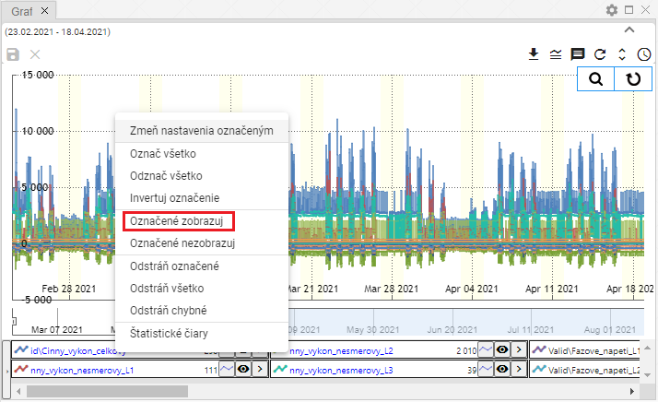

Figure 321: Item marked to display

### Not to display as marked profiles

If you don't want the profiles marked to appear in the graph, go to:

1. Mark the profiles you do not want to display.
2. Right-click the profile name.
3. Select the item Not marked .

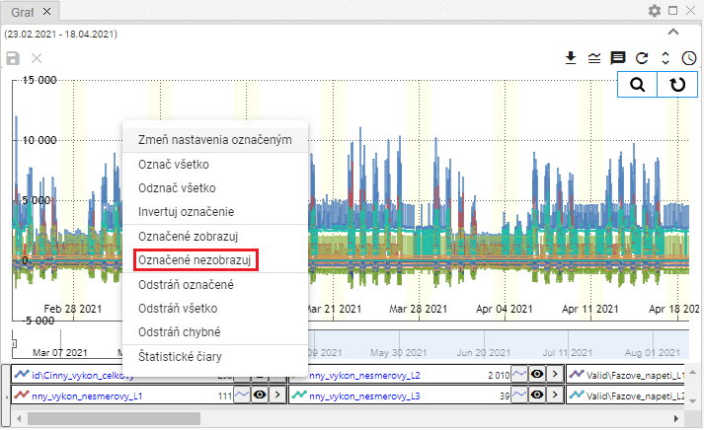

Figure 322: Item Not marked to be displayed

1. The selected profiles will be hidden.

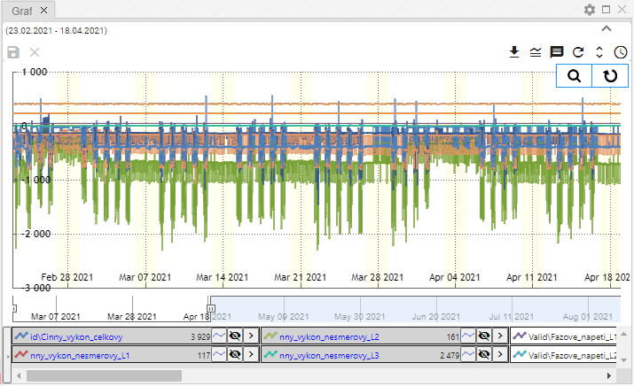

Figure 323: Unseen profiles

### How to remove marked, all or incorrect profiles

You can use three functions to delete profiles:

* Marked page - is used to remove marked profiles,
* Remove everything - all profiles will be removed,
* Remove the error - only the error profiles will be removed.

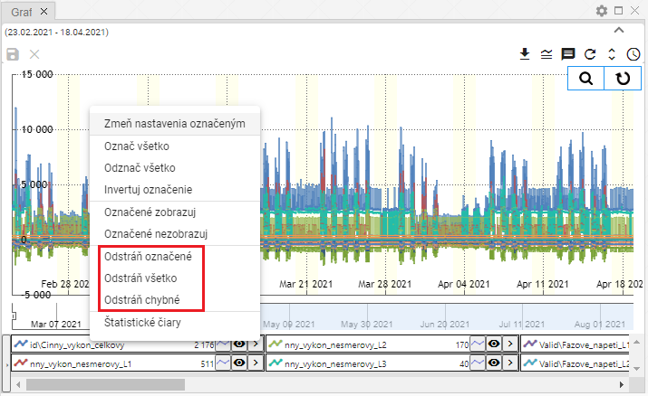

Figure 324: The items Remove marked, Remove all and Remove error

To remove profiles, please follow:

1. To delete the profiles marked, select the profiles you want to delete.
2. Right-click the profile name.
3. Select the items Remove marked, Remove all or Remove error.
4. Profiles will be removed.

### How to set the profile-marked coefficient

To set the coefficient, proceed to:

1. Click on the profile name to select the profiles for which you want to set the coefficient.
   1. To select more profiles, click the left mouse button on the profile name, hold the Ctrl key, and click the left mouse button to select the profile names you want to select.
   2. You can mark multiple profiles simultaneously by clicking the left mouse button on the first profile name, holding the Shift key, and clicking the left mouse button on the last profile.
2. The profiles marked shall be coloured in blue.
3. Right-click the name of one of the profiles marked.
4. A window will appear in which you can select Set the coefficient marked .

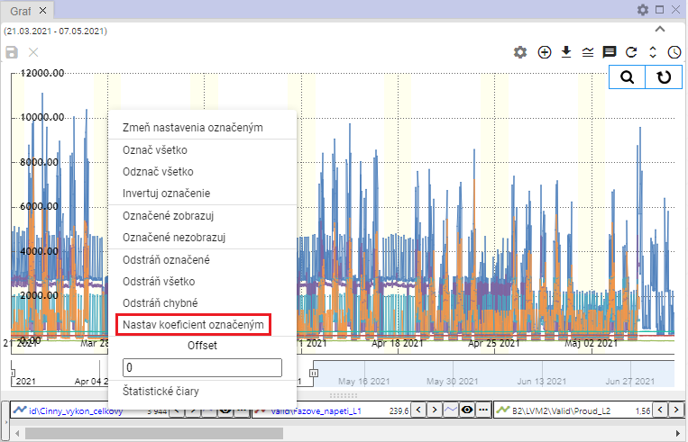

Figure 325: Item Set the coefficient marked

1. The window Setting of the coefficient will appear.
2. Set the coefficient and save by pressing the Ok button.

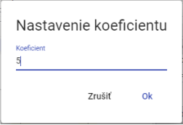

Figure 326: Window Setting the coefficient

1. For the selected profiles, a coefficient is set.

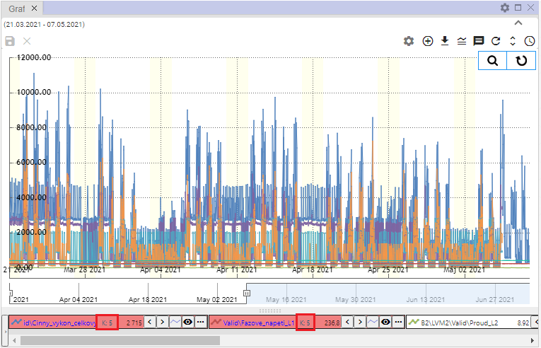

Figure 327: Set coefficient

### How to set the offset

**[TRANSLATION ERROR - MANUAL REVIEW NEEDED] Pre nastavenie offsetu postupujte:**

1. Click on the profiles names to select the profiles you want to set off.
2. Right-click the name of one of the selected profiles.
3. A window will appear where you enter the offset and press Enter.

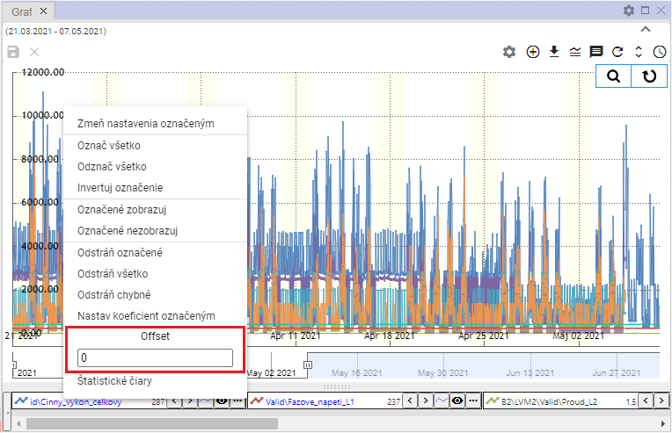

Figure 328: Field Offset

1. The selected profiles will display the set offset information.

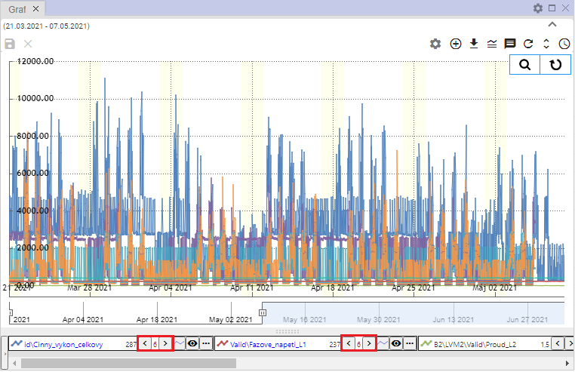

Figure 329: Set offset

### How to display statistical lines

To view the statistical lines, go to:

1. To display statistical lines to only certain profiles, hold the Ctrl key and click the profile names to which the statistical lines are to be displayed.
2. Right-click the profile name.
3. Select the heading 'Statistics lines'.

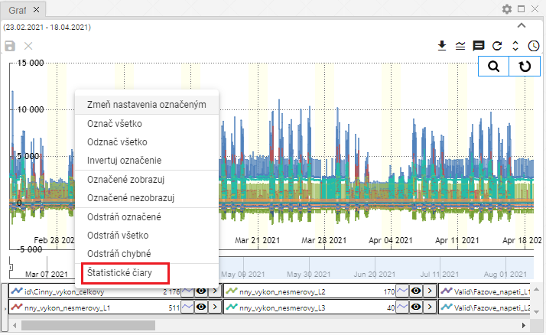

Figure 330: Item of the statistical lines

1. The statistical line window shall be displayed.

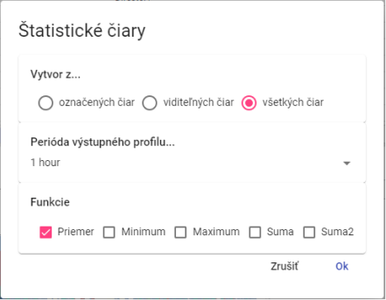

Figure 331: The window of statistical lines

1. Select whether statistical lines are to be created from marked lines, visible or all lines.
2. You can select multiple functions at once.
3. Press the OK button.

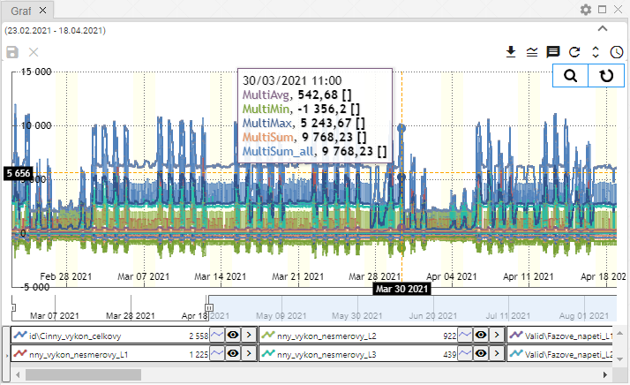

Figure 332: Statistical lines

### How to replace the marked text

The function is used to change the profile name in bulk.

1. Select the profiles you want to change text to in the profile path.
2. Right-click the profile name.
3. The offer will be displayed where you select Replace the marked text.

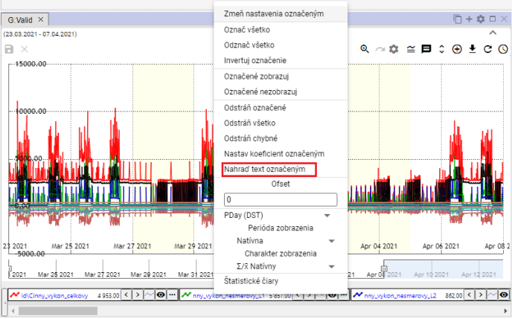

Figure 333: Item Replace the text marked with

1. The window Replace text in the profile path will appear.
2. In the Find box, type the text you want to replace.
3. In the Replace field, enter text to replace text in the Find field.

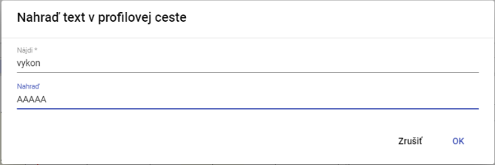

Figure 334: Window Settle text in the profile path

1. Confirm by pressing the OK button.
2. The text entered shall be replaced by a new text.

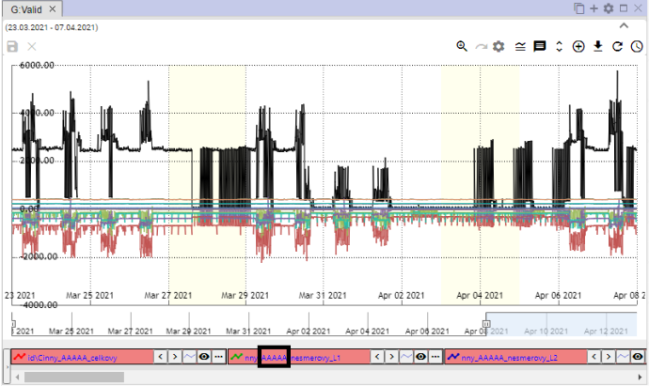

Figure 335: Substituted text

## Functions for working with a single profile

Each profile has a button at the name that serves to display functions.

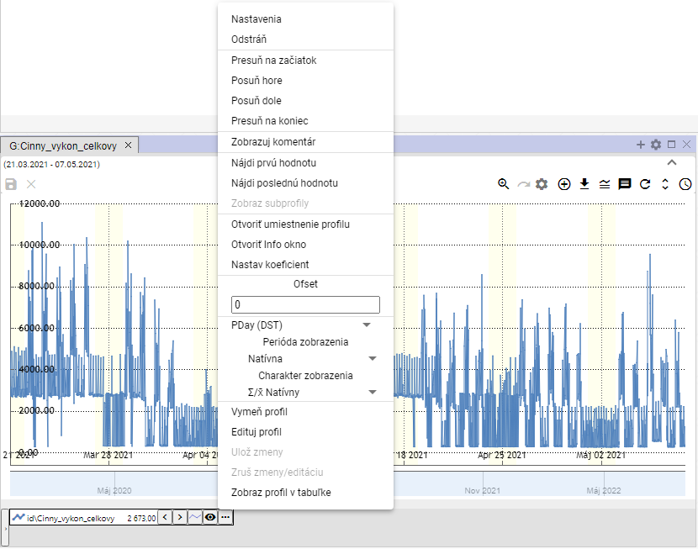

Figure 336: Functions for working with the profile

### How to adjust settings

You can change the display of profile data in the graph in the Settings window.

To change the settings, please proceed to:

1. Click the button on the profile name to change the settings.
2. A window will appear in which you can select the Settings.

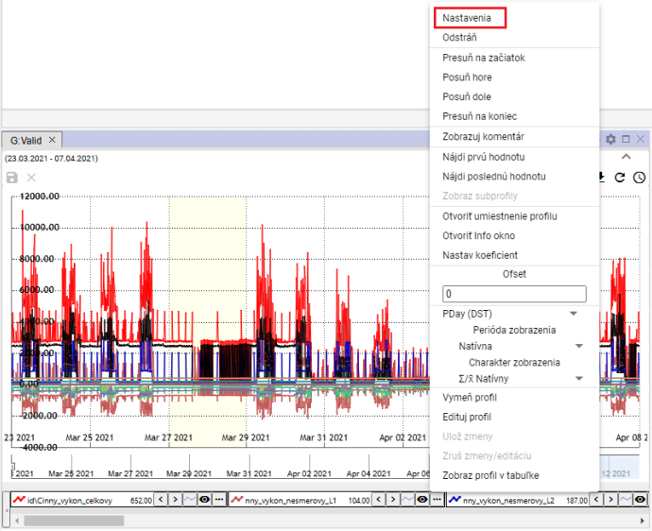

Figure 337: Position of the settings

1. In the window that appears, change the profile settings.
2. Save changes by pressing the OK button.

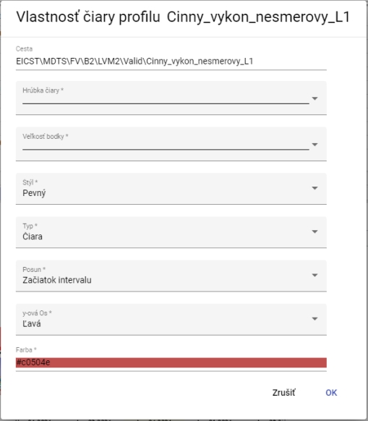

The following table shows the following:

### How to remove profile

Delete the profile:

1. Click the button at the name of the profile you want to delete.
2. The profile is removed from the list of profiles at the bottom of the Graf window and from the profile view.

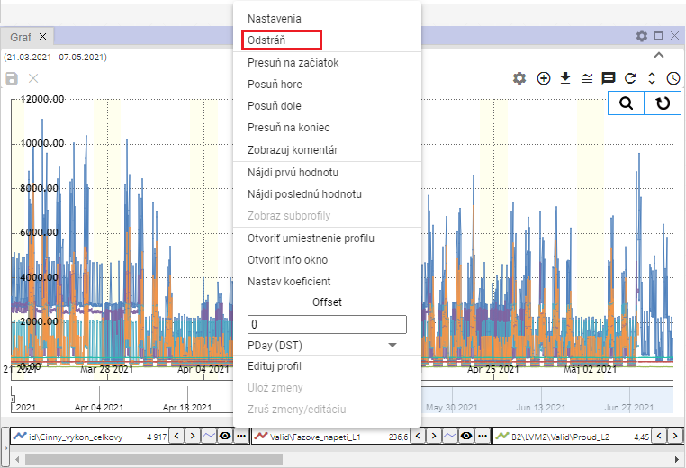

Figure 339: Item Remove

### How to move the profile to start

To move the profile to the beginning of the profile list, proceed to:

1. Click the button on the profile name to move to Start.
2. Select the heading 'Prosper to start'.
3. The selected profile shall be moved to the beginning of the list.

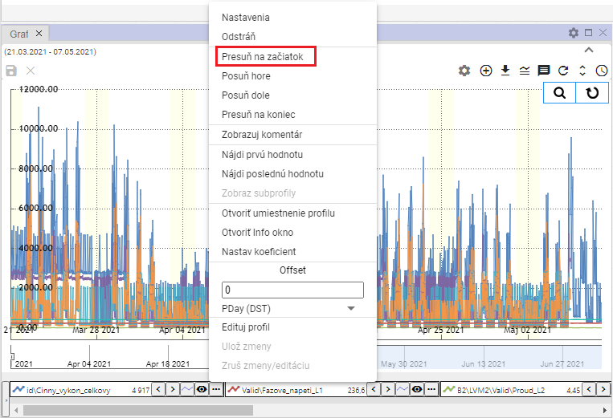

Figure 340: Item Put it to start

### How to move the profile up

The Place above is used to move the profile name in the list of profiles at the bottom of the Graf window one place higher, for example from third position to second position.

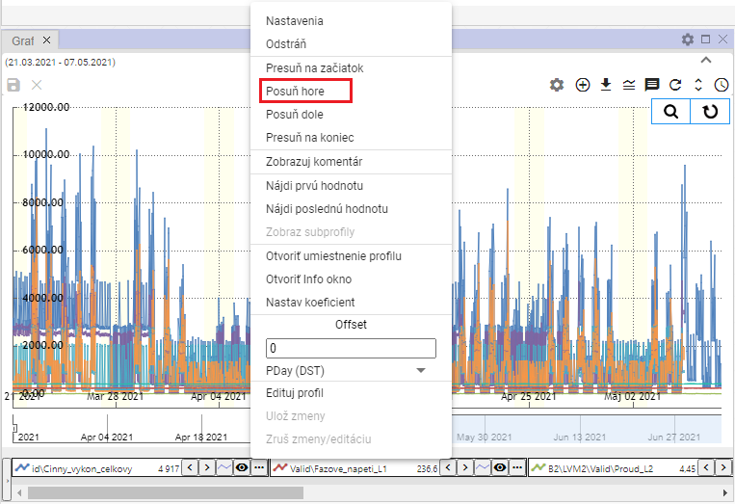

Figure 341: The position of the top

### How to move the profile down

The Full down is used to move the profile name in the list of profiles at the bottom of the Graf window one place lower, for example from second to third.

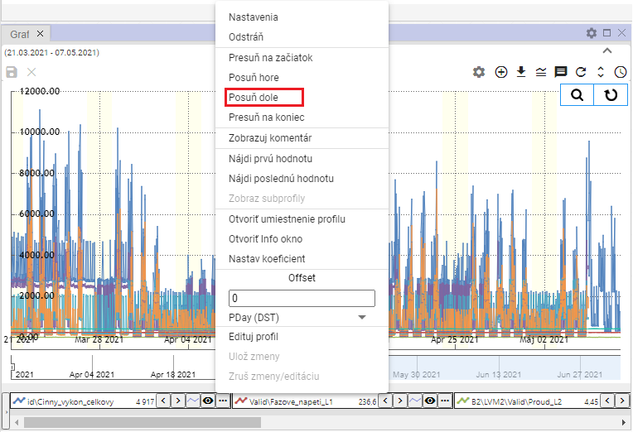

Figure 342: The item Full down

### How to move the profile to the end

The Show to the end section is used to move the profile to the end of the list of profiles at the bottom of the Graf window.

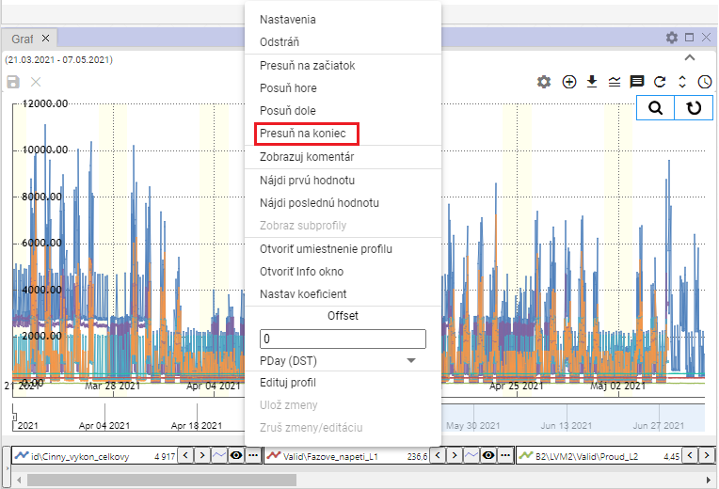

Figure 343: The item Put it to the end

### How to display a comment

The Show Comment specifies the profile name. After selecting Show Comment, a comment is displayed instead of the profile name, Figure 345.

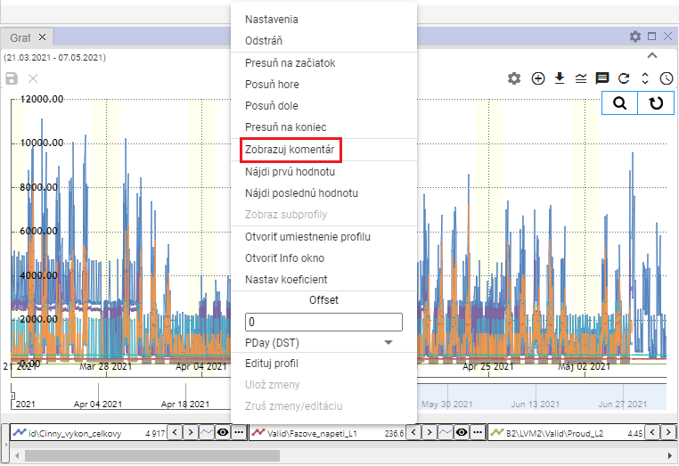

Figure 344: Item Show comment

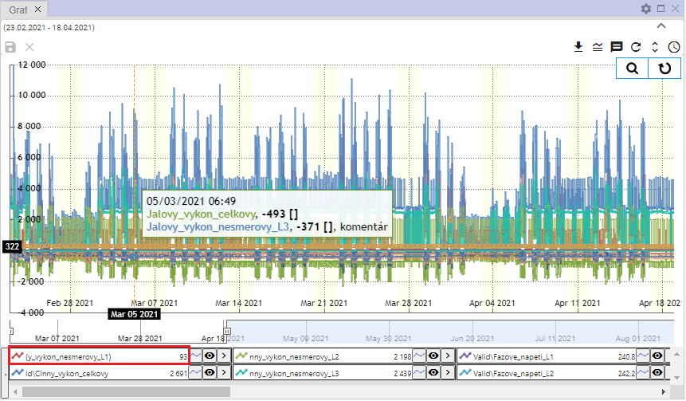

Figure 345: Displayed profile commentary

### How to Find the First Value

The item Find the first value is used to find the first profile value in the graph.

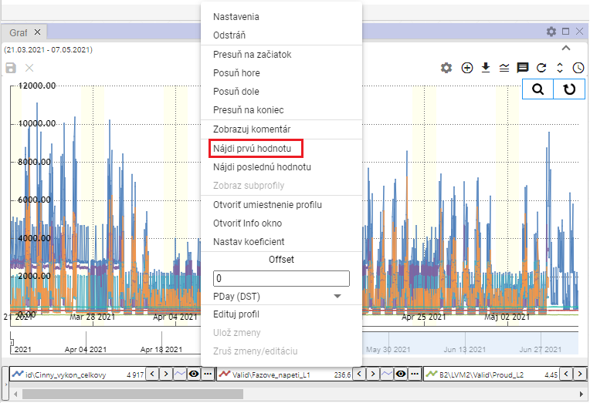

Figure 346: Item Find the first value

### How to Find the Last Value

The item Find the last value is used to find the last value of the profile in the graph.

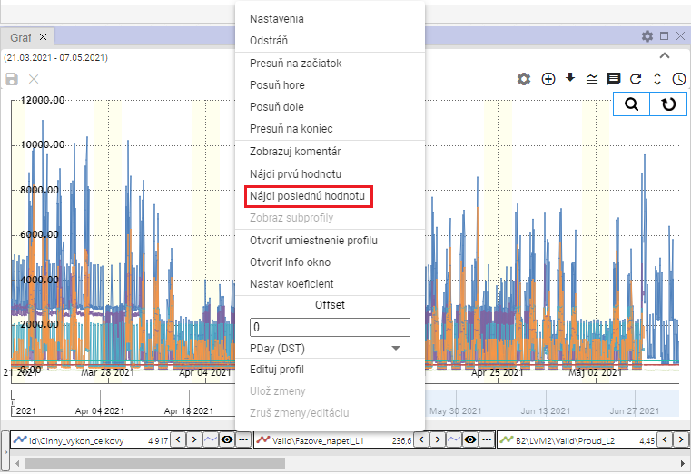

Figure 347: Item Find the last value

### How to display sub-profiles

The calculated profile may have other profiles, so-called sub-profiles, used in the definition.

1. Click the button on the profile name to change the settings.
2. A window will appear in which you can select the subprofile view.
3. All profiles used in the definition of the calculated profile are displayed.

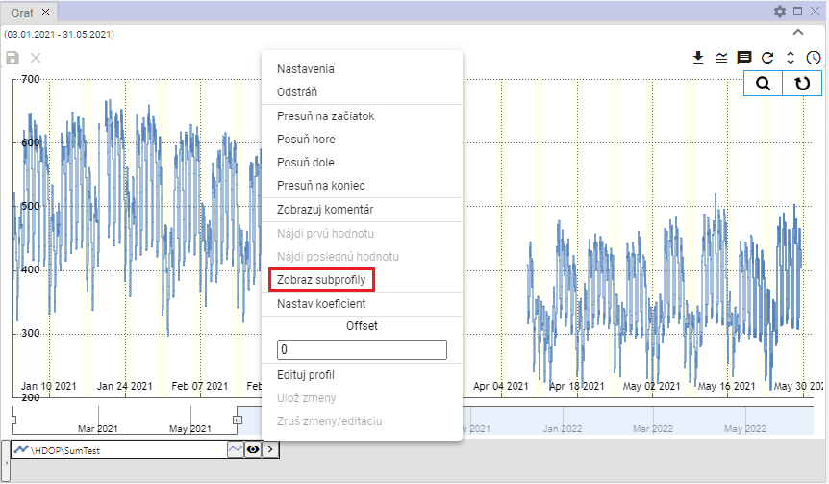

Figure 348: Item Show the subprofile

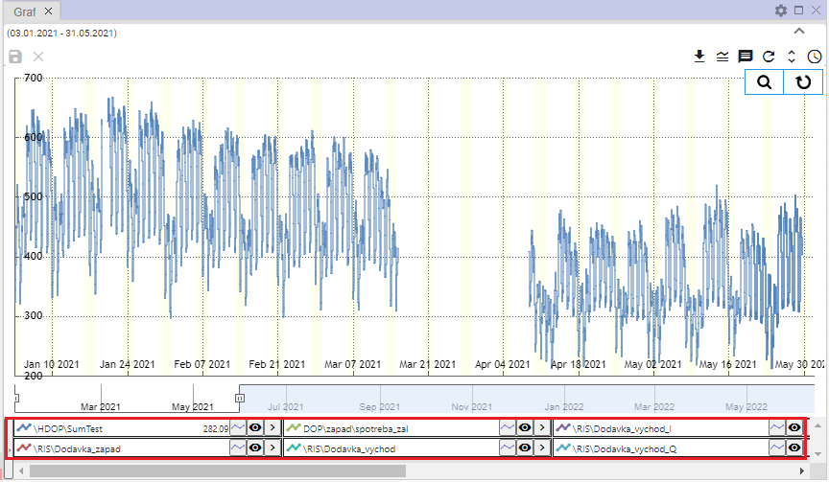

Figure 349: Subprofiles shown

### How to open a profile location

The location of the profile in the tree structure will be displayed:

1. Click the button on the profile name you want to open in the tree.
2. A window will appear in which you can select Open profile location.

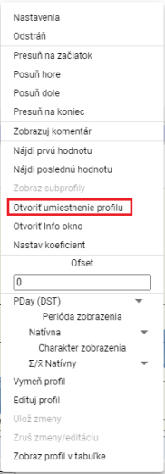

Figure 350: Item Open the profile location

1. In the tree structure, a directory containing the profile is opened.

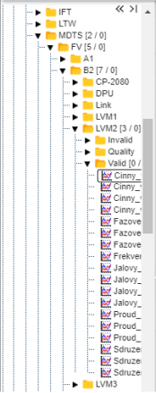

Figure 351: Placement of the profile in the tree structure

### How to open the info window

You can open a window for each profile with information, such as profile name, path to profile, profile type.

You open the information window:

1. Press the three-point icon on each profile.



Figure 352: The function display button

1. Select the "Open the Info window".

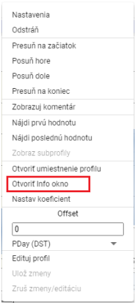

Figure 353: Item Open the Info window

1. In the tree structure, a directory containing the profile shall be opened, Figure 351.
2. The profile information window, which contains three tabs, will appear next: Info, ReadLog and WriteLog, Figure 354.
3. In the Info tab , you can copy the profile name and profile path by pressing a button .

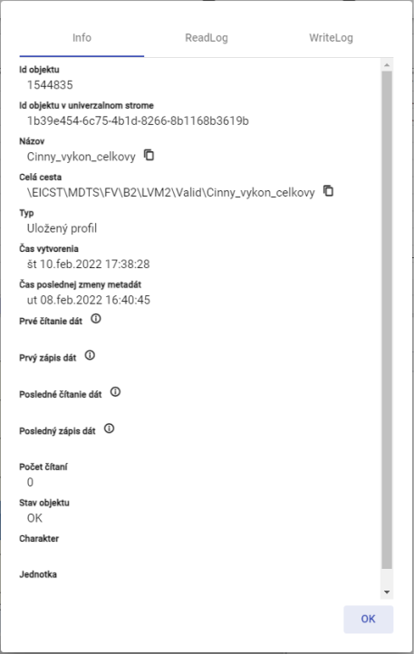

The following table shows the information available for each of the following categories:

### How to set the coefficient

To set the coefficient, proceed to:

1. Click the button on the profile name for which you want to set the coefficient.
2. Select the heading Set the coefficient.

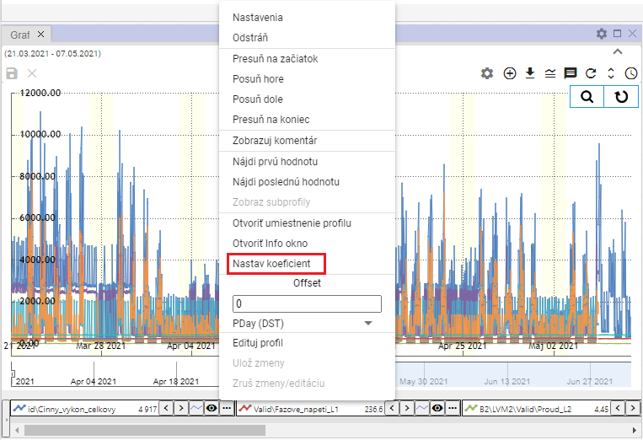

Figure 355: Item Set the coefficient

1. A window will appear in which you enter the coefficient.

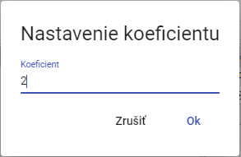

Figure 356: Set the coefficient

1. Save by pressing the OK button.
2. The profile name shall display the information on the set coefficient.



Figure 357: Set coefficient

### How to set the offset

For the set offsets, proceed to:

1. You can enter Offset by clicking the arrows next to the profile name or by clicking the button and then in Offset, enter the value and press Enter.



The following table shows the following:

1. The same value you entered for the offset using the arrows next to the profile name will also appear after clicking the Offset button.

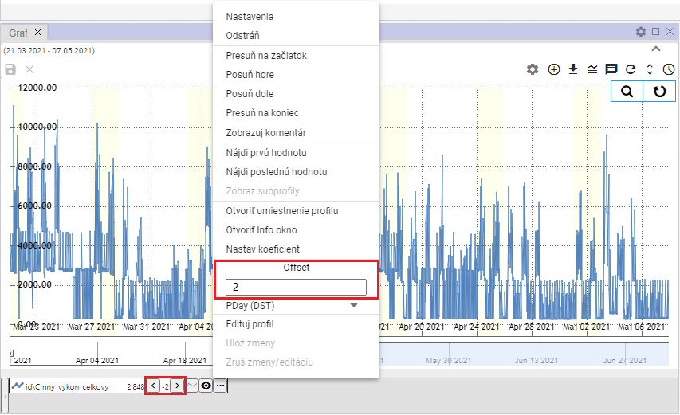

Figure 359: Set offset

1. Under the Offset field, there is a field for selecting the period for offset, Figure 360.

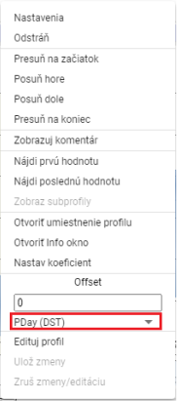

Figure 360: Field for selecting the period for offset

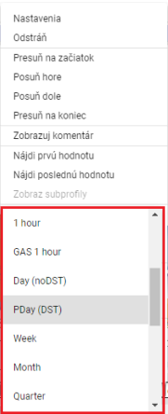

Figure 361: Selection of the time period for the offset

### How to change profile

To change the profile for another profile, please proceed to:

1. Click the button on the profile name you want to change.
2. Please select the heading Change profile.

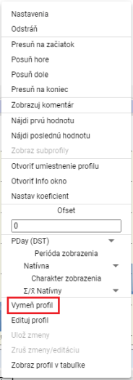

Figure 362: Item Change the profile

1. The window "Change profile" will appear.

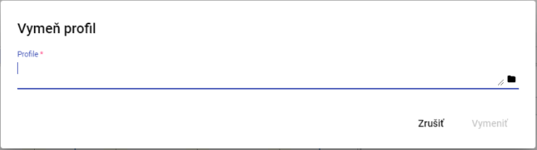

Figure 363: Window Change the profile

1. Write a path to the profile or click a button .
2. For confirmation, press the Replace button.

### How to edit a profile

To edit the profile, please follow:

1. Click the button at the name of the profile you want to edit.
2. Please select the heading Edit profile.

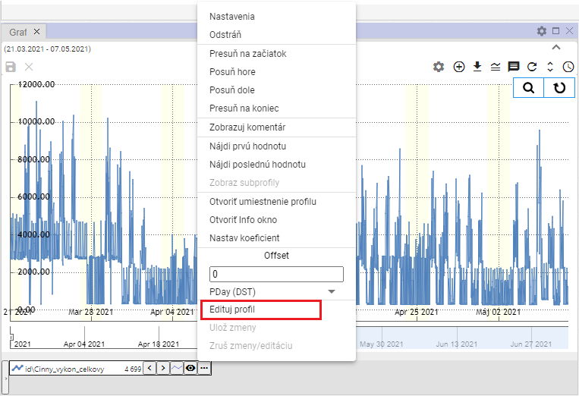

Figure 364: Item Edit profile

1. A copy of the profile shall be created and the fields with the names of the original and the copied profile highlighted in green.

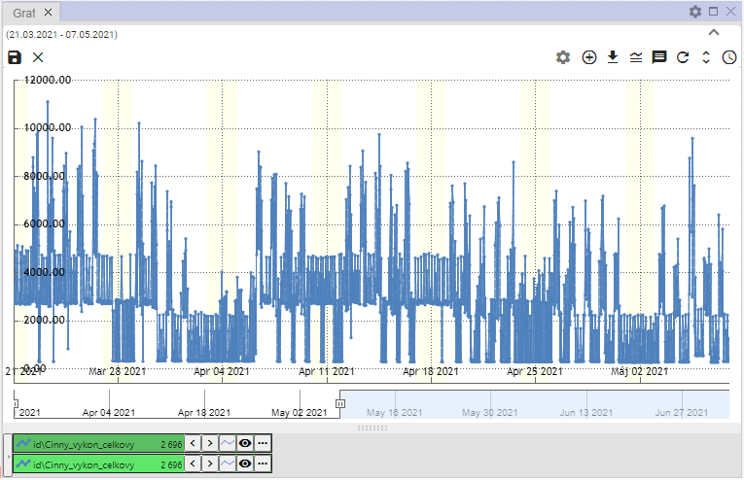

Figure 365: Creating a copy of the profile

1. You need to edit the profile.
2. You can save changes by clicking on the Serve changes button and selecting the Serve changes or pressing the disk icon in the top left corner of the graph.

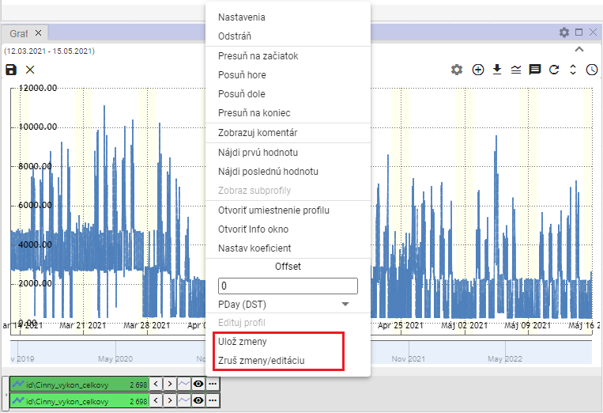

Figure 366: Entries Insert changes and Cancele changes/edit

1. To cancel changes, select Remove changes/edit or press the x button in the top left corner of the graph.

### How to set a profile color

To set the profile color, please follow:

1. Press the button at the profile you want to set the color to.
2. Select the Settings to display the Profile line property window.



Figure 367: Position of the settings

1. In the Profile Line Properties window, click on the Color field.
2. A color selection window will appear. At the bottom, there is a color palette for quick color selection.

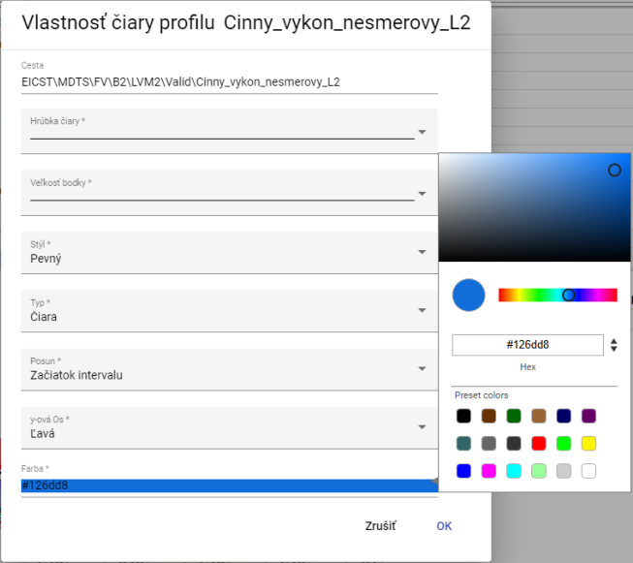

Figure 368: Color selection

1. Click on the selected color.
2. Save the changes by pressing the OK button.

### How to set the dot size

To set the dot size, proceed to:

1. Press the button on the profile name for which you want to set the dot size.
2. Select the Settings to display the Profile line property window.



Figure 369: Position of the settings

1. Click on the "Dot size" field.

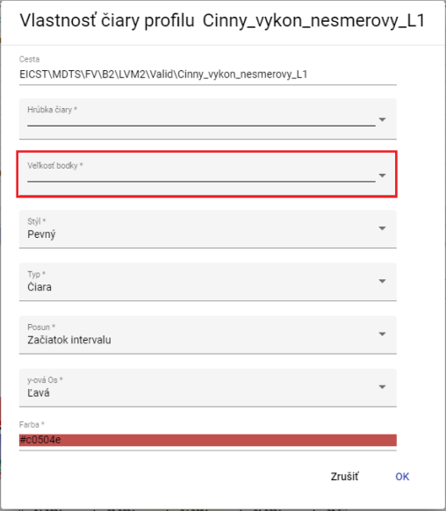

Figure 370: Field Dot size

1. A window will appear where you can click to select the display size for the point.

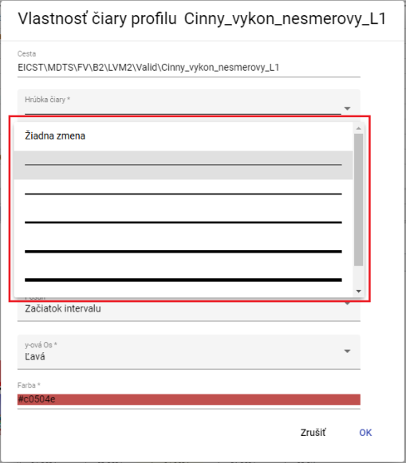

Figure 371: Selection of the dot size

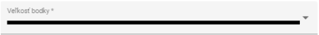

Figure 372: Size selected

1. Save the changes by pressing the OK button.

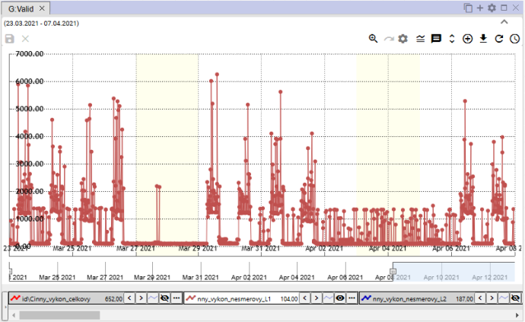

Figure 373: Adjusted dot size

### How to display a profile in a table

You will see the profile in the Graf window in the following table:

1. Click the button at the profile name you want to display in the table.
2. Select the View profile in the table.

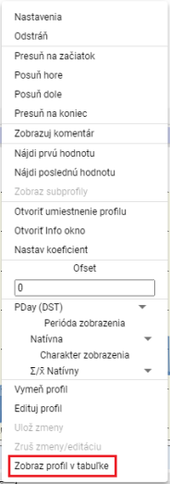

Figure 374: Item Show profile in the table

1. The new tab is added to the Graf window.

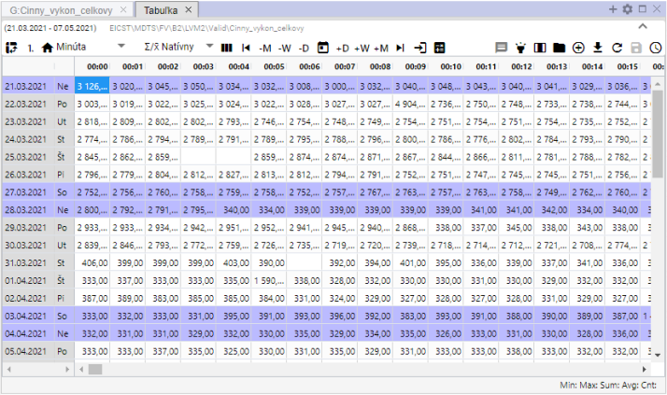

Figure 375: Display of the profile in the table

## Rapid change of graph type

The graph icon button allows you to switch graphs between StepLine, StepArea and StackedColumn. The graph type can also be switched through the Typ field in the Property of the profile window, the procedure is described in Chapter 5.8.1.



Figure 376: Quickly changing type of chart

By default, the Graph window has a graph type StepLine, Figure 377. By pressing the button, the graph type StepArea is set, Figure 378 and the appearance of the graph type change button is changed to .

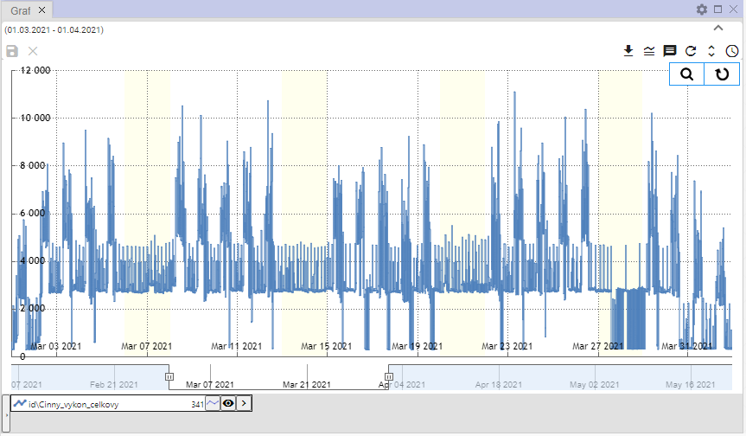

Figure 377: Type of graph StepLine

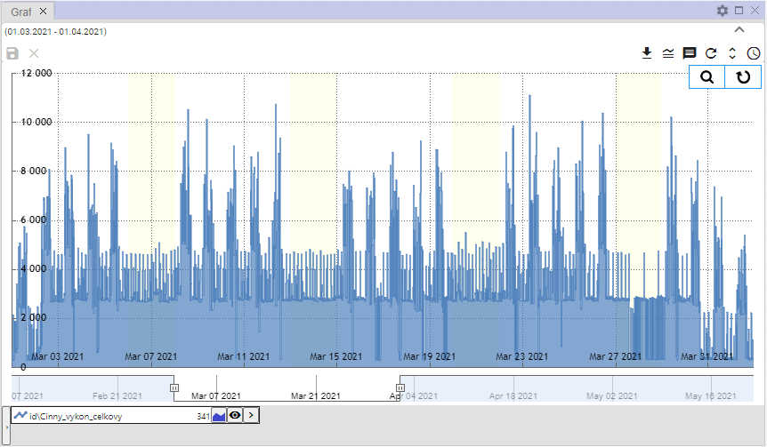

Figure 378: Type of graph StepArea

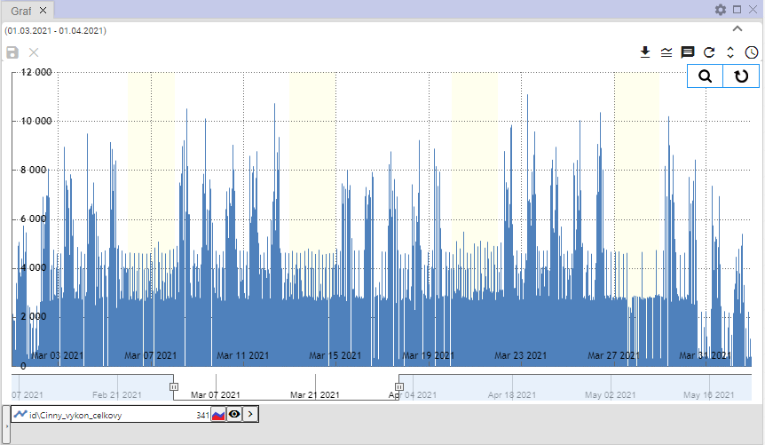

Figure 379: Type of graph StackedColumn

## How to approach a selected part of the graph

For the magnification of the selected part of the graph:

1. Press the Preply button on Zoom which is located in the top right corner of the graph.

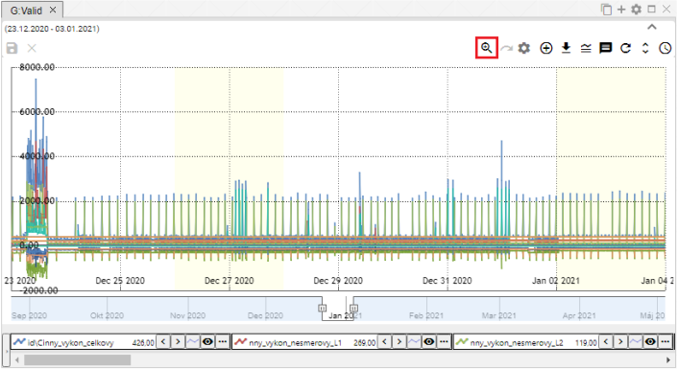

Figure 380: The Prepare to Zoom button

1. Press the left mouse button and select the area in the graph.

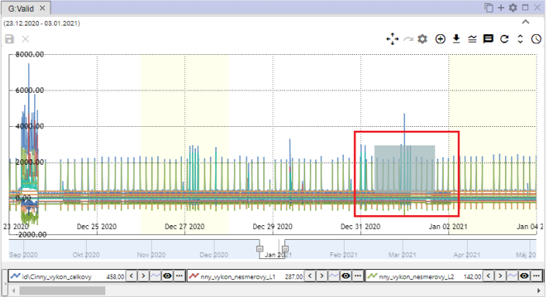

Figure 381: Location in the graph

1. Release the left mouse button.
2. The selected area is approaching.

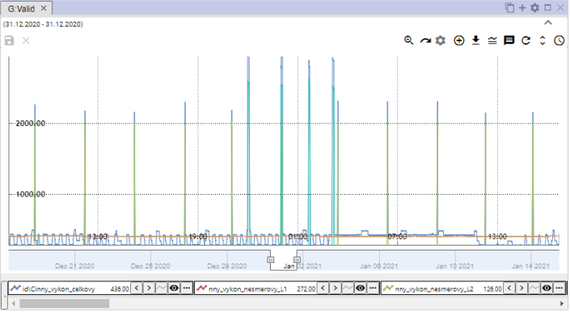

Figure 382: Enlarged position in the graph

1. To restore the y-axis, press the Reset zoom button, Chapter 5.12.

## How to move a graph

Click on the Ready to zoom button, Figure 380, the button changes from a shell to a Ready to move button, Figure 383. It allows you to move in a graph.

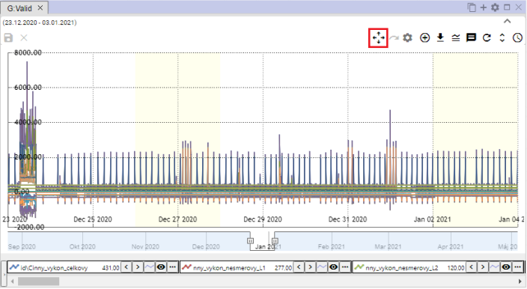

Figure 383: Pressure Prepare to move

## How to cancel zoom

After you have approached the selected area in the graph using the zoom function, you restore the graph by pressing the Reset zoom button.

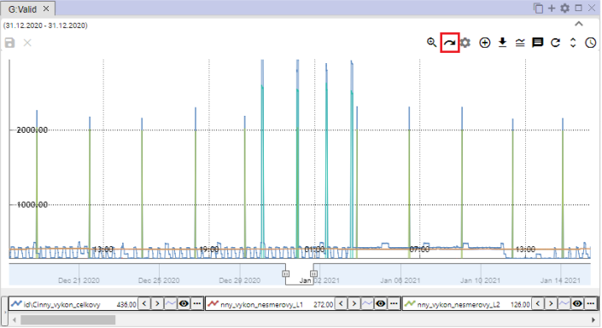

Figure 384: The button to reset zoom

## How to Display/Hide a Legend

At the bottom of the graph window is a list of the profiles displayed, called the legend. To hide the profile list, press the Image/Legend Screen button, which is located in the upper right corner of the Graph window.



The following table shows the following information:

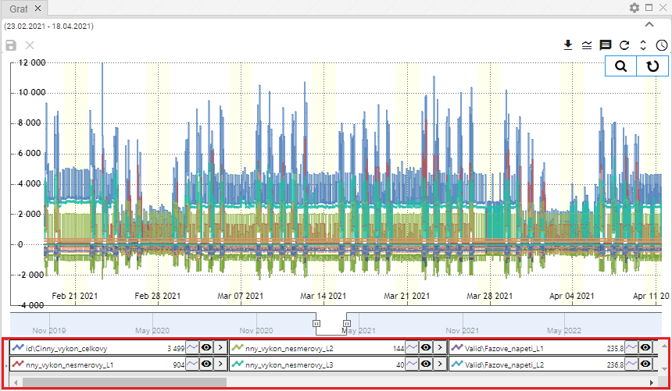

Figure 386: Legend is shown

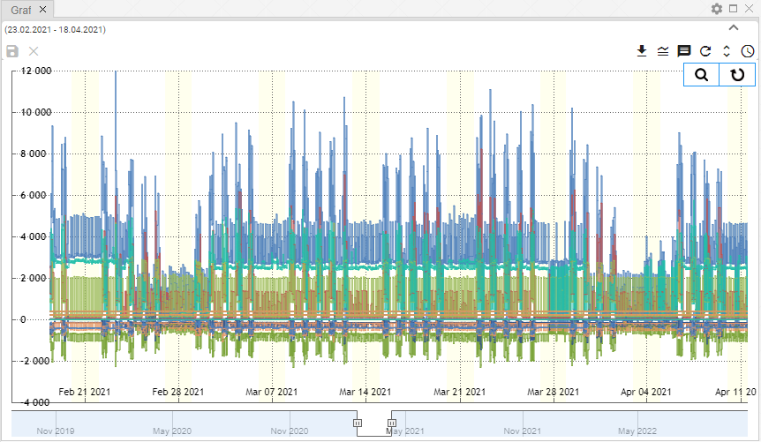

Picture 387: The Hidden Legend

## How to view/hide tooltip

To display the values (tooltip) for a specific location in the graph, set the cursor to the selected location in the graph. You can hide the tooltip by pressing the Shape/Hide tooltip button, which is located in the top right corner of the Graph window.



Figure 388: The button Show/Screw tooltip

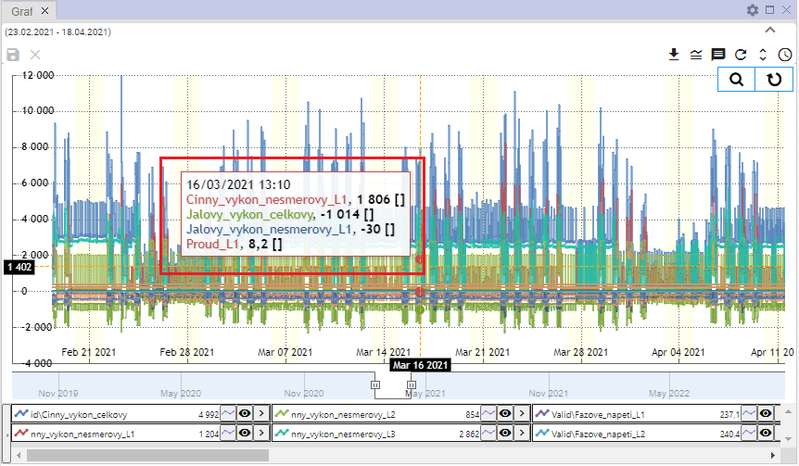

Figure 389: The tooltip shown

## How to set the y-axis to see the values

The Set the y-axis to see values button is used to zoom out the y-line if you do not see all the values (all lines) well when zooming.

Step by step:

1. Press the Zoom button, which is located in the upper right corner of the Graf window.



The following table shows the number of users:

1. Select the location on the graph you want to approach.

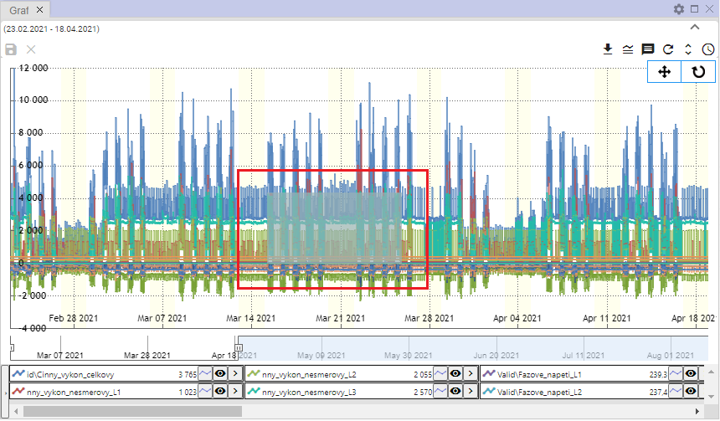

Figure 391: Select a location in the graph

1. The place in the graph is coming up.

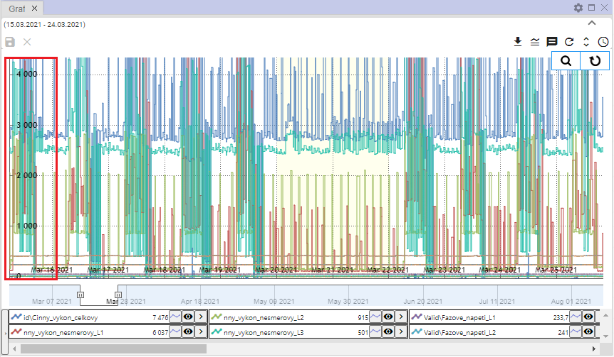

Figure 392: The approximate area of the graph

1. Press the Set the y-axis to see the values.



Figure 393: The Turn the y-axis to see the values

1. The Y-axis is zooming out.

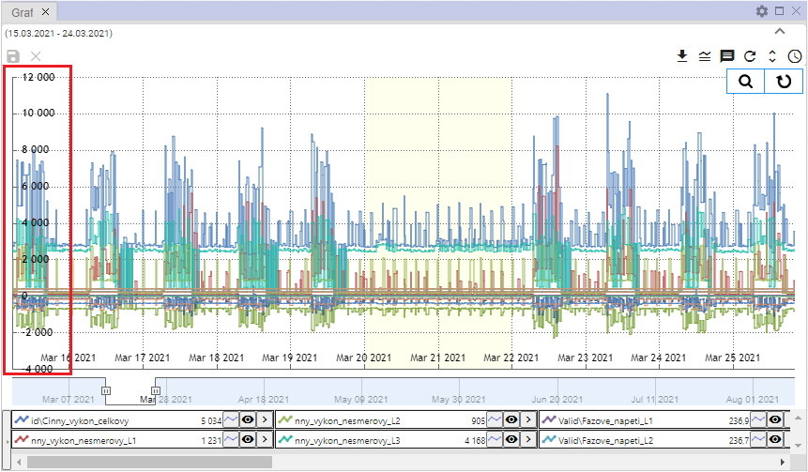

Figure 394: Changed y-axis

## How to change profile

For the change of profile, please proceed to:

1. Click the button at the profile you want to change.
2. Please select the heading Change profile.

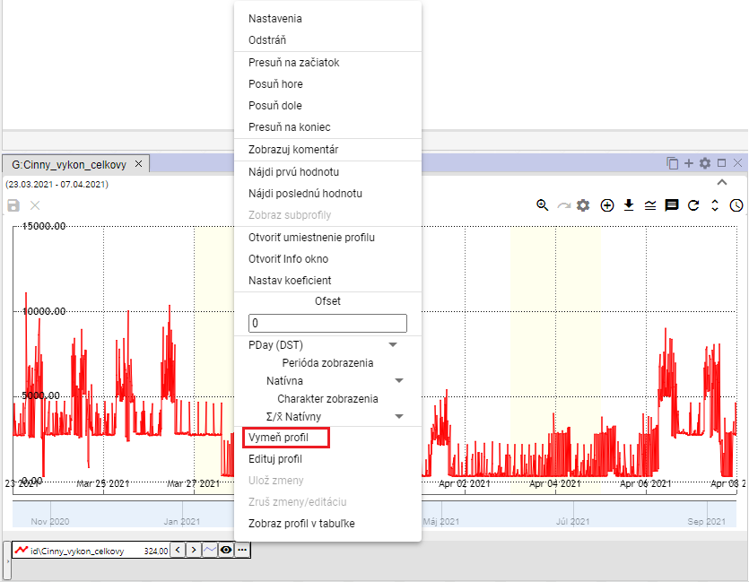

Figure 395: Item Change the profile

1. The window "Change profile" will appear.

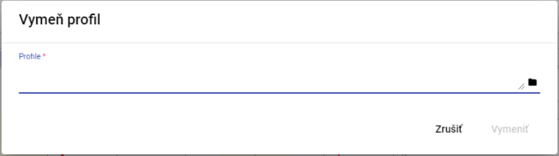

Figure 396: Window Change the profile

1. Enter a path to the profile or click the button and search for the profile.

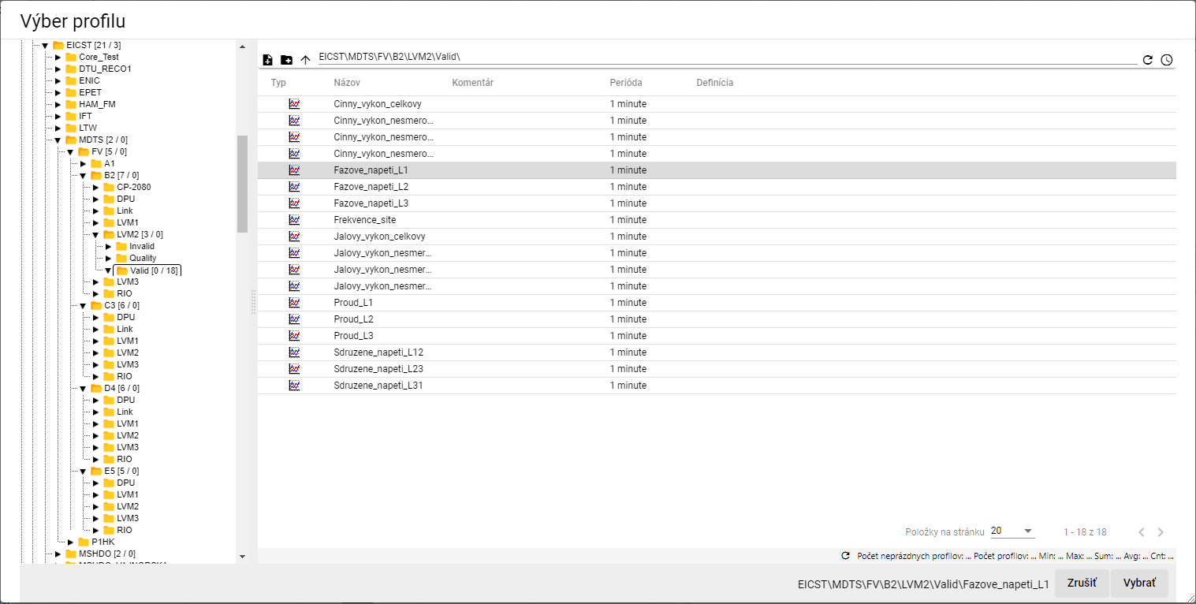

Figure 397: Window Profil selection

1. In the Change profile window, press the Change button.

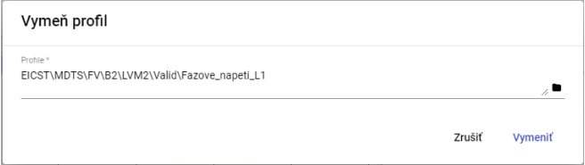

Figure 398: Selected profile

1. Profile in the Graf window will be replaced by the selected profile.

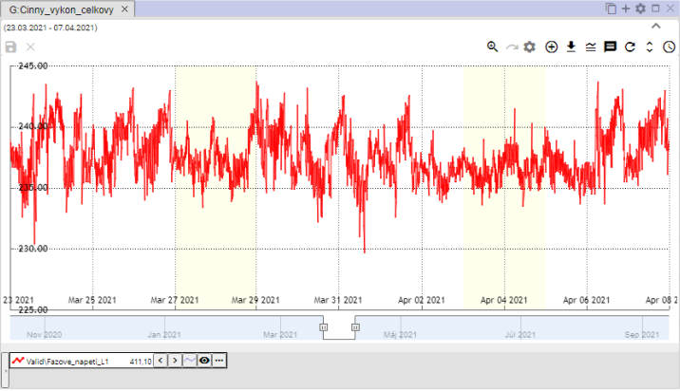

Figure 399: Re-designated profile

# Work with the table

In addition to graphing and surveying, the Profile Manager app also offers the possibility to work with data in a table.

If the user closes the table window with unstored data, a window will appear - Figure 400.

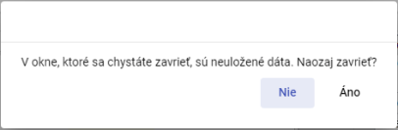

Figure 400: Notice of unpaid data

## How to display a profile in a table

You can view the profile in the table by transferring the profile from the browser to the table (Chapter 4.8) or by transferring the profile from the profile tree to the table.

To view the profile from the profile tree in the table, go to:

1. By default, the table window is empty.

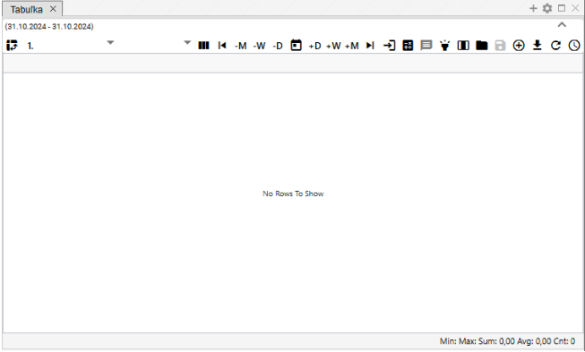

Figure 401: By default, the window to display the table is empty

1. In the profile tree, press the left mouse button to the profile you want to display in the table.
2. Move the profile over the table window and release it.

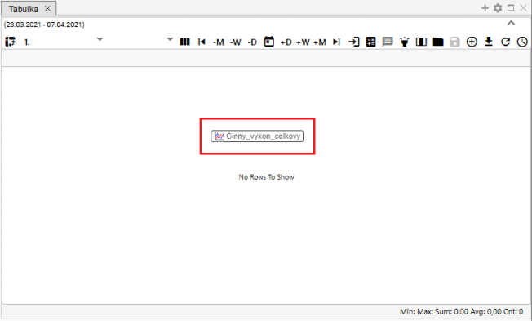

Figure 402: Adding a profile to the table

1. The table window displays the profile values.

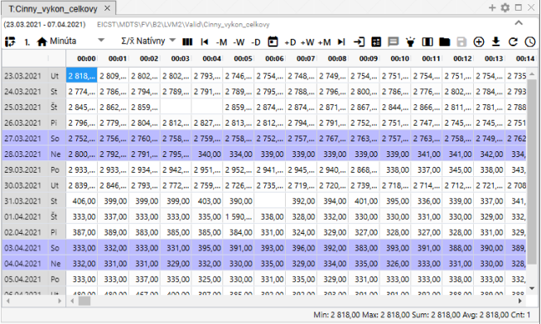

Figure 403: Display of the profile in the table

## How to set a column view

By default, the row view is set in the table. You can set the column view by pressing the Connect to Column View button. You can return the row view by pressing the Connect to Column View button.

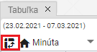

Figure 404: The button Click on the column view

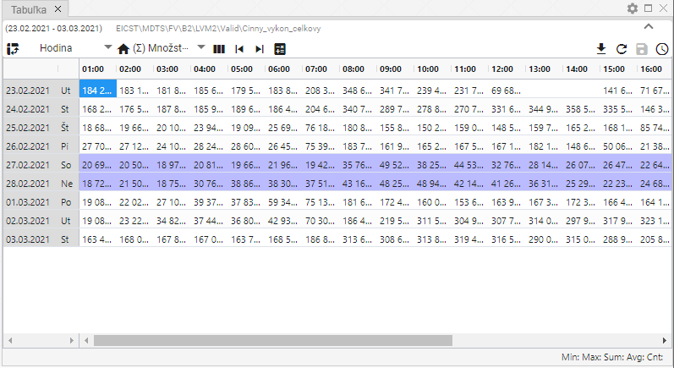

Figure 405: Control panel

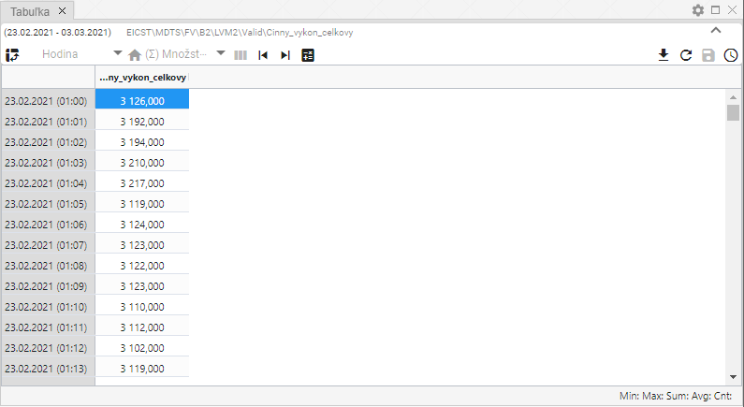

Figure 406: Column view

## How to switch to a single-profile view

By default, the Table window has a single profile view, Image 409. By pressing the button that displays Image 407, the table will be switched to a multi-profile view, Image 410. By switching to a multi-profile view, the appearance of the Image 407 button will change to the Image 408 button that serves to switch the table to a single profile view.



Figure 407: The button Click to the multi-profile view



Figure 408: Press the Click to a single-profile view

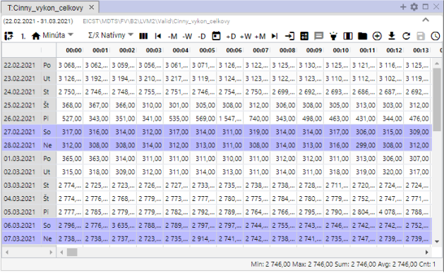

Figure 409: Single-profile view

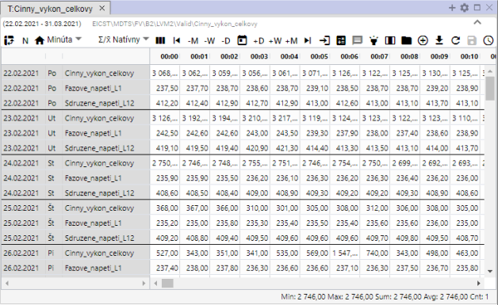

The following table shows the following:

## How to change the time format of the display

The data in the table is normally displayed in a period such as the profile you created, and the data you are displaying in the table is always one day in a row. This means that for the hourly profile you will see 24 columns, for the 15-minute profile you will see 96 columns, for the 1-minute profile you will see 1,440 columns, and for the secondary profile you will see 900 columns.

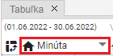

The time-switching device shall be used for the purpose of calculating the time-switching time.

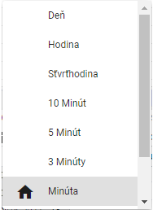

Figure 412: List of time formats in the table

Data may also be viewed in periods:

* Date daily data overview
* Hour hourly data overview
* Quarter of an hour 15 minutes data overview
* 10 Minutes 10 minutes of data
* 5 minutes 5 minutes data overview
* 3 minutes 3 minutes data overview
* Minutes Minutes of data
* Second Secondary data overview
* Unknown is displayed if the table does not know the profile period. Then the profile values are drawn into one column and the column is filled in with data.

## How to set the number of columns

In the Table window, you can set the number of columns to display.

1. Press the Number of columns button at the top of the Table window.

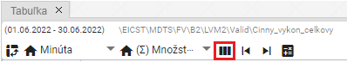

Figure 413: The button Number of columns

1. The window Setting the number of columns will appear.

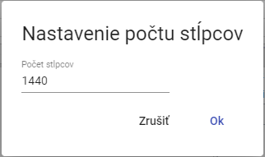

Figure 414: Window Setting the number of columns

1. Enter the number of columns to display.

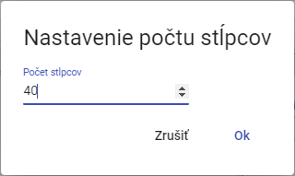

Figure 415: Changed number of columns

1. The number of columns is adjusted.

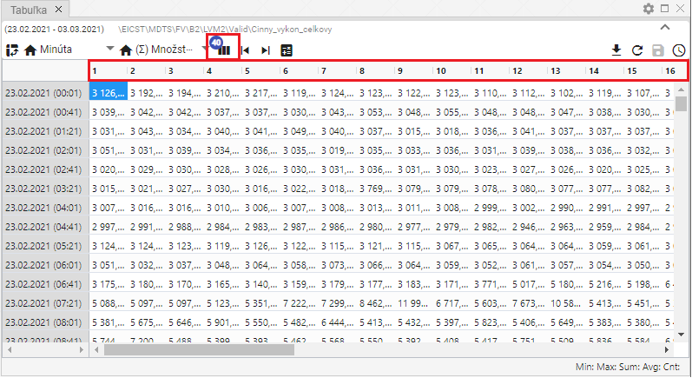

Figure 416: Set number of columns

1. To restore the number of columns, press the Number of columns button and in the Setting number of columns window, press the Remove button.
2. The original number of columns shall be restored.

## How to choose a sampling method

The method of sampling determines how the profile will be sampling when viewed in periods other than its 'natural' period.

In the case of the Multiple mode of sampling, the underlying profile will be understood as quantitative (e.g. energy) and, when viewed over shorter periods, the profile value will be divided by the corresponding ratio.

Native means that the profile character is selected which is defined for the profile in question. This means that the periodic character is used for the flow profile and the quantitative character is used for the quantitative profile. This choice is important especially if I have multiple profiles with different characteristics displayed.

This setting only affects the display of the profile in the table.

Select the sampling method by pressing the Sample method button and selecting from the window that appears, Figure 418.

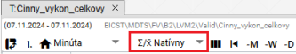

Figure 417: Pressure Sample method

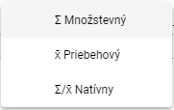

Figure 418: Selection of sampling method

## How to display the first value

The Go to the first value button is used to display the first measured profile value.

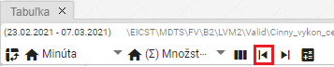

Figure 419: Key Go to the first value

## How to display the last value

The Go to last value button is used to display the last measured profile value.

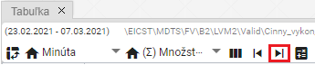

Figure 420: Press the Go to the last value

## How to display the current date

To view the current date, press the Go to the current date. A cell in the table representing the current date and time will appear.

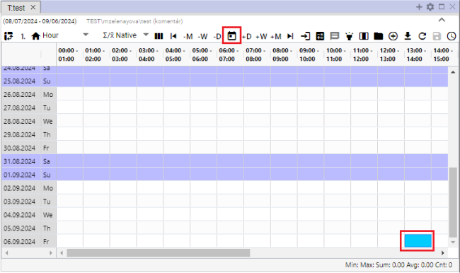

Figure 421: Item Go to the current date

## How to display a specific date

You will see the specific date in the table:

1. Press the Go to a specific date button.

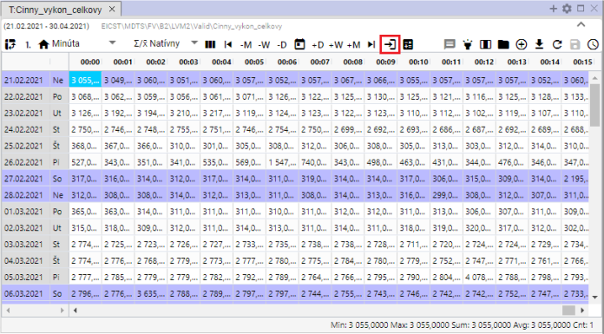

Figure 422: Key Go to a specific date

1. Select the date.

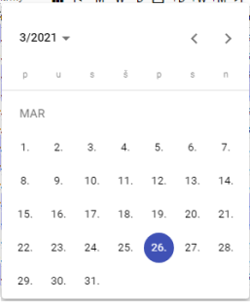

Figure 423: Date of entry

1. The selected date is displayed and the first cell in the selected date is highlighted in blue.

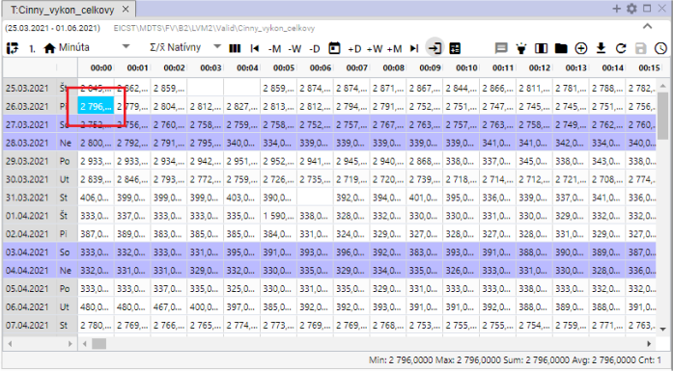

Figure 424: Display of selected date

## How to Move a Date by Day, Week, Month

The date range for which the data in the table is displayed can be moved by using the buttons:

* -M - one month after the date selected,
* -W- subtracts one week from the selected date,
* -D - subtract one day from the date chosen,
* +M - add one month to the selected date,
* +W - add one week to the date chosen,
* +D - add one day to the date chosen.

Step by step:

1. Click on the cell that represents the date from which you want to add or subtract the date range you have chosen.
2. Press the selected switch to move the date.
3. The data display in the table shall be moved to the selected date range.

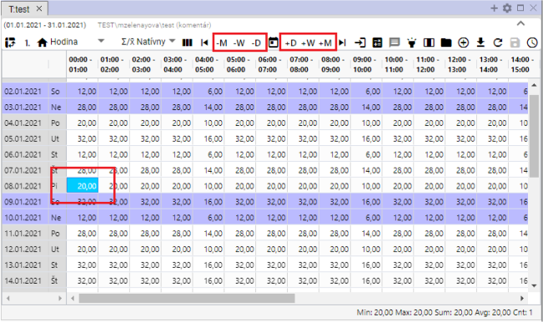

Figure 425: Pressures to move the date by day, week, month

## How to add the column Sum, Priometer, Min, Max

You can add columns:

* Sum turns on/off the daily sum of values in the table.
* The scale turns on/off the daily average of the values in the table.
* Min turns on/off the display of the minimum value of values for a given day.
* Max turns on/off the display of the maximum value of values for a given day.

The standard table does not contain the columns Sum, Priometer, Min and Max. To add them, proceed to:

1. Press the Riad statistics button at the top of the table window.
2. A window will appear where you can select which columns to display.
3. You can attach the column to the right side of the table by clicking the Added right If you do not select the Added right columns Sum, Measure, Min and Max are added to the bottom of the table.

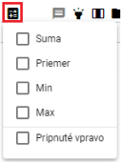

Figure 426: Pressure of the Regional statistics

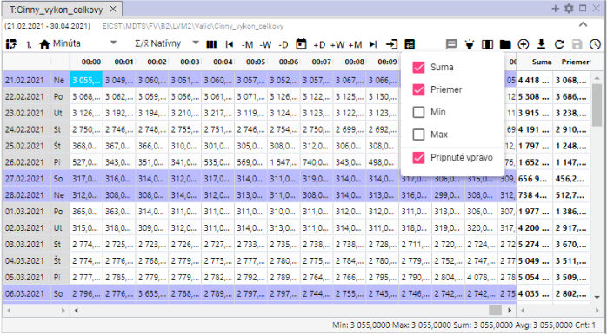

Figure 427: Columns Sum and Measure attached

## How to turn on/off tooltip

By default, the tooltip display in the table is disabled. You can turn on the tooltip by pressing the On/Off tooltip button, which is located in the top right corner of the Table window. To display the values (tooltip) for a specific location in the table, set the mouse cursor to the location you have chosen.

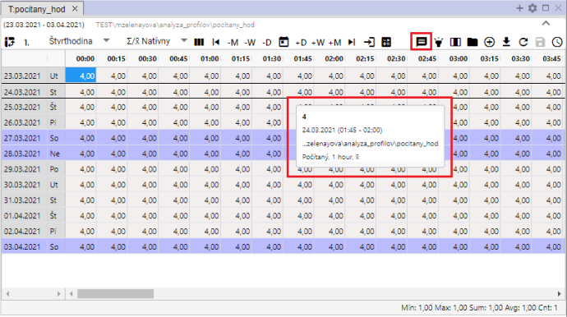

Figure 428: Tooltip shown in the table

## How to turn on/off line accent

Line highlighting means that the line will highlight if you set it to the mouse cursor. If the button On/Off line highlighting is black, the highlighting is on. The button is off if it's gray.

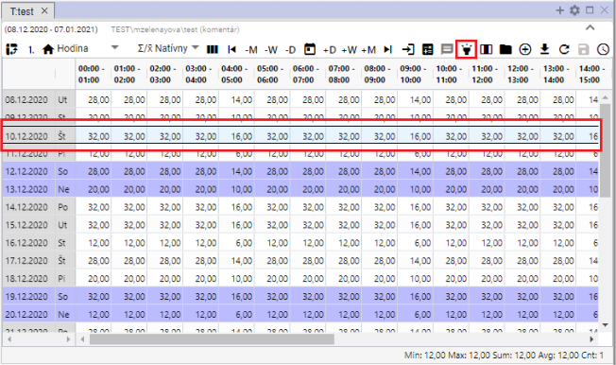

Figure 429: The On/Off line accent and the highlighted line button

## How to adjust the profile value in the table

You can edit the values of the saved profile in the Table window.

Step by step:

1. Click to select the cell in the Table window.

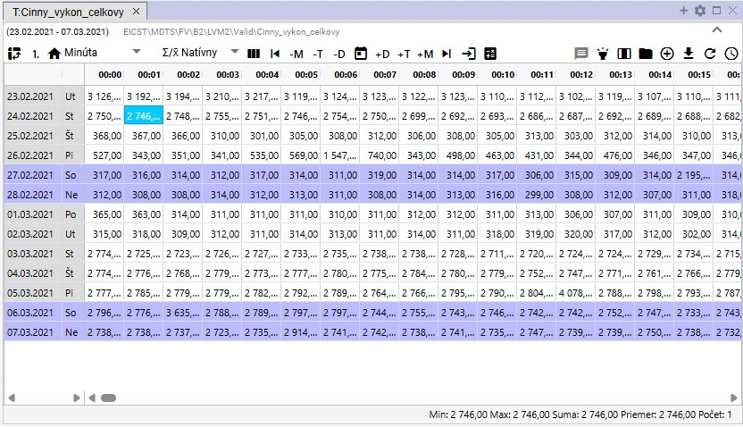

The following table shows the number of cells:

1. Double-click the cell and enter the value.

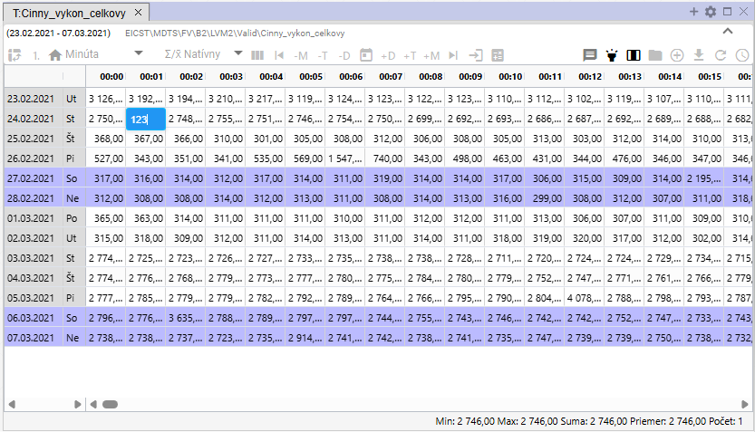

Figure 431: Entry of value

1. After you've adjusted the value, click on another cell in the table.

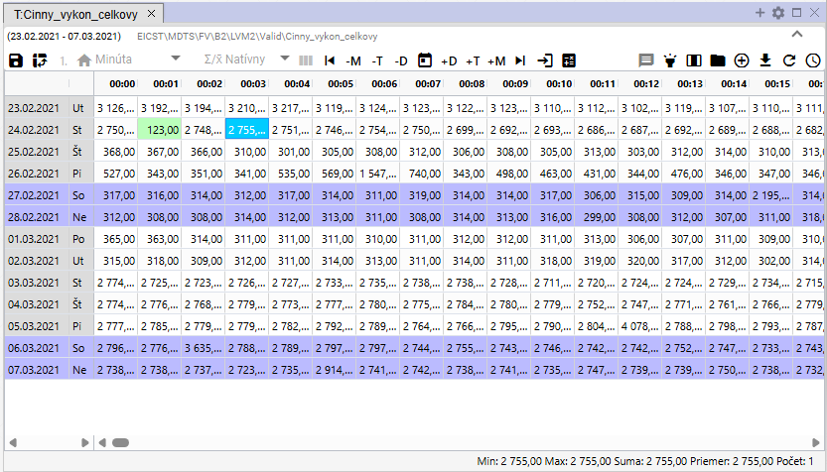

Figure 432: Adjusted value in the table

1. Save the changes by pressing the Save changed values button at the top of the Table window.



Figure 433: Pressure Settings of changed values

## How to change the profile definition

You can change the definition of the calculated profile in the Table window.

1. Right-click the profile of the mouse in the Table window.
2. A window will appear in which you can select the Edite definition.

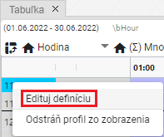

Figure 434: Item Edited definition

1. The window Change the profile definition will appear.

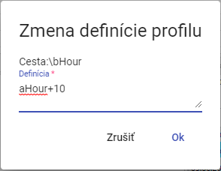

Figure 435: Window Change the definition of the profile

1. Edit the definition and confirm by pressing the Ok button.

## How to remove a profile from a table

To remove the profile, please follow:

1. Right-click the mouse on the profile line you want to delete.
2. A window will appear in which you can select Remove profile from view.

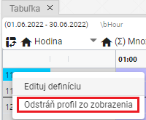

Figure 436: Remove the profile from the display

1. The profile is removed from the Table window.

## How to turn on the automatic column width setting

By default, cells in the Table window have a fixed width. Using the Automatic column width setting button, Figure 437, you can set to see the entire cell content, Figure 438.

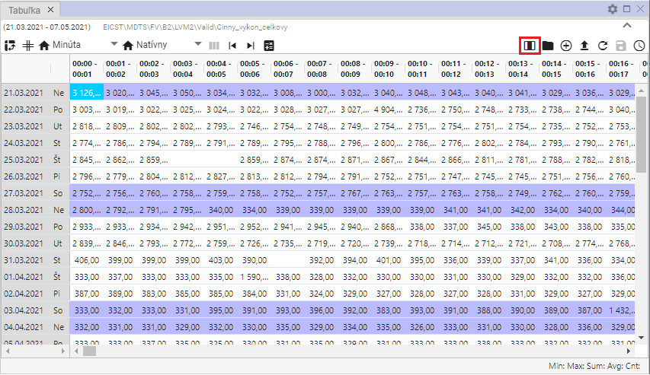

Figure 437: Tape Automatic setting of the width of the columns

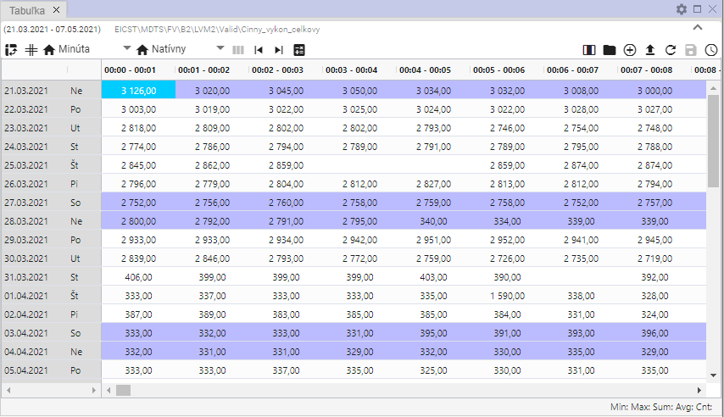

Figure 438: Automatic setting of the width of the columns on

## How to open a profile location

The Open profile location button, Figure 439, is used to open the profile from the Tree Structure Table window, Figure 440.

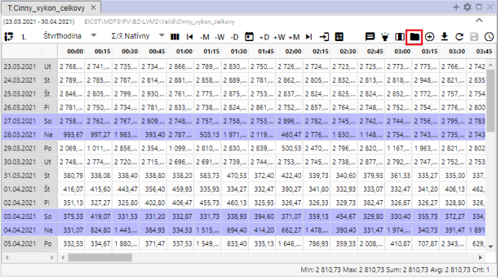

Figure 439: Tape Open the profile location

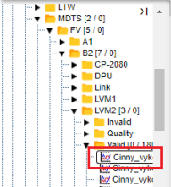

Figure 440: Opening of the profile in the tree structure

## How to add profile

To add a profile to the Table window, follow:

1. Press the Add profile button, which is located in the upper right corner of the Table window.

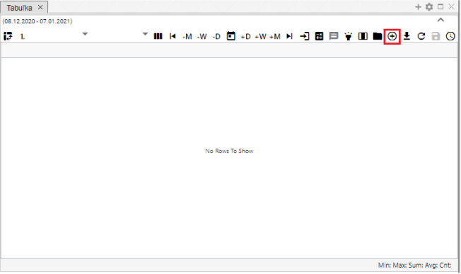

Figure 441: Press the Add profile

1. The Add profile window will appear, where you can enter a path to the profile in the tree structure or press the button to display the Choose profile window.

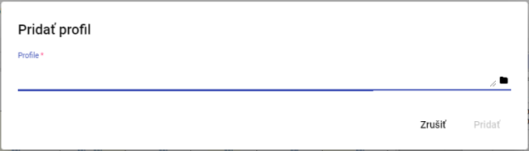

Figure 442: Window Add profile

1. In the Choose Profile window, look for a profile and press the Choose button.

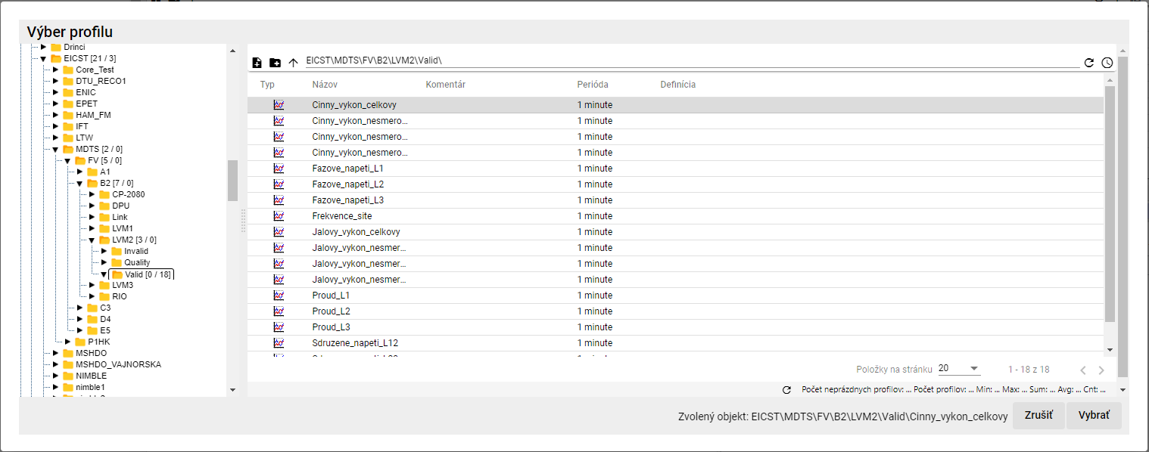

Figure 443: Window Profil selection

1. The Profile path is shown in the Add profile window.

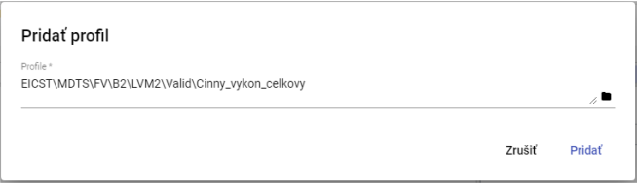

Figure 444: The path to the profile entered

1. Confirm by pressing the Add button.
2. The profile is added in the Table window.

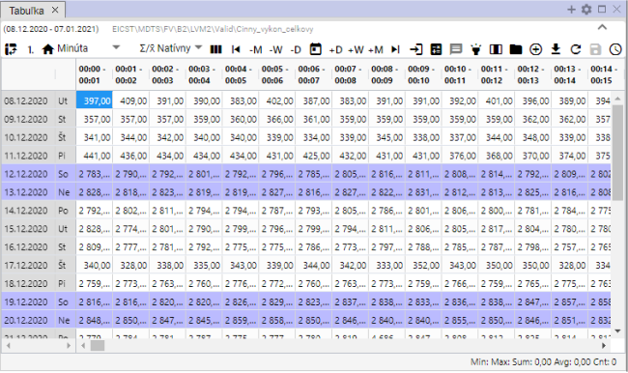

Figure 445: Added profile in the Table window

1. If a profile is displayed in the table and you add another profile, the multiprofile view will automatically turn on.

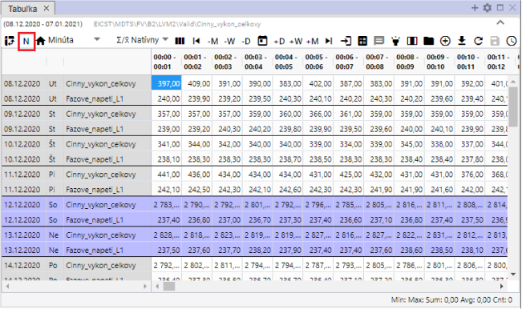

Figure 446: Multi-profile view of the data

## How to export the displayed data to CSV

You can download the data in the Table window by pressing the Export of the data shown to CSV.

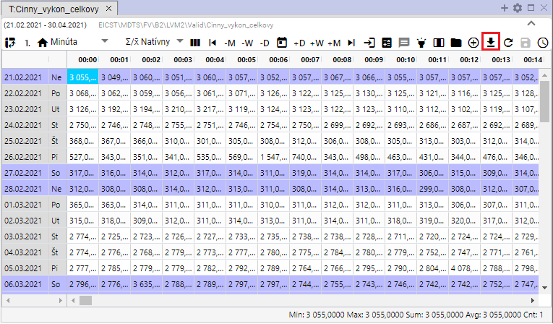

Figure 447: Export the displayed data to CSV



Figure 448: Export withdrawn

## How to change the definition

For the calculated profile, you can change the definition:

1. Right-click any cell in the table.
2. The offer will be displayed where you select the entry Amend definition.

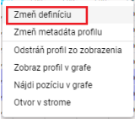

Figure 449: Item Amend the definition

1. The window Change profile expression will appear, where you can adjust the definition of the calculated profile.

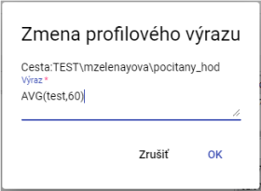

Figure 450: Window Change the profile expression

1. Save the changes by pressing the OK button.

## How to change the profile metadata

Step by step:

1. Right-click the mouse on the cell in the table.
2. The offer will be displayed and you can click on Change profile metadata.

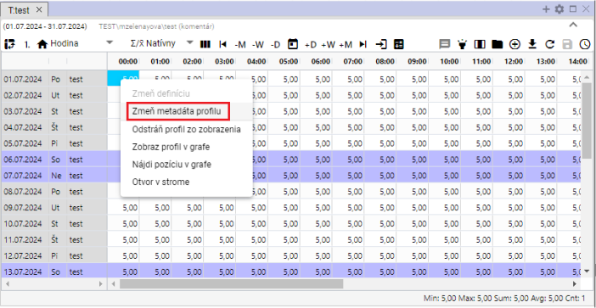

Figure 451: Item Changes of the profile metadata

1. The "Edit Profile" window will appear.

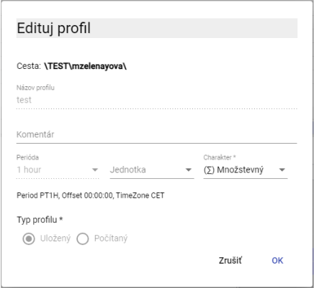

Figure 452: Window Edit profile for the saved profile

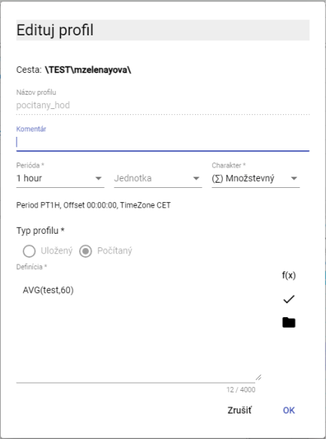

Figure 453: Window Edit profile for the calculated profile

1. For the saved profile, you can edit the fields: Comment, Unit and Character.
2. Save the changes by pressing the OK button.

## How to remove a profile from view

For the deletion of the profile from the table:

1. Right-click any cell in the table.
2. You will see an offer where you select Remove profile from view.

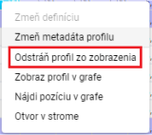

Figure 454: Item Remove profile from view

1. The profile shall be removed from the table.

## How to display a profile in a graph

To see a table profile in the graph, go to:

1. Click on the window header where you want to see the graph. This will activate the window. If the table window is active, the graph will appear in the table window.

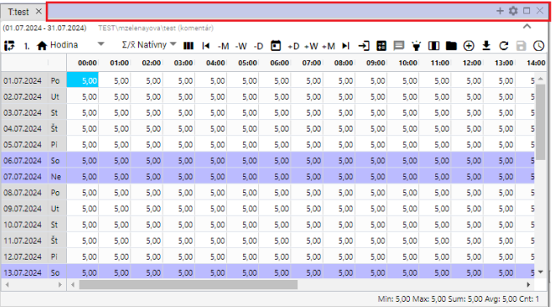

Figure 455: Active window

1. Right-click the mouse on any cell in the table.
2. The offer will be displayed where you select the Show profile in the graph.

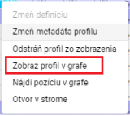

Figure 456: Item Profil image in the graph

1. A new tab showing the graph is added to the active window.

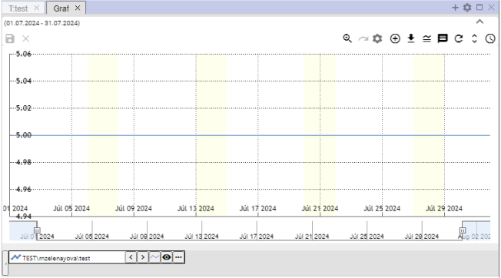

Figure 457: Display of the profile from the table in the graph

## How to find a position in a graph

Step by step:

1. View the profile in the table and in the graph.
2. Right-click the mouse on the cell in the table/place you want to display in the graph.
3. The offer will be displayed where you select the entry Find a position in the graph.

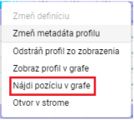

Figure 458: Position Find a position in the graph

1. The graph shows the location of the cell in the table, and the graph moves to select the location in the center of the graph.

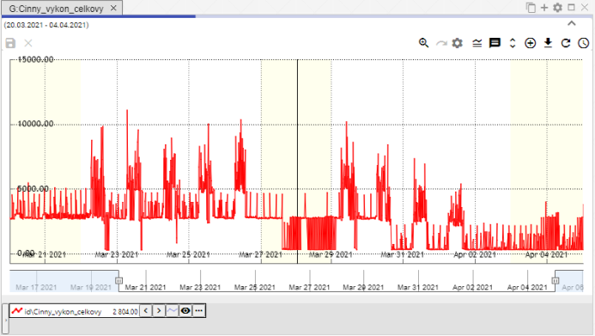

Figure 459: A line appears in the center of the graph representing the selected cell from the table

## How to open a profile in a tree

For opening a tree profile:

1. Right-click any cell in the table window.
2. An offer will open, where you can select the entry "Open in the tree".

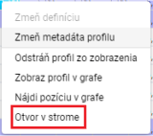

Figure 460: Location Open in the tree

1. In the tree, a directory will open, which will display the profile shown in the table.

## Mark the block with the left mouse button

To mark the block in the table, click the left mouse button on the selected cell in the table, hold the left mouse button pressed, and select the block.

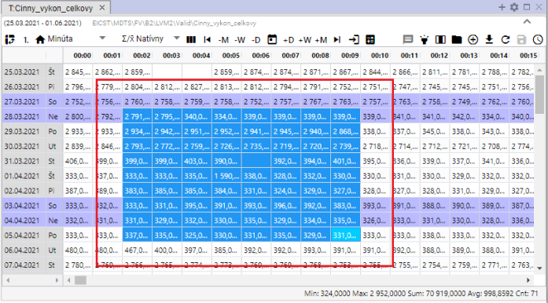

Figure 461: Marking of cells in the table

## How to set the cursor to move in a table using a mouse wheel

In a table, you can move by using a mouse cursor. The move is one day later. You can also move outside the range set in the table. You need to set an active cell in the table.

Step by step:

1. Press the Settings button at the top of the application.



Figure 462: The Settings button

1. The Settings window will appear.
2. In the Table section, click Roll on the mouse to move the cursor.

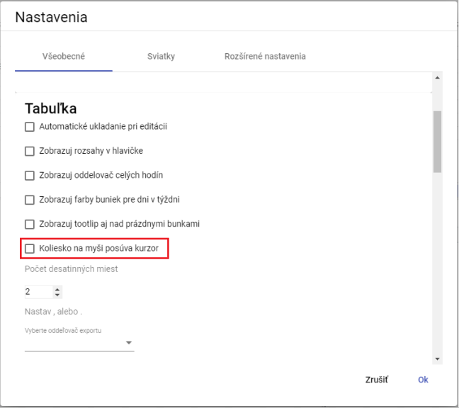

Figure 463: The position of the mouse wheel moves the cursor

1. Save by pressing the OK button.
2. Then in the table, you move the cursor using a mouse wheel. The cursor is an active cell in the table. This cell is blue.

If the item Roll on the mouse moves the cursor is not clicked, the row in the table is moved by the mouse on the wheel.

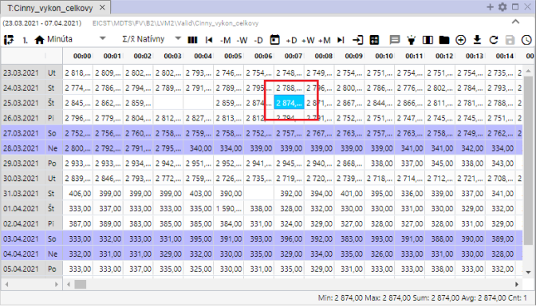

Figure 464: Active cell in the table

## How to change the order of profiles in a table

To change the order of profiles in a table, you need to switch the column view. Each profile represents one column. The column order can be changed. After changing the column order, you can turn the row view on again.

Step by step:

1. Please indicate the required profiles in the table.
2. Press the Put on the column view.

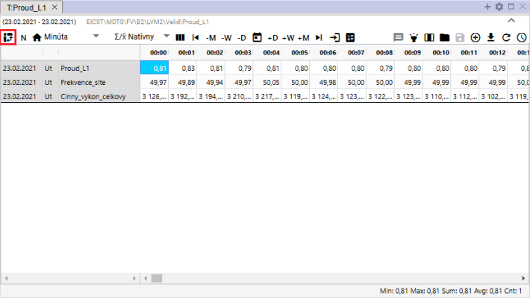

Figure 465: Press the button to click on the column view

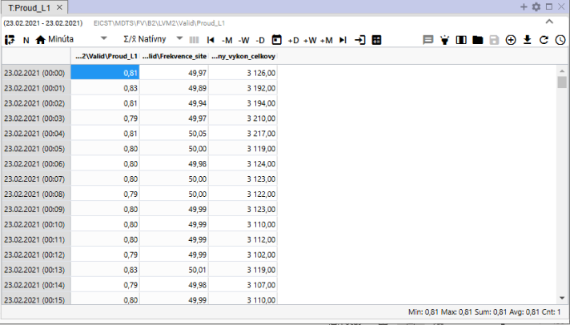

Figure 466: Column view in the table

1. Grab the column head with the left mouse button and move the column to the desired location.

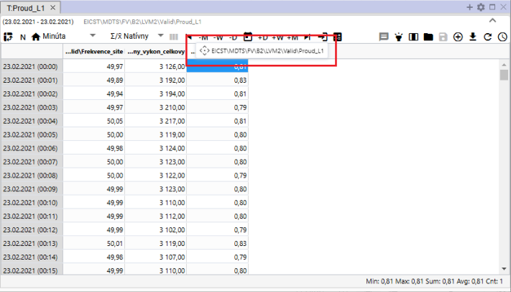

Figure 467: Moving the column

1. After moving the column, you can turn on the profile line again.

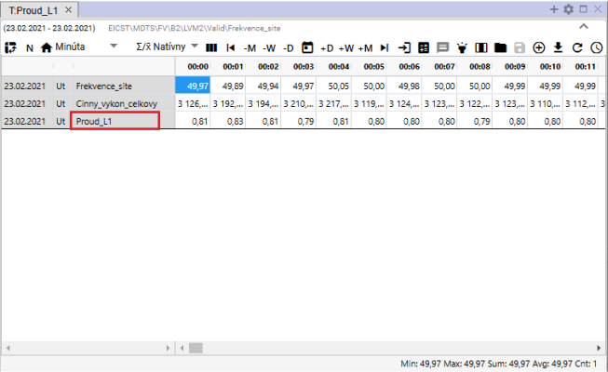

Figure 468: Changed order of profiles

# Arithmetic of calculated profiles

## The sampling rules

For arithmetic operations with profiles with different periods, sampling is performed when they are calculated. This sampling has its own rules, which depend mainly on the set nature of the profiles entering the operation.

### Rules for sampling the input to output profile taking into account the nature

For example: output_profile:= input_profile1 + input_profile2 * input_profile3 ...

1. If the input profile is within the aggregation function (avg, sum, min, max, count) or cp(), its sampling is explicitly determined by its parameter and the following rules are not taken into account.
2. If not, the input profile shall be checked before the arithmetic is applied to sample the output profile according to the following rules:
3. The characterless profile is considered to be continuous. This is the default character, and so it was observed before the character was introduced.
4. If the input and output profile periods are the same, no sampling is done and no characteristics are taken into account at all.
   1. If profiles have different characteristics and we want to convert between them, we have to do it manually using a formula in profile arithmetic.
5. If the entry and exit periods are different, the following shall be sampled:
   1. Down-sampling: if resampled from a milder to a coarse sample, such as:
6. for quantitative, aggregate using SUM is used
7. In the case of rolling stock, AVG aggregation is used
8. Up-sampling: if the sample is re-sampled from a coarse to a fine sample, then:
9. for quantitative output, multiply the input value divided by the ratio of output and input period
10. the input value is multiplied (unchanged) by the current
11. The above sampling only takes into account the nature of the input profile, and the nature of the output profile is not taken into account at all.

## The calculated profile

You'll create a profile by following the following procedure:

1. In the tree structure, right-click the address book name of the address book in which you want to create a new calculated profile. A window with items will appear, in which you will set the mouse cursor to New and select Profile, Figure 469.

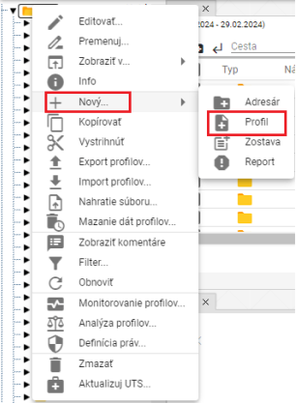

The following table shows the following:

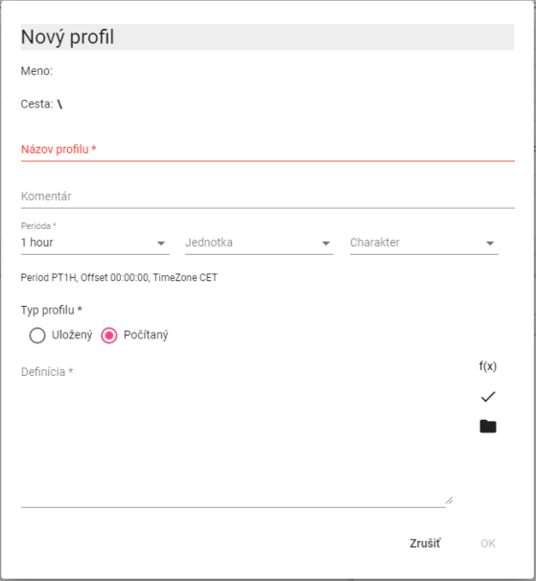

Figure 470: Window for creating a calculated profile

1. In the Profile Name field, enter the name of the profile. The profile name must start with a letter, then it can include the digits and the underscore _. The profile name can contain no more than 22 characters. The profile is determined by the name, or by indicating the path to the profile and the name (way\profile).
2. You can comment.
3. Choose the period, unit and character.
4. In the section Profile type, select Counted.
5. When defining the calculated profile, we can use the buttons:
6. **[TRANSLATION ERROR - MANUAL REVIEW NEEDED] ak chceme pracovať so štandardnými funkciami pre počítaný profil**
7. **[TRANSLATION ERROR - MANUAL REVIEW NEEDED] ak chceme použiť v definícii iný uložený alebo počítaný profil. Pre počítaný profil môžeme použiť v definícii aj iný počítaný profil.**
8. You can create a profile by pressing the OK button.

The profile shall be determined by the name, where appropriate by the path to the profile and the name (way\profile).

* You can also use plugins functions (described later) in the definition for the calculated profile.

The following information shall be provided:

In the Xenergie G2 version, Oracle profiles cannot be created, but according to the specifications of the Xenergie G2 implementation, their backward compatibility can be maintained.

### Method of writing the expression

We write the definition of the calculated into the Definition window.

The profile name must start with a letter, then it may also contain the digits and the underscore _. The profile name may contain a maximum of 22 characters. The profile is determined by its name, or by indicating the path to the profile and its name (cesta\profile).

There is no distinction between capital and capital when defining.

Examples:

**[TRANSLATION ERROR - MANUAL REVIEW NEEDED] \cez**

Reference to profile through the main directory

**[TRANSLATION ERROR - MANUAL REVIEW NEEDED] ..\cez**

Reference to profile through in the directory by 1 level higher

**[TRANSLATION ERROR - MANUAL REVIEW NEEDED] ..\..\oprava\cez**

link to the profile through the 2 levels of directories above, in the sub-address right

**[TRANSLATION ERROR - MANUAL REVIEW NEEDED] 100**

the profile shall contain a value of 100 for the entire time range.

The format of the number is [-]nnn.mmm[E[-]eee.

The expression may contain spaces, tables, and characters in a new line.

### Numbering of the expression

The expression shall be calculated for the required time period for each time (hour, minute) separately.

If the profile has no value in the calculated time, the invalid value shall be worked.

If any of the values that enter the operation +, -, *, /, >, <, >=, <=, =, <>, ̊, &, ! is invalid, the result is invalid.

The distribution of 0 produces an invalid value.

The program always clears all values, even if they are not necessarily necessary, so for example alt(100.0,unknown_profile) is not the correct expression

### The following table shows the calculations of the arithmetic mean:

* The number of +++
* The reading - -
* Multiplication of * **
* The following table summarizes the following:
* Other (excluding

Operations are numbered from left to right. The highest priority is (), then *, **, and /, //.

The operations ++, --, **, // replace the invalid value with a value of 0.

### Functions

The button opens a window where you can select any of the standard functions.

* Aggregate functions
* Other
* **[TRANSLATION ERROR - MANUAL REVIEW NEEDED] Kompozičné funkcie**
* **[TRANSLATION ERROR - MANUAL REVIEW NEEDED] Podmienené**
* **[TRANSLATION ERROR - MANUAL REVIEW NEEDED] Zastarané funkcie**
* **[TRANSLATION ERROR - MANUAL REVIEW NEEDED] Iné**
* **[TRANSLATION ERROR - MANUAL REVIEW NEEDED] Funkcie zaokrúhľovania**
* **[TRANSLATION ERROR - MANUAL REVIEW NEEDED] Funkcie znaku**

After selecting the category, a list of functions with a function reference is opened.

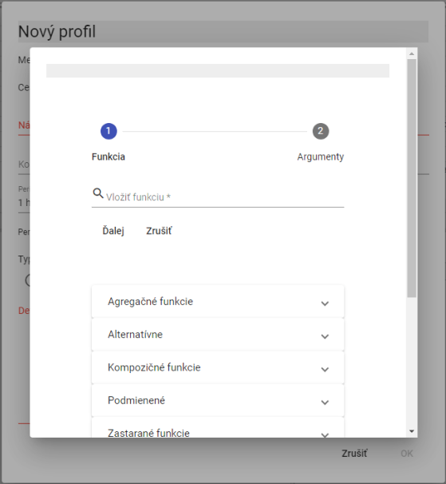

The following table shows the following:

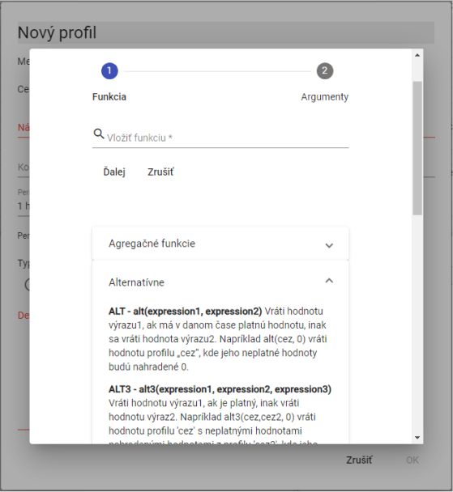

Figure 472: List of functions with function reference

#### Aggregate functions

Aggregate functions have two parameters.

1. **[TRANSLATION ERROR - MANUAL REVIEW NEEDED] profil – názov profilu,**
2. **[TRANSLATION ERROR - MANUAL REVIEW NEEDED] perióda – perióda, s ktorou sa má daná funkcia počítať. Perióda sa zadáva nasledujúcimi konštantami (pre počítanie v platnom čase sú konštanty začínajúce písmenom „P“):**

The constants for determining the period shall always be given in capital letters.

**[TRANSLATION ERROR - MANUAL REVIEW NEEDED] D, PD – denná perióda (v SEČ a v platnom čase – v lete v LSEČ)**

**[TRANSLATION ERROR - MANUAL REVIEW NEEDED] W, PW – týždenná perióda /týždeň začína v pondelok a končí v nedeľu/**

**[TRANSLATION ERROR - MANUAL REVIEW NEEDED] E, PE – týždenná perióda /týždeň začína v sobotu a končí v piatok/**

**[TRANSLATION ERROR - MANUAL REVIEW NEEDED] M, PM – mesačná perióda**

**[TRANSLATION ERROR - MANUAL REVIEW NEEDED] Q, PQ – štvrťročná perióda**

**[TRANSLATION ERROR - MANUAL REVIEW NEEDED] Y, PY – ročná perióda**

For calculated profiles, we can type the period in minutes.

**[TRANSLATION ERROR - MANUAL REVIEW NEEDED] sum(profil, perioda)**

Summing with the period in the SEQ.

(Periods: D, W, E, M, Q, Y, whereas the calculated profiles can be entered in minutes.)

For example, if we calculate the sum of measurements, M) where the measurement profile has an hourly period, the resulting profile will contain the sum of the measurement profile values for that month in all values in the month.

**[TRANSLATION ERROR - MANUAL REVIEW NEEDED] avg(profil, perioda)**

Coordination with the period in the ECSC

For example, if we calculate the function of avg ((temperature, 60), where the temperature profile has a minute period, we get the hourly temperature averages in the resulting profile.

**[TRANSLATION ERROR - MANUAL REVIEW NEEDED] min(profil, perioda)**

Minimum values in the period in the SEQ.

The minimum value shall be calculated for each period.

**[TRANSLATION ERROR - MANUAL REVIEW NEEDED] max(profil, perioda)**

The function is running in the SEC.

The maximum value shall be calculated for each period.

**[TRANSLATION ERROR - MANUAL REVIEW NEEDED] csum(profil, perioda)**

Cumulative summation of the profile values on time units given by the period parameter. The output profile at a given time point yields a value that is the sum of all previous input profile values, from the beginning of the time interval (determined by the period parameter) to a specific time point (including).

For example, if the input profile is hourly, then the output profile with the definition csumprofile_input, PD) will have a value equal to the value of the sum for that entire day in each day, in its last hour (in current time).

**[TRANSLATION ERROR - MANUAL REVIEW NEEDED] pavg(profile,perioda)**

The average of the period in force at the time.

**[TRANSLATION ERROR - MANUAL REVIEW NEEDED] pcsum(profile, perioda)**

Summing up the period.

At each time t determines the sum of values from the beginning of the period to the time t.

**[TRANSLATION ERROR - MANUAL REVIEW NEEDED] pmax(profile,perioda)**

Maximum values in the period in time.

**[TRANSLATION ERROR - MANUAL REVIEW NEEDED] pmin(profile,perioda)**

Minimum values in the period in force.

**[TRANSLATION ERROR - MANUAL REVIEW NEEDED] psum(profil ,perioda)**

Summing up the period in question at the time in question.

(Periods: D, W, E, M, Q, Y, whereas the calculated profiles can be entered in minutes.)

Functions with P at the beginning control the way time is divided into the intervals to be aggregated.

P is the time in force that changes from UTC+1 to UTC+2 in summer .

The PSUM, PAVG, PMIN, PMAX functions are obsolete. (other than PHOUR, PDAY, PTDIV, ... no).

We recommend instead using functions without P in their name and using P as a prefix to the time parameter.

For example, instead of the expression "AVG, X" we recommend using AVG, PX).

By "obsolete" we mean that we no longer recommend using these functions when setting up new calculations.

These outdated functions in the system remain the same, but we will no longer modify their behavior.

The P-free functions that we recommend as a replacement are more versatile and will be gradually expanded over new periods.

The old features can still be used, but we recommend using new, more versatile versions to create new patterns.

#### The alternative

**[TRANSLATION ERROR - MANUAL REVIEW NEEDED] alt(vyraz1,vyraz2)**

**[TRANSLATION ERROR - MANUAL REVIEW NEEDED] alt3(vyraz1,vyraz2,vyraz3)**

**[TRANSLATION ERROR - MANUAL REVIEW NEEDED] ...**

**[TRANSLATION ERROR - MANUAL REVIEW NEEDED] alt9(vyraz1,vyraz2,...,vyraz9)**

If expression 1 has no validity, the calculation shall continue with expression 2 and if it also has no validity, another expression shall be used...

**[TRANSLATION ERROR - MANUAL REVIEW NEEDED] alt(vyraz1,vyraz2)**

If expression1 has no valid value, expression2 shall be taken.

The following information is provided for in the Annex to Implementing Regulation (EU) No 1308/2013:

If the profile ...\cez does not contain a valid value, the function uses a value of 0 to process it.

**[TRANSLATION ERROR - MANUAL REVIEW NEEDED] alt3(výraz1, výraz2, výraz3)**

If expression1 has no valid value, use expression2 if it also has no valid value, take expression3.

Alternative functions may sometimes be appropriately substituted:

For example:

**[TRANSLATION ERROR - MANUAL REVIEW NEEDED] alt(dodavatel1,0)+alt(dodavatel2,0)**

can be replaced

the supplier1++supplier2

It adds up two profiles by replacing the invalid value with 0.

For example:

I'm not sure what I'm talking about.

or

I'm not sure.

The invalid value in the cez profile shall be replaced by the value from the cez2 profile, or, if the cez2 profile does not contain a valid value either, the value 0 shall be used. The second option is of course more efficient.

#### Stop the spread of the error / suppress the error

**[TRANSLATION ERROR - MANUAL REVIEW NEEDED] nv()**

A function that returns an empty (invalid) value. (NO_VALUE) All operations with an invalid value produce an invalid value.

Examples:

**[TRANSLATION ERROR - MANUAL REVIEW NEEDED] nv()**

**[TRANSLATION ERROR - MANUAL REVIEW NEEDED] nv()+100**

The result will be a profile containing invalid values.

valid(profile)

If an error is detected in the acquisition of profile values (for example, it does not exist), the result is invalid values. If the VALID function is not used and the specified profile does not exist, the program will display an error message (the definition of the calculated profile is incorrect) and the expression will not be executed.

For example:

**[TRANSLATION ERROR - MANUAL REVIEW NEEDED] test**

or

**[TRANSLATION ERROR - MANUAL REVIEW NEEDED] alt(test,0)**

If the test profile is incorrect (or does not exist), the program will alert you to the error when entering the following terms.

If the test profile becomes incorrect after this expression is entered, an error message will appear in the resulting profile info window.

For example:

valid(test)

The resulting profile will be fine, but it will not contain a valid value.

The following table shows the results of the test:

The resulting profile will be fine and will contain values of 0.

#### A simple condition

**[TRANSLATION ERROR - MANUAL REVIEW NEEDED] cond(logicky_vyraz,vyraz1,vyraz_nepravda)**

If the expression is logically true, the expression shall be executed.

Logical_expression may contain:

* Expressions and numerical values
* The following comparison operators: >, <, >=, <=, =, <>

Logical expressions can be linked using logical operations:

* Logical component (and at the same time): &
* The logical sum (or):
* The denial: !

The order of evaluation of logical operations is: &amp; # 91; and we can edit it with this .

For example:

The following is the list of the following:

All values in the profile less than 0, shall be replaced by 0.

For example:

The following is the list of the following:

If the profile through contains a valid value, the result will be 1, otherwise the result will be 0.

For example:

I'm not going to say anything.

The following table shows the following:

The resulting profile in both cases shall not contain values less than 0 and greater than 1000.

#### Multiple condition

**[TRANSLATION ERROR - MANUAL REVIEW NEEDED] cond2(logický_výraz1, výraz1,logický_výraz2, výraz2, výraz_nepravda)**

**[TRANSLATION ERROR - MANUAL REVIEW NEEDED] ...**

**[TRANSLATION ERROR - MANUAL REVIEW NEEDED] cond9(logický_výraz1, výraz1,…logický_výraz9, výraz9, …výraz_nepravda)**

If the logical expression is true, the expression is executed, if the logical expression is true, the expression is executed, if the logical expression is true, the expression is executed, if the logical expression is true, the expression is executed, if the logical expression is true, the expression is executed, if the logical expression is true, the expression is executed, if the logical expression is true, the expression is executed, if the logical expression is true, the expression is executed, if the logical expression is true, the expression is executed, if the logical expression is true, the expression is executed, if the logical expression is true, the expression is executed, if the logical expression is not true, the expression is executed.

For example:

The following table shows the number of units of the same type of unit:

The following table shows the number of units of the vehicle:

In both cases, if the real profile value is less than 102%, the value of the meal profile value is returned to 1, if it is greater than 102%, and less than 105%, the value is returned to 1.1, otherwise the value is returned to 1.2.

#### Folding functions

**[TRANSLATION ERROR - MANUAL REVIEW NEEDED] day(výber_dní)**

The output is a profile containing units and zeros. The function will record 1 for the days of the week that are specified in the argument. The function works in the SEC. The day of the week is identified by a number in the order: Po(1), Ut(2), St(3), Št(4), Pi(5), So(6) and Ne(7).

The entry :day(136) will create such a 0-1 profile that will have units in Po(1), St(3) and So(6).

**[TRANSLATION ERROR - MANUAL REVIEW NEEDED] hour(výber_hodín)**

The output is a profile containing units and zeros. The function returns 1 for the hours of the day that are given in the argument.

The record for the calculated profile: hour(1, 5 - 10, 18, 24) will record the value 1 for hours 1, 5, 6, 7, 8, 9, 10, 18 and 24.

**[TRANSLATION ERROR - MANUAL REVIEW NEEDED] month(výber_dní)**

The output is a profile containing units and zeros. The function will record 1 for the days of the month that are given in the argument.

The entry: month(1, 3, 10 13, 30) returns the value of 1 for days 1, 3, 10, 11, 12, 13, 30.

**[TRANSLATION ERROR - MANUAL REVIEW NEEDED] pday(výber_dní)**

The output is a profile containing units and zeros. The function returns 1 for the days of the week that are specified in the argument. The function works in real time. The day of the week is identified by a number in the order: Po(1), Ut(2), St(3), Št(4), Pi(5), So(6) and Ne(7).

The entry :pday(136) returns such a 0-1 profile that will have units in Po(1), St(3) and So(6)

The function is running in real time.

**[TRANSLATION ERROR - MANUAL REVIEW NEEDED] phour(výber_hodín)**

The output is a profile containing units and zeros. The function will record 1 for the hours in the days that are given in the argument.

The entry: four(1, 5 - 10, 18, 24) returns the value 1 for hours 1, 5, 6, 7, 8, 9, 10, 18 and 24.

The function is running in real time.

**[TRANSLATION ERROR - MANUAL REVIEW NEEDED] pmonth(výber_dní)**

The output is a profile containing units and zeros. The function returns 1 for the days of the month that are given in the argument.

The entry pmonth(1, 3, 10 13, 30) returns the value of 1 for days 1, 3, 10, 11, 12, 13, 30.

The function is running in real time.

**[TRANSLATION ERROR - MANUAL REVIEW NEEDED] ptdiv(výraz0, čas1,výraz1,...., časX, výrazX )**

By time1 use the profile values expression0, from time1 (including) to time2 use the profile values expression2, ..., from timeX (including) use the profile values expressionX.

Time is entered in DD.MM.RR[RR] [HH:MM].A year may be entered in full (1990-2030) or in abbreviated form (00-30,90-100).

The pdive function is running in real time.

**[TRANSLATION ERROR - MANUAL REVIEW NEEDED] tdiv(výraz0, čas1,výraz1,...., časX, výrazX)**

By time1 use the profile values expression0, from time1 (including) to time2 use the profile values expression2, ..., from timeX (including) use the profile values expressionX.

Time is entered in DD.MM.RR[RR] [HH:MM].A year may be entered in full (1990-2030) or in abbreviated form (90-100,00-30).

The TIV function is working in the SEC.

**[TRANSLATION ERROR - MANUAL REVIEW NEEDED] vdiv(vstupny_výraz, výraz0, hodnota1, výraz1,... hodnotaX, výrazX)**

If the input_expression is less than value1, it is replaced by the expression0. If it is greater than (equal) than value1 and less than value2 it is replaced by the expression1, ... If it is greater than (equal) than valueX it is replaced by the expressionX.

For the calculated profile, the function NO_VALUE assigns a value NO_VALUE.

#### Rounding functions

The number of decimal places parameter determines the position to which it is rounded.

If the number of_decimal_places is 2, the rounding functions will be rounded to whole tens.

**[TRANSLATION ERROR - MANUAL REVIEW NEEDED] round(výraz, počet_desatinných_miest)**

Mathematical rounding (from 5 above absolute value) If the parameter number_decimal_place =0, round the number 1.5 to 2 - round the number -1.5 to -2.

**[TRANSLATION ERROR - MANUAL REVIEW NEEDED] roundup(výraz, počet_desatinných_miest )**

Rounding up always at absolute value. If the parameter number_decimal_place =0, round the number 1.1 to 2.

**[TRANSLATION ERROR - MANUAL REVIEW NEEDED] trunc((výraz, počet_desatinných_miest )**

Cutting the number of places specified. If the parameter number_decimal_place =0, the number 1.1 is cut to 1 and the number -1.1 to -1.

#### The following information shall be provided:

**[TRANSLATION ERROR - MANUAL REVIEW NEEDED] abs(výraz)**

Absolute value of each value in the profile.

**[TRANSLATION ERROR - MANUAL REVIEW NEEDED] minus(výraz)**

The values greater than 0 shall replace 0.

**[TRANSLATION ERROR - MANUAL REVIEW NEEDED] plus(výraz)**

The values less than 0 shall replace 0.

For example:

The following table shows the results of the calculation of the total weight of the product:

It's the same as abs(odch)

For example:

The following table shows the results of the calculation:

It's the same as plus

For example:

The following table shows the results of the calculation of the total weight of the product:

It's the same as minus

# Additional/additional functions

The subscription features are not standard parts of the Profile Manager supply, but are ordered separately.

## Monitoring of profiles

The function is used to monitor profiles. The monitoring job is used to guard profiles. For example, it controls that the value in the profile does not fall below zero or exceed 100.

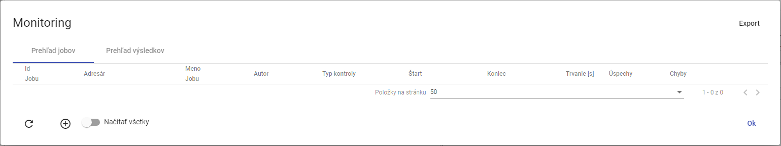

The following table shows the following:

### How to create a new monitoring job

**[TRANSLATION ERROR - MANUAL REVIEW NEEDED] Pre vytvorenie nového monitorovacieho jobu postupujte:**

1. Right-click the mouse on the tree structure directory.
2. The offer will be displayed where you select the heading Monitoring profiles.

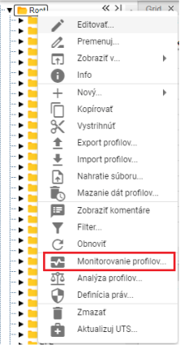

Figure 474: Item Monitoring of profiles

1. The Monitoring window will appear.
2. Press the button or right-click the existing job and select Create a new job.

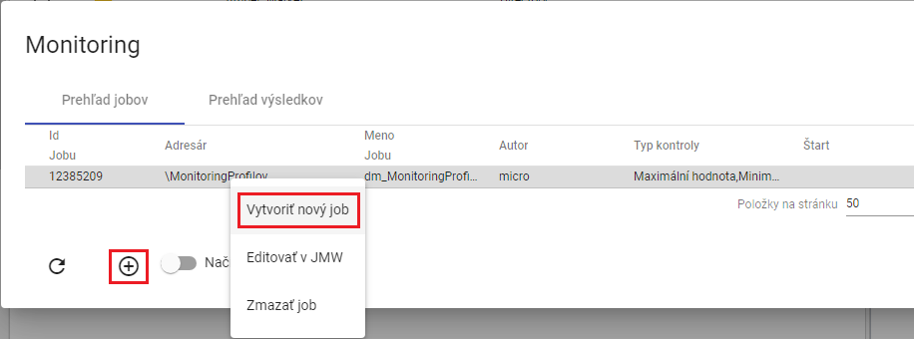

Figure 475: Item Create a new job

1. The window New monitoring job appears.

* **[TRANSLATION ERROR - MANUAL REVIEW NEEDED] „Kritériá“ - kritéria podľa ktorých sa profil monitoruje,**
* **[TRANSLATION ERROR - MANUAL REVIEW NEEDED] „Zmena hodnoty“ - kritérium kontrolujúce zmenu hodnoty v monitorovanom profile. Profil je monitorovaný v stanovenom časovom intervale, ak sú všetky hodnoty v intervale rovnaké, zobrazí sa chybové hlásenie.( Profile: „Názov profilu“ No change in value in interval 27.3.2017 1:00:00 - 27.3.2017 4:00:00),**
* **[TRANSLATION ERROR - MANUAL REVIEW NEEDED] „Monotónne“ - kritérium kontrolujúce monotónnosť hodnôt v monitorovanom profile v stanovenom intervale. Ak sa pri zvolenej stúpajúcej monotónnosti v časovom úseku nachádzajú hodnoty porušujúce stúpajúcu monotónnosť, zobrazí sa chybové hlásenie. (Profile: „Názov profilu“ Monotony condition of the series is not fullfilled at time point 6.4.2017 11:00:00),**
* **[TRANSLATION ERROR - MANUAL REVIEW NEEDED] „Stúpajúce“ – kritérium kontroluje stúpavosť. Profil musí stále rásť.**
* **[TRANSLATION ERROR - MANUAL REVIEW NEEDED] „Maximálna hodnota“ - kritérium kontrolujúce dosiahnutie maximálnej hodnoty v monitorovanom profile. Ak sa v hodnotách zvoleného profilu v stanovenom časovom intervale nachádza hodnota presahujúca zvolenú maximálnu hodnotu, zobrazí sa chybové hlásenie.(Profile: „Názov profilu“ 1.1.2013 0:00:00 > 14 is larger than allowed max: 8),**
* **[TRANSLATION ERROR - MANUAL REVIEW NEEDED] „Minimálna hodnota“ - kritérium kontrolujúce dosiahnutie minimálnej hodnoty v monitorovanom profile. Funguje analogicky ako kritérium maximálnej hodnoty,**
* **[TRANSLATION ERROR - MANUAL REVIEW NEEDED] „Chýbajúca hodnota“ - kritérium kontrolujúce počet chýbajúcich hodnôt v monitorovanom profile v stanovenom intervale. Ak počet chýbajúcich hodnôt v stanovenom intervale presiahne parameter „Chýbajuca hodnota“, zobrazí sa chybové hlásenie.(Profile: „Názov profilu“ Interval 1.1.2013 0:00:00 - 2.1.2013 0:00:00 contains 3 empty values.),**
* **[TRANSLATION ERROR - MANUAL REVIEW NEEDED] „Rozdielna hodnota“ - kritérium kontrolujúce rozdiel medzi maximálnou a minimálnou hodnotou v monitorovanom profile v stanovenom intervale. Ak rozdiel max a min hodnoty v stanovenom intervale presiahne parameter „Rozdielna hodnota“, zobrazí sa chybové hlásenie.( Profile: „Názov profilu“ Difference in values was 12),**
* **[TRANSLATION ERROR - MANUAL REVIEW NEEDED] „Začiatok intervalu (D:H:M:S)“ - je Interval začiatku monitorovania dát v profile. Vzťahuje sa relatívne k času spustenia akcie alebo k zadanému absolútnemu času,**
* **[TRANSLATION ERROR - MANUAL REVIEW NEEDED] „Koniec intervalu (D:H:M:S)“ - je Interval konca monitorovania dát. Vzťahuje sa relatívne k času spustenia akcie alebo k zadanému absolútnemu času,**
* **[TRANSLATION ERROR - MANUAL REVIEW NEEDED] „Časová zóna“ - je zóna v ktorej sa nachádza server na ktorom beží JMW. Zóna sa zohľadňuje pri posuvnom časovom okne, kedy sa podľa nej určuje lokálny čas spustenia akcie,**
* **[TRANSLATION ERROR - MANUAL REVIEW NEEDED] „Zarovnanie“ - voľba zarovnanie umožňuje zarovnať časové okno dát monitorovaného profilu na nasledovné časové obdobia:**
  + **[TRANSLATION ERROR - MANUAL REVIEW NEEDED] deň v platnom čase**
  + **[TRANSLATION ERROR - MANUAL REVIEW NEEDED] hodinu v platnom čase**

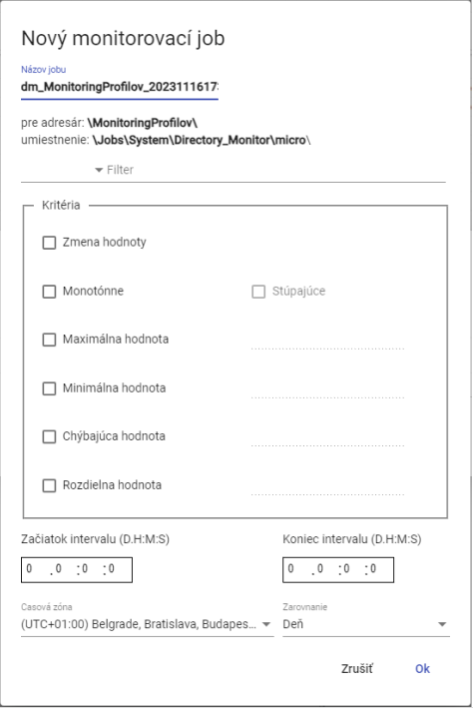

Figure 476: Window New monitoring job

1. By default, the job name is pre-filled.
2. Click on the box to the left of Filter, and a window will appear to select the filter condition.

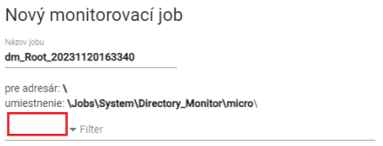

Figure 477: Field for selecting the filter

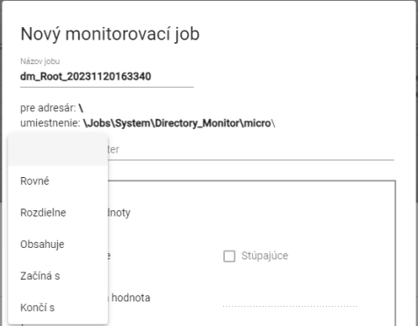

Figure 478: Window for selecting filter conditions

1. Click on the Filter field and enter the filter value. For example: Starting with A will only go through profiles whose name starts with A.



Figure 479: Field for setting the filter value

1. Enter the monitoring criteria in the Criteria block.

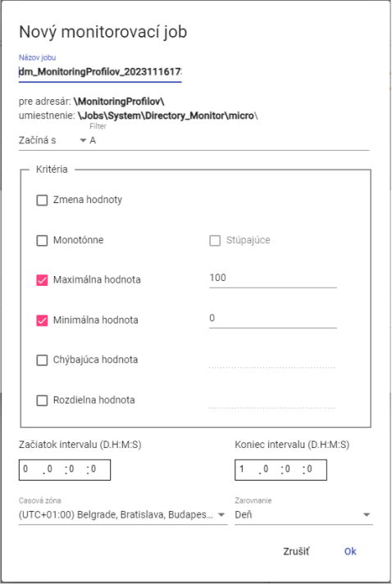

Figure 480: The job task

1. Enter the start and end intervals.
2. You can choose the time zone and the alignment.
3. To create a monitoring job, press the Ok button.
4. The Monitoring window displays a new monitoring job.

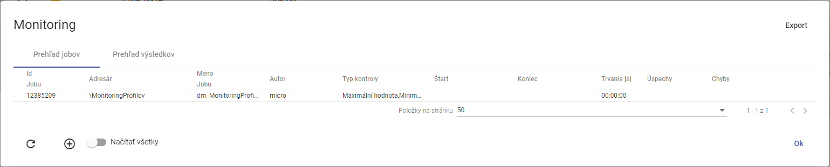

Figure 481: Monitoring job created

### **[TRANSLATION ERROR - MANUAL REVIEW NEEDED] Ako editovať job v JMW**

**[TRANSLATION ERROR - MANUAL REVIEW NEEDED] Pre úpravu jobu postupujte:**

1. **[TRANSLATION ERROR - MANUAL REVIEW NEEDED] Kliknite pravým tlačidlom myši na job a vyberte položku „Editovať v JMW“.**

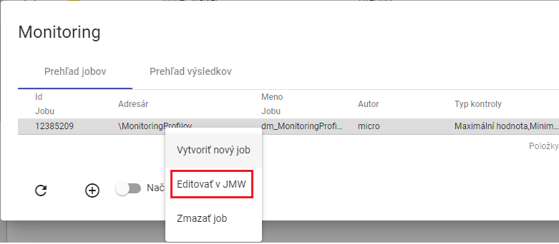

Figure 482: Item Edit in JMW

1. **[TRANSLATION ERROR - MANUAL REVIEW NEEDED] V novej záložke v prehliadači sa otvorí job v aplikácii „Job Manager“.**

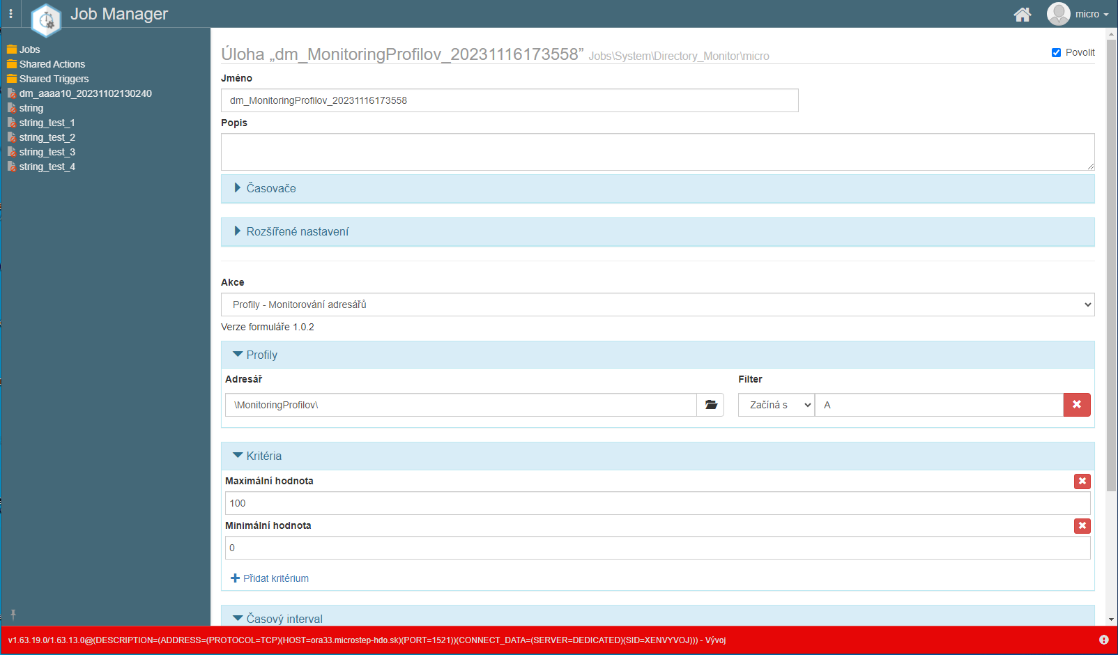

Figure 483: Editing a job in the Job Manager

1. **[TRANSLATION ERROR - MANUAL REVIEW NEEDED] Postup pre úpravu jobu sa nachádza v dokumentácii k aplikácii „Job Manager“.**

### **[TRANSLATION ERROR - MANUAL REVIEW NEEDED] Ako zmazať job**

**[TRANSLATION ERROR - MANUAL REVIEW NEEDED] Pre zmazanie jobu postupujte:**

1. **[TRANSLATION ERROR - MANUAL REVIEW NEEDED] Kliknite pravým tlačidlom myši v okne „Monitoring“ na job, ktorý chcete zmazať.**

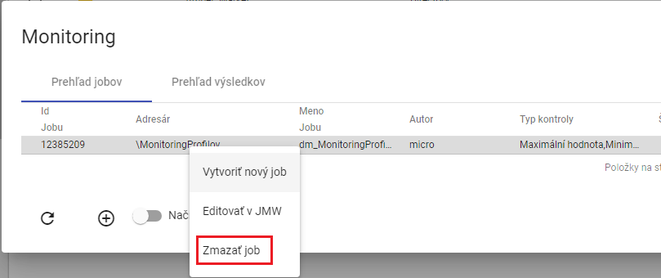

Figure 484: Delete the job

1. **[TRANSLATION ERROR - MANUAL REVIEW NEEDED] Zobrazí sa okno pre potvrdenie vymazania, v ktorom stlačte tlačidlo „Áno“.**

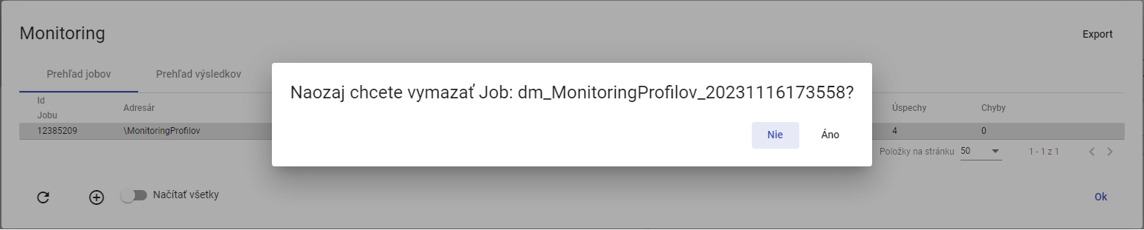

Figure 485: Window for confirming the erasure of the job

### **[TRANSLATION ERROR - MANUAL REVIEW NEEDED] Ako exportovať monitorovacie joby a výsledky jobov**

**[TRANSLATION ERROR - MANUAL REVIEW NEEDED] Pre exportovanie jobov v záložke „Prehľad jobov“ stlačte tlačidlo „Export“, ktoré sa nachádza v pravom hornom rohu okna „Monitoring“. Pre exportovanie výsledkov jobov zobrazte záložku „Prehľad výsledkov“ a stlačte tlačidlo „Export“. Stiahne sa CSV súbor.**

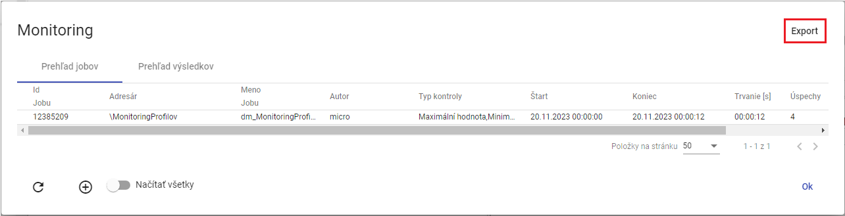

The following table shows the following:

### How to view all monitoring jobs

To view all monitoring jobs, press the Read all button. The Monitoring window will display all monitoring jobs from the tree structure.

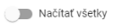

Figure 487: The Read all button

### How to restore the job list in the Monitoring window

To re-upload the job list, press the button in the bottom left corner of the Monitoring window.

### How to view the results of the monitoring job

In the Monitoring window, see the tab Preview of results. This is a list of the monitoring job launches. If the criteria for monitoring the profile have been violated, the results text ERR appears in the results column and the detail provides an error description. If the criteria have been met, the result is OK.

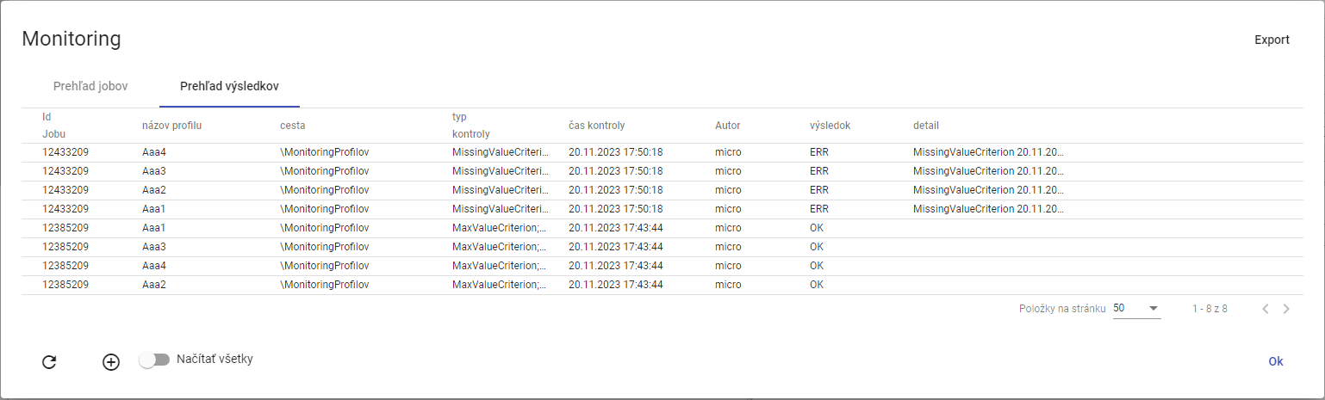

Figure 488: Tab An overview of the results

## Analysis of the profiles

Profile analysis is a static image at the time of calculation, meaning that if someone deletes a profile, the profile analysis remains. Profile analysis allows the user to filter and sort data.

If you close the profile analysis, you can reopen it.

Profile analysis is valid 15 minutes after creation.

Export of the displayed data in profile analysis is developed in Chapter 8.2.4.

### How to create a profile analysis

To create a profile analysis, please proceed to:

1. In the tree structure, right-click the profile directory to create a profile analysis.
2. A window will appear where you can click on Profile analysis.

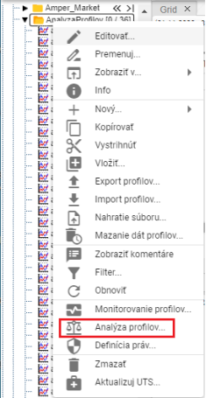

Figure 489: Item Analysis of profiles

1. The second option is to view the profile directory in the Searcher window and click the Statistics button in the upper right corner of the Searcher window.



Figure 490: The Statistics button

1. The Profile Analysis window will appear.
2. The default option is to create a new period.

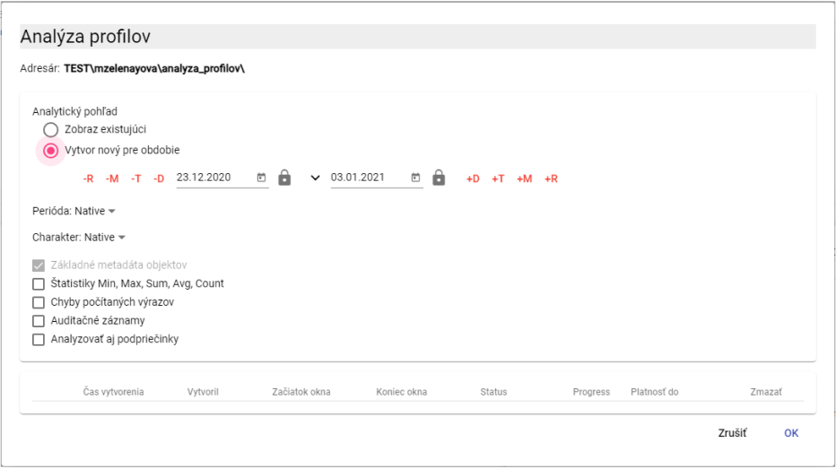

Figure 491: Profile analysis window

1. Set the time period for the profile analysis. Click the button to see the default date range options.

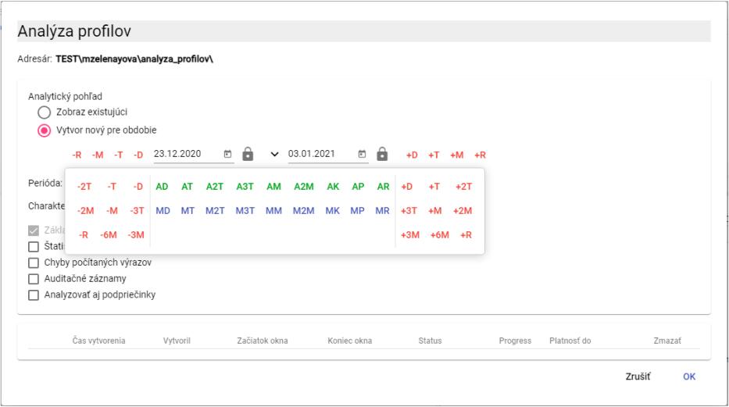

Figure 492: Selection of the date

1. By default, the Period field has the value Native. To enter another period, click Period and select period.

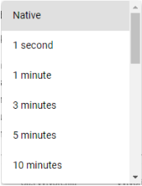

Figure 493: Selection of periods

1. The profile character is used to identify how to sample the values in the profile for a more subtle or rough sampling. The Charakter value is Native. To select the character, click Charakter and select Multiple or Regular.

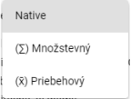

Figure 494: Character selection

1. To calculate statistics in the analysis, click on the box Statistics Min, Max, Sum, Avg, Count.

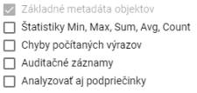

The following table shows the total amount of the exposure value of the exposure value of the exposure value of the exposure value of the exposure value of the exposure value of the exposure value of the exposure value of the exposure value of the exposure value of the exposure value of the exposure value of the exposure value of the exposure value of the exposure value of the exposure value of the exposure value of the exposure value of the exposure value of the exposure value of the exposure value of the exposure value of the exposure value of the exposure value of the exposure value of the exposure value of the exposure value of the exposure value of the exposure value of the exposure value of the exposure.

1. If you want an error to be written in the event of an error, click the box Errors in the counted terms.
2. Select the box Audit records if you want to write data: First reading, Last reading, First entry and Last entry.
3. If sub-parts are to be included in the analysis, click the box Analyze sub-parts.
4. To create a profile analysis, press the OK button.
5. A new tab called A address name will be created in the Experiment window.

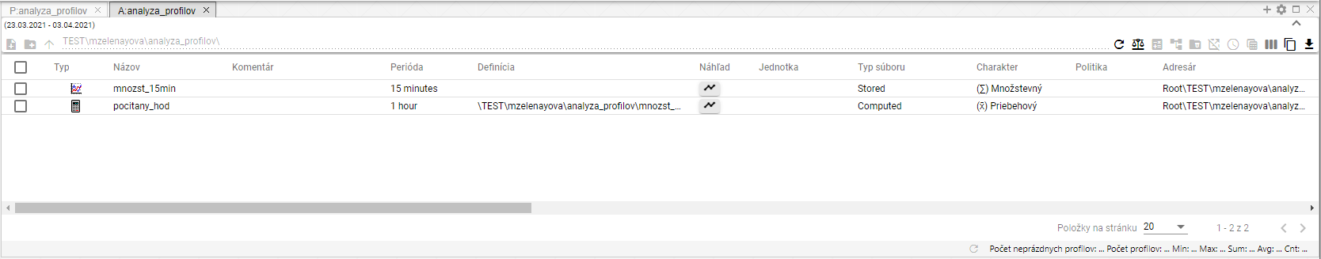

Figure 496: Profile analysis produced

1. In the profile analysis window, you can filter the data. Use the cursor mouse to set the name of the column in which you want to enter the filter.



The following table shows the following:

1. To sort the data in the column, set the mouse cursor to the column name. The arrow will appear.



Figure 498: The data sorting button in columns

### How to display an existing profile analysis

If you have closed the profile analysis and want to reopen it, it is possible for the duration of the profile analysis.

To open an existing profile analysis, please proceed to:

1. In the Profile Analysis window, click Existing image
2. Click to select the analysis you want to display.

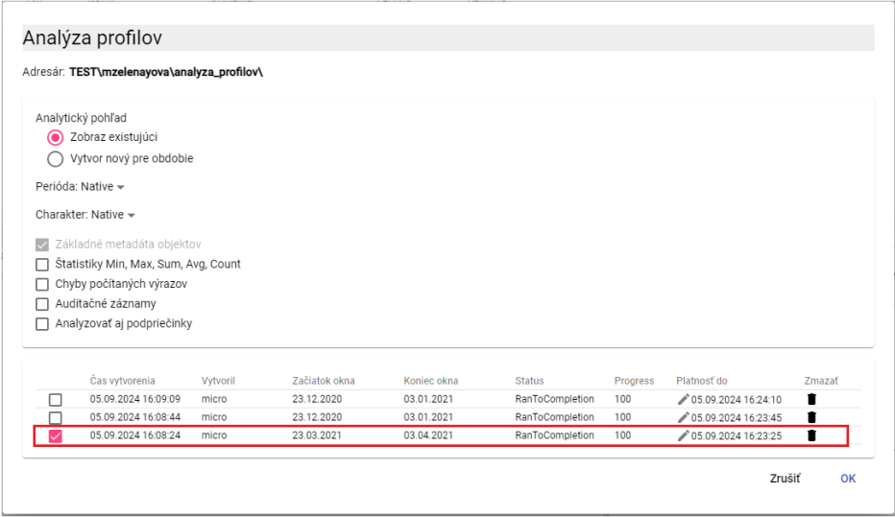

Figure 499: Display of existing profile analysis

1. Press the OK button.
2. The profile analysis is displayed in the Experiment window.

### How to change the validity of the profiles analysis created

Profile analysis is valid for 15 minutes by default, but you can extend it.

For the extension of the profile analysis, please proceed to:

1. In the Profile Analysis window, in the analysis row for which you want to extend validity, click the pencil icon.

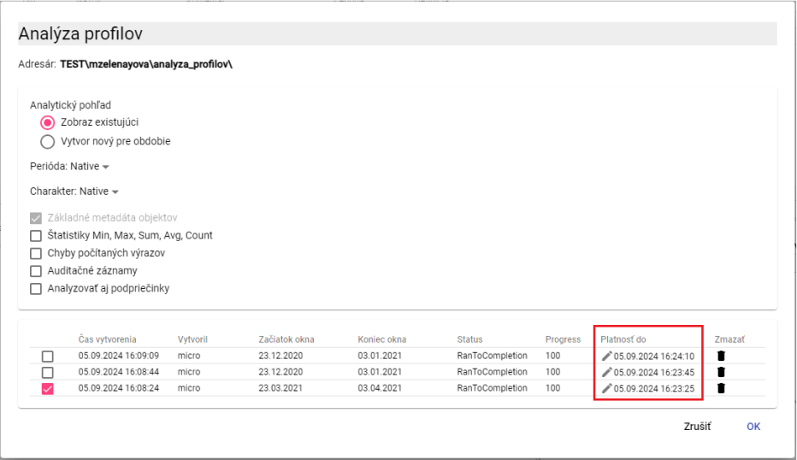

Figure 500: Field Payment to

1. The field Payment to will be made available for editing.

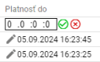

Figure 501: Extending the scope of the profile analysis

1. The first field represents days, the second field represents hours, the third field represents minutes, the fourth field represents seconds. If you want to extend validity by 2 days, write 2 in the first field.
2. Put it down by pressing a button .
3. The validity of the profiling analysis shall be extended.

### How to export the displayed data in profile analysis

For exporting data in profile analysis, please proceed to:

1. Press the button in the upper right corner of the Explorer window.

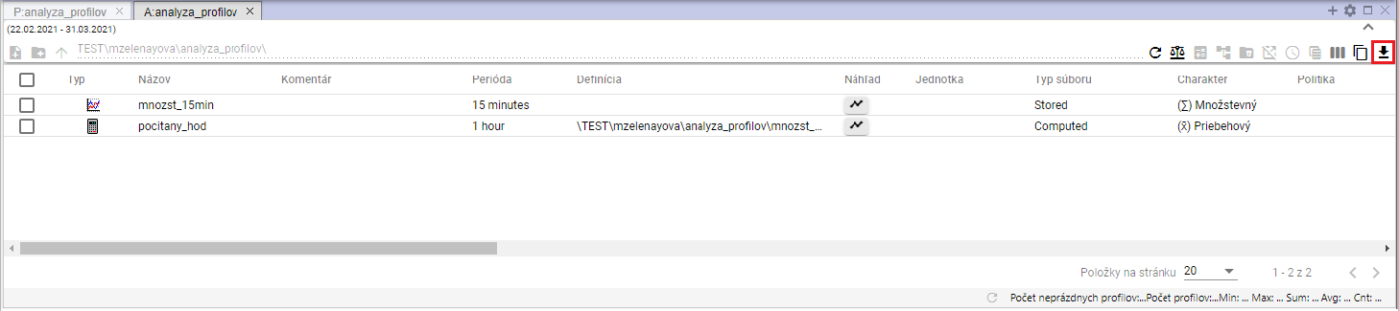

The following table shows the calculation of the export price of the product:

1. The window Export will appear.

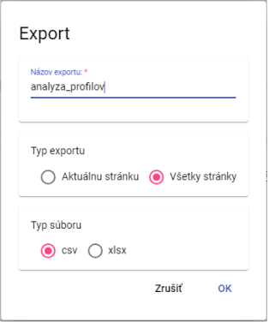

The following table shows the number of exports of the product:

1. The Export Type section is set to All pages. All data is exported. If you select Current page, only the data displayed is exported.
2. In the File type section, select the export file type.
3. Please press the OK button to confirm the export.

## Report Manager

### How to create a new report

To create the report, please proceed to:

* 1. In the tree structure, right-click the directory to add a new report.
  2. An offer will appear where you can set the mouse cursor to New and then select Report.

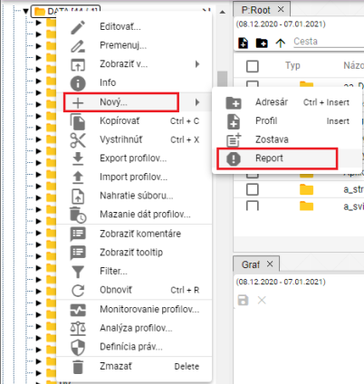

The following table shows the number of days in which the report is to be submitted:

* 1. The tab Report Manager will appear where you can enter the data for the new report.

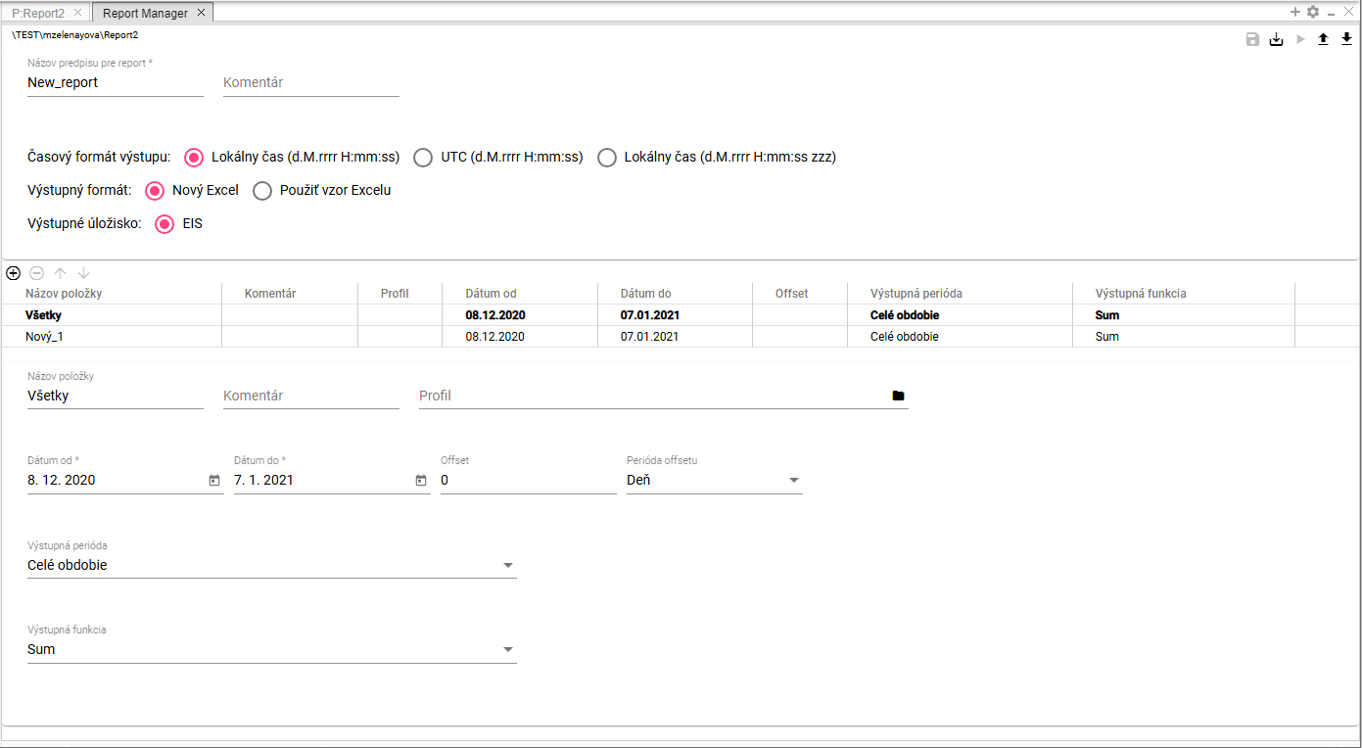

The following table shows the results of the analysis:

* 1. In the Name of the report rule field , the text is automatically New_report. You can change the name.

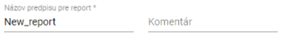

Figure 506: Fields Name of the reporting rule and Commentary

* 1. You can write a comment in the "Comment" field.
  2. Select the output time format. Local time (d.M.rrrr H:mm:ss) is selected as standard.



Figure 507: Field Time format of the output

* 1. In the Output Format field, select the output format for the report.



Figure 508: Field Available format

* 1. If you select Use the Excel template, the fields Excel Name and List Name in Excel will appear.

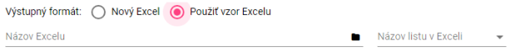

Figure 509: Fields for the assignment of the excel

* 1. In the Excel Name field, click the button to display the Choose xlsx window, where you can search for excel in tree structure.

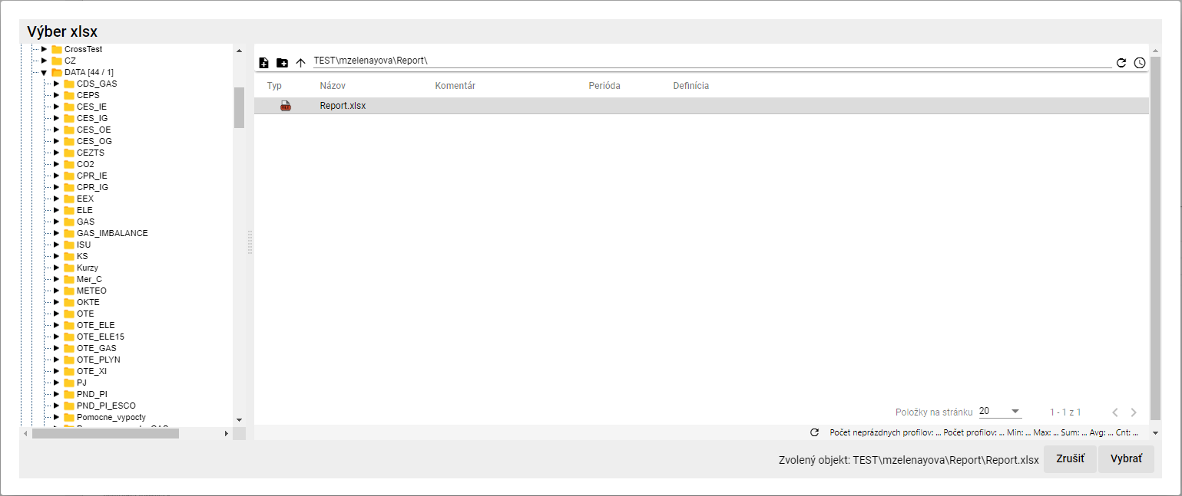

Figure 510: Window View xlsx

* 1. In the Voice xlsx window, after finding Excel, press the Choose button.
  2. Click on the Letter names field in Excel and select the name of the letter.



Figure 511: Fields filled in Name of excelu and Name of sheet in Exceli

* 1. Please fill in the entries.

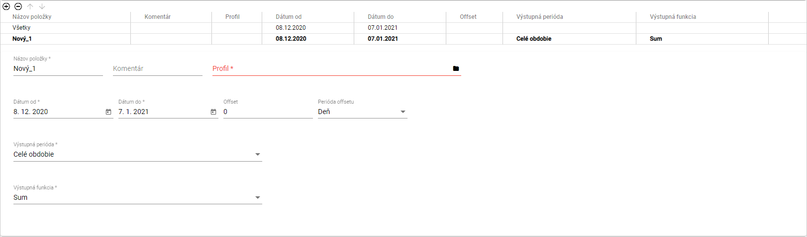

Figure 512: Data for entries to be entered

* 1. To enter the same data for all items at once, click All. The data you enter will be filled in for all profiles.
  2. To fill in the data for each profile separately, click the item in the table to which you want to enter the data.



Figure 513: Selected item in the table

* 1. Fill in the data below the table.
  2. In the Name field, NEW_1 is automatically filled in. You can change the name.
  3. You can write a comment in the "Comment" field.
  4. In the Profile field, type the path to the profile or click the button to display the Choose profile window.
  5. In the Choose Profile window, look for a profile and press the Choose button.

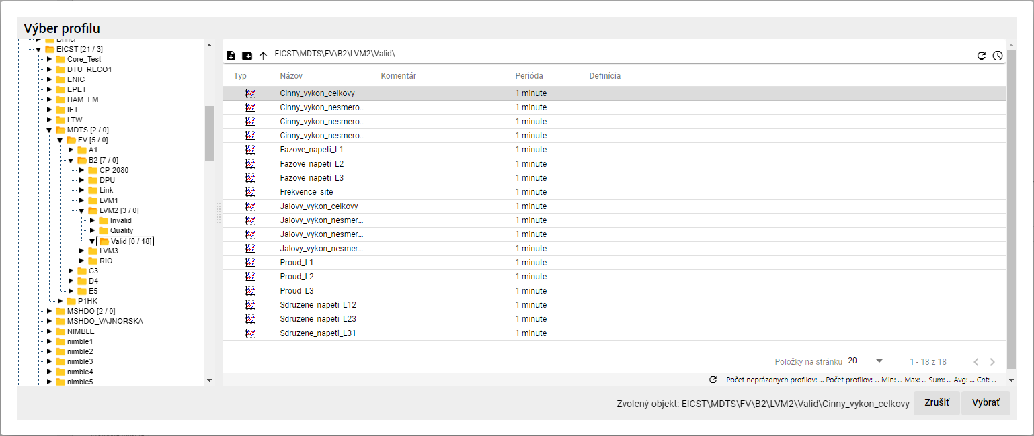

Figure 514: Window Profil selection

* 1. Select the dates Date from and Date to.
  2. You can set the offset in the Offset field.
  3. In the field Offset Period, select the period.
  4. Click on the box Available Period and select the period from the offer shown.
  5. Click on the box Output function and select a function.

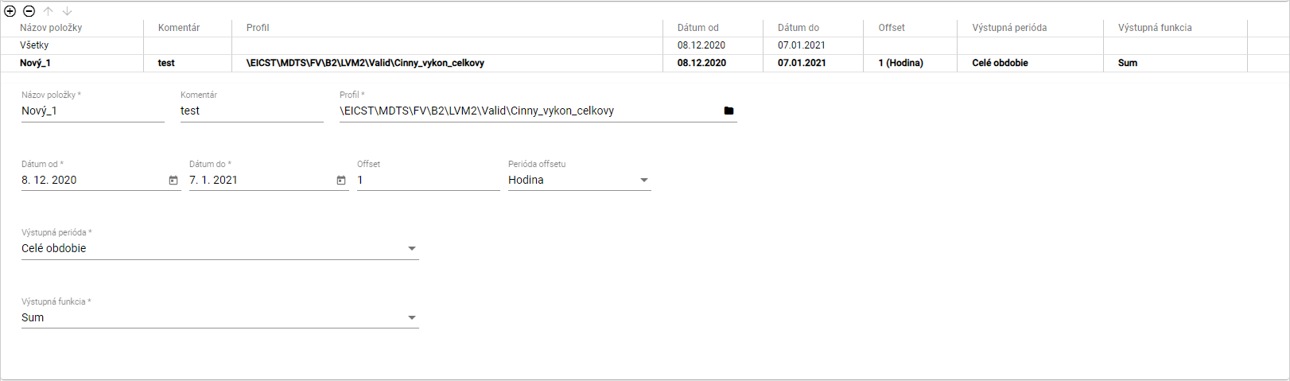

Figure 515: Data completed for the item

* 1. You can also add a profile by transferring it from the tree structure to the table in the Report Manager tab. In the tree structure, grab the profile with the left mouse button and move the profile above the table.

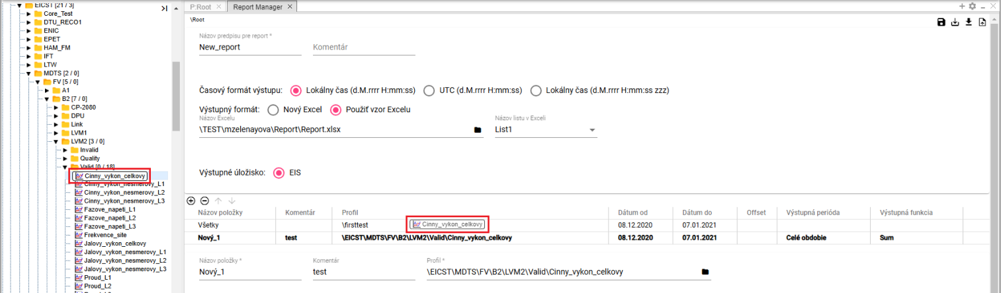

Figure 516: Transfer of profile from tree structure to table



Figure 517: Added profile from tree structure

* 1. You can add the profile to the Report Manager tab and from the browser. Click the Profile Explorer window to transfer the profile to the table in the Report Manager tab. Touch the left mouse button to transfer the profile to the top of the table in the Report Manager tab. Open the profiles. The profiles are added to the table in the Report Manager tab.

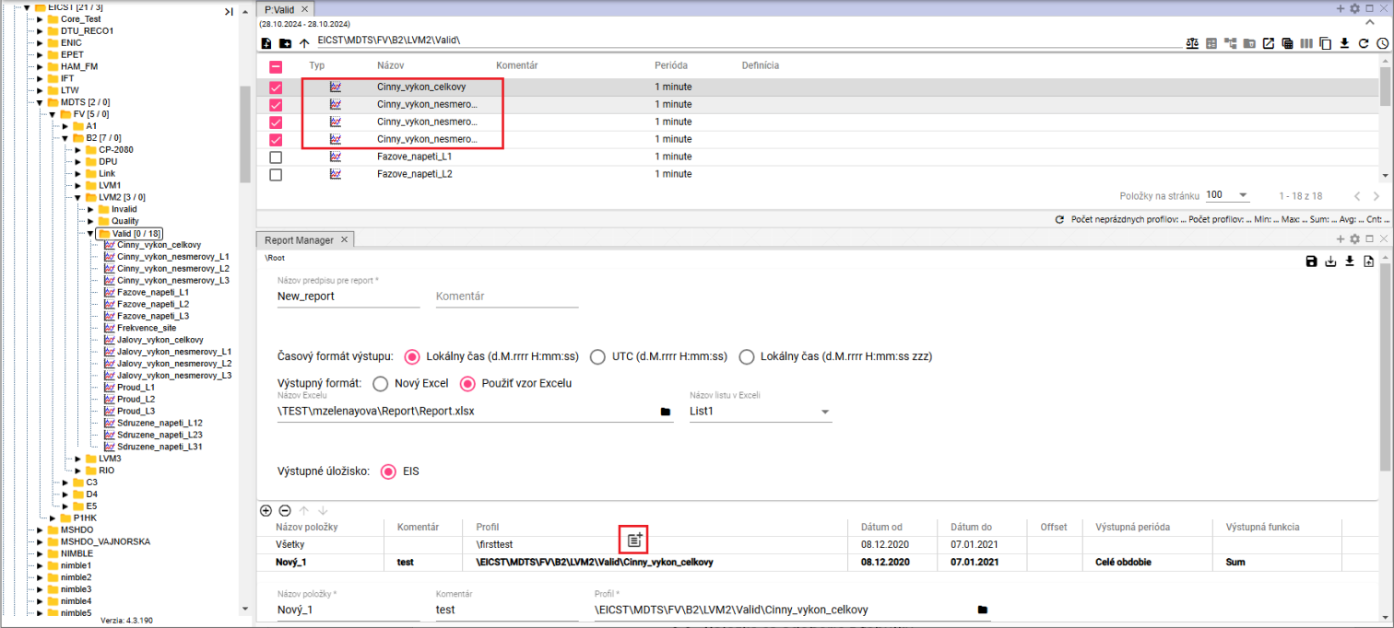

Figure 518: Transferring profiles from the table to the Report Manager using the Drag and Drop function

* 1. You can add another item by pressing a button .
  2. To remove an item, click on the item in the table and press the button.
  3. You can change the order of profiles in the table by using buttons .
  4. You save the report by pressing the Save button, which is located in the upper right corner of the Report Manager screen.



Figure 519: The Put in

* 1. To save the report to another directory, press the Save as button.
  2. The window "New report" will appear.
  3. In the Cesta field , enter the path to the new directory or search the directory using the button .

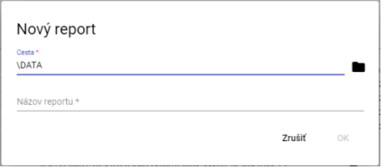

Figure 520: Window New report

* 1. Enter the name of the report in the Report Name field.
  2. You will save the report by pressing the OK button.
  3. You can generate a report by pressing the Generate report button, which is located in the upper right corner of the Report Manager screen.



Figure 521: Pressure Generate a report

* 1. The window Setting time range will appear, in which you select the time range.

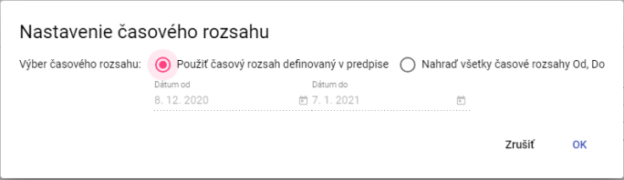

Figure 522: Window Setting the time range

* 1. To generate the report, press the OK button.
  2. To download the generated report, click on the Export button at the top of the toolbar, which will display the Export window.
  3. In the Export window, click the Delete button, which is in the generated report row.

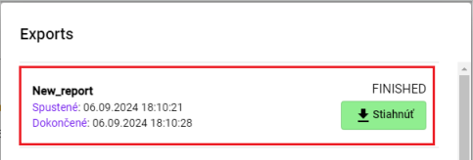

Figure 523: Report generated

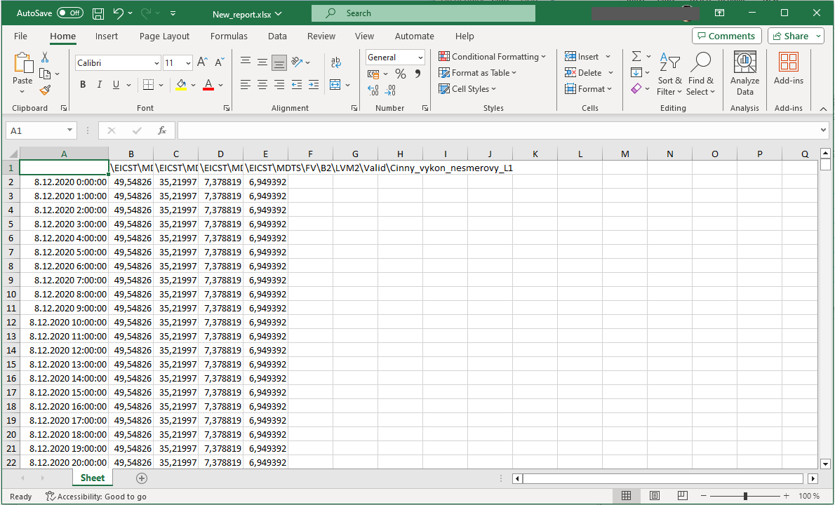

Figure 524: Downloaded report

* 1. You can save the file to a disk in CSV or PGZ2 format. To download the file, press the Locate the file to a disk... and select the format in which the file is to be downloaded.

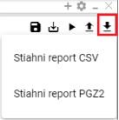

Figure 525: Offer the button Show the set to the disk...

### Rights for the Report Manager

The rights for Report Manager can be set:

* Read - if the user does not have the right to Read, he or she will not open the form either pgz or pgz2.
* Create - if the user does not have the right to Create, the Serve as... button will not be allowed or the New... option to create Report will not appear in the menu.
* Write - if the user does not have the right Write, he will not be allowed to press the Save button, only the Save as ... button will be allowed and saved to disk.
* Execute - if the user does not have the right to Execute, the Generate report button will not be allowed.

## How to recover deleted items from basket

You restore the items from the basket:

1. Display the content of the basket in the tree structure or in the Explorer, 4.14.



Figure 526: Cotton in the tree structure

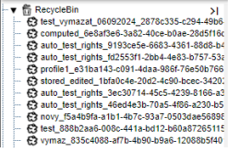

Figure 527: Display of the content of the basket in the tree structure

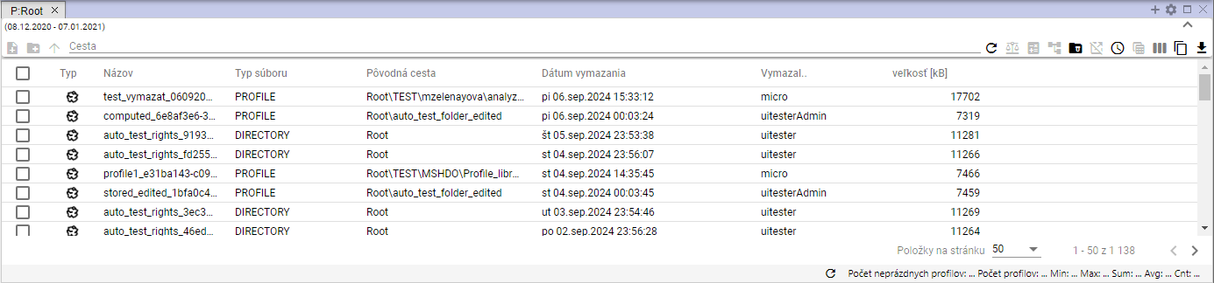

Figure 528: The content of the basket in the scanner window

1. Right-click the mouse on the item in the basket that you want to restore.
2. You will see an offer where you can select to get back from the basket.

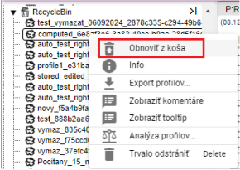

Figure 529: Item Restore from basket

1. The "Recover file" window will appear.

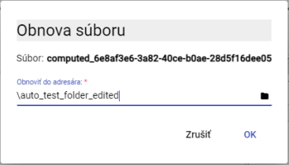

Figure 530: Window Recover the file

1. The 'Restore to directory' field shows the path to the directory from which the file was deleted. To restore the file to another directory, enter the path to the directory or search the directory using a button.
2. To confirm the recovery of the file, press the OK button.



© 2025 MicroStep HDO spol. s r.o.

MicroStep and MicroStep-HDO are registered trademarks.This document is the intellectual property of MicroStep-HDO s.r.o. and may only be used for the purposes for which it was transmitted.

*MicroStep-HDO s.r.o., Vajnorská 158, 831 04  Bratislava*

*www.microstep-hdo.com, e-mail: info@microstep-hdo.sk*